
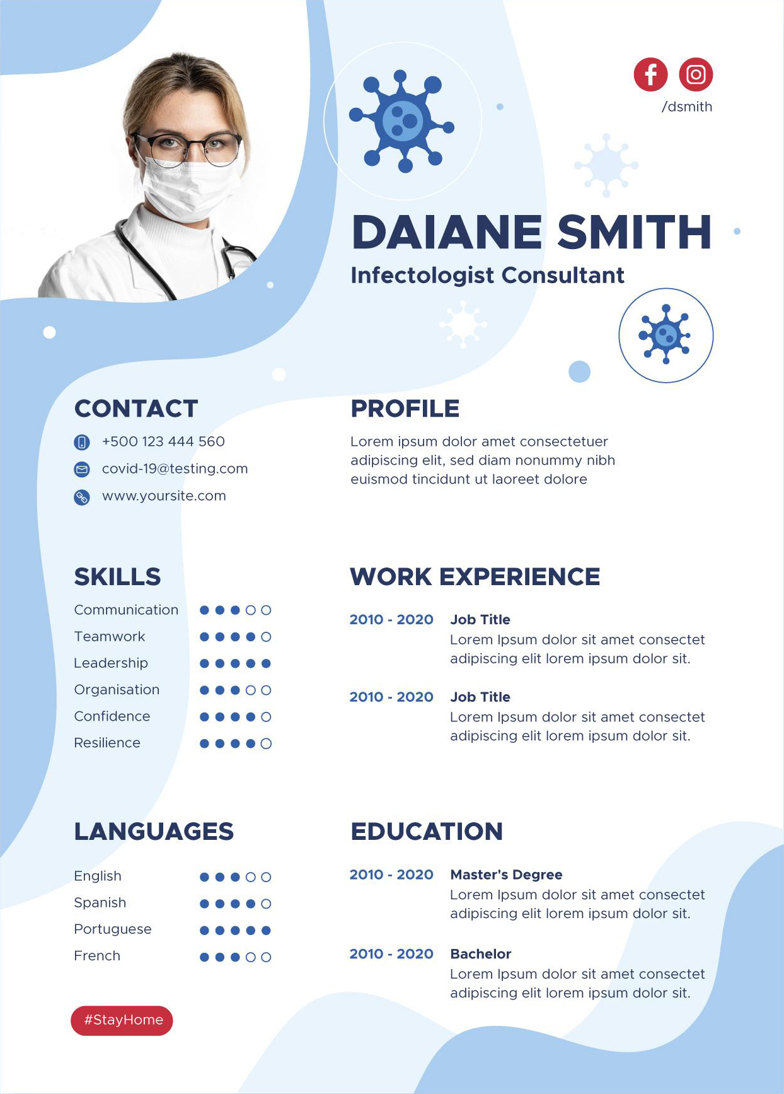
CONTACT
SOFIA PRISCILLA
Licensed Practical Nurse
/helpshared
#StayHome
+1 234-567-8900
priscilla@email.com
www.helpshared.com
428 2nd Ave NE, Stewartville, MN 55976, USA

SKILLS
CPR
Pharmacology
Medical records
Organizational
Phlebotomy
Vital sign

CERTIFICATIONS
Registered Nurse (RN)
CNOR Certified
Basic Life Support (BLS) Certification

SUMMARY
Motivated Licensed Practical Nurse with over three years of experience as an LPN. Seeking a role with Green Country Clinic as a Licensed Practical Nurse.

WORK EXPERIENCE

2024 - 2026 MediCare Hospital
Monitor patient vitals before, during, and after operation
Take patient medical history and assess mental and physical readiness for surgery.

2022 - 2023 Healthwise Solutions
Support patient health through regular check-ins and monitoring of known conditions and new symptoms.

EDUCATION

2020 - 2021 Zen Medical Institute
Complete education in Associate of Applied Science in Nursing

2018 - 2020 Kaminska Dermatology
Bachelor of Science in Nursing.

