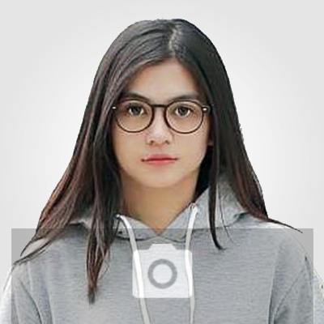
FRANCISKA
TOBING

ART DIRECTOR

081245678900  Franciska123@email.com  www.helpshared.com

SUMMARY
Art director with 5 years of experience developing and executing successful editorial content plans. Skilled in managing writers, overseeing production, driving website traffic, and producing engaging content that resonates with readers.

CONNECT

 LINKEDIN.COM/IN/FRANSISKATOBING

 FACEBOOK.COM/FRANSISKATOBING

 INSTAGRAM.COM/FRANSISKATOBING

SKILLS

Branding & Identity
Concept Art
Design
Illustration
Adobe Photoshop
Photography

WWW.HELPSHARED.COM
EXPERIENCE

Global Media, New York, NY 02/2022 – Present

Art Director

Supervised 27 multi-functional project team members to develop effective advertising concepts, from ideation through final projects.

Directed the design of 19 customer sites that won 2020, 2021, and 2022 RW Branding & Design Award within three years on the job.

Supervised 35 creative team members by fostering a highly communicative and collaborative team culture on 246 creative projects.

Polyhire, London, United Kingdom 10/2020 – 08/2022

Brand Manager

Supervised the daily operations of a $24.5M brand, including its marketing campaigns and product launches.

Created innovative promotional strategies for 200 existing products, increasing the revenue of Polyhire by 34% annually.

EDUCATION

Milena University, New York, NY 05/2020

Master of Fine Arts — Visual Communication

REFERENCE

JAY NUGROHO
Ceo of Global Studio
Phone : 022-3343973
Email : Jaynugroho@email.Com

