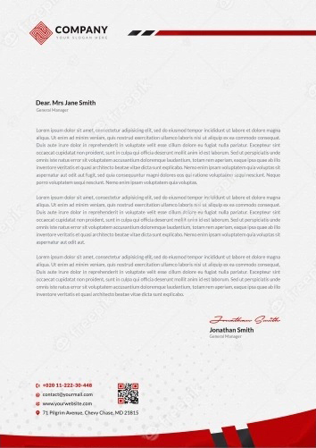
Sofia Caroline
WWW.HELPSHARED.COM
(+012) 888 4567 | alexacamille@email.com
September 8, 2026
Anna Jefferson
Hiring Manager
Alexa Media Group
Dear Anna Jefferson,
I am writing to express my strong interest in the Fresher Business Analyst position at Ethereal Elevation. As a recent graduate with a degree in Business Analytics, I am excited about the opportunity to apply my skills and knowledge to contribute to the success of your organization.
During my academic journey, I have developed a solid foundation in data analysis, market research, and business strategy. Through various coursework and projects, I have gained hands-on experience in analyzing complex data sets, identifying trends, and providing actionable insights. I am confident that my analytical mindset and attention to detail will enable me to effectively contribute to Ethereal Elevation's data-driven decision-making process.
What truly excites me about this position is the chance to work with a dynamic team in a fast-paced industry. Ethereal Elevation's commitment to innovation and its reputation for excellence align perfectly with my career aspirations. I am eager to collaborate with professionals who share my passion for leveraging data to drive business growth and enhance customer experiences.
In addition to my technical skills, I possess strong communication and problem-solving abilities. I have honed my interpersonal skills through group projects and presentations, where I effectively communicated complex ideas to diverse audiences. Furthermore, my ability to think critically and adapt to changing circumstances has been demonstrated through my academic achievements and extracurricular involvement.
I am particularly drawn to Ethereal Elevation's emphasis on fostering a collaborative and inclusive work environment. I believe that diverse perspectives lead to more innovative solutions, and I am excited about the opportunity to contribute to a team that values and celebrates diversity.
In closing, I would like to reiterate my enthusiasm for the Fresher Business Analyst position at Ethereal Elevation. I am confident that my skills, passion, and dedication make me an ideal candidate for this role. I appreciate your time and consideration, and I look forward to the opportunity to discuss how I can contribute to the success of your organization.
Best regards,
Helpshared.Com
Sofia Caroline
Jeannette Ortega
(142) 367-5893
jeannette@ortega.com
January 2, 2025
Anna Jefferson
Hiring Manager
Ethereal Elevation
Dear Hiring Manager,
As a recent business graduate and an avid follower of the tech industry, I am thrilled to apply for the Entry Level Business Analyst position at Microsoft. My fascination with technology began as a child, when I would spend hours tinkering with my parents' computer, and has grown throughout my academic career. Microsoft's commitment to innovation and its impact on people's lives aligns with my passion for technology, making it an ideal place for me to kick-start my career.
During my time at university, I led a team of five students in a semester-long project to analyze the financial performance of a local business, using data-driven insights to propose strategies for growth. Our recommendations led to a 20% increase in revenue for the business within six months. This experience taught me the importance of understanding the data and its implications, which I believe will be invaluable in my role as a Business Analyst at Microsoft.
In addition, I interned at Resume Worded, where I assisted in streamlining the company's CRM system, ultimately reducing manual data entry by 30% and increasing overall efficiency. This experience not only honed my analytical skills but also allowed me to gain hands-on experience in working with various software tools.
I am particularly excited about the opportunity to contribute to Microsoft's mission of empowering people and organizations to achieve more. I am confident that my analytical abilities, combined with my passion for technology, will enable me to make a significant impact as a Business Analyst at Microsoft.
Thank you for considering my application. I look forward to the opportunity to discuss how my skills and experiences align with Microsoft's needs and how I can contribute to the continued success of the company.
Sincerely,

Jeannette Ortega

