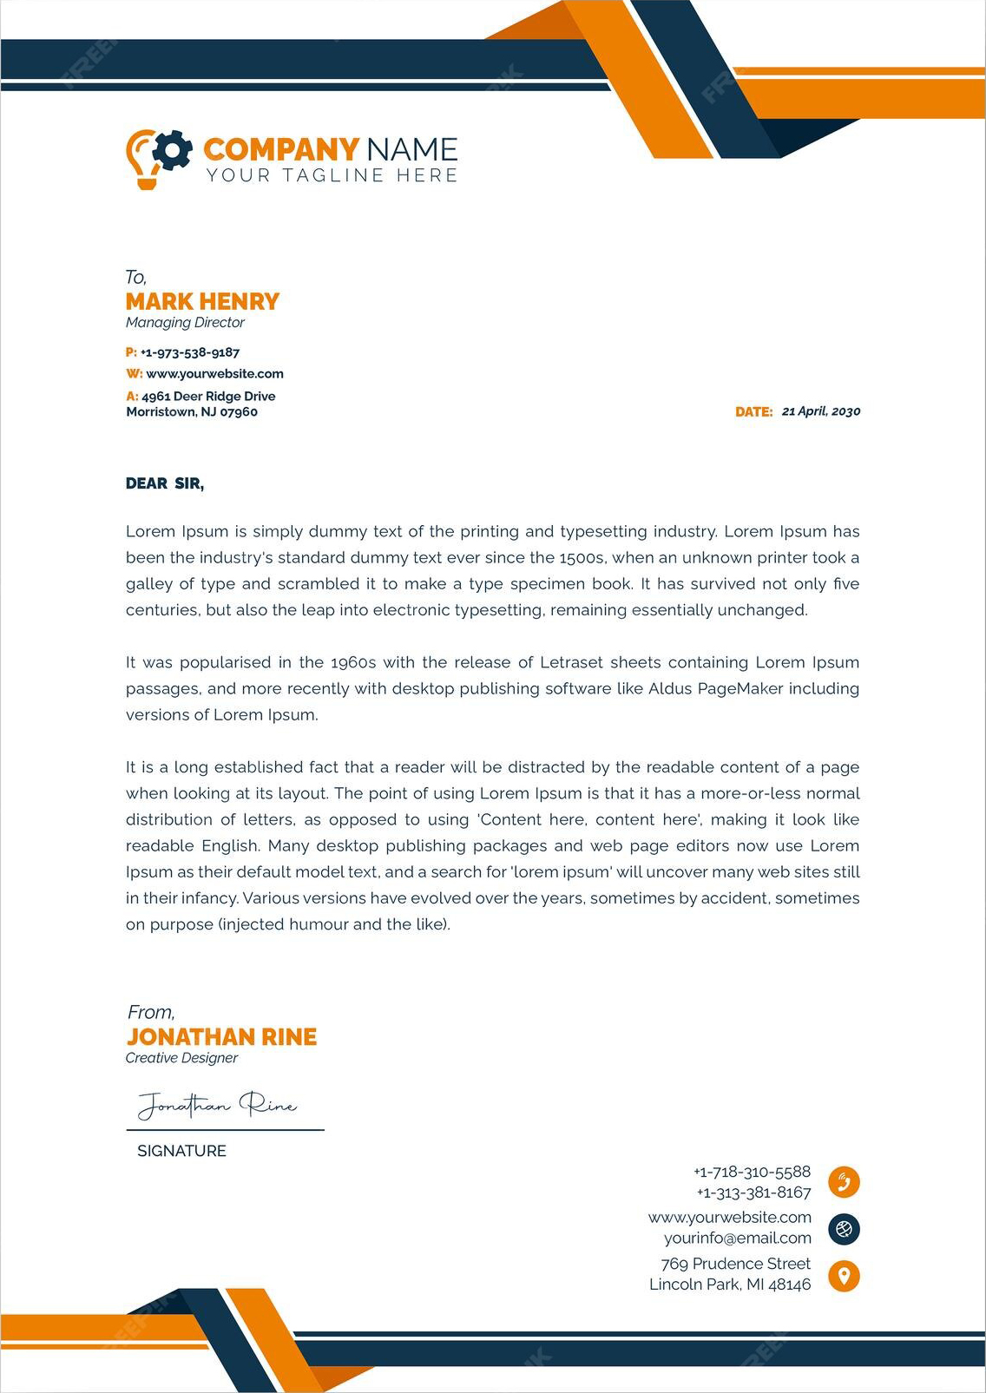
MARK GRAYSON
WWW.HELPSHARED.COM
January 28, 2026
Juliana Clark
Hiring Manager
Mediatech
Dear Juliana Clark,
I am writing to express my strong interest in the Fresher Software Engineer position at Mediatech. As a recent graduate with a degree in Computer Science and a passion for software development, I am excited about the opportunity to contribute to your innovative team and make a meaningful impact in the industry.
From a young age, I have been fascinated by the power of technology to transform the way we live and work. This fascination led me to pursue a degree in Computer Science, where I gained a solid foundation in programming languages, algorithms, and software engineering principles. Throughout my academic journey, I have actively sought out opportunities to apply my knowledge and skills in real-world projects, including internships and collaborative coding competitions. These experiences have not only sharpened my technical abilities but also honed my problem-solving and teamwork skills.
What truly sets me apart as a candidate is my strong passion for continuous learning and growth. I am always eager to explore emerging technologies and stay updated with the latest industry trends. This drive for knowledge has motivated me to pursue various online courses and certifications, allowing me to expand my skill set beyond the classroom. I am confident that my enthusiasm for learning, coupled with my technical expertise, will enable me to quickly adapt to the dynamic nature of the software engineering field.
In addition to my technical qualifications, I possess excellent communication and interpersonal skills, which I believe are crucial for effective collaboration within a team. I thrive in fast-paced environments and am adept at managing multiple projects simultaneously. My ability to analyze complex problems and devise innovative solutions has been commended by both professors and colleagues.
I am particularly drawn to Mediatech due to its reputation for pushing boundaries and delivering cutting-edge solutions. Your commitment to innovation aligns perfectly with my own aspirations, and I am eager to contribute to your mission of revolutionizing the software industry. I am confident that my technical expertise, passion for learning, and strong work ethic make me an ideal fit for your team.
Thank you for considering my application. I would be thrilled to discuss my qualifications further and demonstrate my potential to contribute to Mediatech. I have attached my resume for your review. I look forward to the opportunity of speaking with you in person..
Sincerely,
Helpshared.Com
markgrayson@ email.com
+1 234-567-8900
148 Charlotte Area , North Carolina
Mark Grayson

Jenna Coleman
(+013) 222 6789
jennacoleman@email.com
January 28, 2026
Aliana Jones
Hiring Manager
Unisoft
Dear Hiring Manager,
As a lifelong fan of innovative technology, I was thrilled to come across the Entry Level Software Engineer position at Microsoft. I've always admired Microsoft's dedication to creating accessible and powerful tools for people around the world. Your commitment to fostering creativity and empowering individuals resonates with me on a personal level, as I've seen firsthand the impact your products have had on the lives of my family members.
During my final year at university, I developed a mobile app to assist visually impaired individuals with navigation, utilizing Microsoft's Azure platform. The app garnered over 3,000 users within the first two months of its launch and was featured in our local newspaper. This experience not only honed my technical skills but also taught me the value of empathy-driven development. I am confident that my ability to create user-centric solutions will make me a valuable addition to Microsoft's software engineering team.
In a recent summer internship at Resume Worded, I optimized the performance of a key feature by implementing a more efficient algorithm, resulting in a 25% decrease in load time. This improvement directly led to better user experience and increased customer satisfaction scores. My strong analytical skills and passion for optimizing code would enable me to contribute effectively to Microsoft's ongoing pursuit of excellence in software performance.
As someone who has grown up using Microsoft products, I am incredibly excited about the opportunity to work on projects that will have a tangible impact on the lives of millions of users worldwide. I am eager to learn from the talented engineers at Microsoft and contribute my skills to help shape the future of technology.
Thank you for considering my application. I look forward to the opportunity to discuss how my skills and passions align with Microsoft's mission and the Entry Level Software Engineer role.
Sincerely,

Jenna Coleman

