Concept of Operations



## **Company E (AGCO)**

Oliver Fridorf – 201907235

Tobias Andersen – 201905423

Lasse Bjørnskov – 201907292

Michael Nørbo – 202202966

Anisa Mohamed – 201806371

Julia walczynska – 202202970

Claes Jensen – 201907300

Henrik Buhl – 201905590

Dilan Celebi – 202202967

Johansen, Alexander Stæhr – 201905865

Kuang, Liulihan – 201906612

Rammohan, Shivaram - 202202968

Table of contents

**1. Introduction** 2

**1.1 Purpose** 2

**1.2 Executive summary** 2

**1.3 Revision summary** 2

**2. Capability Need** 2

**2.1 Business Need(s)** 2

**2.2 Business Need Capability Gap** 2

**2.3 Current situation** 2

**3. Operations and Support Description** 2

**3.1 Missions (Primary/Secondary)** 2

**3.2 Users and Other Stakeholders** 3

**3.2.1 Manufacturer (ACGO)** 3

**3.2.2 Customer (Suppliers/Farmers)** 3

**3.2.3 User (Farmers)** 3

**3.3 Policies, Assumptions and Constraints** 3

**3.4 Operation Description** 4

**3.4.1 OpCon** 4

**3.4.2 Employment Modes** 5

**3.4.3 Scheduling and Operations Planning** 6

**3.4.4 Operating Environment** 6

**3.4.5 Geographic Area(s)** 6

**3.4.6 Environmental Conditions** 6

**3.4.7 Interoperability with Other Elements** 6

**3.5 Product Support Description** 6

**3.6 Potential Impacts** 6

**3.7 Scenarios — Support Name, Functional Capabilities Needed** 6

**4. Functional Capabilities** 6

**4.1 Operations** 6

**4.1.1. Cropping the product** 6

**4.1.2. Header preprocessing** 6

**4.1.3. Storage in a feederhouse** 7

**4.1.4. Harvest processing** 7

**4.1.5. Harvest cleaning** 7

**4.1.6. Harvest handling** 7

**4.1.7. Residue management** 7

**4.2 Acronyms and Abbreviations** 7

**4.3 References** 7

Document revision history:

|  |  |  |  |
| --- | --- | --- | --- |
| Rev. | Date | Change description | Creator |
| 1.0 | 2023-03-08 | Added all the contents for the Conops documents in different catagories from each contributer | Alexander, Henrik, Liulihan, Shivaram, Micheal, Tobias, Dilan |
| 1.1 | 2023-03-08 | Formatted all the contents in the document to be more clear and precise | Dilan, Michael |
| 1.2 | 2023-03-08 | Self reviewed the entire document and made minor fixes | Henrik, Alexander, Liulihan |

Document review version

|  |  |  |
| --- | --- | --- |
| Rev. | Date | Review group |
| 1.0 |  |  |
|  |  |  |

# **1. Introduction**

Modern day farmers have high expectations and requirements for the equipment they use to harvest their produce. Farmers have reported poor performance from the AGCO powerflow headers used on their harvesters. The product does not deliver the desired control characteristics expected, and a new solution must be developed to facilitate the needs of the farmers. This Concept of Operations has been developed by Agro-Tech for AGCO for the development of the Active Support Wheels, which are intended to solve problems reported by the farmers. It has been created with the intention that it will support in accomplishing the project goals.

Specifically, this document underlines the requirements that are needed for the systems design, while providing all stakeholders with the necessary resources to ensure successful collaboration between all potential stakeholders

# **1.1 Purpose**

This concept of operations aims to collect the combined vision for the development and final product for the Active Support Wheels. It is used to unify the needs and final uses of the product to ensure that all stakeholders agree with the operation and support for the Active Support Wheels.

This requires that all stakeholders agree on balancing the goals of the project, against what is possible considering budget, technology and time, to achieve a product that operates optimally in the intended use cases.

To ensure proper communication and agreement, CONOPS uses both business and operation scenarios to illustrate the uses and requirements of the product. The scenarios have been conceptualized by the inputs from all stakeholders. This is done to ensure that the product archives the common goals of the CONOPS

## **1.2 Executive summary**

Throughout this ConOps, the header of a combine harvester is described and the problem with the header being unstable, clarified. The stakeholders are evaluated, and the needs and high-level requirements are presented. The problem statement is explored and elaborated, both in the case of the current method and operations, and a possible solution is proposed and explained. An in-depth presentation of the concept of operations is made of the whole system, as well as the subsystems of the combine harvester and the environmental and geographical situations are declared.

## **1.3 Revision summary**

|  |  |
| --- | --- |
| **Revision date** | **Comment** |
| 08/03/2023 | Document initialized and key sections made |
|  |  |
|  |  |
|  |  |

# **2. Capability Need**

This section will describe the needs of stakeholders of interest and point out the capability gap of each need. The needs include a better combine header to increase the performance of existing technology thereby increasing farming efficiency.

## **2.1 Business Need(s)**

The different stakeholders have different needs that should be met by the product to be designed. The users of the combine have not been satisfied with the performance of the combine head, which has resulted in slower speeds and less efficient harvesting of crops. A solution should be created to mitigate the poor performance. ACGO needs a product which attaches to existing combine headers and can track the incline of an uneven field.

## **2.2 Business Need Capability Gap**

The current implemented control system suffers from slow response time, overshot and instability leading to oscillations. This calls for a solution to modify the current system in a way that improves performance. The current system should be able to track the ground with decent accuracy, but tests have shown poor controllability of the feedback system. This results in a system that can be controlled by a joystick, but not with the feedback system. This results in a manual system instead of an autonomous one which does not live up to the need of ACGO.

## **2.3 Current situation**

In the current situation of farming using combiners, the 40 ft wide header for farming the crops is usable in cases where there is no incline or instability in the ground. When either incline or instabilities occur, the combine harvester will not cut the crop at the appropriate height, or the header will dig up the soil of the field.

The header of the combine harvester could be redesigned in its entirety and thereby approach the problem in another way, but due to the large costs of redesigning and the large quantity of already produced combines, this approach would not be feasible.

# **3. Operations and Support Description**

## **3.1 Missions (Primary/Secondary)**

Certain actions must be taken by the system's subprocess: Cropping the product, processing it with a header, storing it in a feeder house, sending it to the processor to clean the system, returning to the processor to repeat the process if necessary, or sending it to the grain handler to obtain clean grain. It can also be sent to the reside management from the cleaning system to produce mog.

- The primary part of this project that creates semi-autonomous header for combine harvester. This will include creating a control system to make sure the header is low enough while being parallel to the ground.

## **3.2 Users and Other Stakeholders**

### **3.2.1 Manufacturer (ACGO)**

ACGO manufactures the harvester, the combine header, and the support wheel system. ACGO has a stake, interest, and responsibility in the production and operation of the harvesters. This includes the desired operations of the combine header and support wheel system.

Sub-stakeholders of the manufacturing:

* Combine header engineers
  + The combine header engineers are responsible for the desired operation of the combine header. They have a direct responsibility for the desired functionality of the header.
* Support wheel system engineers
  + The support wheel system engineers are responsible for the desired operation of the combine header. They have a direct responsibility for the desired functionality of the support wheel system.

### **3.2.2 Customer (Suppliers/Farmers)**

The customer is the buyer of the harvester. This could be a supplier chain intending to sell the harvester to other customers. The customer has a stake in the operation of the harvester in accordance with its described functionalities.

### **3.2.3 User (Farmers)**

The users are the people operating the harvester. This could be farmers or farmer employees that are operating the harvester. The users have a stake in the operation of the harvester for their desired use of the machinery.

## **3.3 Policies, Assumptions and Constraints**

Some of the policies that AGCO employs include sustainability, environmental protection, economic performance, and social well-being, ecologically efficient and cost-effective product regulations, and product rules that are environmentally friendly and cost-effective.

The following represent the primary constraints facing the company:

* The wheels and the structure must be capable of carrying a weight of 500 kg each, the size of the header must be 12.40 m width and 4600 kg weight and the ground position sensor range must be 300 mm.
* The system must support the IP66 protection rating providing defense against 12.5 mm high-pressure water jets.
* Tires must be resistant to the soil texture between JB1 and JB7.
* To prevent soil compaction, the soil's stress level must be safeguarded, and no more than 75 KPa should be applied to the soil.
* A prototype must cost less than 2.000 USD per unit.
* For the series production, the maximum cost must be less than 5.000 USD per unit.
* During the European harvest season, a working prototype must be made available for beta testing with clients.

## **3.4 Operation Description**

In this section, the following subjects will be described: operating concept (OpCon), employment modes, scheduling and operations planning, operating environment, geographic area(s), environmental conditions, interoperability with other elements.

### **3.4.1 OpCon**

In the following section, we will dive into the operating concept.

#### **3.4.1.1 Combine Harvester**

The combine harvest system consists of 6 sub-processes:

1. Header (crop cutting)
2. Feederhouse (crop feeding)
3. Processor (feeding, thresholding, separation, discharge)
   1. Cleaning System (feeding, stratification, pre-separation, cleaning, tailing)
      1. Grain handling (chaff spreading, chopping, straw spreading)
   2. Residue Management (bin filling, bin, unloading)

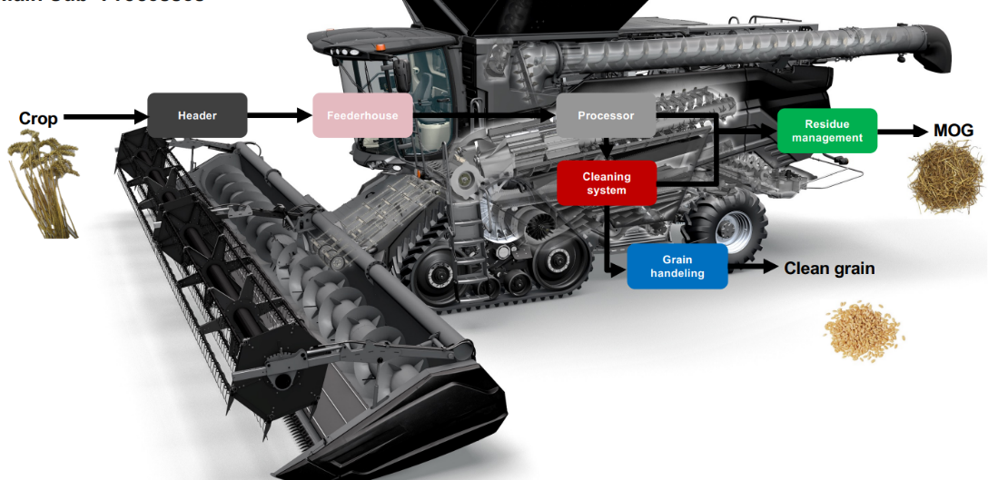

#### **3.4.1.2 Combine Header**

The header of the combine harvester operates mainly in 4 states. When the harvester is operating at a field, the first thing to occur is the crop being fed into the header, as seen at point 1. The crop is then cut at the stem, as shown at point 2, before being transported into the collector, which handles and distributes the crop into the combine harvester.

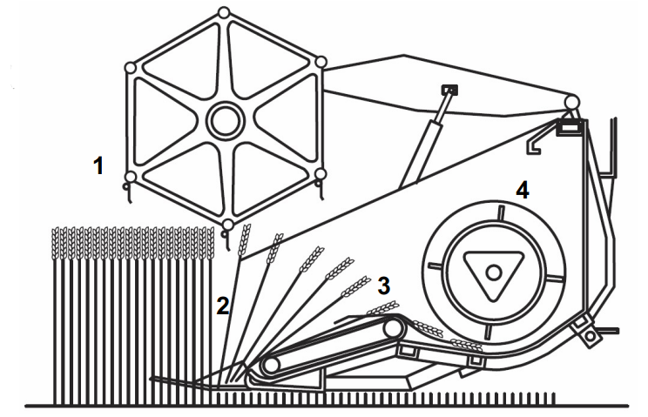

#### **3.4.1.3 Header Position Control**

A header position control is controlling and managing the lift, pitch, and tilt angle of the header to control orientation, which is automatically controlled by the Auto Header Height Control (AHHC) system. The position and orientation of the header is hydraulically actuated. Dragod sensors are used to detect the ground; rods are connected to potentiometers, which are used to measure the DOF angles.

#### **3.4.1.4 Proposed solution: Active Support Wheels concept**

The active support wheels act to both stabilize the header of the harvester and brace the impact of the overshot and oscillations caused by the AHHC hardware problems. The active support wheels are hydraulic, in order to control the height of the header, as well as the pressure applied to the ground, so as not to dig down into the soil.

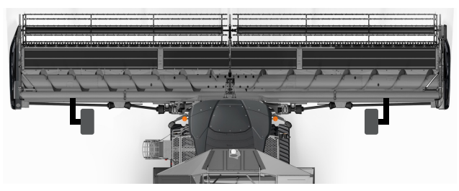

### **3.4.2 Employment Modes**

During transit for the combine harvester, the proposed solution of active wheels support should be retractable, in order to satisfy the boundary regarding the maximum width of a vehicle on public roads. The active wheels are also controllable from the cockpit of the harvester, in which the driver will have full control over the hydraulics and positioning of the wheels. When not manually controlled from the cockpit, the wheels will act automatically through sensors and control systems.

### **3.4.3 Scheduling and Operations Planning**

The harvester is available for operation for desired and continuous use. The harvester operates on industrial grade diesel, which is required for operation.

### **3.4.4 Operating Environment**

* Concrete road for transport
* Fields

### **3.4.5 Geographic Area(s)**

* Flat land areas

### **3.4.6 Environmental Conditions**

* JB1-JB7
* Operate in all soil-environments

### **3.4.7 Interoperability with Other Elements**

The active support wheel system will be integrated into the combine header and AHHC system. Wheels will be added to the combine header.

## **3.5 Product Support Description**

The development of the product is done by AgroxTech along with support from feedback from the farmer stakeholder and AGCO stakeholder. Also, subcontractors will assist in the development.

When the product is done it will be added to an existing product no longer require support from other than the farmer stakeholders. During the installation support will be required from AgroxTech.

## **3.6 Potential Impacts**

Anticipated impact of the system is that the farmers will be able to increase their efficiency of their harvest by increasing AHHC of the header

Because the system is integrated into an existing system no further impacts will be expected

## **3.7 Scenarios — Support Name, Functional Capabilities Needed**

# **4. Functional Capabilities**

This section describes functional capabilities of the product and how the associated objectives are achieved.

## **4.1 Operations**

In this section, we will explain the primary capabilities of the system, inspired by the system described given in section 3.1.

### **4.1.1. Cropping the product**

The crops are first fed by a rotating reel into a cutting knife. This process ensures that the crops are being cut at an appropriate height.

### **4.1.2. Header preprocessing**

The crop is transported transversely to an auger where the crop is being collected.

### **4.1.3. Storage in a feederhouse**

Through the conveyor belts and the auger, the crop is transported from the header of the harvester into a feeder house, where it is held until the machine is ready to unload the harvest.

### **4.1.4. Harvest processing**

The purpose of the processor is to expose the harvest to various mechanical actions where grain and seed are separated from the rest of the plant material.

### **4.1.5. Harvest cleaning**

The cleaning system is designed to remove any remaining plant material or debris from the harvested crop before it is stored or unloaded. In general, the cleaning system typically involves the use of various mechanical actions, such as shaking or blowing. If deemed not clean enough, the process will be redone.

### **4.1.6. Harvest handling**

After the harvest is cleaned, it is either stored locally, in a dedicated container, or remotely.

### **4.1.7. Residue management**

The residue management is related to the process of managing the leftover plant material, such the following: stalks, stems, and leaves, after a crop has been harvested.

There are multiple ways in which a harvester can implement residue management, albeit we only consider the ones employed by our case, including:

1. **Chopping:** One common method of residue management is chopping the leftover plant material into small pieces using a chopper mechanism attached to the harvester. This chopped material can then be spread evenly over the field, where it can decompose and provide nutrients for the soil.
2. **Spreading:** Another common method of residue management is spreading the leftover plant material over the field using a spreader mechanism attached to the harvester. This can help distribute the material more evenly and speed up the decomposition process.

## **4.2 Acronyms and Abbreviations**

|  |  |
| --- | --- |
| Abbreviations | Definition |
| AHHC | Auto Header Height Control System |
| KPa | Kilo Pascal |
| DOF | Depth of field |
| OpCon | Operating Concept |

## **4.3 References**

[1] The company presentation. <https://brightspace.au.dk/content/enforced/91504-LR20118/AGCO%20Case%20Story.pdf?_&d2lSessionVal=nhRvcUoHeHaz2uQZBK1LjRIdr&_&d2lSessionVal=dJEMLs7NqtO6eLSA1U7SJunD7>

Contributions:

|  |  |  |
| --- | --- | --- |
| **Date** | **Contribution** | **Contributor** |
| 2023-03-08 | Functional capabilities | Alexander, Henrik, Liulihan, Shivaram |
| 2023-03-08 | Operations and Support Description | Micheal, Tobias |
| 2023-03-08 | Capabaility Need | Dilan |