System requirement specification (SRS)



## **Company E (AGCO)**

Oliver Fridorf – 201907235

Tobias Andersen – 201905423

Lasse Bjørnskov – 201907292

Michael Nørbo – 202202966

Anisa Mohamed – 201806371

Julia walczynska – 202202970

Claes Jensen – 201907300

Henrik Buhl – 201905590

Dilan Celebi – 202202967

Johansen, Alexander Stæhr – 201905865

Kuang, Liulihan – 201906612

Rammohan, Shivaram - 202202968

Document revision history:

|  |  |  |  |
| --- | --- | --- | --- |
| Rev. | Date | Change description | Creator |
| 1.0 | 2023-08-13 | System requirement specification draft created | Oliver, Julia, Anisa |
| 1.1 | 2023-03-29 | Add more qualitative requirements for testing (eg. Demonstration) | Oliver |
| 1.2 | 2023-04-12 | Implemented changes from Kenneth. How to measure quality | Oliver and Lasse |

Document review version

|  |  |  |
| --- | --- | --- |
| Rev. | Date | Review group |
| 1.0 |  |  |
|  |  |  |

# Scope

The system we are working with is the automatic levelling header on a combine.   
This consists of several different mechanical/hydraulic components.

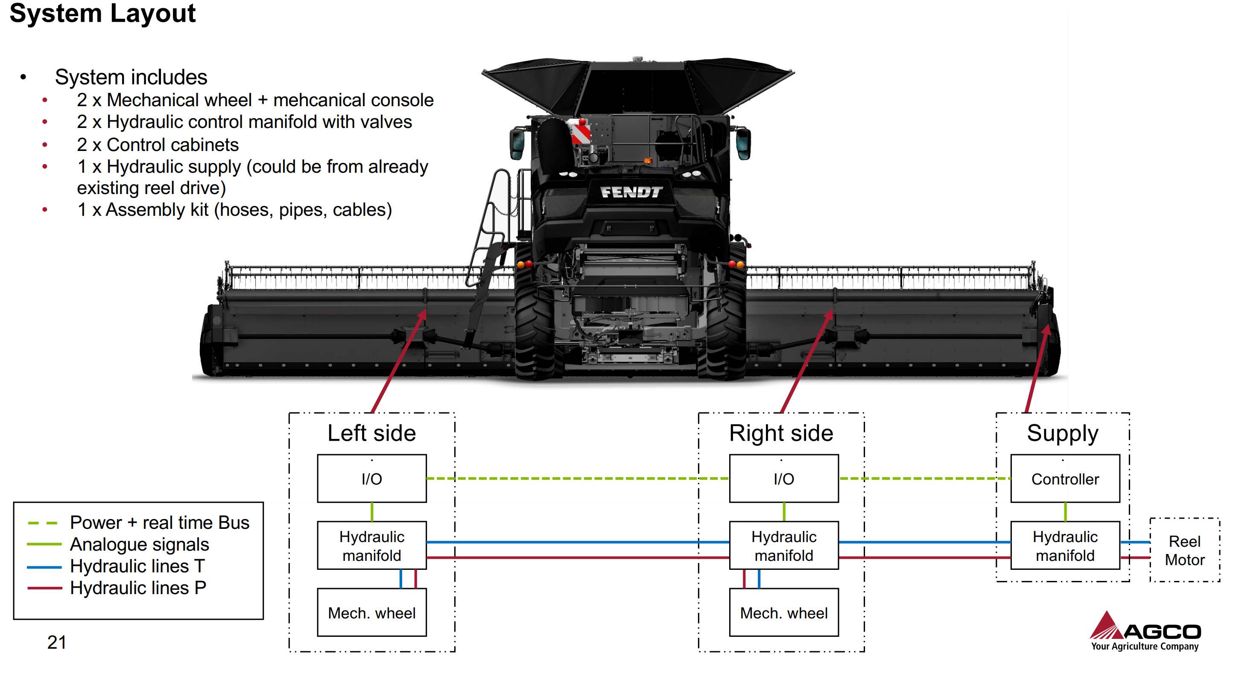



These parts are called the Auto Header Height Control system (AHHC) and controls the position of the header when harvesting.

This system has three measurement parameters that the system can control.

Lift angle $θ_{1}$ which provides the desired stubble height.   
Pitch angle $θ_{2}$ which provides the desired cut angle  
Tilt angle $ϕ_{1}$ which is the side-to-side angle, normally used to provide clean cut on side-hill condition.

$ϕ_{1}$ is the parameter that our system will control and make sure that the system does not oscillate when on uneven fields as it leads to poor performance.

The current system has problems with slow response, position overshoot, and oscillations due to instability.

Our system is an add-on to the AHHC-system that improves the performance on uneven fields.   
This will not be a hardware change, but a solution that adds to the AHHC systems and fixes the inherent hardware issues in the hydraulic control system.

The system will consist of a wheel on the either side of the header. This wheel is position controlled by hydraulic actuators.   
The system will contain sensors for height and cylinder pressure.

# Requirement descriptions and Quality provision

|  |  |  |  |
| --- | --- | --- | --- |
| **Requirement category** | **Req. id** | **Requirement description** | **Quality provision method** |
| **Required states and modes** | R1 | There are two modes that the system should operate in: the harvesting mode and the transportation mode | Demonstration of switching between modes to a satisfactory degree for present farmers. |
| R2 | In harvesting mode, the system should stabilize the header on an uneven field. | Demonstration. Stubble variation should be less than 10 cm over 1m. The harvester will be driven like normal and the stubbles will be measured. |
| R3 | In transportation mode, the system should be compact enough not to interfere with the loading onto the header trailer and fit within the width limits set by the EU for transporting trailers. | Analysis. The width of the installed system should be analysed and fit within the regulations. |
| **System capability** | R4 | The wheels and structure should be able to **handle a load of 500 kg**. | Testing of prototype system and analytical simulations.  Once the prototype is built, it will be subjected to load testing, finding where the maximum load is and if it fatigues. |
| R5 | System shall be of at least **IP66 protection rating**. | External testing firm verification |
| R6 | Operator shall be able to **enable and disable wheels** from cabin. | Demonstration with mounted prototype system. The system shall be operated by invited farmer and shall fully retract and extend. |
| R7 | The system should have sensors that allow it to maintain a constant cylinder pressure and control the wheel position. | Testing of prototype system to see if sensor can regulate the pressure correctly within the specified tolerance under loads similar to that of operating conditions. |
| R8 | Wheel actuators shall be able to move wheels such that **header is kept level when passing a height increase of 150 mm** at the right side of the header **driving 8 km/h**. | Testing of mounted prototype to verify the system response time. The combine will be drive at 8 km/h over a created height increase of 150 mm. |
| R9 | Tires may **maximum sink 30 mm** into soil. | Testing of prototype system in worst case soil conditions. A load of 500 kg will be applied to the wheels and the sinkage will be measured. |
| R10 | Maximum stress on the soil in the contact area from the tires **should not increase 75 KPa** to avoid soil compaction | Testing of prototype system. The wheel will be subjected to a maximum load of 500 kg in the lab to measure the pressure on a pressure plate. |
| **System external interface** | R11 | The actuator drivers that move the wheels should have a **fixed supply pressure**.  To minimize the delay time, the pressure should always be available. | Testing of prototype system. The pressure is monitored during an operation cycle and the pressure should be within the tolerances. |
| R12 | The hardware system should be able to be **controlled by the AHHC** based on its sensor input and control signals. | Demonstration of system. In uneven field, the header height should be controlled within the specification by the AHHC, without the intervention of the operator. |
| R13 | The “standalone” kit should only require a minimum of header modification. | Analysis of mounting hardware. Prototype mounting should be contained exclusively on the wheel assembly. |
| R14 | **One kit should fit all header sizes** andthe external mounting method should be universal. | Analysis of header compatibility. Mounting hardware should be tested on supported headers to make sure they are compatible. |
| R15 | Integration on Powerflow headers **without changes to combine hardware or software.** | Analysis of header compatibility. System shall be demonstrated to work independently of the combine. |
| **System internal interface** | R16 | **IO connection** between wheels to allow for position sharing | Demonstration of position sharing. Moving one wheel should give independent response from the other wheel in the control hardware/software |
| **System internal data** | R17 | The system should be **error resilient** for IO signals. | Test under relevant standard for EMC interference compliance. |
| **Safety** | R18 | The wheels and structure should be **overload protected** in case the load excess 500 kg. | Demonstration of overload protection and safe failure. The wheel structure should be loaded beyond their rating and the system should fail safely. |
| **System environment** | R19 | The system is design to be operated in **moist soil condition across soil texture JB1 to JB7**. | Test the design in the worst-case soil condition and ensure that other requirements are still satisfied. |
| **Computer resource** | **R20** | The control system software for controlling the wheel position and cylinder pressure should be able to run on the hardware that is already present in the harvester. | Analysis of existing system capability and proposed system requirements. The added system should be able to operate with its own hardware/software package without changing the existing combine system |
| **System quality factors** | R21 | It should live up the standards for reliability, maintainability, availability, flexibility, reusability, testability, usability set by AGCO. | Testing and analysis of prototype from AGCO. |
| **Design and construction** | R22 | During series production the **maximum price per unit should be 5.000 USD**. | Analysis of price based on final design, material prices and manufacturing costs.  A bill of materials is compiled and evaluated |
| **Personnel-related** | R23 | The system should be able to be mounted and serviced by a **qualified AGCO technician**. | Demonstration. The installation procedure should be completed within five hours and without abnormal strain on technician. |
| **Training-related** | R24 | The system should require **minimal training** to be operated by the end user (not more than a two-hour course.) | Demonstration of training course from select farmers. |
| **Logistics- related** | R25 | A transport mode shall be available such that wheels **do not exceed width limit during road transport** on trailer in Europe (This might be 2.55 m) | Test and analysis of final design to ensure compatibility with regulations and specification. |
| **Other** | R26 | Cost target for production of 5 **prototypes maximum 10.000 USD** per unit | Final tally of cost should be done to and care should be taken to limit costs. A bill of materials is compiled and evaluated. |

Contributions:

|  |  |  |
| --- | --- | --- |
| **Date** | **Contribution** | **Contributor** |
| 2023-03-08 | First draft of systems requirements | Oliver, Julia, Anisa |
| 2023-03-29 | Add more qualitative requirements for testing (eg. Demonstration) | Oliver |
|  |  |  |
|  |  |  |