Preliminary design



## **Company E (AGCO)**

Oliver Fridorf – 201907235

Tobias Andersen – 201905423

Lasse Bjørnskov – 201907292

Michael Nørbo – 202202966

Anisa Mohamed – 201806371

Julia walczynska – 202202970

Claes Jensen – 201907300

Henrik Buhl – 201905590

Dilan Celebi – 202202967

Johansen, Alexander Stæhr – 201905865

Kuang, Liulihan – 201906612

Rammohan, Shivaram - 202202968

# Documents revision history

|  |  |  |  |
| --- | --- | --- | --- |
| Rev | Date | Change description | creator |
| 1.0 | 22/03-2023 | Created document | Claes, Lasse and Henrik |
|  |  |  |  |

# Documents review version

|  |  |  |
| --- | --- | --- |
| Rev. | Date | Review group |
| 1.0 |  |  |
|  |  |  |

# Introduction

This document details the design’s systems, its basic requirements, and the high-level design features.

# Functionality

The system is the Auto Header Height Control system (AHHC), which will be responsible for controlling the header of the combine. It consists of a controller that will adjust the tilt, pitch and tilt angle of the header, so that it will follow the ground evenly. Therefore, the system is using accurate height sensing and actuator to position the header in the appropriate position according to the chosen setting. Furthermore, the system is able to attach the existing equipment and thereby expand its usability.

# Functional breakdown diagram:

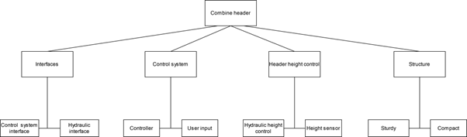

# Subsystem overview

The requirement-IDs can be found in the system requirements documents.

|  |  |  |  |
| --- | --- | --- | --- |
| Function | Description | Requirements | Engineering capability |
| Hydraulic height control | Hydraulic actuator that can move the header to appropriate height | R7, R8 | Mechanical engineering |
| Height sensor | Electrical sensor for height measurements | R11 | Electrical engineering |
| Control system interface | Electrical interface for controlling various subsystems | R5, R16, R17 | Electrical engineering |
| Hydraulic interface | Mechanical interface for moving actuator etc | R11 | Mechanical engineering |
| Controller | The controller will make sure the header will track the ground. | R1, R2, R12, R20 | Software engineering |
| User input | The user should be able to select operational modes e.g. “in operation”, “transportation” etc | R6,R20 | Software engineering |
| Structure | The system is required to have a specified size under transportation | R3, R4, R9, R13, R14, R15, R18 | Mechanical engineering |

# Contributions:

|  |  |  |
| --- | --- | --- |
| **Date** | **Contribution** | **Contributor** |
| 2023-03-08 | Everything | Claes, Lasse and Henrik |
|  |  |  |
|  |  |  |