Detailed Design Document



## **Company E (AGCO)**

Oliver Fridorf – 201907235

Tobias Andersen – 201905423

Lasse Bjørnskov – 201907292

Michael Nørbo – 202202966

Anisa Mohamed – 201806371

Julia Walczynska – 202202970

Claes Jensen – 201907300

Henrik Buhl – 201905590

Dilan Celebi – 202202967

Johansen, Alexander Stæhr – 201905865

Kuang, Liulihan – 201906612

Rammohan, Shivaram - 202202968

Document revision history

|  |  |  |  |
| --- | --- | --- | --- |
| Rev. | Date | Change description | Creator |
| 1.0 | 2023-03-29 | Created the document | Claes |
| 1.1 | 2023-04-12 | Added section 3 and section 4 | Anisa, Julia, Dilan, Michael, Claes |

Document review version

|  |  |  |
| --- | --- | --- |
| Rev. | Date | Review group |
| 1.0 | 2023-04-12 |  |
|  |  |  |

Contributions

|  |  |  |  |
| --- | --- | --- | --- |
| **Date** | | **Contribution** | **Contributor** |
| 2023-03-29 | | Initial Commit | Oliver, Claes, Lasse, Tobias |
| 2023-04-12 | | Section 3 | Julia, Anisa |
| 2023-04-12 | Section 4 | Dilan, Michael | |
|  | |  |  |

# **Scope**

## **Identification**

The system which this document describes the design off, is an add on to the powerflow header form AGCO, with reported inadequate height control. The system consist of hydraulic controlled wheel, which rides on the ground to provide stability to the header. The hydraulics are controlled by feedback sensors on each wheel, which feedback to a controller that regulates the hydraulics accordingly. The hydraulic pressure is supplied by connecting the system to the existing hydraulics of the header.

## **System** **overview**

The system described in this document aims to alleviate the problems reported by farmers concerning the powerflow headers from AGCO. The header is subject to instability when operating in uneven terrain, do great dissatisfaction to the user. The system is designed as an add-on to the existing powerflow headers that will act as a stabilizer, limiting the problems reported by users.

## **Document** **Overview**

This document will contain how the system and subsystem will be structured to satisfy the system requirements. It is the primary reference for subsequent implementation, and it will contain all the information needed by developers to construct the system.

This document is intended for internal use only and should not be distributed. External holders of the document should delete the document once the purpose for their access has been completed.

# **Referenced documents**

This document references System Requirements Document version 1.1, hereafter referred to as the SRS.   
This document references Preliminary Design Description version 1.1, hereafter referred to as PDD.  
This document references Interface Control Document version 1.1, hereafter referred to as ICD.  
This document references Tracability matrix version 1.1

# **System-wide design decisions**

This section will describe the system in detail and describe the design decision being made accordingly.

Figure 1 - Flow diagram of system functions

## **Design decisions regarding inputs the system will accept and outputs it will produce.**

|  |  |
| --- | --- |
| **Inputs** | **Outputs** |
| Combine is in harvest mode. AHHC enable button is pressed by operator. | AHHC system is engaged, and the header will level automatically to reduce stubble wobble when driving on uneven ground. |
| Combine is in harvest mode. Manual level control enable button is pressed by operator. | Lever for level control is unlocked and operator can adjust height of the header. |
| Transport mode button is pressed by operator. | The wheels of the AHHC system are retracted and placed in the appropriate mode for transportation of the header. |
| Over-pressure sensor is triggered indicating a load of more than 500 kg on the structure. | Pressure release valve is opened and pressure is drained from actuators reliving the load on the wheel and structure. |

## **Design decisions on system behaviour in response to each input or condition, including actions the system will perform, response times and other performance characteristics.**

Task: Enable transport mode

Input (trigger): Transport mode button is pressed by operator.

Precondition: Combine is in harvest mode

Response time: 20s

Subtasks:

1. Auto Header Height Control system receives the signal that the button is pressed
2. The AHHC system sends the request to the actuator to retract the wheels
3. The actuator retracts the wheels

Task: Enable manual control

Input: Manual level control button is pressed by operator

Precondition: Combine is in harvest mode. Combine is in automatic mode.

Response time: 1s

Subtasks:

1. AHHC system receives the signal that the button is pressed
2. The AHHC system sends the request to the lever to unlock the level control
3. The lever unlocks the level control

Task: Enable automatic control

Input: Automatic level control button is pressed by operator

Precondition: Combine is in harvest mode. Combine is in manual mode.

Response time: 1s

Subtasks:

1. AHHC system receives the signal that the button is pressed
2. The AHHC system sends the request to the lever to lock the level control
3. The lever locks the level control

Task: React to load of more than 500kg on the structure

Input: Over-pressure sensor is triggered

Precondition: Combine is in harvest mode.

Response time: 20s

Subtasks:

1. The sensors send a signal to the AHHC system about over-pressure
2. The AHHC system sends request pressure release valve to be opened
3. The pressure valve opens and the pressure is drained from the actuators

## **Design decisions on how system databases/data files will appear to the user.**

Not applicable

## **Selected approach to meet safety, security, and privacy requirements.**

The relevant requirements regarding safety, security and privacy and how they are approached are listed below.

|  |  |  |  |
| --- | --- | --- | --- |
| Category | Req. ID | Requirement description | Approach |
| Safety | R18 | The wheels and structure should be overload protected in case the load excess 500 kg. | Use sensors to monitor the pressure |

## **Design and construction choices for hardware or hardware-software systems, such as physical size, color, shape, weight, materials, and markings.**

**Wheels**

Design and construction choices regarding the wheels are proposed by the subcontractor.

The chosen wheel solution consists of two farming tires (T448) with extra strong treads and easy rolling patterns. Each tire should be able to fit on a rim with the size: 6.75 x 14.5 - 8 mm. The technical specifications of the chosen tire and rim are found below.

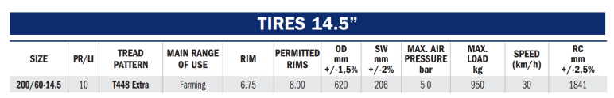Table 1 - Technical specifications of the chosen tire from Trelleborg Wheel Systems

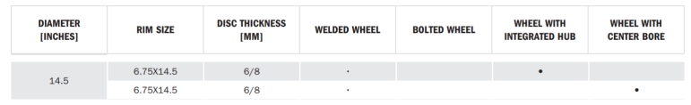Table 2 - Technical specifications of the chosen rim from Trelleborg Wheel Systems

The suggested rim type is the one with an integrated hub as shown in the figure below.

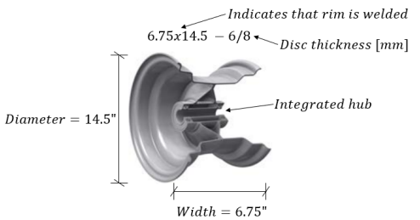

Figure 1 - Cross-sectional view of the integrated hub rim with dimensions

The chosen tire is illustrated in the figure below.

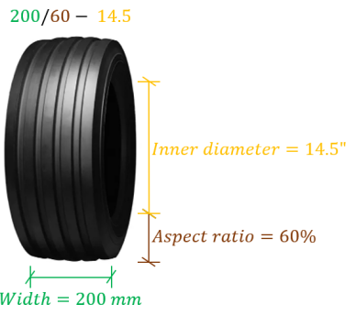

Figure 2 - Illustration of the chosen tire model (T448) with dimensions

**Sensors**

A proposed sensor for the system:

<https://www.sick.com/dk/da/vskesensorer/tryksensorer/pbs-plus/c/g507653>

**Actuators**

A proposed actuator for the system:

<https://www.linak.dk/produkter/lineaere-aktuatorer/la36/>

## **Other system-wide design decisions made in response to requirements, such as selected approach to providing required flexibility, availability, and maintainability**

|  |  |  |  |
| --- | --- | --- | --- |
| Req. ID | Requirement description | Category | Design decisions |
| R6 | Operator shall be able to enable and disable wheels from cabin. | Flexibility | Button to switch between manual and automatic mode |

# **System Architectural Design**

## **System components**

The following section describes the system components with unique ID’s, associated requirements, purpose, development status, and resources used by the component. Previously described component descriptions from the ConOps document section 3.4.1 are re-used when relevant.

## **Component overview**

|  |  |  |  |
| --- | --- | --- | --- |
| **Component** | **Component ID** | **Requirements** | **Development** |
| Combine Header | C1 | R2, R15, R21 | Finished |
| Header Position Control | C1.1 | R12, R15, R21 | In iteration |
| Auto Header Height Control system | C1.1.1 | R15, R21 | In iteration |
| Active Support Wheels | C1.1.1.1 | R21 | In development |
| Feederhouse | C2 | R21 | Finished |
| Processor | C3 | R21 | Finished |
| Cleaning system | C3.1 | R21 | Finished |
| Bin Filling | C3.2 | R21 | Finished |
| Sensor | C4 | R7, R21 | Finished |

## **Component Description**

**C1: Combine Header**

**Purpose**: Combine header controls how the header moves and where it is positioned using hydraulic power.

**Description**: The header of the combine harvester operates mainly in 4 states. When the harvester is operating at a field, the first thing to occur is the crop being fed into the header. The crop is then cut at the stem before being transported into the collector, which handles and distributes the crop into the combine harvester.

**Resources**: The header utilizes a Header Position Control system to control the orientation of the header.

**C1.1: Header Position Control**

**Purpose:** Controlling the orientation of the combine header.

**Description:** A header position control is controlling and managing the lift, pitch, and tilt angle of the header to control orientation, which is automatically controlled by the Auto Header Height Control (AHHC) system. The position and orientation of the header is hydraulically actuated. Dragod sensors are used to detect the ground; rods are connected to potentiometers, which are used to measure the DOF angles.

**Resources:** The Header Position Control utilizes the AHHC system.

**C1.1.1: Auto Header Height Control system**

**Purpose:** Controlling the height of the harvester

**Description:** The AHHC system is an automatic system that controls the orientation of the header during operation.

**Resources:** The AHHC system utilizes the Active Support Wheel system to assist in stabilization by using wheel support.

**C1.1.1.1: Active Support Wheels**

**Purpose:** Providing stabilization for the header and assisting the AHHC during operation using wheel support.

**Description:** Tires that at maximum will sink 25 mm into the soil under moist soil conditions across soil texture JB1 to JB7.

**Resources:** -

**C2: Feederhouse**

**Purpose:** Feederhouse’s purpose is to gather the crop from the header and transfer it to the threshing mechanism in a consistent and efficient manner. The main use is transportation.

**Description:** The Feederhouse typically consists of a series of rotating augers, belts or chains that move the crop towards the threshing mechanism while also separating any large debris or foreign objects.

**C3: Processor**

**Purpose:** The purpose of the Processor is to perform several key functions during the harvesting process, including feeding, threshing, separating, and discharging the crop.

**Description**: The feeding function involves pulling the crop into the machine using a pickup or header, and then conveying it towards the threshing mechanism. The threshing function involves breaking apart the crop to separate the valuable grain or forage material from the non-valuable parts, such as stalks or leaves. The separating function involves separating the valuable material from the non-valuable material, which may be done using a variety of mechanisms such as sieves, blowers or gravity separators. Finally, the discharged function involves directing the harvested material to a storage container or wagon.

**C3a: Cleaning System**

**Purpose:** The Cleaning System is an essential component of crop harvesting equipment, as it helps to ensure the quality and purity of the harvested crop by removing any unwanted materials.

**Description:** The Cleaning System typically includes several stages or functions, including feeding, stratification, pre-separation, cleaning, and tailing. The stratification function involves separating the crop into different layers based on size and weight. The pre-separation function involves removing any large debris or foreign objects from the crop before it moves on to the cleaning stage.

**C3b: Bin Filling**

**Purpose:** The purpose of the Bin Filling/Unloading system is to efficiently and safely transfer the harvested crop from the harvesting machine's storage bin to an external storage or processing facility.

**Description:** During the harvesting process, the harvested crop is collected and stored in a hopper or bin within the harvesting machine. When the bin becomes full, the Bin Filling/Unloading system is engaged to transfer the crop to an external storage or processing facility

**C4: Sensors**

**Purpose:** The purpose of the sensors is to sense physical properties.

**Description:** Sensors provide readings about physical (mostly environmental) properties.

## **Concept of execution**

Component Relationship Diagram:

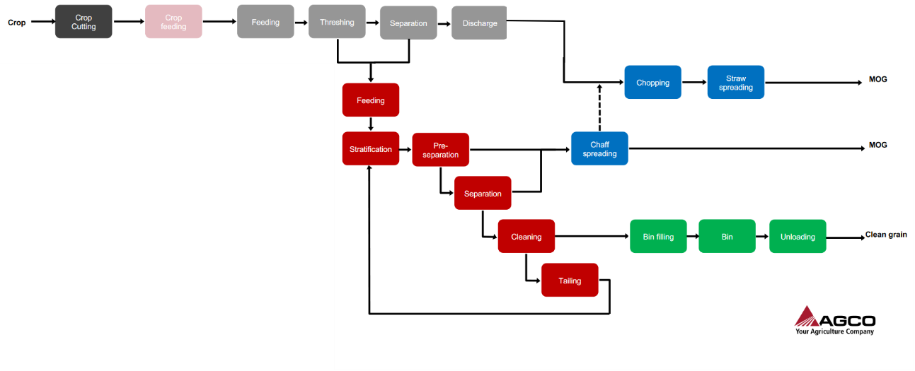

## **Interface design**

See Interface Control Description document.