

## **Company E (AGCO)**

Oliver Fridorf – 201907235

Tobias Andersen – 201905423

Lasse Bjørnskov – 201907292

Michael Nørbo – 202202966

Anisa Mohamed – 201806371

Julia walczynska – 202202970

Claes Jensen – 201907300

Henrik Buhl – 201905590

Dilan Celebi – 202202967

Johansen, Alexander Stæhr – 201905865

Kuang, Liulihan – 201906612

Rammohan, Shivaram - 202202968

SEMP

## Document revision history

|  |  |  |  |
| --- | --- | --- | --- |
| Rev. | Date | Change description | Creator |
| 1.0 | 2023-02-22 | Created the SEMP document. Added the preliminary Planning, Decision Management and Risk Management. | Everybody |
| 1.1 | 2023-03-22 | Revision control added | Lasse, Tobias |

## Document review history

|  |  |  |
| --- | --- | --- |
| Rev. | Date | Review group |
| 1.0 | 2023-xx-xx | #### |
|  |  |  |

# Planning

Project deadlines

* Working prototype: June-August
* Final product production ready: July

**Name different responsible persons for different tasks**

Tasks/Roles:

* Moderator (responsible for controlling group meetings)
* Coordinator (responsible for getting an overview of what should be discussed in the meeting beforehand)
* Referent (responsible for summarizing meetings)

Timetable:

|  |  |  |  |
| --- | --- | --- | --- |
| **Meeting date** | **Moderator** | **Referent** | **Coordinator** |
| 15/02 | Oliver | Michael | - |
| 22/02 | Oliver | Anisa | - |
| 01/03 | Tobias | Claes | Lasse |
| 08/03 | Lasse | Tobias | Oliver |
| 15/03 | Michael | Lasse | Tobias |
| 22/03 | Anisa | Michael | Lasse |
| 29/03 | Julia | Anisa | Michael |
| 05/04 | Claes | Julia | Anisa |
| 12/04 | Henrik | Oliver | Julia |
| 19/04 | Dilan | Henrik | Claes |
| 26/04 | Alexander | Dilan | Henrik |
| 03/05 | Kuang | Alexander | Dilan |
| 10/05 | Shivaram | Kuang | Alexander |
| 17/05 | Oliver | Shivaram | Kuang |
| 24/05 | Tobias | Oliver | Shivaram |
| 31/05 | Lasse | Tobias | Oliver |
| 07/06 | Michael | Lasse | Tobias |
| 14/06 | Anisa | Michael | Lasse |

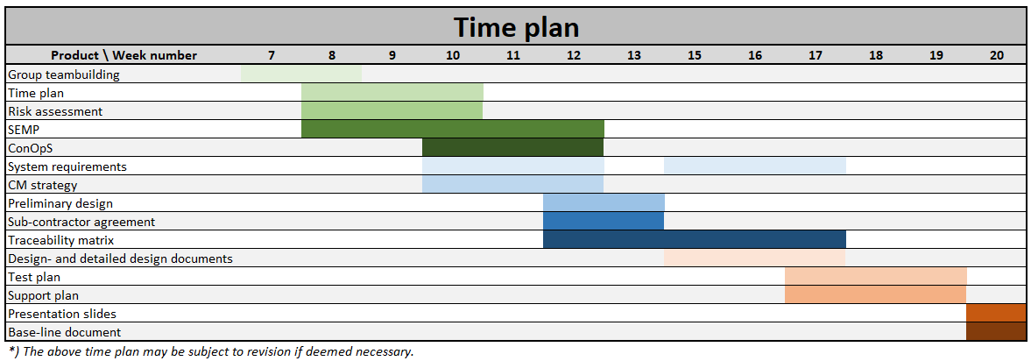

**Name different responsible persons for communicating with stakeholders**

Stakeholders:

* AGCO (responsible for communication with AGCO): **Michael**
* Own group (responsible for coordinating meetings, communicate with subgroups): **Oliver**
* Group D – work for them / review their work (responsible for communication): **Tobias**
* Group G – subcontractor (responsible for communication with group): **Dilan**
* Stefan Lecturer (responsible for hand-ins): **Claes**

# Assessment and Control

* To be done

# Risk Management

Here we will discuss the high-level risk that we think we will encounter during the product development.

|  |  |  |  |  |
| --- | --- | --- | --- | --- |
| **Problem** | **Description** | **Effects/Impacts** | **Possible Solutions** | **Risk Evalution** |
| People not delivering | People do not deliver a specific piece of work that was promised | It will delay the people relying on that piece of work.  It can create internal conflicts | Good internal communication. | Internal: low likelihood and high consequences. |
| External: medium likelihood and medium consequences |
| Bad communication | Both internal and external communication fails. People in our company will be waiting on work or instructions.  Miscommunication with AGCO leading to wrong specifications. | Project delay.  Project fits the wrong specifications, or they might have changed.  Project cannot be delivered. | Good structure. Having people responsible for communication with different stakeholders. | Medium/low likelihood and high consequence. |
| Lack of technical knowledge | Very specific technical requirements that this company does not have the technical knowledge to fulfil or know if they are realistic. | Project fails.  Product might not live up to specifications/ expectation | Outsource work to other companies. | High likelihood and low consequence. |
| Lack of project experience | No one at the company has much experience with this type of work, so the company finds it hard to know what is expected of a SEMP and how to proceed most optimally. | Organizational problems.  Unrealistic internal deadline. | Attend class and research topic. | High likelihood and medium consequence. |
|  |  |  |  |  |

A more comprehensive risk management cannot be done before we have established contact with the company we work for (AGCO).

# Decision Management

# Purpose of decision management

The purpose is to ensure that AgroxTech selects the most beneficial course of project actions where alternatives exists.

# Operations

We do so by implementing “*decision gates*”, which are to be considered approval events in our schedule. For each gate, we specify entry and exit criteria, and define the time where they are included into the project management baseline.

## Decision analysis

During each decision gate, we will apply decision analysis, which is a systematic approach for selecting the optimal choice among a set of alternatives when faced with uncertainty. This approach employs a probabilistic assessment of potential outcomes associated with each alternative and calculates the expected value of the outcome to determine the optimal choice.

To execute our decision analysis, we will be guided by the following 10 principles:

1. Gain a comprehensive understanding of the business situation by gathering relevant information and analyzing it systematically.
2. Utilize a value creation framework to identify and assess potential opportunities and use this lens throughout the decision-making process.
3. Establish clear and specific objectives and make the trade-offs that must be made, in order to achieve them, explicit.
4. Conduct a thorough investigation to uncover and formally frame the underlying problem(s) that need to be solved.
5. Generate a range of creative and unique alternatives that have the potential to address the identified problem(s).
6. Identify and consult with relevant experts in order to gather meaningful and reliable information, and to assess the feasibility and potential impact of proposed solutions.
7. Recognize and embrace uncertainty as an inevitable part of the decision-making process and use it as a catalyst for improving future performance.
8. Avoid getting stuck in "analysis paralysis" situations by setting clear deadlines and decision criteria, and by prioritizing action over analysis when appropriate.
9. Apply systemic thinking to develop a holistic understanding of the current situation, and to identify the key factors that will shape future outcomes.
10. Foster learning and clarity of action by engaging in productive dialog with stakeholders, seeking feedback and input, and encouraging constructive debate and discussion.

At last, we will be using decision trees to evaluate alternatives. An example of a decision tree can be found below:

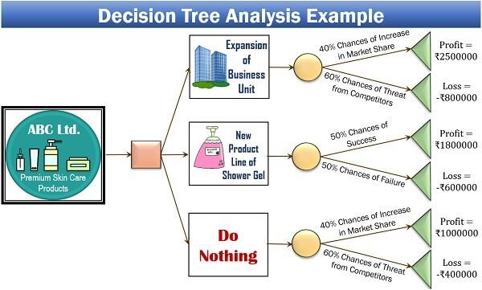

*Figure 1: decision tree example.*

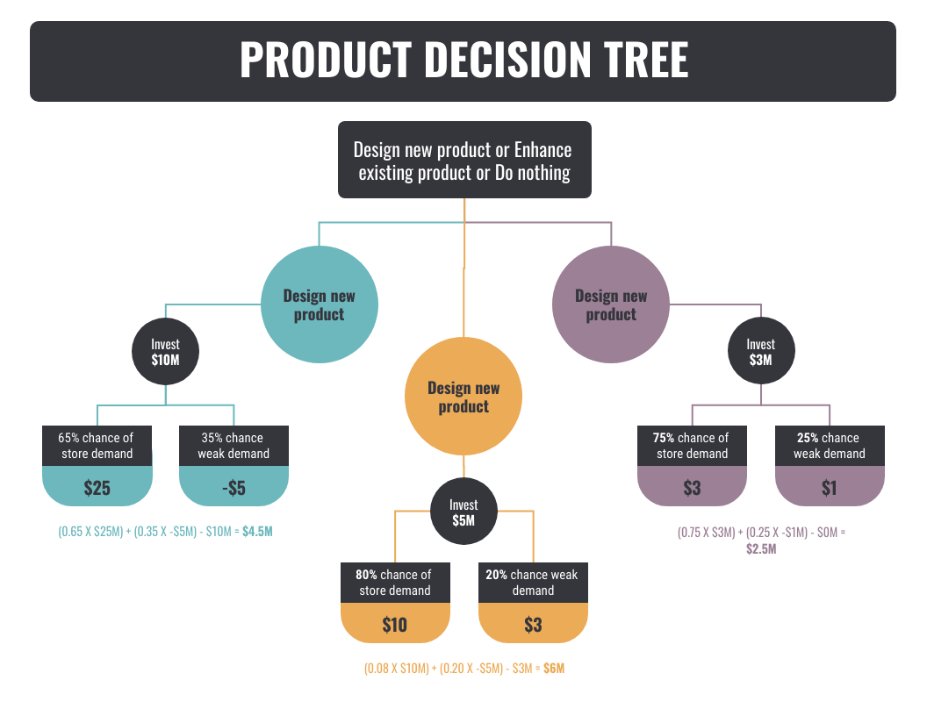

Tekstfelt

# Configuration Management

**Configuration Management Strategy**

Requirements needed facilitated:

* Version Control

Tools:

* Git (Version Control)
  + Files are stored on Git-Hub using Git as version control. The protocol for editing a file should aim to be:
    - Pull desired file
    - Make changes to the file
    - Commit the changes with a descriptive message of performed changes
    - Push the changes to main branch

# Information Management

* To be done

# Quality Management

* To be done

## Contributions

|  |  |  |
| --- | --- | --- |
| **Date** | **Contribution** | **Contributor** |
| 2023-02-22 | Decision management | Alexander, Henrik, Shivaram, Liulihan |
| 2023-02-22 | Timeplan | Lasse, Claes, Oliver, Tobias |
| 2023-02-29 | Configuration Management | Anisa, Dilan, Michael |
| 2023-02-29 | Risk management | Everybody |