

## **Company E (AGCO)**

Oliver Fridorf – 201907235

Tobias Andersen – 201905423

Lasse Bjørnskov – 201907292

Michael Nørbo – 202202966

Anisa Mohamed – 201806371

Julia walczynska – 202202970

Claes Jensen – 201907300

Henrik Buhl – 201905590

Dilan Celebi – 202202967

Johansen, Alexander Stæhr – 201905865

Kuang, Liulihan – 201906612

Rammohan, Shivaram - 202202968

Request for proposal regarding wheel solution

# Document revision history

|  |  |  |  |
| --- | --- | --- | --- |
| Rev. | Date | Change description | Creator |
| 1.0 | 2023-02-15 | Document created | Oliver, Anisa & Julia |
|  |  |  |  |

AgroxTech Group  
Group E

# Scope

The system we are working with is the automatic levelling header on a combine.   
This consists of several different mechanical/hydraulic components.

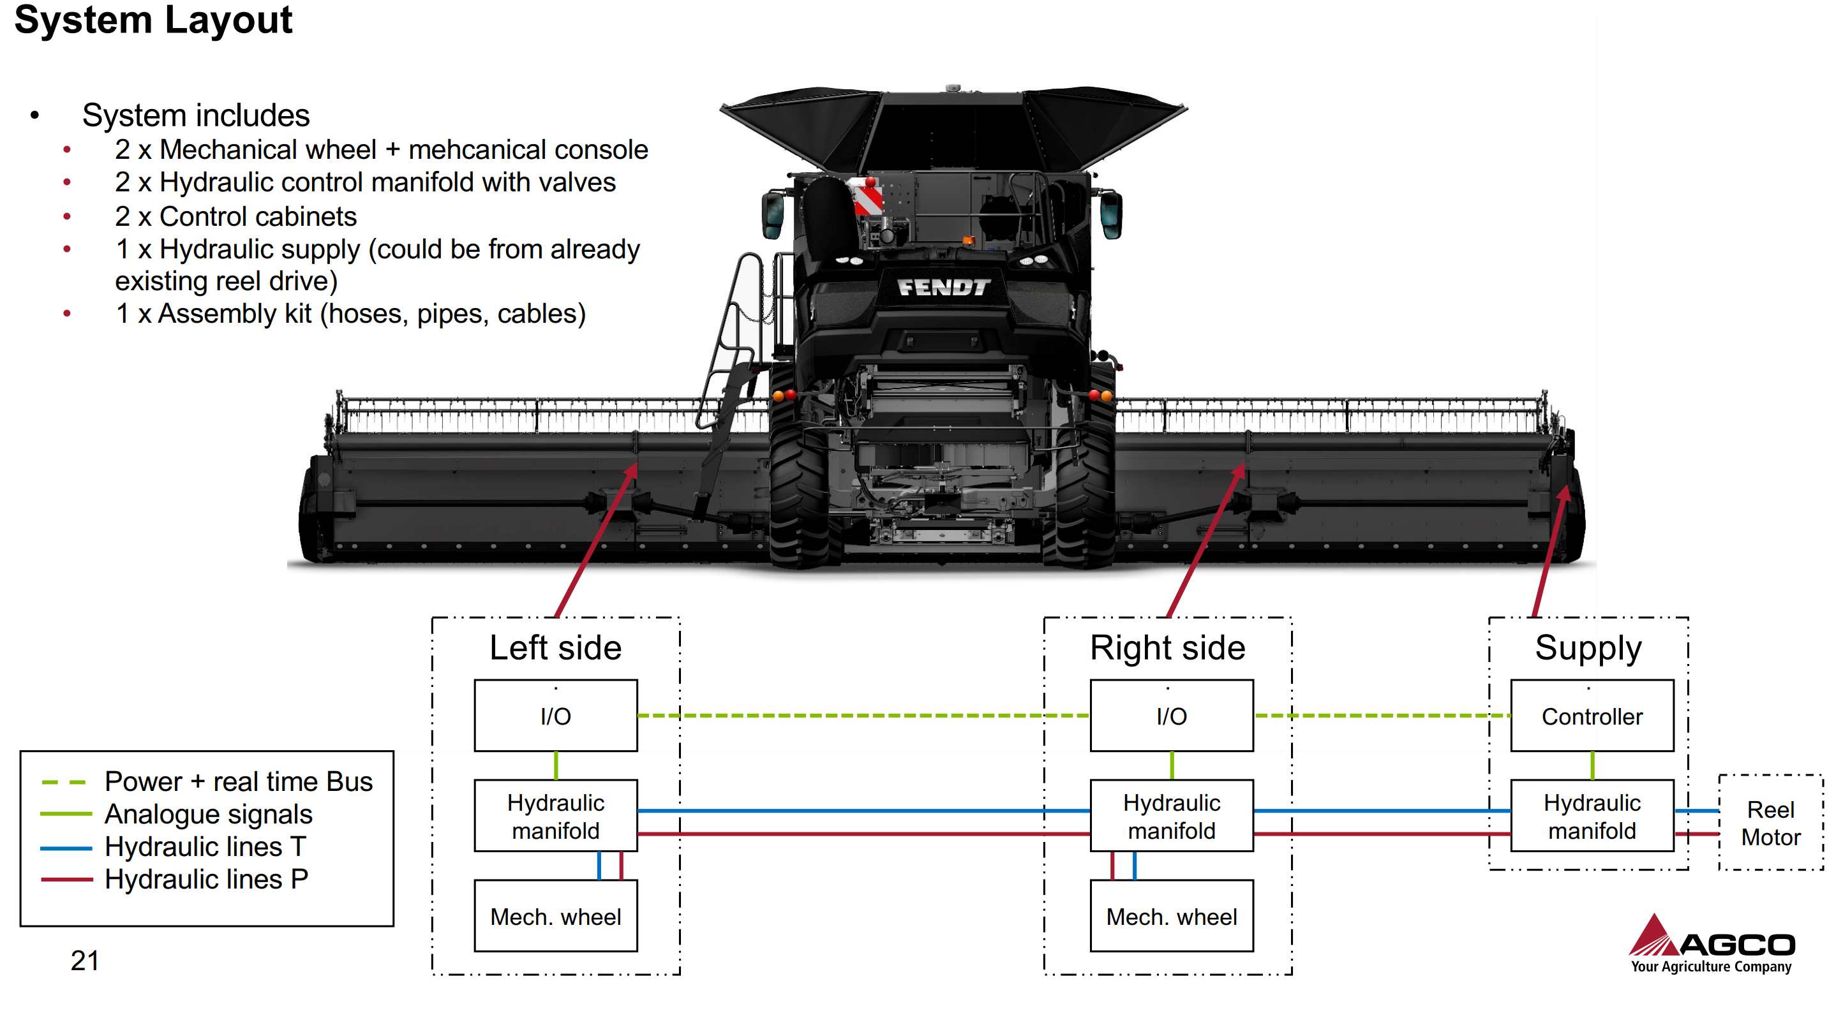

These parts are called the Auto Header Height Control system (AHHC) and controls the position of the header when harvesting.

This system has three measurement parameters that the system can control.

Lift angle $θ_{1}$ which provides the desired stubble height.   
Pitch angle $θ_{2}$ which provides the desired cut angle  
Tilt angle $ϕ_{1}$ which is the side-to-side angle, normally used to provide clean cut on side-hill condition.

$ϕ_{1}$ is the parameter that our system will control and make sure that the system does not oscillate when on uneven fields as it leads to poor performance.

The current system has problems with slow response, position overshoot, and oscillations due to instability.

Our system is an add-on to the AHHC-system that improves the performance on uneven fields.   
This will not be a hardware change, but a solution that adds to the AHHC systems and fixes the inherent hardware issues in the hydraulic control system.

The system will consist of a wheel on the either side of the header. This wheel is position controlled by hydraulic actuators. The system will contain sensors for height and cylinder pressure.

What we desire from you is a solution regarding the wheels.

What we desire from you is a solution regarding the wheels.

# Evaluation Criteria

For received proposals regarding the add on wheels to the AHHC-system, we will evaluate on price, reliability, quality, and durability. Ranking and final decision between proposals will be done through these evaluation criteria, with price being the most important.

# Deliverables and proposal response format

For the proposal the following documents should be submitted:

* Bill of materials
* Schematic drafts
* Cost estimate

The proposal should be in the following format:

|  |  |  |  |  |  |  |
| --- | --- | --- | --- | --- | --- | --- |
| *Schematic of product* | | | | | | |
| **Bill of materials** | | | | | | |
|  | Part number | Manufacturer | Lead time |  | | Cost |
| Material #1 |  |  |  |  |  |
| Material #2 |  |  |  |  |  | |
|  |  |  |  | Total cost | ### DKK | |

All of the documents should be delivered simultaneously as shown above at the specified date under section 7.

# Contractual terms and conditions

**Term and Schedule:**

* Subcontractor will begin work on 1 April 2023. Subcontractor agrees to complete this Project within 1 May 2023 from the beginning of work.
* Subcontractor is responsible for notifying Customer of any delay in performance immediately upon Subcontractor’s knowledge that performance under this Agreement will be delayed.
* Should the Subcontractor’s performance of the Work be delayed or interfered with as a result of actions by the owner, contractor, Customer, or another subcontractor, Subcontractor is entitled to request an extension of time for the performance of their Work. Subcontractor further agrees that the extension of time for performance of this Project shall not be permitted without the Customer’s written consent, which shall not be unreasonably withheld.

**Obligation:**

* Subcontractor agrees to provide Customer with a list of any and all subcontractors and suppliers
* Subcontractor hires and agrees to update said list throughout the life of the Project.
* Subcontractor agrees to work with Customer when scheduling and will make every effort to avoid conflicts and interference with the Customer’s work, as well as the work of any other subcontractors.
* Subcontractor will make available any information necessary for Subcontractor’s subcontractors and suppliers to provide any notice required or contemplated by this state’s mechanics lien laws.

**Claims:**

Customer and Subcontractor both agree to attempt to resolve any and all disputes on this Project in good faith prior to filing legal action. Further, Subcontractor will immediately notify Customer upon becoming aware of a dispute with Subcontractor’s subcontractors and suppliers.

**Change Orders, Amendments, Alterations to Contract**

Any change order, amendment, or alteration to this Agreement or the project Drawings must be agreed to by the Customer and Subcontractor in writing.

**Termination by Subcontractor**

If the Subcontractor breaches any obligation created by this Agreement or the attached Drawings (if any), Customer may give the Subcontractor a Notification of Breach which provides Subcontractor notification identifying the breach, in writing. Upon receipt of such Notification of Breach, Subcontractor will have seven (7) days to cure the breach. If the breach cannot be cured in seven (7) days, the Customer is entitled to terminate this Agreement and take possession of the Project. Alternatively, the Owner may cure the breach and deduct the cost of curing the breach from the amounts otherwise owed to the Customer. Regardless of Termination, Customer will be liable to make payments owed and unpaid to Subcontractor for the work performed prior to Termination.

**Termination by Customer**

If the Customer breaches any obligation created by this Agreement, Subcontractor may give the Customer a Notification of Breach which provides the Customer notification identifying the breach, in writing. Upon receipt of such Notification of Breach, Customer will have seven (7) days to cure the breach. If the breach cannot be cured within seven (7) days, the Subcontractor is entitled to terminate this Agreement. Subcontractor will remain entitled to payment for work performed prior to Termination.

# Requirements for proposal preparation

***List of requirements for the delivered solution.***

R3: Wheel diameter should not exceed 90 centimetres in diameter to fit within trailer width limits when being transported.

R4: The wheel should be able to handle a load of 500 kg during operation.

R10 / R20: Tires may maximum sink 30 mm into soil under moist soil condition across soil texture JB1 to JB7.

R11: Maximum stress on the soil in the contact area from the tires should not increase 75 KPa to avoid soil compaction

R22: The selected solution should live up to the general standards for reliability, maintainability, availability, flexibility, reusability, testability, usability set by AGCO.

R24: The wheels should be able to be installed and service by an AGCO technician.

# Process Schedule

|  |  |
| --- | --- |
| Last possible date for requesting additional info, and extensions | 20/3-2023 16:00 CET |
| Deadline for submission of proposal | 22/3-2023 14:00 CET |
| Announcement of selected proposal | 22/3-2023 14:20 CET |
| Deadline for filing decision protest | 25/4-2023 16:00 CET |

# Contacts

For contacting purposes, please contact Dilan Celebi, Head of External Affairs:

Dilan Celebi  
Head of External Affairs  
AgroxTech Group  
[202202967@post.au.dk](mailto:202202967@post.au.dk)