SEMP

# Planning

Project deadlines

* Working prototype: June-August
* Final product production ready: July

**Name different responsible persons for different tasks**

Tasks/Roles:

* Moderator (responsible for controlling group meetings)
* Coordinator (responsible for getting an overview of what should be discussed in the meeting beforehand)
* Referent (responsible for summarizing meetings)

Timetable:

|  |  |  |  |
| --- | --- | --- | --- |
| **Meeting date** | **Moderator** | **Referent** | **Coordinator** |
| 15/02 | Oliver | Michael | - |
| 22/02 | Oliver | Anisa | - |
| 01/03 | Tobias | Claes | Lasse |
| 08/03 | Lasse | Michael | Oliver |
| 15/03 | Michael | Lasse | Tobias |
| 22/03 | Anisa | Tobias | Lasse |
| 29/03 | Julia | Anisa | Michael |
| 05/04 | Claes | Julia | Anisa |
| 12/04 | Henrik | Oliver | Julia |
| 19/04 | Dilan | Henrik | Claes |
| 26/04 | Alexander | Dilan | Henrik |
| 03/05 | Kuang | Alexander | Dilan |
| 10/05 | Shivaram | Kuang | Alexander |
| 17/05 | Oliver | Shivaram | Kuang |
| 24/05 | Tobias | Oliver | Shivaram |
| 31/05 | Lasse | Tobias | Oliver |
| 07/06 | Michael | Lasse | Tobias |
| 14/06 | Anisa | Michael | Lasse |

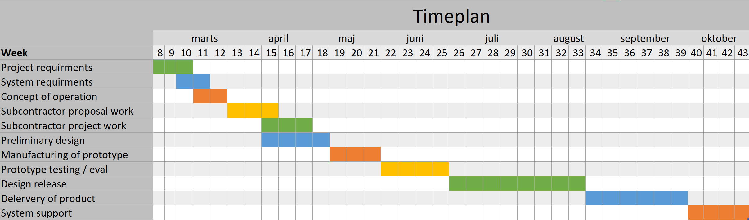

**Name different responsible persons for communicating with stakeholders**

Stakeholders:

* AGCO (responsible for communication with AGCO): **Michael**
* Own group (responsible for coordinating meetings, communicate with subgroups): **Oliver**
* Group D – work for them / review their work (responsible for communication): **Tobias**
* Group F – subcontractor (responsible for communication with group): **Dilan**
* Stefan Lecturer (responsible for hand-ins): **Claes**

# Assessment and Control

* To be done

# Risk Management

Here we will discuss the high-level risk that we think we will encounter during the product development.

|  |  |  |  |  |
| --- | --- | --- | --- | --- |
| **Problem** | **Description** | **Effects/Impacts** | **Possible Solutions** | **Risk Evalution** |
| People not delivering | People do not deliver a specific piece of work that was promised | It will delay the people relying on that piece of work.  It can create internal conflicts | Good internal communication. | Internal: low likelihood and high consequences. |
| External: medium likelihood and medium consequences |
| Bad communication | Both internal and external communication fails. People in our company will be waiting on work or instructions.  Miscommunication with AGCO leading to wrong specifications. | Project delay.  Project fits the wrong specifications, or they might have changed.  Project cannot be delivered. | Good structure. Having people responsible for communication with different stakeholders. | Medium/low likelihood and high consequence. |
| Lack of technical knowledge | Very specific technical requirements that this company does not have the technical knowledge to fulfil or know if they are realistic. | Project fails.  Product might not live up to specifications/ expectation | Outsource work to other companies. | High likelihood and low consequence. |
| Lack of project experience | No one at the company has much experience with this type of work, so the company finds it hard to know what is expected of a SEMP and how to proceed most optimally. | Organizational problems.  Unrealistic internal deadline. | Attend class and research topic. | High likelihood and medium consequence. |
|  |  |  |  |  |

A more comprehensive risk management cannot be done before we have established contact with the company we work for (AGCO).

# Decision Management

* To be done

# Configuration Management

**Configuration Management Strategy**

Requirements needed facilitated:

* Version Control

Tools:

* Git (Version Control)
  + Files are stored on Git-Hub using Git as version control. The protocol for editing a file should aim to be:
    - Pull desired file
    - Make changes to the file
    - Commit the changes with a descriptive message of performed changes
    - Push the changes to main branch

# Information Management

* To be done

# Quality Management

* To be done