**Отчет по настроке ПИД-регулятора**

**Выполнил Столяров А.В. гр. 22201**

Уникальные параметры: T0 = 1.23, n = 4

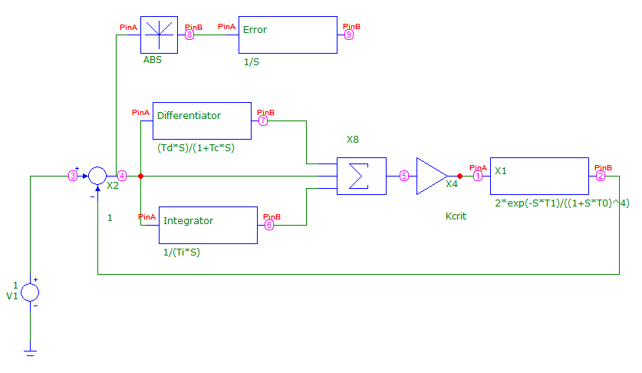

**Метод Никольса-Циглера**

|  |  |  |  |
| --- | --- | --- | --- |
| T1 | 0 | 1.5 | 3 |
| Kcrit | 1.975 | 1.0288 | 0.795 |
| Tcrit | 7.886 | 11.694 | 15.186 |
| K | 1.185 | 0.617 | 0.477 |
| Ti | 3.943 | 5.847 | 7.593 |
| Td | 0.986 | 1.461 | 1.898 |
| Tc | 0.123 | 0.183 | 0.237 |

**При T1 = 0**:

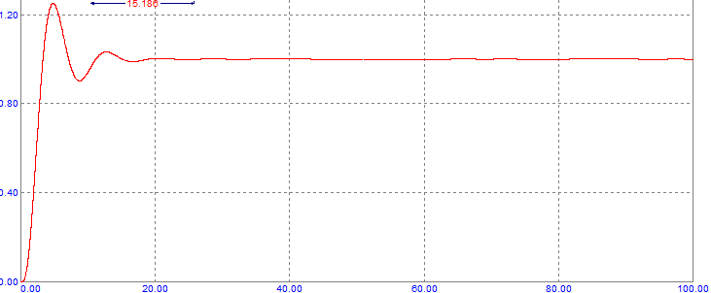

**При T1 = 1.5**

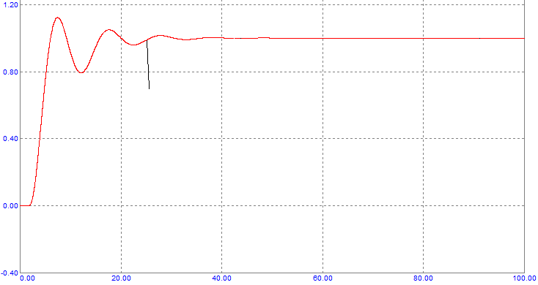

**При T1 = 3**

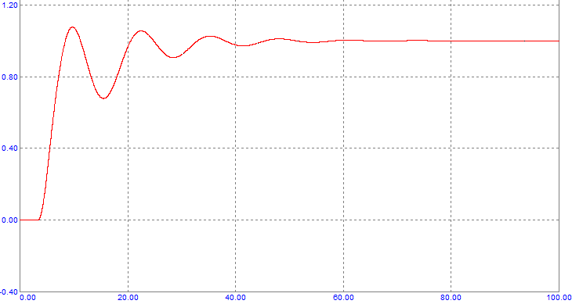

**Метод интегрального критерия качетсва**

**При T1 = 0**

Шаг 1 (Ti = const)

|  |  |  |  |  |
| --- | --- | --- | --- | --- |
| Ki | Ti | Td | Tc | S |
| 1.185 | 3.943 |  |  | 3.068 |
| 0.55 | 3.943 |  |  | 3.637 |
| 1.5 | 3.943 |  |  | 3.575 |
| 1.025 | 3.943 |  |  | 2.917 |
| **1.0** | 3.943 |  |  | **2.878** |

Шаг 2 (Ki = const)

|  |  |  |  |  |
| --- | --- | --- | --- | --- |
| Ki | Ti | Td | Tc | S |
| 1.0 | 3.5 |  |  | 3.22 |
| 1.0 | 6.3 |  |  | 3.243 |
| **1.0** | **4.9** |  |  | **2.716** |

Шаг 3 (Ti = const)

|  |  |  |  |  |
| --- | --- | --- | --- | --- |
| Ki | Ti | Td | Tc | S |
| 0.7 | 4.9 |  |  | 3.501 |
| 1.6 | 4.9 |  |  | 3.522 |
| **1.0** | **4.9** |  |  | **2.716** |

Ki = 1, Ti = 4.9

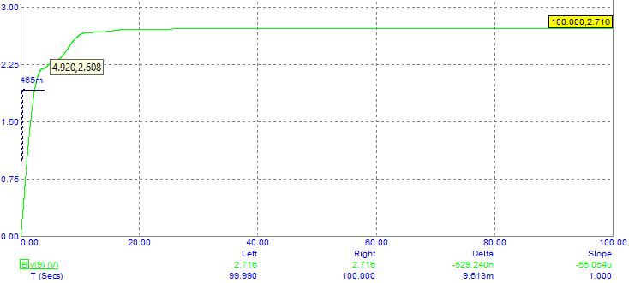

**При T1 = 1.5**

Шаг 1 (Ti = const)

|  |  |  |  |  |
| --- | --- | --- | --- | --- |
| Ki | Ti | Td | Tc | S |
| 0.617 | 5.847 |  |  | 5.652 |
| 0.5 | 5.847 |  |  | 5.855 |
| 0.65 | 5.847 |  |  | 5.877 |
| **0.575** | **5.847** |  |  | **5.474** |

Шаг 2 (Ki = const)

|  |  |  |  |  |
| --- | --- | --- | --- | --- |
| Ki | Ti | Td | Tc | S |
| 0.575 | 4.0 |  |  | 6.258 |
| 0.575 | 7.1 |  |  | 6.29 |
| 0.575 | 5.55 |  |  | 5.361 |
| **0.575** | **5.05** |  |  | **5.288** |

Шаг 3 (Ti = const)

|  |  |  |  |  |
| --- | --- | --- | --- | --- |
| Ki | Ti | Td | Tc | S |
| 0.45 | 5.05 |  |  | 5.622 |
| 0.63 | 5.05 |  |  | 5.605 |
| 0.54 | 5.05 |  |  | 5.183 |

Шаг 4 (Ki = const)

|  |  |  |  |  |
| --- | --- | --- | --- | --- |
| Ki | Ti | Td | Tc | S |
| 0.54 | 5.9 |  |  | 5.522 |
| 0.54 | 4.4 |  |  | 5.456 |
| 0.54 | 5.045 |  |  | 5.182 |

Ki = 0.54, Ti = 5.045

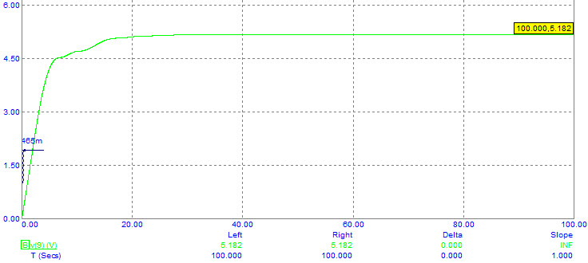

**При T1 = 3**

Шаг 1 (Ti = const)

|  |  |  |  |  |
| --- | --- | --- | --- | --- |
| Ki | Ti | Td | Tc | S |
| 0.477 | 7.593 |  |  | 8.846 |
| 0.4 | 7.593 |  |  | 9.496 |
| 0.51 | 7.593 |  |  | 9.463 |
| **0.455** | **7.593** |  |  | **8.670** |

Шаг 2 (Ki = const)

|  |  |  |  |  |
| --- | --- | --- | --- | --- |
| Ki | Ti | Td | Tc | S |
| 0.455 | 4.5 |  |  | 9.267 |
| 0.455 | 8.2 |  |  | 9.297 |
| **0.455** | **6.35** |  |  | **7.737** |

Шаг 3 (Ti = const)

|  |  |  |  |  |
| --- | --- | --- | --- | --- |
| Ki | Ti | Td | Tc | S |
| 0.38 | 6.35 |  |  | 8.363 |
| 0.5 | 6.35 |  |  | 8.259 |
| **0.44** | **6.35** |  |  | **7.668** |

Шаг 4 (Ki = const)

|  |  |  |  |  |
| --- | --- | --- | --- | --- |
| Ki | Ti | Td | Tc | S |
| 0.44 | 4.5 |  |  | 9.019 |
| 0.44 | 7.8 |  |  | 8.936 |
| **0.44** | **6.2** |  |  | **7.597** |

Шаг 5 (Ti = const)

|  |  |  |  |  |
| --- | --- | --- | --- | --- |
| Ki | Ti | Td | Tc | S |
| 0.4 | 6.2 |  |  | 7.782 |
| 0.47 | 6.2 |  |  | 7.819 |
| **0.435** | **6.2** |  |  | **7.587** |

Шаг 6 (Ki = const)

|  |  |  |  |  |
| --- | --- | --- | --- | --- |
| Ki | Ti | Td | Tc | S |
| 0.435 | 5 |  |  | 7.92 |
| 0.435 | 6.8 |  |  | 7.973 |
| **0.435** | **5.9** |  |  | **7.491** |

Ki = 0.435, Ti = 5.9

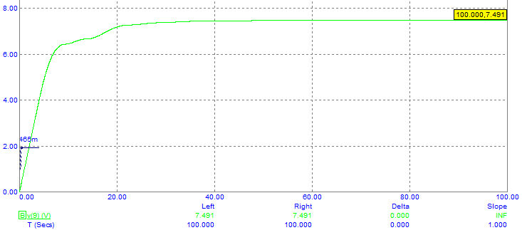

**По параметрам переходной характеристики объекта**

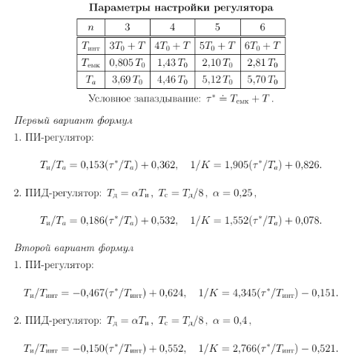

T0 = 1.23

Tемк = 1.43*T0 = 1.7589

**Первый вариант**

|  |  |  |  |
| --- | --- | --- | --- |
| Т | 1 | 2 | 10 |
| K | 1.248 | 1.086 | 0.769 |
| Ti | 3.432 | 3.618 | 5.106 |
| Td | 0.858 | 0.904 | 1.276 |
| Tc | 0.107 | 0.113 | 0.16 |

T = 1

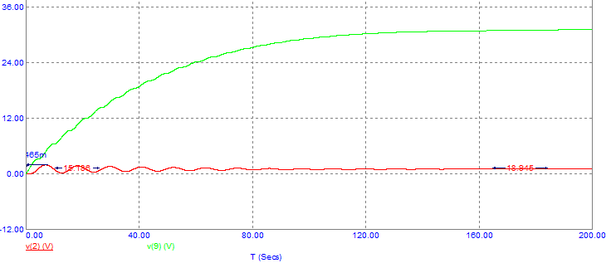

T = 2

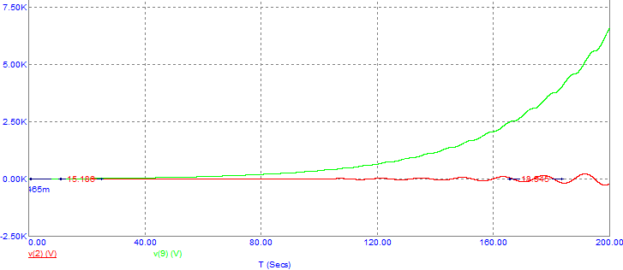

T = 10

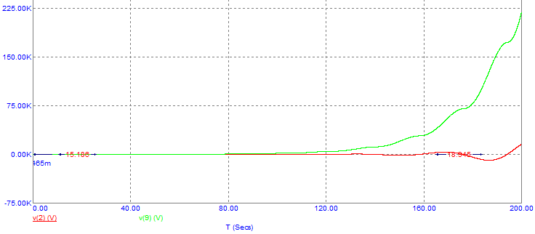

**Второй вариант**

|  |  |  |  |
| --- | --- | --- | --- |
| Т | 1 | 2 | 10 |
| K | 1.302 | 1.019 | 0.603 |
| Ti | 2.854 | 3.256 | 6.472 |
| Td | 1.142 | 1.302 | 2.589 |
| Tc | 0.143 | 0.163 | 0.324 |

T = 1

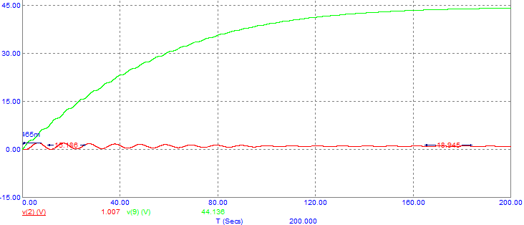

T = 2

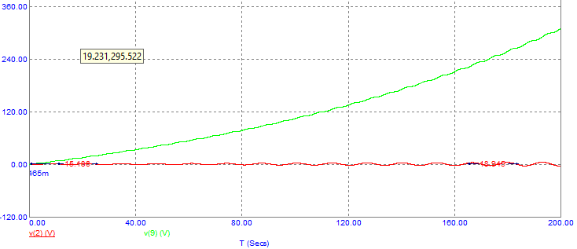

T = 10

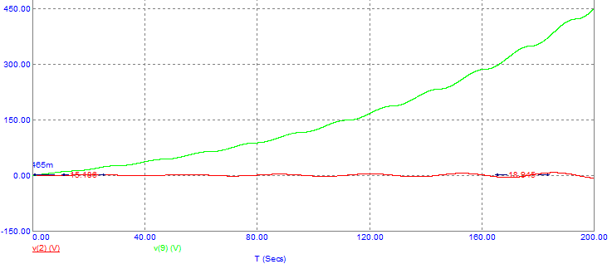

**Свои формулы настройки**

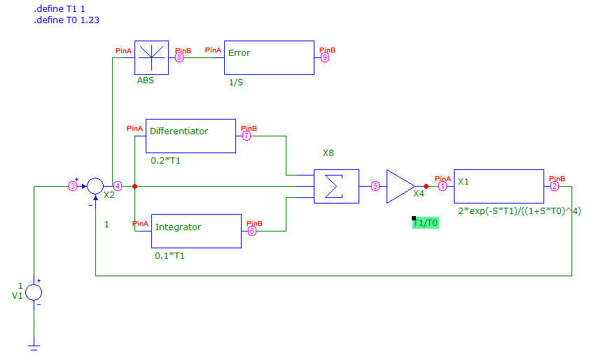

T1 = 1

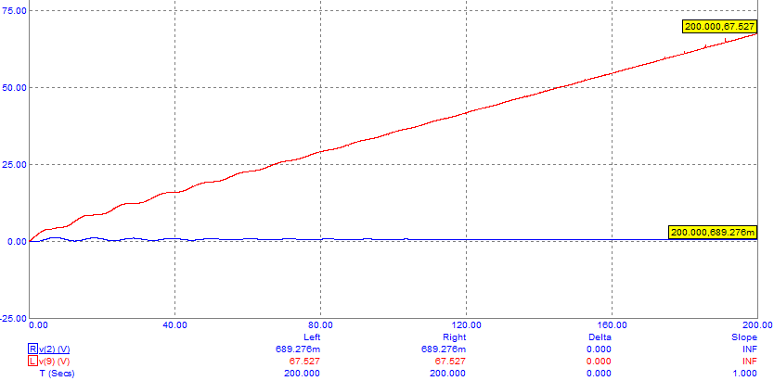

T1 = 2

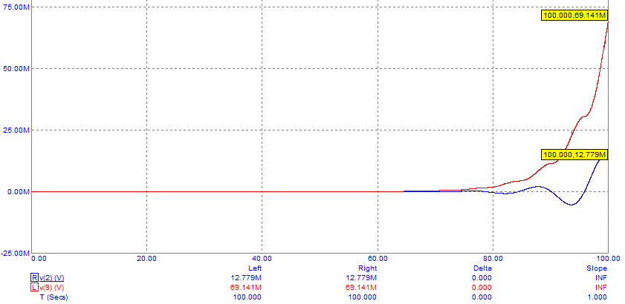

T1 = 10

