**Отчет по настроке ПИ-регулятора**

**Выполнил Столяров А.В. гр. 22201**

Уникальные параметры: T0 = 1.23, n = 4

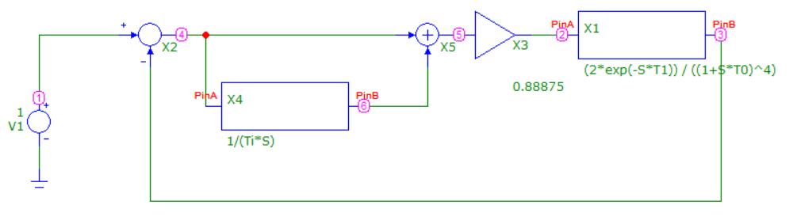

**Метод Никольса-Циглера**

|  |  |  |  |
| --- | --- | --- | --- |
| T1 | 0 | 1.5 | 3 |
| Kcrit | 1.975 | 1.0288 | 0.795 |
| Tcrit | 7.886 | 11.694 | 15.283 |
| K | 0.88875 | 0.46296 | 0.35775 |
| Ti | 6.57 | 9.745 | 12.736 |

**При T1 = 0**:

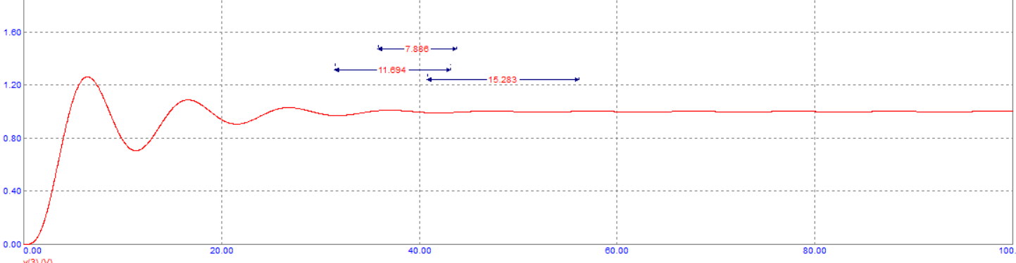

**При T1 = 1.5**

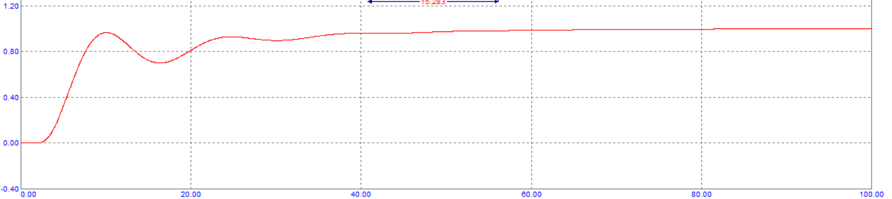

**При T1 = 3**

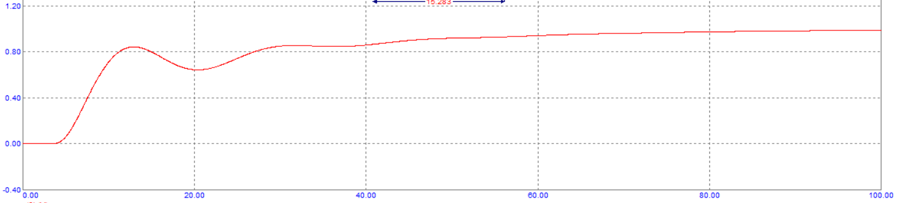

**Метод интегрального критерия качетсва**

**При T1 = 0**

Шаг 1 (Ti = const)

|  |  |  |
| --- | --- | --- |
| Ki | Ti | S |
| 0.88875 | 6.57 | 5.673 |
| 1 | 6.57 | 6.543 |
| 0.7 | 6.57 | 5.125 |
| 0.6 | 6.57 | 5.488 |
| **0.725** | **6.57** | **5.109** |

Шаг 2 (Ki = const)

|  |  |  |
| --- | --- | --- |
| Ki | Ti | S |
| 0.725 | 5 | 5.24 |
| 0.725 | 8 | 5.687 |
| 0.725 | 3.5 | 6.69 |
| 0.725 | 5.5 | 5.091 |
| **0.725** | **6** | **5.037** |

Шаг 3 (Ti = const)

|  |  |  |
| --- | --- | --- |
| Ki | Ti | S |
| 0.75 | 6 | 5.112 |
| 0.6 | 6 | 5.149 |
| 0.65 | 6 | 5.003 |
| 0.685 | 6 | 4.983 |
| **0.675** | **6** | **4.98** |

Шаг 4 (Ki = const)

|  |  |  |
| --- | --- | --- |
| Ki | Ti | S |
| 0.675 | 6.5 | 5.150 |
| 0.675 | 5.2 | 4.969 |
| **0.675** | **5.6** | **4.931** |
| 0.675 | 5.75 | 4.941 |
| 0.675 | 5.45 | 4.934 |

Шаг 5 (Ti = const)

|  |  |  |
| --- | --- | --- |
| Ki | Ti | S |
| 0.6 | 5.6 | 4.957 |
| 0.625 | 5.6 | 4.907 |
| 0.655 | 5.6 | 4.905 |
| 0.645 | 5.6 | 4.901 |
| **0.6375** | **5.6** | **4.9** |

Шаг 6 (Ki = const)

|  |  |  |
| --- | --- | --- |
| Ki | Ti | S |
| 0.6375 | 5.65 | 4.911 |
| 0.6375 | 5.5 | 4.884 |
| 0.6375 | 5.4 | 4.873 |
| 0.6375 | 5.1 | 4.876 |
| **0.6375** | **5.25** | **4.868** |

Ki = 0.6375, Ti = 5.25

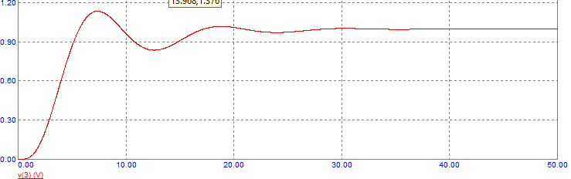

**При T1 = 1.5**

Шаг 1 (Ti = const)

|  |  |  |
| --- | --- | --- |
| Ki | Ti | S |
| 0.46296 | 9.745 | 10.502 |
| 0.4 | 9.745 | 12.139 |
| 0.7 | 9.745 | 12.556 |
| **0.55** | **9.745** | **9.317** |

Шаг 2 (Ki = const)

|  |  |  |
| --- | --- | --- |
| Ki | Ti | S |
| 0.55 | 5 | 10.644 |
| 0.55 | 11 | 10.312 |
| **0.55** | **8** | **8.639** |
| 0.55 | 7.5 | 8.657 |
| 0.55 | 8.5 | 8.719 |

Шаг 3 (Ti = const)

|  |  |  |
| --- | --- | --- |
| Ki | Ti | S |
| 0.65 | 8 | 11.376 |
| 0.35 | 8 | 11.414 |
| **0.5** | **8** | **8.453** |

Шаг 4 (Ki = const)

|  |  |  |
| --- | --- | --- |
| Ki | Ti | S |
| 0.5 | 10 | 10.01 |
| 0.5 | 4.5 | 10.262 |
| **0.5** | **6.85** | **8.194** |

Шаг 5 (Ti = const)

|  |  |  |
| --- | --- | --- |
| Ki | Ti | S |
| 0.6 | 6.85 | 10.363 |
| 0.33 | 6.85 | 10.375 |
| 0.465 | 6.85 | 7.943 |

Шаг 6 (Ki = const)

|  |  |  |
| --- | --- | --- |
| Ki | Ti | S |
| 0.465 | 4 | 10.344 |
| 0.465 | 9.5 | 10.331 |
| **0.465** | **6.25** | **7.881** |

Ki = 0.465, Ti = 6.25

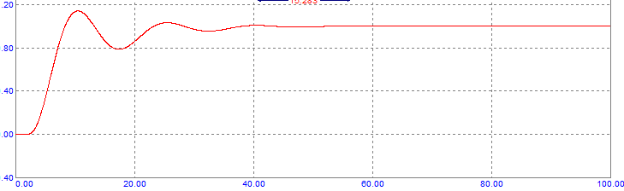

**При T1 = 3**

Шаг 1 (Ti = const)

|  |  |  |
| --- | --- | --- |
| Ki | Ti | S |
| 0.35775 | 12.736 | 17.794 |
| 0.3 | 12.736 | 21.209 |
| 0.61 | 12.736 | 21.284 |
| 0.455 | 12.736 | 14.119 |
| **0.48** | **12.736** | **13.7** |

Шаг 2 (Ki = const)

|  |  |  |
| --- | --- | --- |
| Ki | Ti | S |
| 0.48 | 6 | 16.41 |
| 0.48 | 15.5 | 16.230 |
| **0.48** | **9.75** | **12.586** |

Шаг 3 (Ti = const)

|  |  |  |
| --- | --- | --- |
| Ki | Ti | S |
| 0.3 | 9.75 | 16.249 |
| 0.546 | 9.75 | 16.298 |
| **0.423** | **9.75** | **11.822** |

Шаг 4 (Ki = const)

|  |  |  |
| --- | --- | --- |
| Ki | Ti | S |
| 0.423 | 5 | 14.949 |
| 0.423 | 12.65 | 14.95 |
| **0.423** | **8.825** | **11.261** |

Шаг 5 (Ti = const)

|  |  |  |
| --- | --- | --- |
| Ki | Ti | S |
| 0.3 | 8.825 | 14.708 |
| 0.515 | 8.825 | 14.65 |
| 0.407 | 8.825 | 11.231 |
| **0.411** | **8.825** | **11.215** |

Шаг 6 (Ki = const)

|  |  |  |
| --- | --- | --- |
| Ki | Ti | S |
| 0.411 | 5 | 14.07 |
| 0.411 | 11.6 | 14.111 |
| 0.411 | 8.35 | 11.004 |
| **0.411** | **8.18** | **10.965** |

Ki = 0.411, Ti = 8.18

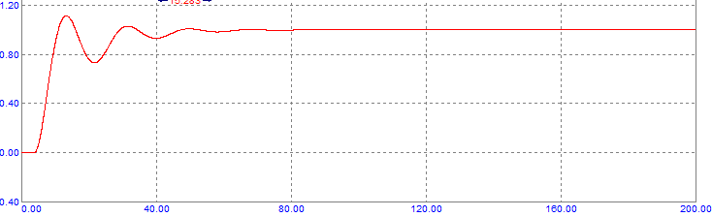

**По параметрам переходной характеристики объекта**

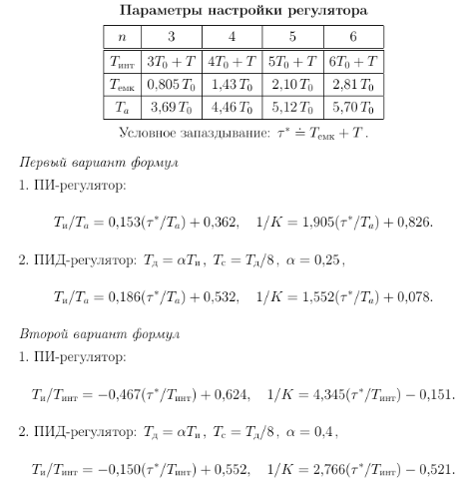

T0 = 1.23

Tемк = 1.43*T0 = 1.7589

**Первый вариант**

|  |  |  |  |
| --- | --- | --- | --- |
| Т | 1 | 2 | 10 |
| tau | 2.7589 | 3.7589 | 11.7589 |
| Ta | 5.4858 | 5.4858 | 5.4858 |
| K | 0.5605 | 0.4692 | 0.2037 |
| Ti | 2.408 | 2.561 | 3.785 |

T = 1

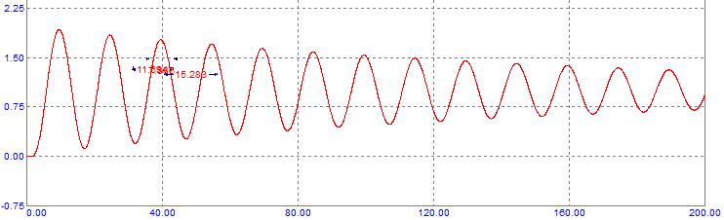

T = 2

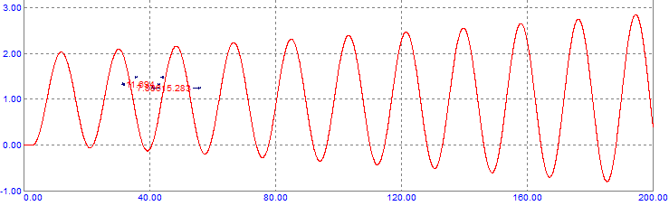

T = 10

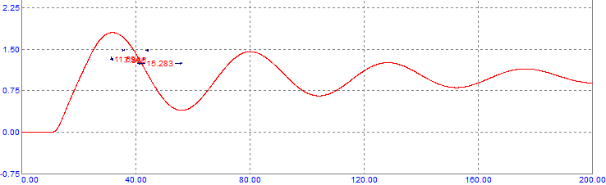

**Второй вариант**

|  |  |  |  |
| --- | --- | --- | --- |
| Т | 1 | 2 | 10 |
| tau | 2.7589 | 3.7589 | 11.7589 |
| Tint | 5.92 | 6.92 | 14.92 |
| K | 0.5336 | 0.4527 | 0.3055 |
| Ti | 2.4057 | 2.5627 | 3.8187 |

T = 1

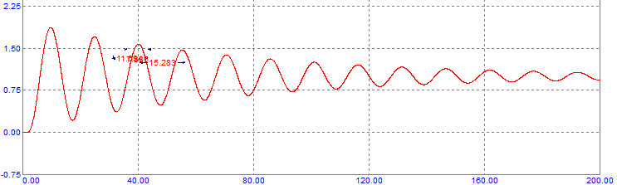

T = 2

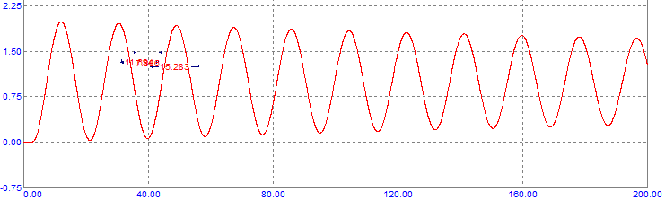

T = 10

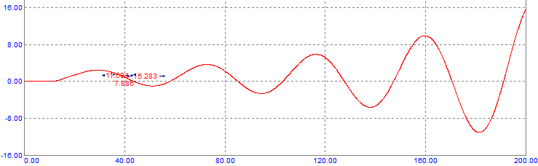

**Сравнение**

**Метод Никольса – Циглера**:

Т1 = 0

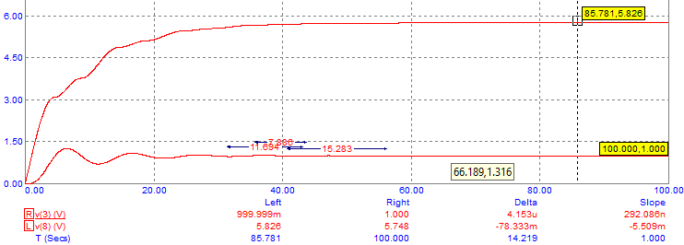

Т1 = 1.5

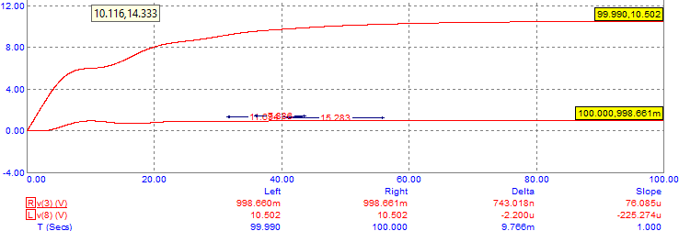

Т1 = 3

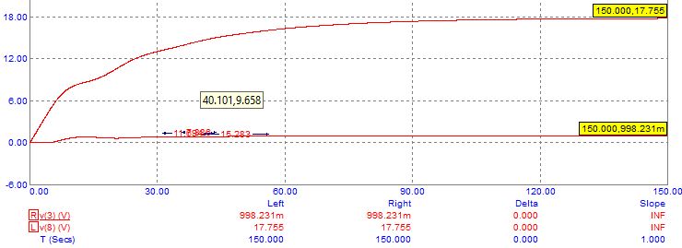

**Метод интегрального критерия качества**:

Т1 = 0

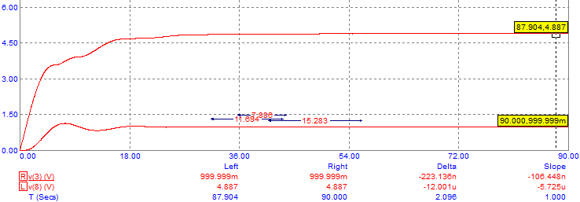

Т1 = 1.5

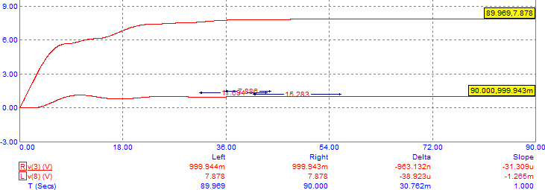

Т1 = 3

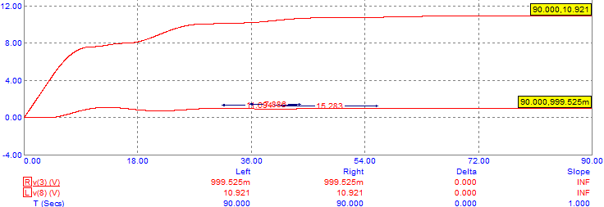

**Метод параметров переходной характеристики объекта**:

Первый вариант

Т1 = 1

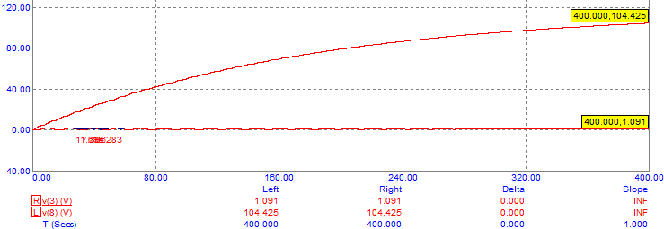

Т1 = 2

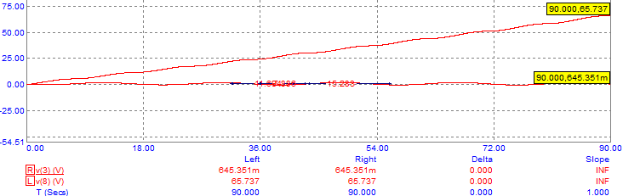

Т1 = 10

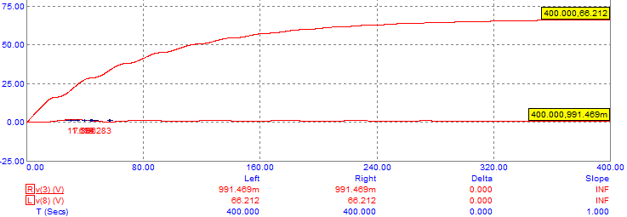

Второй вариант

Т1 = 1

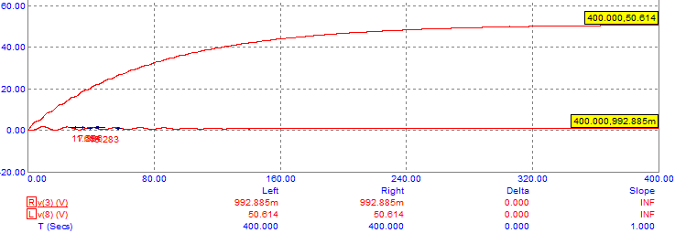

Т1 = 2

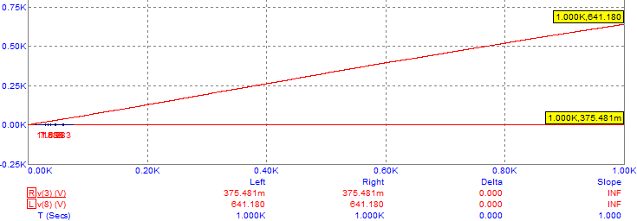

Т1 = 10

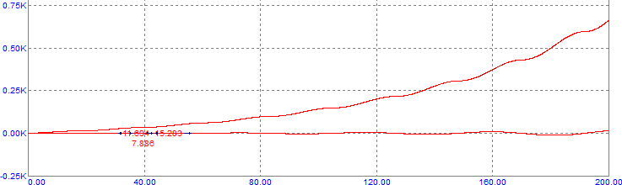

Лучшим вариантом является: метод интегрального критерия качетсва, при Т1 = 0

Следует заметить, что интегральный критерий справился лучше всех, метод Никольса-Циглера показал приличные результаты, а по параметрам переходной характеристики объекта иногда вообще не сходится и площадь бесконечная, либо сходится, но очень медленно и площадь очень болшая, хоть и конечная.