

**HT SP**

**Inglês Instrumental – 2022**

Prof. Altamir Gomes dos Santos / Prof. Edley Matos dos Santos

Helyson Santiago Freitas ID:184831

Name:

**EXERCISES: Unit 15**

**15.1** Look at the pictures. What has happened? Choose from:

**go to bed ~~clean his shoes~~ stop raining close the door fall down have a bath**

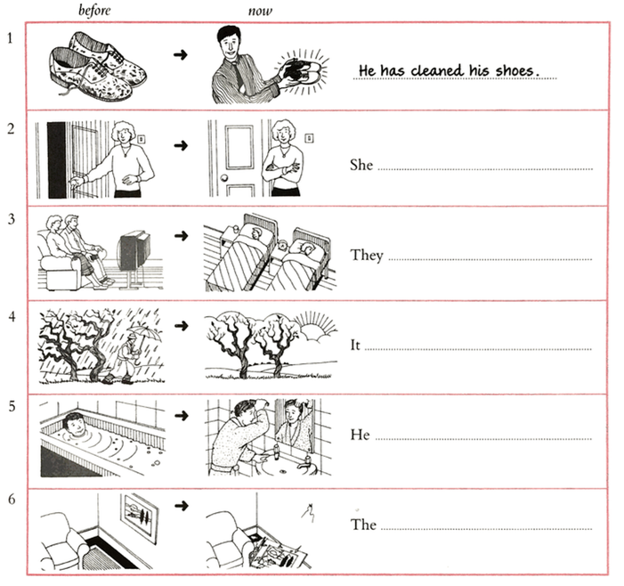

**He has cleaned his shoes.**

picture has fallen down.

has had a bath.

has stopped raining.

have gone to bed.

has closed the door.

**15.2** Complete the sentences with a verb from the list.

**~~break~~ ~~buy~~ ~~decide~~ ~~finish~~ ~~forget~~ ~~go~~ ~~go~~ ~~invite~~ ~~see~~ ~~not/see~~ ~~take~~ ~~tell~~**

**ve finished**

1 ‘Can I have this newspaper?’ ‘Yes, I’_________________ with it.’

‘ve (have)bought

2 I _________________ some new shoes. Do you want to see them?

‘s (has) gone

3 ‘Where is Liz?’ ‘She _________________ out.’

seen

have

4 I’m looking for Paula. _____________ you ______________ her?

‘s (has) broken

5 Look! Somebody __________________ that window.

‘ve (have) told

6 ‘Does Lisa know that you’re going away?’ ‘Yes, I ______________ her.’

‘s (has) taken

7 I can’t find my umbrella. Somebody _______________ it.

gone

has

8 I’m looking for Sarah. Where ______________ she ____________ ?

‘ve (have) forgotten

9 I know that woman, but I __________________ her name.

‘s (has) invited

10 Sue is having a party tonight. She _________________ a lot of people.

decided

have

11 What are you going to do? __________________ you ________________?

haven’t seen

12 ‘Where are my glasses?’ ‘I don’t know. I _________________ them.’

**EXERCISES: Unit 16**

**16.1** Write a sentence with **just** for each picture.

‘ve (have) just bought a (new) car.

**They’ve just arrived.**

|  |  |
| --- | --- |
| 1 ________________________  ‘s (has) just woken/got up.  2 He _____________________________ | 3 They ___________________________  has just started.  4 The race ________________________ |

|  |  |
| --- | --- |
|  |  |



**16.2** Complete the sentences. Use **already** + present perfect.



_______________________

No, they __________________________ it.

I ___________________________________

He _________________________________

I ___________________________________

She ________________________________

**He’s already arrived.**

What time is Paul arriving?

Do Sue and Bill want to see the film?

Don’t forget to phone Tom.

When is Martin going away?

Do you want to read the newspaper?

When does Linda start her new job?

1

2

3

4

5

6

‘ve (have) already seen

‘ve (have) already phoned him

‘s (has) already gone (away)

‘ve (have) already read it

‘s (has) already started it

**16.3** Write a sentence with **just** (**They’ve just** … / **She’s just** … etc.) or a negative sentence with **yet** (**They haven’t** … **yet**/**She hasn’t** … **yet** etc.).

They’ve (have) just finished their dinner

It hasn’t stopped raining.

He hasn’t opened it yet.

The bus hasn’t gone yet.

The bus has just gone.

**16.4** Write questions with **yet**.

|  |  |
| --- | --- |
| 1 Your friend has got a new job. Perhaps  she has started it. You ask her:  **Have you started your new job yet?**  __________________________________ | 3 Your friend must write a letter. Perhaps  she has written it now. You ask her:  Have you written the letter yet?  _________________________________ |
| 2 Your friend has some new neighbors.  Perhaps he has met them. You ask him:  met your new neighbors yet?  Have  _______ you ______________________ | 4 Tom was trying to sell his car. Perhaps he has sold it now. You ask a friend about Tom:  Has tom sold his car yet?  _________________________________ |