# CmsTalkToCms

We are going to see how we can manage, share our content between multiple CMS. The whole idea here is how we can share the content across multiple CMS.

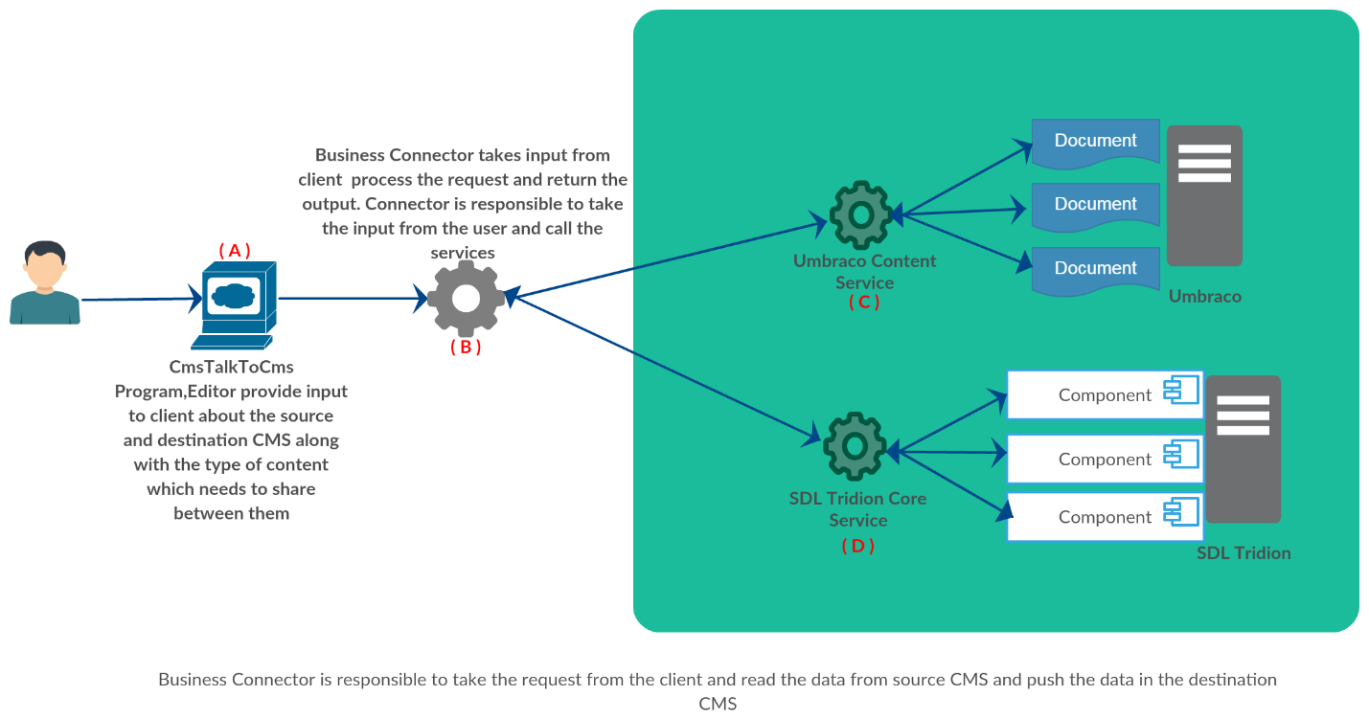

High-Level Architecture Diagram

Let's discuss the diagram

## Point A

* 1. Here I have created a C# console based application which takes inputs from user and forward that request to business connector
  2. Inputs are like
     + Read data from CMS A process it in a manner which is accepted by CMS B.
     + Mentioned the type of the data (In case of Tridion schema and for Umbraco parent document type)
     + Returns the count and details of the transaction.
     + User authentication is done at this level.

## Point B

* 1. Business connector is the core of this architecture.
     + It will consume all the input provide by the Client
     + Based on that it will first call the source CMS could be point (C) or (D) .
       - Here we extract all the items which needs to share.
       - Transform the data in a manner which is accepted by the destination CMS
       - Once data transformation is done then we will call the destination CMS service which could be point (C) or (D).
       - Service will validate the data
       - Finally, data is pushed to destination CMS.
     + Destination service
       - Will also validate the data before performing CRUD operation
       - Service will check if any item in the list send by the source already exist
       - If yes will run update else create new item.
  2. After all the data is either updated created or rejected the response will be send back to the business connector and business connector share that response with the client Point A.

## Point C

* 1. I have created Custom web service .ASMX
  2. Using **Umbraco.core** DLL provided by Umbraco.
  3. Using this DLL we can perform all the CRUD operations.

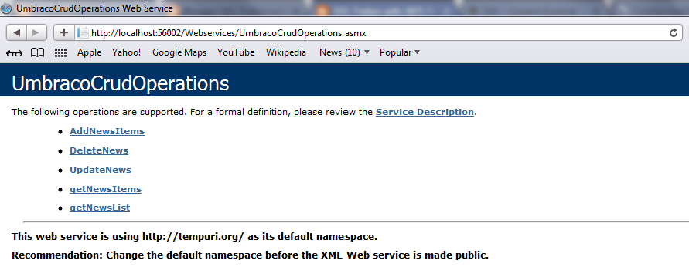

## Point D

* 1. Tridion core service is used for CRUD operations.
  2. ISessionAwareCoreService is used to create the core service client.

## Summary

With this we can automate the Content with in same CMS and with multiple CMS.

* Tridion content automation
* Umbraco Content automation
* Content can be shared between multiple CMS or we can use this in migration
  + Tridion to Umbraco
  + Umbraco to Tridion