**Joins:** Joins are used to retrieve data from two or more tables. Fetching the records from different tables will be easy using joins. Joins are used with select statements.

**Different types of joins are:**

**Inner Join (simple Join):** Combines rows from the tables if they meet a specified condition.

Syntax: SELECT columns from table1

INNER JOIN table2

ON table1.col1=table2.col2

Example:

select * from users inner join ratings on users.id=ratings.user_id;

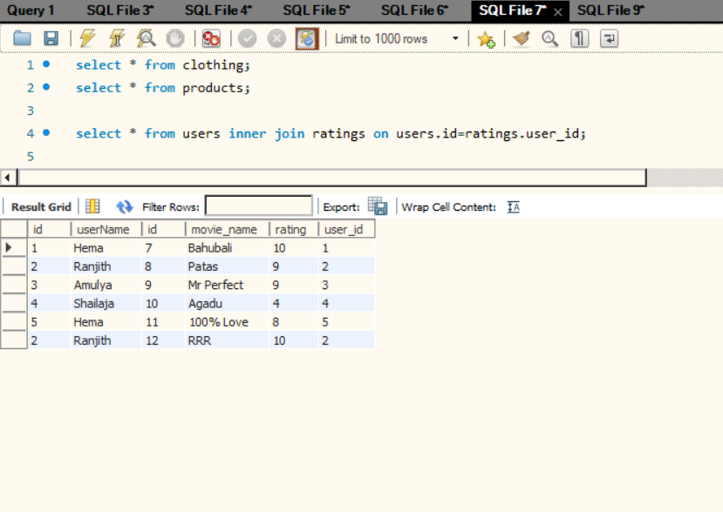

**Left Join:** It is used to Retrieve All rows from left table and only matched rows from right table and will get null values for unmatched rows.

Syntax: SELECT columns from table1

LEFT JOIN table2

ON table1.col1=table2.col2

Example: select * from users left join ratings on users.id=ratings.user_id;

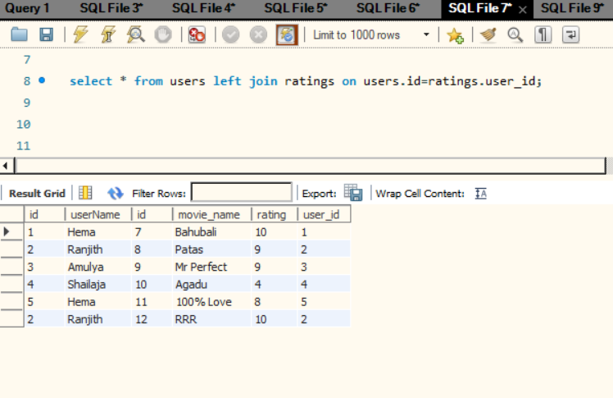

**Right Join (vice-versa of left join):** It is used to retrieve all rows from right table and only matching rows from left table and it gives null values in the left table for the rows which are not matched.

Syntax: SELECT columns from table1

RIGHT JOIN table2

ON table1.col1=table2.col2

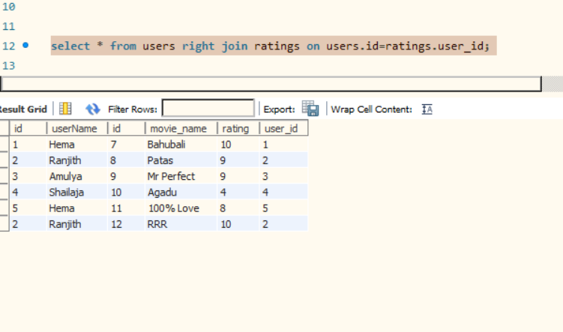

**Self-Join:** The rows in the table are joined with the same data in the same table or it can be said as each row from the right table is joined with all the rows from left table.

Syntax: SELECT * from table1 SELF JOIN table2;

Example: select * from ratings self join ratings;

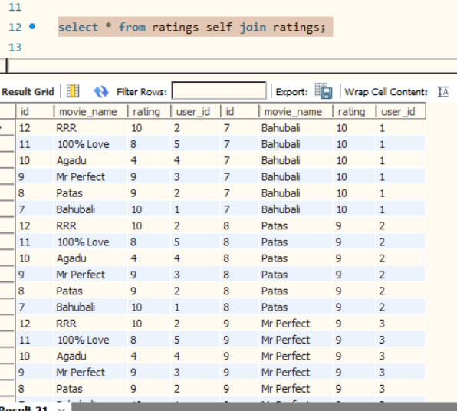

**Full Join:** Full join is not supported by mySql and sqlite but it can be achieved by the union of left join and right join.

Syntax: select * from users left join ratings on users.id=ratings.user_id

union

select * from users right join ratings on users.id=ratings.user_id;

**Cross Join or Cartesian Join:** Each row from the first table is combined with all the rows in the second table.

Syntax: Select * from table1 cross join table2;

Example: select * from users cross join ratings;

