**Task 1: Arithmetic Operators**

Create two variables a and b with numeric values.

Calculate the sum, difference, product, and quotient of a and b.

Print the results.

a=**5**b=**4**print(a+b)  
print(a-b)  
print(a*b)  
print(a/b)

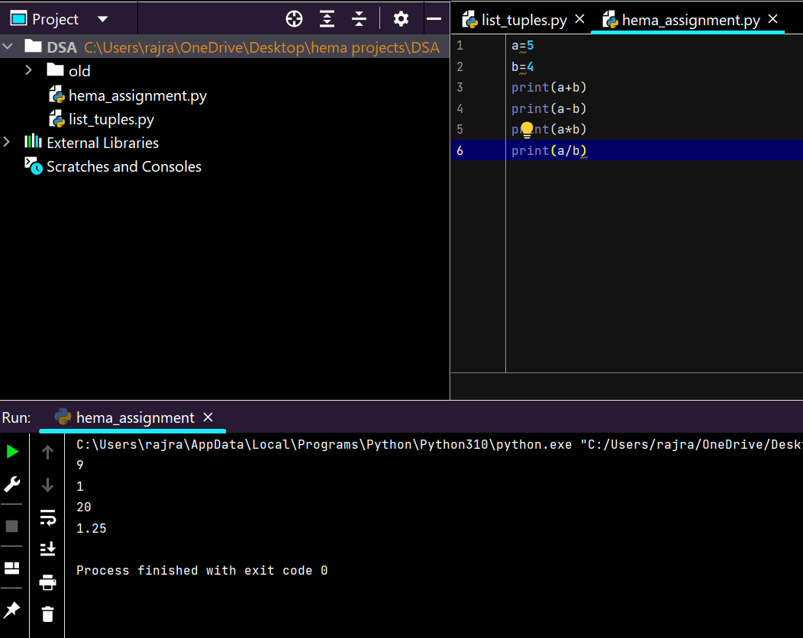

**Task 2: Comparison Operators**

1. Compare the values of a and b using the following comparison operators: <, >, <=, >=, ==, and !=.
2. Print the results of each comparison.
3. a=5

b=4

print(a<b) o/p False

1. a=5

b=4

print(a>b) o/p True

1. a=5, b=4

print(a<=b) o/p False

1. a=5, b=4

print(a>=b) o/p True

1. a=5, b=5

print(a==b) o/p True

1. a=5, b=5

print(a!=b) o/p False

**Task 3: Logical Operators**

1. Create two boolean variables, x and y.
2. Use logical operators (and, or, not) to perform various logical operations on x and y.
3. Print the results.

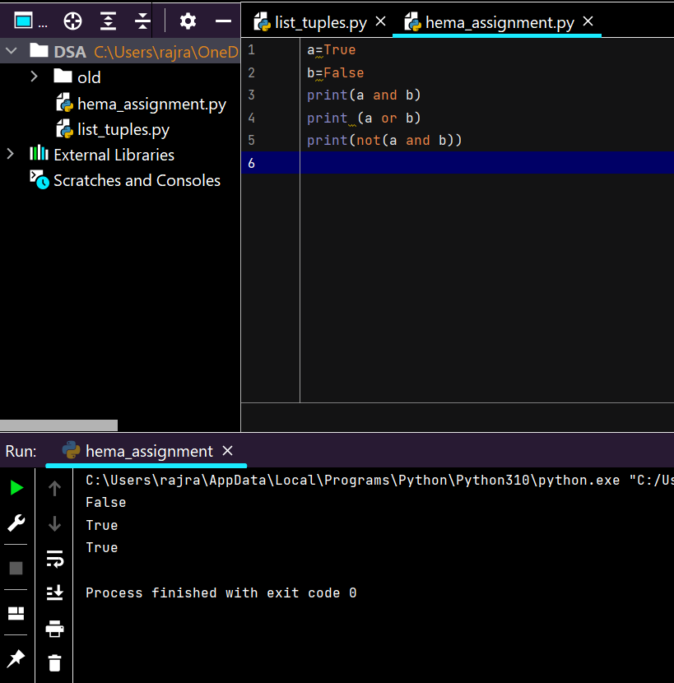

**Task 4: Assignment Operators**

1. Create a variable total and initialize it to 10.
2. Use assignment operators (+=, -=, *=, /=) to update the value of total.
3. Print the final value of total

🡪 a=5

b=3

a+=b

print(a) o/p 8

* a=5

b=3

a -= b

print(a) o/p 2

* a=5

b=3

a*=b

print(a) o/p 15

* a=5

b=2

a/=b

print(a) o/p 2.5

**Task 5: Bitwise Operators (Optional)**

1. If you are comfortable with bitwise operators, perform some bitwise operations on integer values and print the results. If not, you can skip this task.

* And

a=8 (1000)

b=8

print(a & b) o/p 8

* Or

a=8

b=2 (0010)

print(a | b) o/p 10

* Not

a=2

print(~a) o/p -3

**Task 6: Identity and Membership Operators**

1. Create a list my_list containing a few elements.
2. Use identity operators (is and is not) to check if two variables are the same object.
3. Use membership operators (in and not in) to check if an element is present in my_list.
4. Print the results.

* Is

a=[5,6,7,4,5]

b=a

print(a is b) o/p True

* Is not

a=[4,6,7,5,8,9]

b=[4,6,7,5,8,9]

print (a is not b) o/p True

* a= [4,4.5,True,7,7]

print (4 in a) o/p True

* a=[4,4.5,True,7,7]

print (6 not in a) o/p True