**Task 1**

use hema;

create table users(id int not null primary key auto_increment, userName varchar(30));

show tables;

delete from users where id is NULL;

insert into users(userName) values('Hema'),('Ranjith'),('Amulya'),('Shailaja');

**select * from users;**

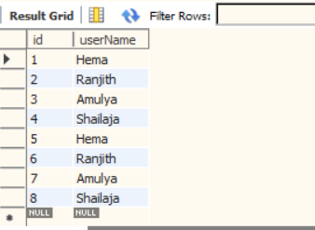

create table orders(order_id int not null primary key auto_increment,cost int(30),user_id int,foreign key(user_id) references users(id) on delete cascade);

select * from orders;

insert into orders(user_id,cost) values('4','350');

**select userName,count(*) from users join orders on orders.user_id=users.id group by userName;**

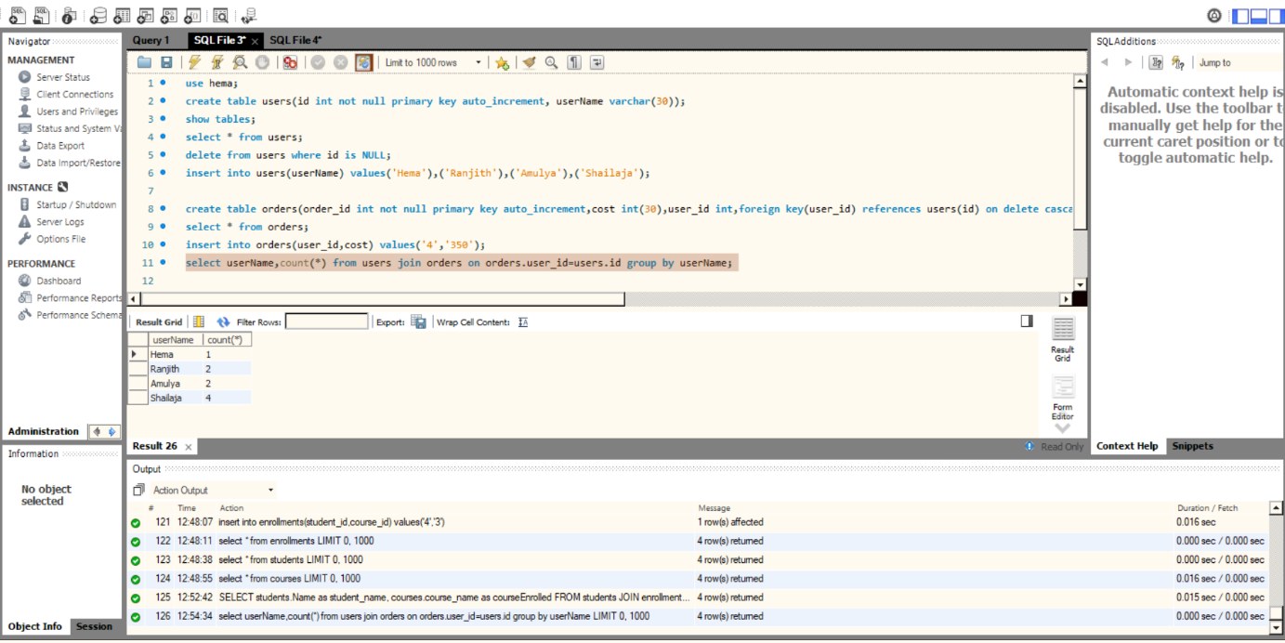

**Task 2**

create table students(id int not null primary key auto_increment, name varchar(30));

insert into students(name) values('d');

select * from students;

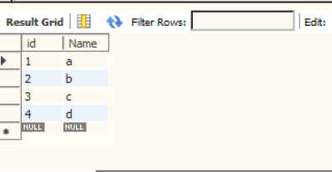

create table courses (course_id int not null primary key auto_increment,course_name varchar(30));

insert into courses(course_name) values('Biology');

select * from courses;

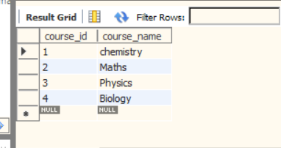

create table enrollments(student_id int,course_id int,foreign key(course_id) references courses(course_id));

select * from enrollments;

insert into enrollments(student_id,course_id) values('4','3');

select students.Name as student_name, courses.course_name as courseEnrolled

from students

join enrollments ON enrollments.student_id = students.id

join courses ON enrollments.course_id = courses.course_id;

