-- CREATE database MYPROJECTS;

create database MyProjects;

show databases;

|  |
| --- |
| hema |
| hema1 |
| information_schema |
| myprojects |
| mysql |
| performance_schema |
| sys |

use MyProjects;

--  Task 1: Creating Table Employee1

create table Employee1(id int primary key not null auto_increment,name char(30),salary int);

show tables;

employee1

--  Task 2: Inserting Data into Employee1 table

insert into Employee1(name,Salary) values('hema',80000),('ranjith',100000),('amulya',50000),('archana',20000),('gouthami',30000),('shailaja',40000),('ram',45000),

('sita',44000),('purple',46000);

select * from Employee1;

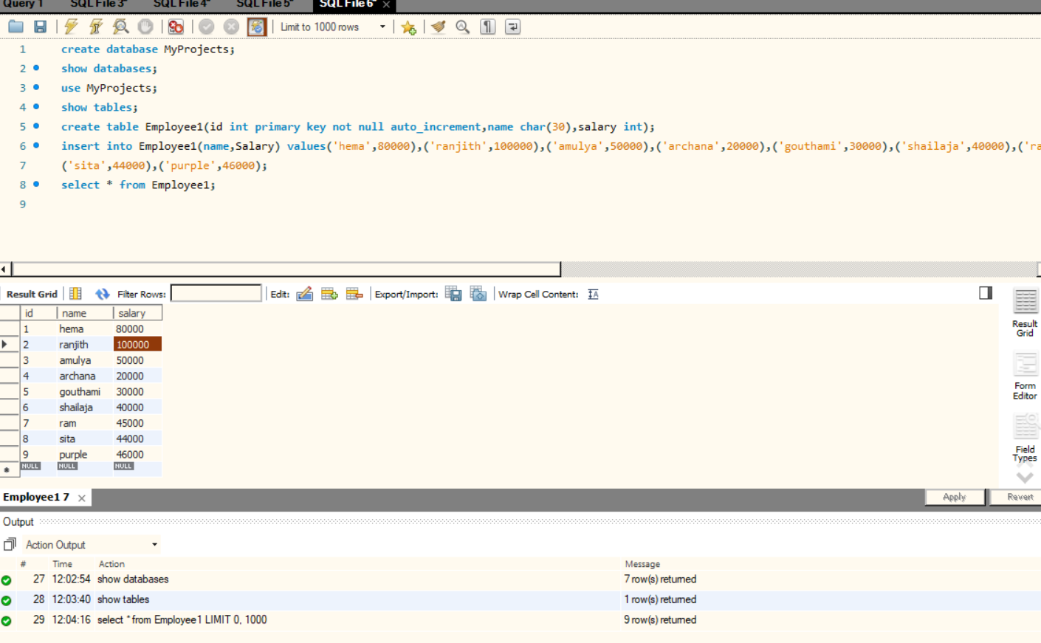

--  Task 3: Select with WHERE

-- Retrieve the names and salaries of employees whose salary is greater than 50000.

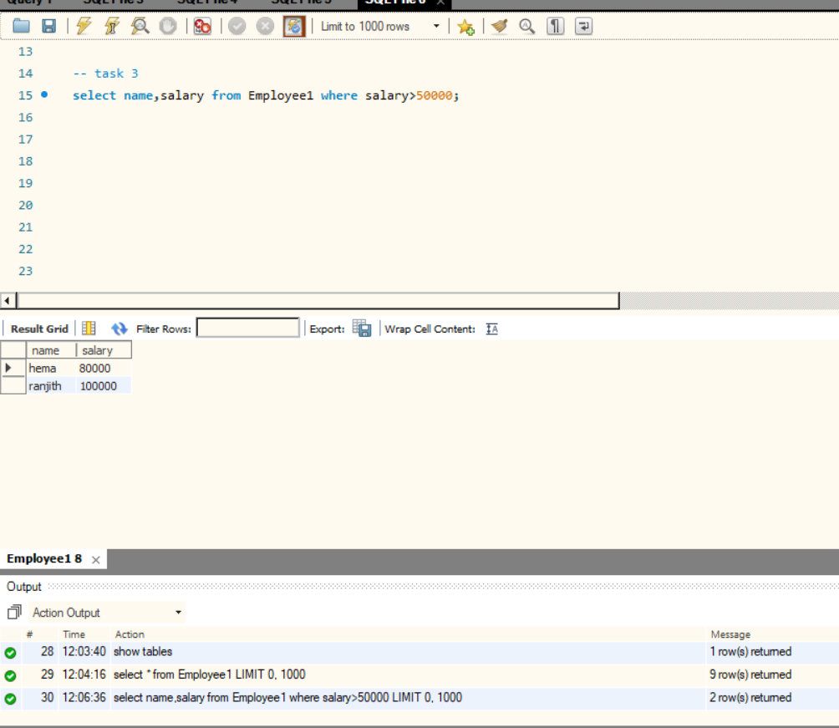

-- Task 4: Select with AND

-- Retrieve the first and last names of employees whose salary is between 40000 and 60000.

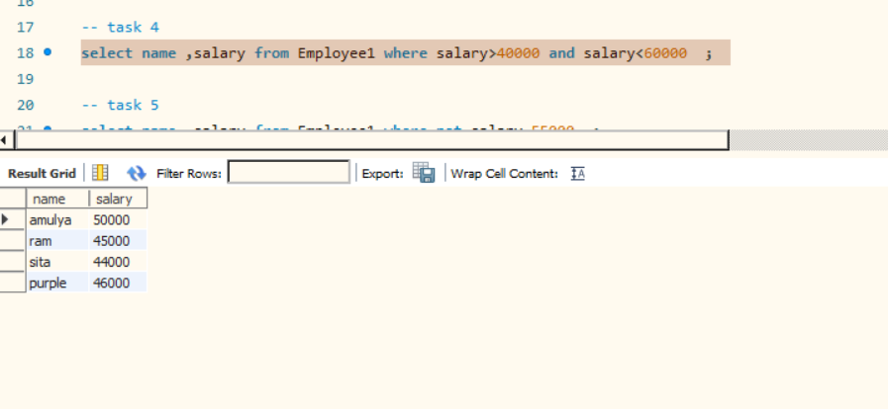

--  Task 5: Select with NOT

-- Retrieve the first and last names of employees whose salary is not equal to 55000.

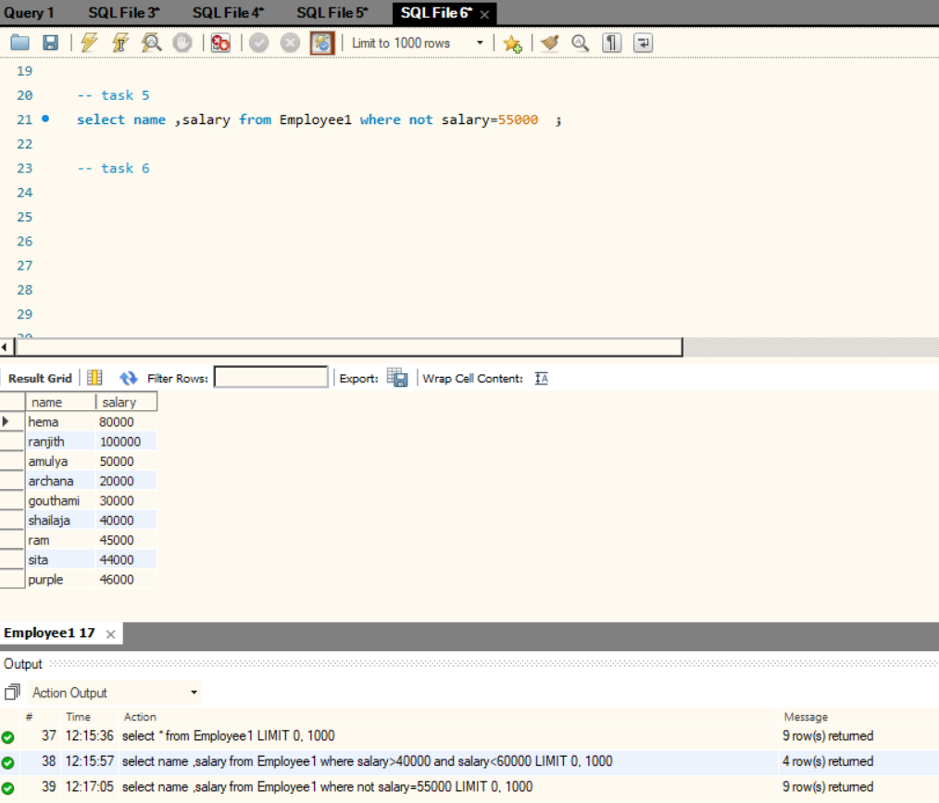

-- Task 6: Order By

-- Retrieve the first and last names of all employees, ordered by their salary in descending order.

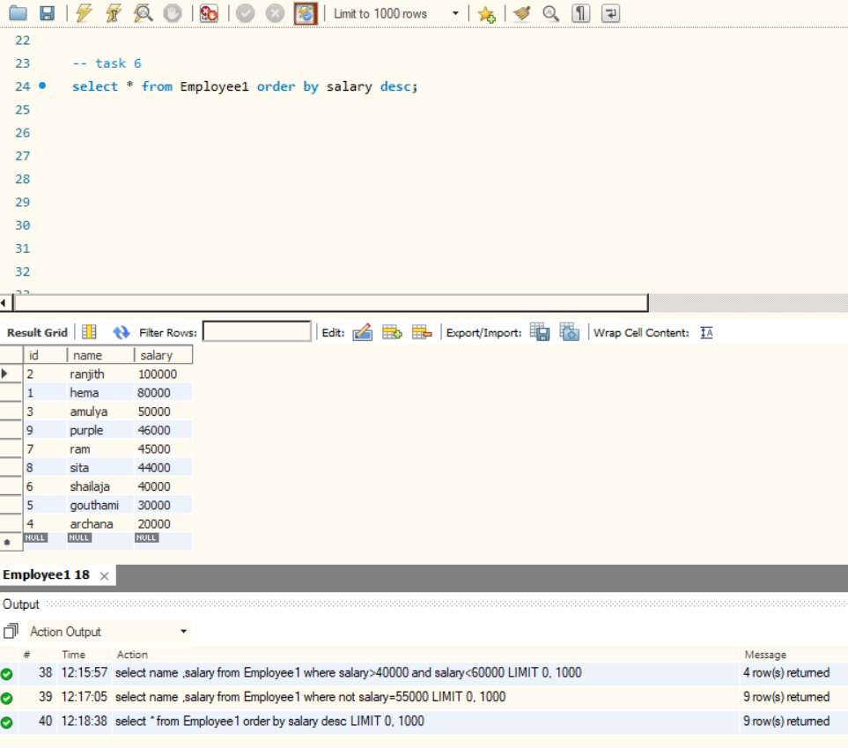

--  Task 7: Select with OR

-- Retrieve the first and last names of employees whose salary is either less than 45000 or greater than 60000.

