LEGALEASE / PROJECT REPORT • CONTENTS

Table of Contents
A concise, presentation-ready guide to the project
NO. | SECTION | WHAT YOU WILL FIND
01 | Abstract | Project overview and outcome
02 | Introduction | Purpose and user journey
03 | Problem Statement & Objectives | Need, goals and expected value
04 | Scope & Technology Stack | What is included and tools used
05 | Workflow & System Architecture | How the system works end-to-end
06 | Core Features & Implementation | AI generation, editing and export
07 | Milestones, Testing & Validation | Delivery plan and quality checks
08 | Challenges & Solutions | Engineering decisions and reliability
09 | Limitations, Future Scope & Conclusion | Responsible use and next steps
10 | References | Key technical sources
11 | Application Screenshots | Visual walkthrough of the running app

LEGALEASE / PROJECT REPORT • 01 / ABSTRACT

Abstract
Project summary
LegalEase is a browser-based application that uses Generative AI to create structured first drafts of common legal documents. Instead of starting with a blank page, users select a document type and provide the parties, key terms and effective date. The application sends these details to Google Gemini and displays the returned draft in an editable preview.
The project combines a Streamlit interface with a FastAPI service layer and a dedicated AI and formatting core. Users can revise generated text, add optional jurisdiction details, apply company branding and export the final draft in TXT, DOCX or PDF format. The Word and PDF outputs support a more professional presentation through logos, headings, terms formatting and footers.
A central design choice is separation of concerns: the frontend manages interaction, the backend validates and routes requests, the AI module builds prompts and handles generation failures, and the export module prepares downloadable files. The application also includes mock mode, which supports demonstrations and automated tests when a Gemini API key is unavailable.
OUTCOME LegalEase streamlines routine first-draft preparation and formatting. It is a drafting assistant—not a legal-advice system or a guarantee of enforceability.

Keywords
Generative AI • Legal document drafting • Google Gemini • Streamlit • FastAPI • Document automation • DOCX/PDF export

LEGALEASE / PROJECT REPORT • 02 / INTRODUCTION

Introduction
Turning simple details into a structured draft
Written agreements are common in employment, freelance work, confidentiality arrangements and property rental. Preparing them from scratch requires attention to structure, formal wording and presentation. Reusing an old document can also leave outdated or irrelevant clauses in place.
LegalEase offers a guided drafting flow. A user selects a document category, enters the parties, adds terms separated by semicolons, and supplies an effective date. An optional jurisdiction can provide additional context. Gemini then produces a multi-section draft, which the user can inspect and edit before downloading.

How the user journey feels
- Describe the agreement using a small set of form fields.
- Generate a structured draft through the AI core.
- Review the preview and correct details or placeholders.
- Apply optional company branding and export the document.

Design principles
PRINCIPLE | HOW IT APPEARS IN THE PROJECT
Accessible | A browser-based Streamlit interface; no local installation for the live app.
Editable | Users can revise the generated text before any download.
Portable | TXT, DOCX and PDF formats support different workflows.
Maintainable | Frontend, API, AI generation and formatting are separated.
Transparent | The tool states that output is a draft and may require legal review.

LEGALEASE / PROJECT REPORT • 03 / PROBLEM & OBJECTIVES

Problem Statement & Objectives
Why the project is useful

Problem statement
Individuals, freelancers and small businesses often need routine agreements but may not have a reusable, well-structured template or immediate access to professional drafting support. Three recurring obstacles are uncertainty about the clauses a document should contain, difficulty converting everyday terms into formal wording, and the manual effort needed to create a polished final file.
CHALLENGE | EFFECT ON THE USER | LEGALEASE RESPONSE
Structure | Important sections or signature details may be missed. | Generates a multi-section draft with numbered clauses.
Wording | Informal notes are difficult to express consistently. | Uses a structured prompt to produce formal first-draft language.
Presentation | Formatting, branding and page details take time. | Exports formatted Word and PDF files as well as plain text.

Project objectives
- Generate a structured legal first draft from four core inputs.
- Adapt the generated clauses to the selected document type, parties and supplied terms.
- Provide a preview and editing step before export.
- Support TXT, DOCX and PDF downloads with optional branding.
- Keep the interface, API, AI logic and formatting modules independently maintainable.
- Deploy a public version that can be opened in a browser.
IMPORTANT BOUNDARY LegalEase does not verify legal validity or replace a qualified lawyer. Users must complete placeholders and arrange professional review for important documents.

LEGALEASE / PROJECT REPORT • 04 / SCOPE & TECHNOLOGY

Scope & Technology Stack
What the application delivers

Scope
IN SCOPE | OUT OF SCOPE
Drafting contracts, NDAs, leases, offer letters and general agreements. | Legal advice or verification of enforceability.
Editable preview and TXT/DOCX/PDF export. | Digital signatures or e-signing workflows.
Optional jurisdiction and company branding. | User login, document history and saved accounts.
Local, Docker and Streamlit Cloud run modes. | Analysis of existing contracts uploaded by a user.

Technology stack
LAYER / TOOL | RESPONSIBILITY
Streamlit | Form inputs, preview, editing, sidebar settings and download buttons.
FastAPI + Uvicorn | REST endpoints, request validation, CORS and health checks.
Google Gemini + google-genai | Prompt-based document generation and model access.
python-docx, fpdf2, Pillow | Word/PDF creation, logos, terms formatting and footers.
python-dotenv + config.py | Configuration from environment variables, .env or Streamlit secrets.
pytest | Automated tests, including mock-mode generation and export checks.
Docker / Procfile | Packaging and optional separate backend hosting.

DEPLOYMENT The documented live version runs on Streamlit Community Cloud in standalone mode. API mode is also supported for a separately hosted FastAPI backend.

LEGALEASE / PROJECT REPORT • 05 / WORKFLOW & ARCHITECTURE

Workflow & System Architecture
A clear path from user input to downloadable file
1 • STREAMLIT FRONTEND
Collects document type, parties, terms and effective date; displays preview and editing controls.
2 • FASTAPI BACKEND (API MODE)
Validates the request model and routes generation/export requests.
3 • GEMINI AI CORE
Builds a structured prompt, calls Gemini, retries/falls back when possible, or uses mock mode.
4 • EXPORT LAYER
Sanitizes text and creates TXT, DOCX or PDF files with formatting and optional branding.

Request lifecycle
- The user completes the form and clicks Generate Document.
- The frontend sends a JSON request; FastAPI validates the required fields in API mode.
- The AI core assembles a prompt and requests a response from Gemini.
- The generated draft returns to the interface and appears in a styled preview.
- The user edits the text and selects TXT, DOCX or PDF for download.
RUN MODES API mode sends requests to a running FastAPI service. Standalone mode lets Streamlit call the AI core directly, which suits a single-process cloud deployment.

LEGALEASE / PROJECT REPORT • 06 / CORE FEATURES

Core Features & Implementation
How the design becomes a working application
FEATURE | IMPLEMENTATION DETAIL | USER VALUE
Guided input | Document type, parties, terms, date and optional jurisdiction. | A focused form reduces blank-page friction.
AI generation | GeminiDocumentGenerator constructs the prompt and calls the model. | Produces a structured first draft tailored to supplied details.
Editable preview | Generated text is kept in session state and exposed in an edit area. | Users can fix placeholders and wording before export.
Branding | Sidebar accepts a logo, company name and footer email. | Documents can look consistent with a business identity.
Multi-format export | Separate formatter functions create TXT, DOCX and PDF. | One draft supports multiple downstream uses.
Fallback and mock mode | Retries/model fallback and a sample document when configured. | Demonstration and testing can continue when AI access is unavailable.

Export formats
- TXT — plain UTF-8 text containing the edited draft.
- DOCX — Word document with logo, Times New Roman styling, terms table and page-numbered footer.
- PDF — formatted pages with title/logo header, section styling and footer details.

Key backend routes
METHOD / ROUTE | PURPOSE
GET / | Welcome message and service check.
POST /generate | Accepts required fields and returns generated document text.
POST /export/{fmt} | Formats supplied text as TXT, DOCX or PDF.
GET /health | Reports service status and mock-mode state.
GET /document-types | Returns available document categories.

LEGALEASE / PROJECT REPORT • 07 / DELIVERY & TESTING

Milestones, Testing & Validation
From setup to demonstrable deployment
MILESTONE | FOCUS | DELIVERED CAPABILITY
1. Model & architecture | Select model and define layers. | Gemini integration plan, configuration and project structure.
2. Core functionality | Generate, preview, edit and export. | AI generator and TXT/DOCX/PDF formatting.
3. API integration | Create request model and endpoints. | FastAPI routes including generation, export, health and document types.
4. Frontend | Build the interactive user interface. | Streamlit form, dark theme, example loader and branding controls.
5. Deployment | Package and publish the application. | Run scripts, Docker definitions and public cloud deployment.

Validation approach
- Automated pytest suite runs in mock mode without requiring an API key.
- Manual API checks can be performed through FastAPI's /docs interface and command-line requests.
- Functional checks cover multiple document types, long term lists, special characters, editing before export and branding.
- Failure-path checks cover missing API keys, invalid credentials and rate-limit responses.

Expected quality checks
TEST AREA | EXPECTED RESULT
Different document types | The draft structure reflects the selected agreement category.
Edit then export | All downloaded formats contain the user's revised text.
Special characters | Text remains readable in TXT, DOCX and PDF.
Missing key / mock mode | A sample document keeps the interface testable.
Branding | Logo and footer details appear in supported formatted exports.

LEGALEASE / PROJECT REPORT • 08 / RESULTS & NEXT STEPS

Challenges, Limitations & Future Scope
Reliability with responsible use

Challenges and solutions
CHALLENGE | RESPONSE
Model retirement / SDK change | Moved to the current configurable Gemini model alias and google-genai SDK.
API failures and rate limits | Added retries, model fallback and clearer messages for common errors.
No API key during testing | Added mock mode so the UI and export flow can be tested independently.
Plain text needed polished output | Built a separate export layer for logos, headings, terms tables and footers.
Cloud deployment runs one process | Provided standalone mode while retaining API mode for separate hosting.

Limitations and responsible use
- The generated text is not legal advice and does not guarantee enforceability.
- Bracketed placeholders may remain and must be completed or corrected.
- Outputs can vary between runs and may include clauses that do not fit the situation.
- Generation depends on an external AI service and its availability and quotas.
- Users should avoid submitting confidential information they would not share with a third-party AI service.

Future enhancements
Potential extensions include reviewed jurisdiction-specific templates, contract analysis of uploaded files, multilingual drafting, user accounts and document history, e-signature integration, legal-reference integration and an automated benchmark for draft quality.

Conclusion
LegalEase demonstrates how Generative AI can reduce repetitive effort in preparing and formatting a legal first draft. Its editable workflow, multiple export formats, modular architecture and mock-mode testing make it practical to demonstrate and extend. Its value is strongest when it accelerates preparation while leaving final review and legal judgment to people.

References
- FastAPI documentation — fastapi.tiangolo.com
- Streamlit documentation — docs.streamlit.io
- Google Gemini API documentation — ai.google.dev/gemini-api/docs
- python-docx — python-docx.readthedocs.io
- fpdf2 — py-pdf.github.io/fpdf2/
- pytest — docs.pytest.org
- LegalEase project repository — github.com/tnsridharan10/LegalEase

LEGALEASE / PROJECT REPORT • 11 / APPLICATION SCREENSHOTS

Application Screenshots
Visual walkthrough of LegalEase
The images below are extracted from the original project document and arranged as a compact application gallery. They illustrate the form, generated preview and export experience.
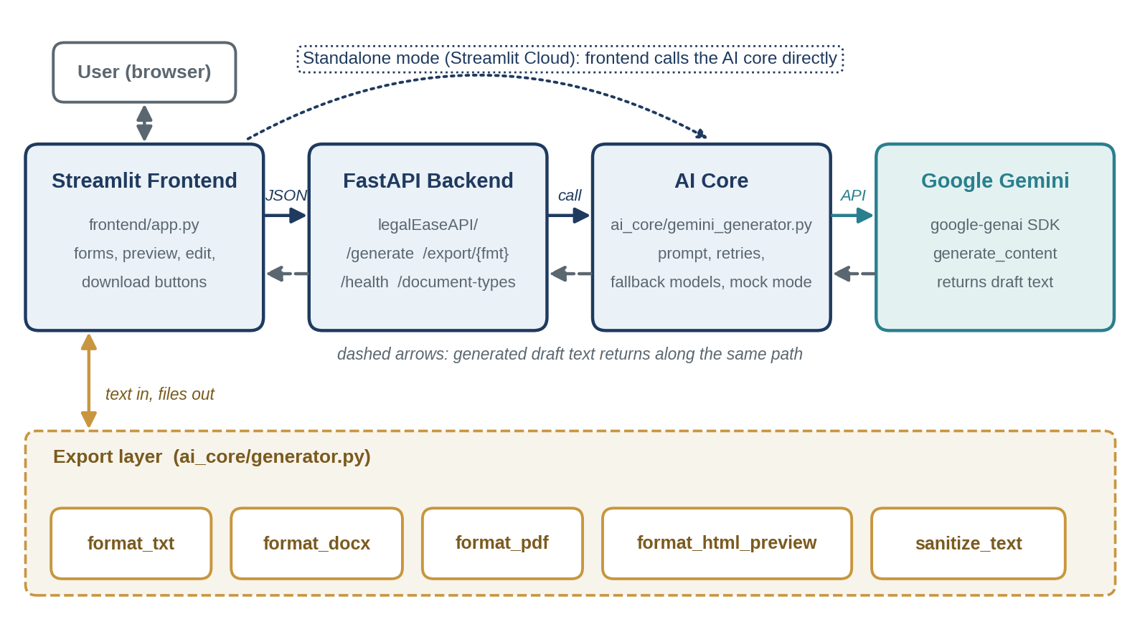
Application interface / input form
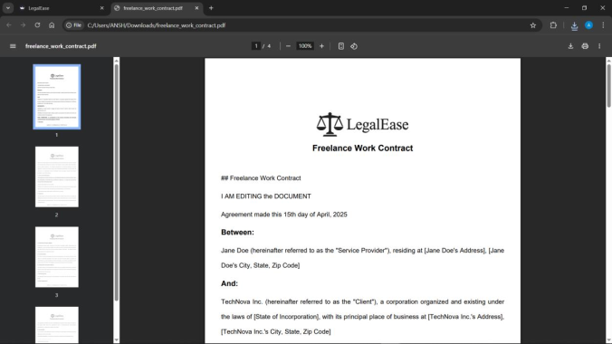
Generated document preview
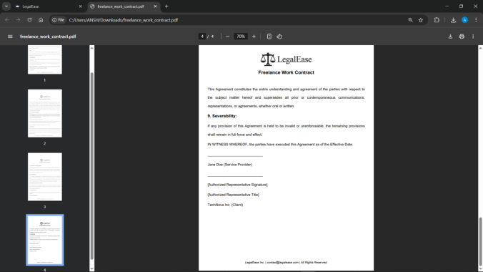
Editing and export controls
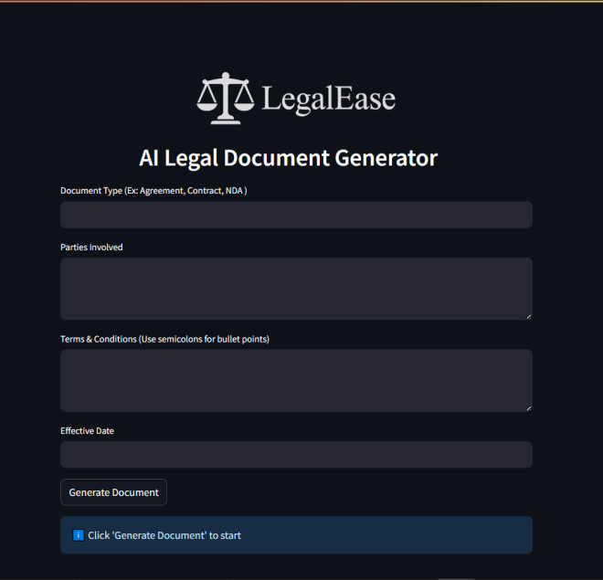
Formatted document output
Live application: https://legalease-vp5dqvuzajm864fq9gqqha.streamlit.app/

