1. **INTRODUCTION** 
   1. **Project Overview**

Citizen AI is an advanced digital platform developed to foster effective communication between citizens and government bodies. In today’s fast-paced digital age, where expectations for immediate and accurate responses are high, Citizen AI acts as a revolutionary system that leverages artificial intelligence and cloud technologies. The system is built using Flask as the backend framework and utilizes IBM Watson and IBM Granite models for powerful natural language processing (NLP) capabilities. It provides real-time, intelligent responses to citizen inquiries and allows government officials to monitor feedback and sentiment through a robust analytics dashboard. This platform not only facilitates better engagement but also supports data-driven policy-making and improves the overall public service experience.

* 1. **Purpose**

The primary objective of Citizen AI is to enhance civic engagement by transforming how governments respond to citizens. It aims to automate repetitive interactions, provide 24/7 assistance, and empower citizens to access vital information easily. The project supports transparency and accountability in governance, ensuring timely and relevant communication that builds trust and satisfaction among the public.

1. **IDEATION PHASE** 
   1. **Problem Statement**

|  |  |
| --- | --- |
| Date | 25 Jan 2025 |
| Team ID | LTVIP2025TMID31809 |
| Project Name | citizen ai – intelligent citizen engagement platform |
| Maximum Marks | 2 Marks |

Many citizens experience difficulty in accessing government services and getting their queries addressed efficiently. The manual processes currently in place lead to delays, miscommunication, and frustration. A significant gap exists between government service providers and the public due to a lack of interactive, intelligent, and scalable communication systems. The need for a platform that can address these challenges and simplify the interaction process is more critical than ever.

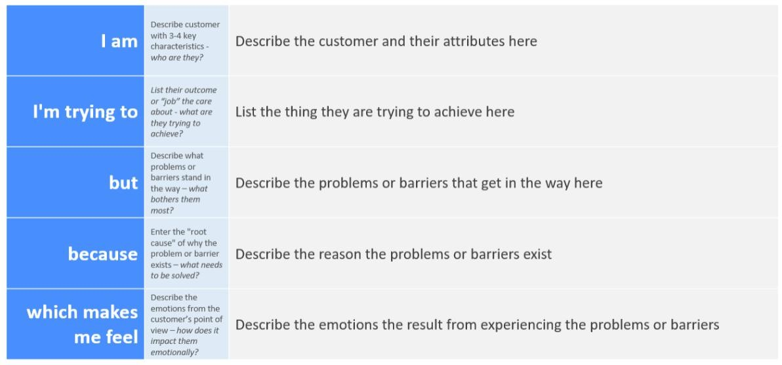

* 1. **Empathy Map Canvas**

|  |  |
| --- | --- |
| Date | 25 Jan 2025 |
| TeamID | LTVIP2025TMID31809 |
| ProjectName | citizen ai – intelligent citizen engagement platform |
| Maximum Marks | 4 Marks |

An empathy map is a simple, easy-to-digest visual that captures knowledge about a user’s behaviours and attitudes.

It is a useful tool to helps teams better understand their users.

Creating an effective solution requires understanding the true problem and the person who is experiencing it. The exercise of creating the map helps participants consider things from the user’s perspective along with his or her goals and challenges.

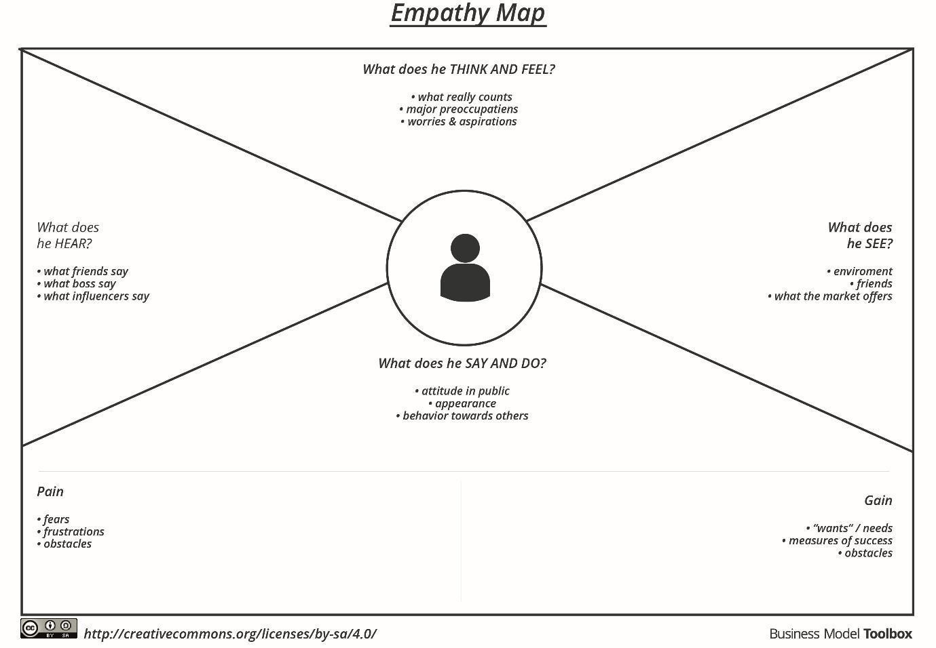

* 1. **Brainstorming**

Brainstorming provides a free and open environment that encourages everyone within a team to participate in the creative thinking process that leads to problem solving. Prioritizing volume over value, out-of-the-box ideas are welcome and built upon, and all participants are encouraged to collaborate, helping each other develop a rich amount of creative solutions.

Use this template in your own brainstorming sessions so your team can unleash their imagination and start shaping concepts even if you're not sitting in the same room.

**Step-1: Team Gathering, Collaboration and Select the Problem Statement**

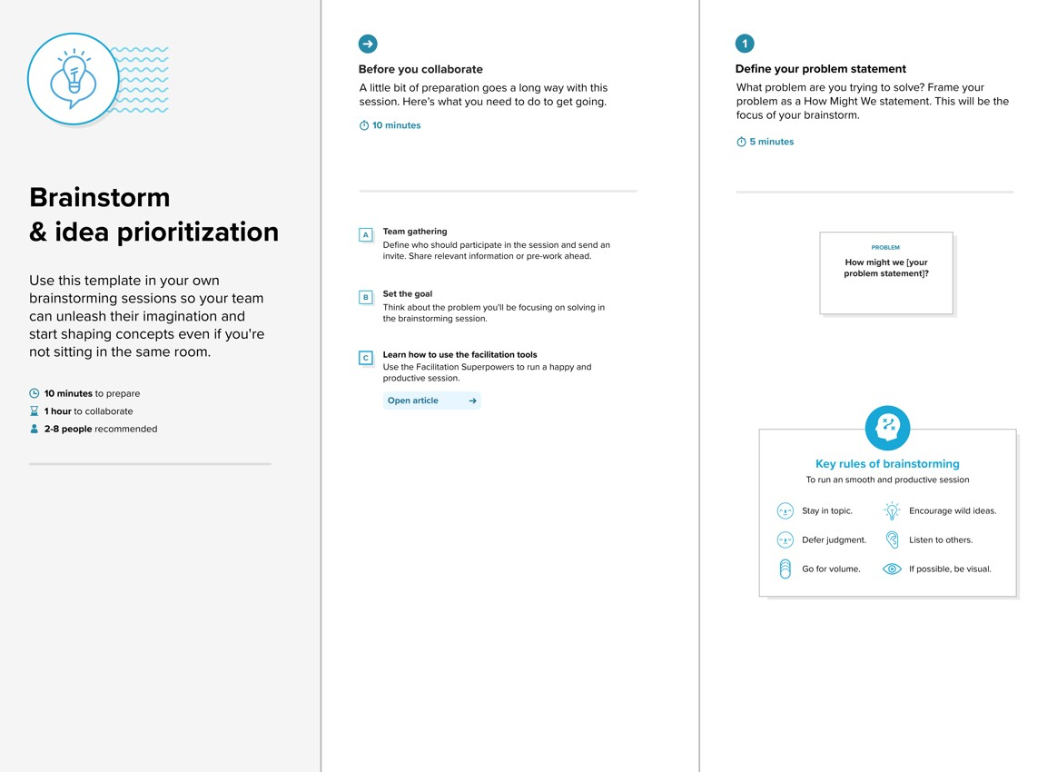

**Step-2: Brainstorm, Idea Listing and Grouping**

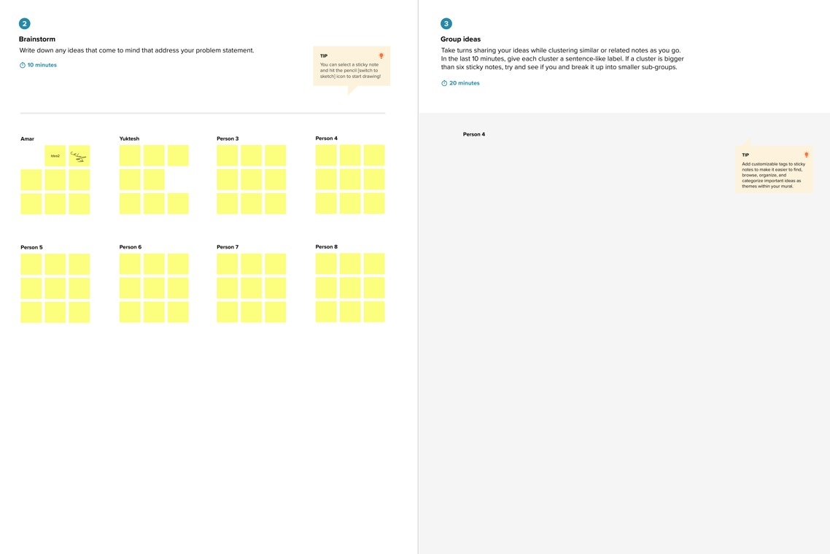

**Step-3: Idea Prioritization**

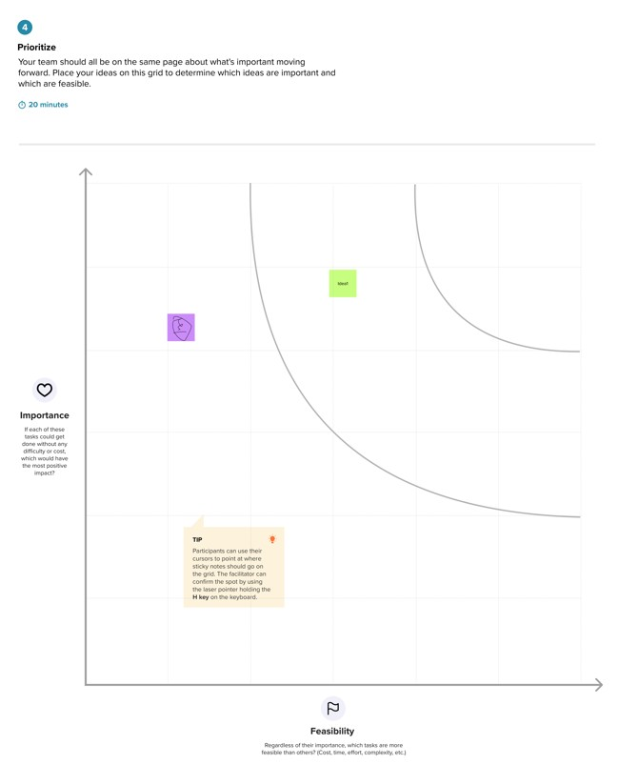

1. **REQUIREMENT ANALYSIS** 
   1. **Customer Journey Map**
2. A citizen accesses the Citizen AI platform via a web browser.
3. The user interacts with the chatbot by typing a query or concern.
4. The chatbot processes the input using IBM Granite NLP models.
5. A contextual and personalized response is returned to the user.
6. Feedback from the user is analyzed for sentiment and logged.
7. Officials monitor the feedback via a dynamic dashboard.

Each step in the journey is designed to be intuitive, time-efficient, and responsive to the unique needs of individual users. The backend system ensures smooth query routing, language comprehension, and storage of useful feedback for continuous improvement.

**3.2 Solution Requirement**

* Responsive Web UI
* Secure backend using Flask
* NLP APIs from IBM Watson and IBM Granite
* Real-time sentiment analysis engine
* Cloud object storage for logging interact
* Dashboard for visualizing trends and metrics
* Feedback collection module
* Admin access controls These requirements were gathered based on user stories, surveys, and expert interviews during the early analysis stage.
  1. **Data Flow Diagram**

**User Input → Flask Application → NLP Processing (Watson/Granite) → Response**

**Generation → Sentiment Analysis → Dashboard Update**

This linear yet modular flow allows the system to be expanded in the future for multilingual queries, voice input processing, and advanced intent classification.

* 1. **Technology Stack**
* Frontend: HTML, CSS, Bootstrap, JavaScript
* Backend: Python with Flask framework
* AI/NLP: IBM Watson and IBM Granite APIs
* Database: Optional (Firebase or JSON-based logging)
* Cloud: IBM Cloud for storage and deployment
* Visualization: Chart.js or D3.js for dashboard

The chosen stack balances simplicity, scalability, and modernity, ensuring quick deployment and ease of maintenance. **4. PROJECT DESIGN**

* 1. **Problem-Solution Fit**

The solution precisely addresses the communication challenges between citizens and government. It offers an AI-powered system that can handle multiple queries simultaneously and ensures consistent, transparent service delivery without manual intervention. It also provides key metrics to government departments to enable proactive service improvement.

|  |  |
| --- | --- |
| Date | 25 Jan 2025 |
| Team ID | LTVIP2025TMID31809 |
| Project Name | citizen ai – intelligent citizen engagement platform |
| Maximum Marks | 2 Marks |

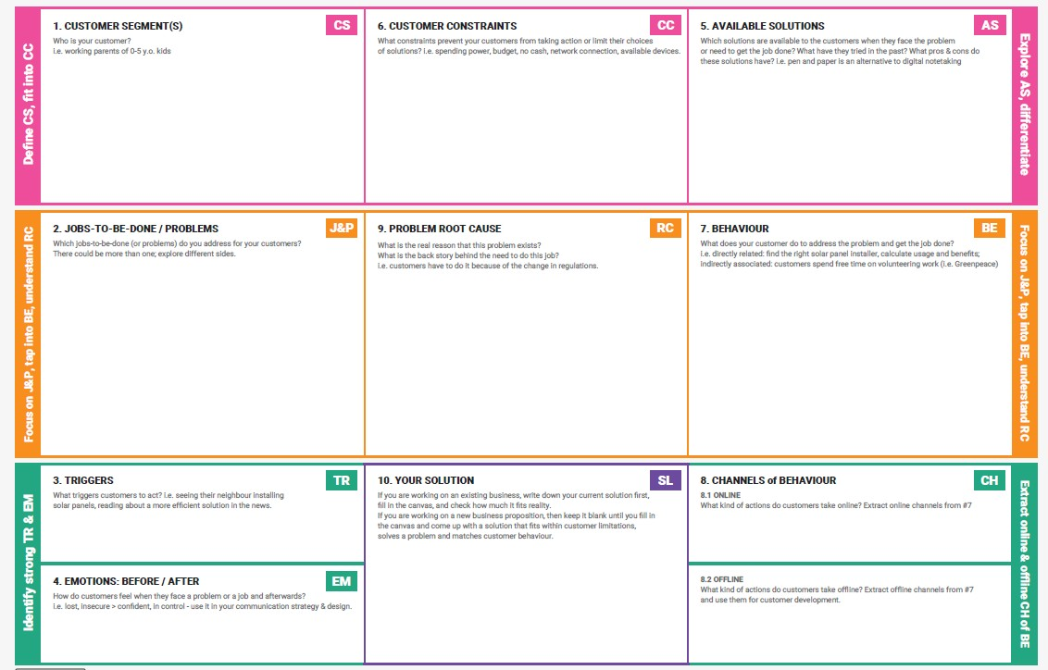

* 1. **Proposed Solution**

Citizen AI offers a web-based AI assistant integrated with IBM’s NLP models. It understands citizen queries, responds in a human-like manner, analyzes public sentiment, and logs issues for further review. It also features a dashboard that visually represents the collected data and sentiment trends, enabling efficient monitoring by government departments.

|  |  |
| --- | --- |
| Date | 25 Jan2025 |
| Team ID | LTVIP2025TMID31809 |
| Project Name | citizen ai – intelligent citizen engagement platform |
| Maximum Marks | 2 Marks |

|  |  |  |
| --- | --- | --- |
| **S.No.** | **Parameter** | **Description** |
| 1. | Problem Statement | Many citizens face delays and confusion while accessing |
|  | (Problem to be solved) | government services due to lack of real-time, scalable support systems. |
| 2. | Idea / Solution Description | A web-based AI platform that uses IBM Watson to answer citizen queries instantly, analyze sentiment, and provide insights to officials through a dynamic dashboard. |
| 3. | Novelty / Uniqueness | Combines real-time AI chatbot, sentiment analysis, and analytics dashboard into a single civic engagement tool.  Offers contextual, personalized responses using IBM Granite models. |
| 4. | Social Impact / | improves citizen satisfaction by offering fast, 24/7 query |
|  | Customer Satisfaction | support. Increases transparency and builds trust in digital governance. |
| 5. | Business Model | Freemium model for basic services; premium subscriptions |
|  | (Revenue Model) | for local governments. Revenue can be generated from Analytics dashboards, support services, or customization features. |

* 1. **Solution Architecture**
* User Layer: Web-based interface for interaction
* Logic Layer: Flask app handling requests and routing
* AI Layer: IBM Watson and Granite processing queries
* Sentiment Engine: Analyzes citizen feedback
* Dashboard Layer: Visualizes user sentiment and query trends

This architecture promotes modularity, simplifies debugging, and facilitates quick updates or third-party integration.

|  |  |
| --- | --- |
| Date | 15 Feb 2025 |
| Team ID | LTVIP2025TMID31809 |
| Project Name | citizen ai – intelligent citizen engagement platform |
| Maximum Marks | 4 Marks |

1. **PROJECT PLANNING & SCHEDULING**

**5.1 Project Planning**

A systematic project plan was designed to break down the development into manageable phases. Each phase was allotted specific tasks and timelines to ensure organized progression.

|  |  |
| --- | --- |
| Date | 15 Feb 2025 |
| Team ID | LTVIP2025TMID31809 |
| Project Name | citizen ai – intelligent citizen engagement platform |
| Maximum Marks | 5 Marks |

**Product Backlog, Sprint Schedule, and Estimation (4 Marks)**

|  |  |  |  |  |  |  |
| --- | --- | --- | --- | --- | --- | --- |
| **Sprint** | **Functional**  **Requirement**  **(Epic)** | **User**  **Story**  **Number** | **User Story /**  **Task** | **Story**  **Points** | **Priority** | **Team**  **Members** |
| Sprint-  1 | Registration | USN-1 | As a user, I can register for the application by entering my email, password, and confirming my password. | 2 | High |  |
| Sprint-  1 |  | USN-2 | As a user, I will receive confirmation email once I have registered | 1 | High |  |
| **Sprint** | **Functional**  **Requirement**  **(Epic)** | **User**  **Story**  **Number** | **User Story /**  **Task** | **Story**  **Points** | **Priority** | **Team**  **Members** |
|  |  |  | for the application |  |  |  |
| Sprint-  2 |  | USN-3 | As a user, I can register for the application through Facebook | 2 | Low |  |
| Sprint-  1 |  | USN-4 | As a user, I can register for the application through Gmail | 2 | Medium |  |
| Sprint-  1 | Login | USN-5 | As a user, I can log into the application by entering email &  password | 1 | High |  |
|  | Dashboard |  |  |  |  |  |

**Project Tracker, Velocity & Burndown Chart: (4 Marks)**

|  |  |  |  |  |  |  |
| --- | --- | --- | --- | --- | --- | --- |
| **Sprint** | **Total**  **Story**  **Points** | **Duration** | **Sprint**  **Start**  **Date** | **Sprint End**  **Date**  **(Planned)** | **Story Points**  **Completed (as on**  **Planned End Date)** | **Sprint**  **Release**  **Date**  **(Actual)** |
| Sprint-  1 | 20 | 6 Days | 24 Oct  2022 | 29 Oct 2022 | 20 | 29 Oct 2022 |
| Sprint-  2 | 20 | 6 Days | 31 Oct  2022 | 05 Nov 2022 |  |  |
| **Sprint** | **Total**  **Story**  **Points** | **Duration** | **Sprint**  **Start**  **Date** | **Sprint End**  **Date**  **(Planned)** | **Story Points**  **Completed (as on**  **Planned End Date)** | **Sprint**  **Release**  **Date**  **(Actual)** |
| Sprint-  3 | 20 | 6 Days | 07 Nov  2022 | 12 Nov 2022 |  |  |
| Sprint-  4 | 20 | 6 Days | 14 Nov  2022 | 19 Nov 2022 |  |  |

1. **FUNCTIONAL AND PERFORMANCE TESTING** 
   1. **Performance Testing**

|  |  |
| --- | --- |
| Date | 21 Feb 2025 |
| Team ID | LTVIP2025TMID31809 |
| Project Name | citizen ai – intelligent citizen engagement platform |
| Maximum Marks |  |

**Test Scenarios & Results**

|  |  |  |  |  |  |
| --- | --- | --- | --- | --- | --- |
| **Test**  **Case**  **ID** | **Scenario (What to test)** | **Test Steps (How to test)** | **Expected Result** | **Actual**  **Result** | **Pass/Fail** |
| **FT-01** | **Text Input Validation**  **(e.g., topic, job title)** | **Enter valid and invalid text in input**  **fields** | **Valid inputs accepted, errors for invalid inputs** |  |  |
| **FT-02** | **Number Input**  **Validation (e.g., word count, size, rooms)** | **Enter numbers within and outside the valid range** | **Accepts valid values, shows error for out-of-range** |  |  |
| **FT-03** | **Content Generation (e.g., blog, resume, design idea)** | **Provide complete inputs and click**  **"Generate"** | **Correct content is generated based on input** |  |  |

|  |  |  |  |  |  |
| --- | --- | --- | --- | --- | --- |
| **FT-04** | **API Connection**  **Check** | **Check if API key is correct and model responds** | **API responds successfully** |  |  |
| **PT-01** | **Response Time Test** | **Use a timer to check content generation time** | **Should be under 3 seconds** |  |  |
| **PT-02** | **API Speed Test** | **Send multiple API calls at the same time** | **API should not slow down** |  |  |
| **PT-03** | **File Upload Load Test**  **(e.g., PDFs)** | **Upload multiple PDFs and check processing** | **Should work smoothly without crashing** |  |  |

1. **RESULTS** 
   1. **Output Screenshots**

Screenshots were captured at various development stages to illustrate functionality:

Home page :

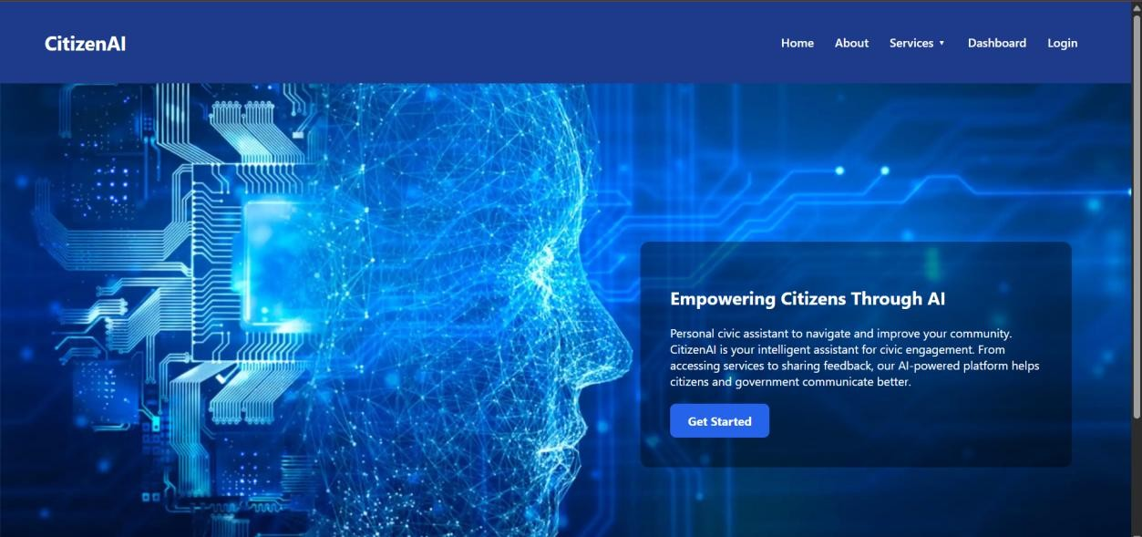

About page :

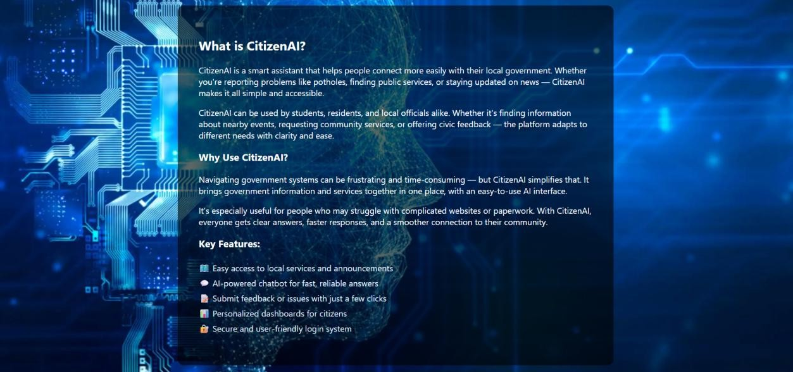

Login page :

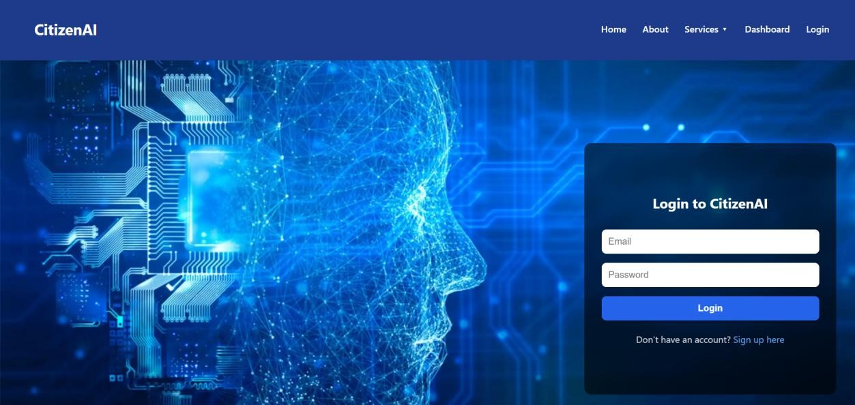

Signup page :

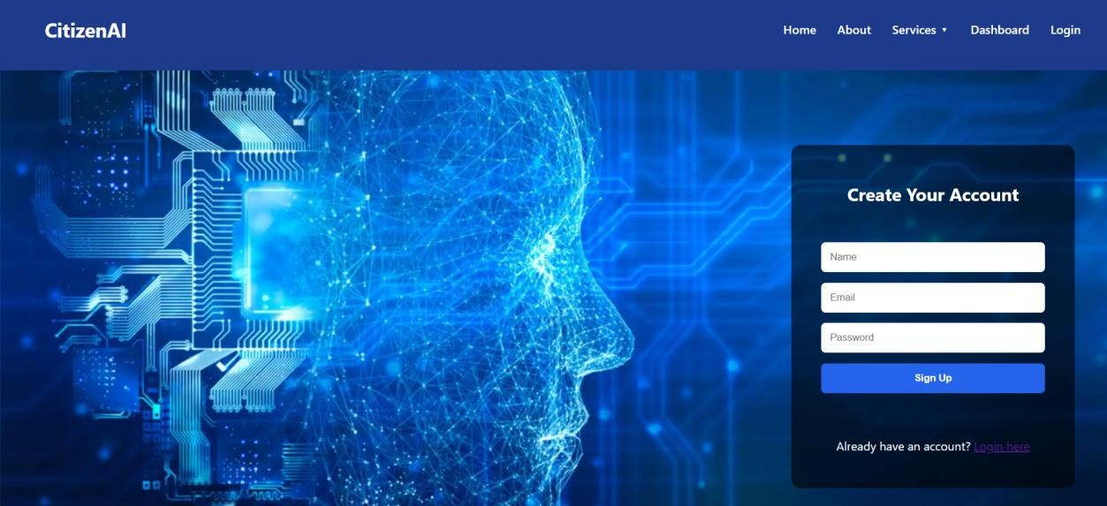

Chat interface with citizen queries and AI responses page :

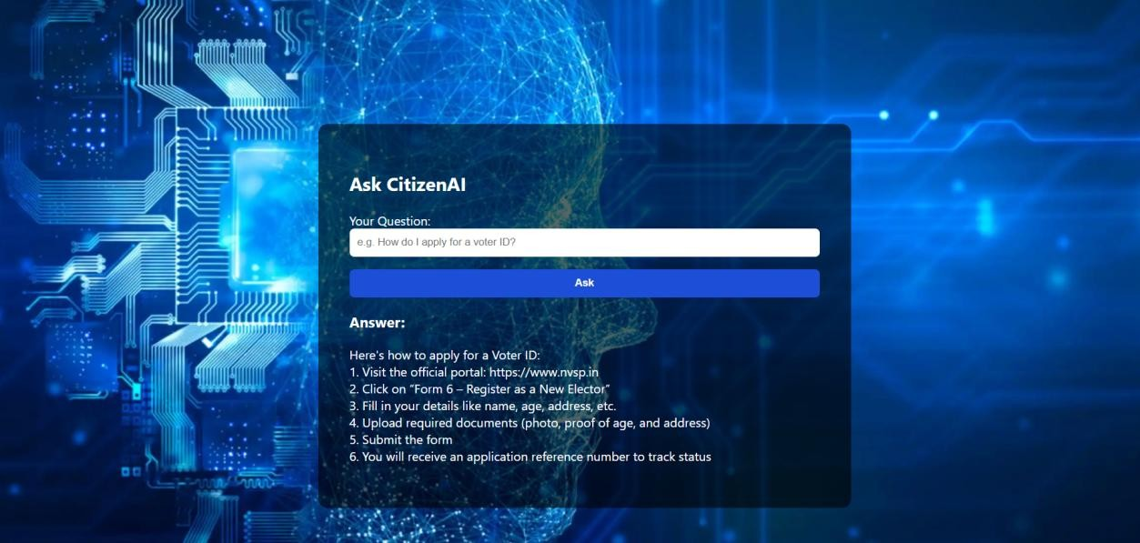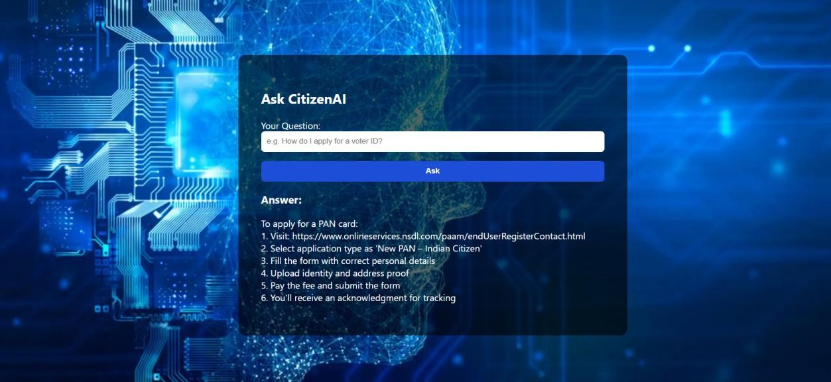

Sentiment analysis results labeled as Positive, Neutral, or Negative :

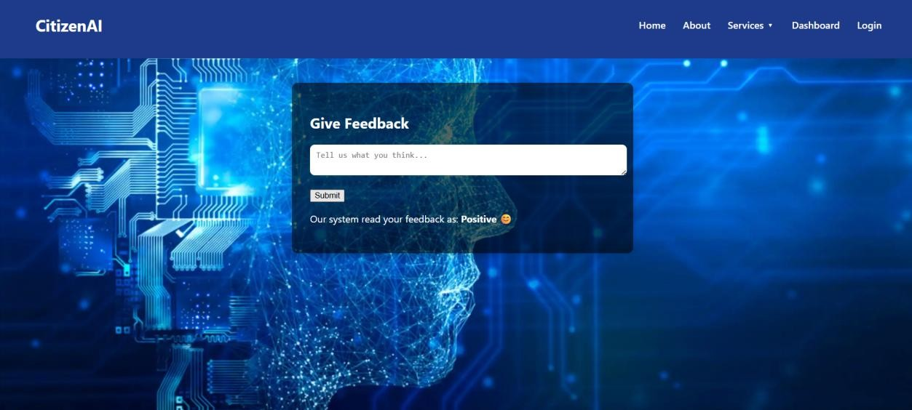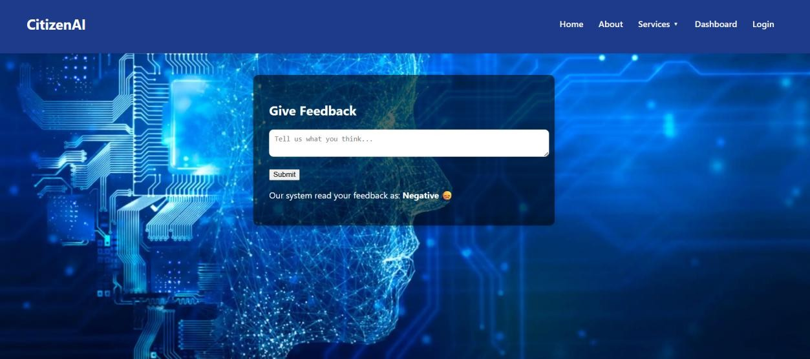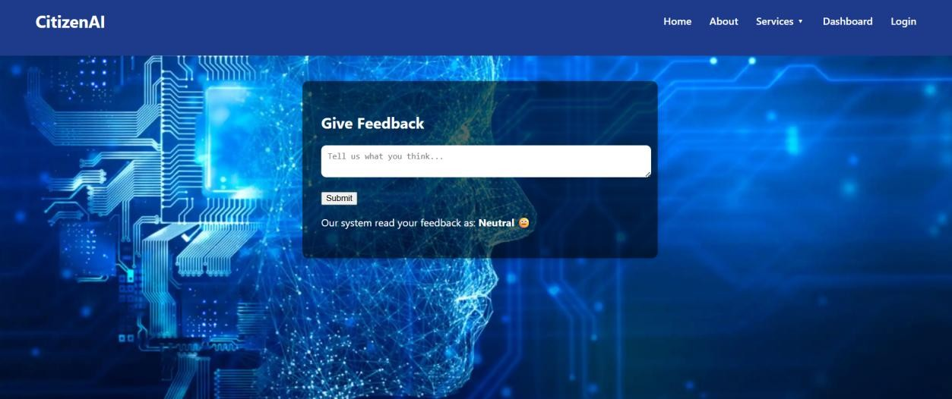

Dashboard charts showing user sentiment over time and interaction volume :

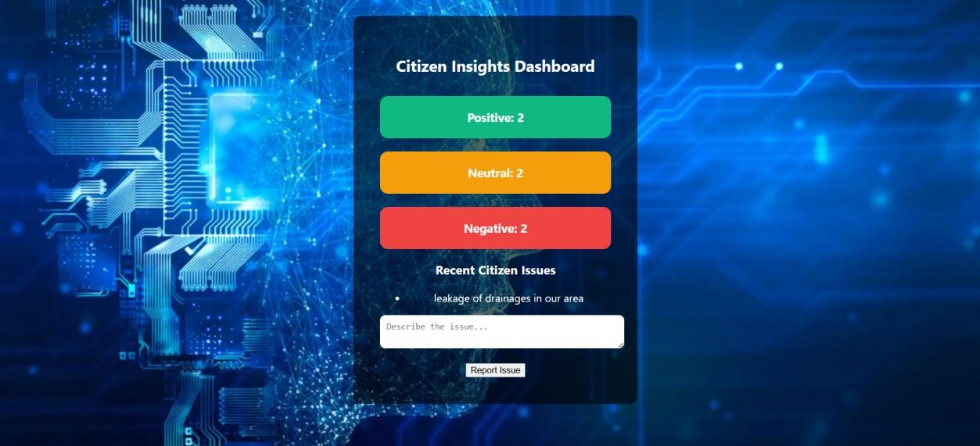

These visuals validate the system's usability, response speed, and efficiency in information delivery.

1. **ADVANTAGES & DISADVANTAGES**

**Advantages:**

* Enhances public satisfaction by offering instant and intelligent responses.
* Reduces manual workload on government staff.
* Helps government agencies gain insight into citizen concerns and priorities.
* Improves accessibility and inclusivity through a web-based platform.
* Scalable and adaptable for future integration of features like voice, mobile support, and multilingual communication. Disadvantages:
* Initial development may require technical expertise and training.
* Heavily dependent on cloud infrastructure and third-party APIs.
* May not be accessible to individuals without internet access.
* Requires regular updates and maintenance to stay effective and relevant

**Disadvantages:**

* Initial development may require technical expertise and training.
* Heavily dependent on cloud infrastructure and third-party APIs.
* May not be accessible to individuals without internet access.
* Requires regular updates and maintenance to stay effective and relevant

1. **CONCLUSION**

Citizen AI represents a transformative step in e-governance and public service delivery. By leveraging AI, cloud computing, and user-centered design, the platform bridges the gap between citizens and government bodies. It enables quick, meaningful communication and helps build public trust. The successful implementation of Citizen AI can inspire further digital innovation in the public sector, offering long-term benefits to society.

1. **FUTURE SCOPE**

The future scope of Citizen AI includes numerous enhancements to broaden its usability and impact:

* Integration of voice-based interactions for visually impaired users or hands-free use.
* Expansion into regional languages to make the platform accessible to diverse linguistic populations.
* Development of a mobile app version for on-the-go access.
* Enhanced analytics features such as predictive modeling to forecast common issues.
* Integration with external databases and e-Governance services for deeper utility.
* Use of advanced machine learning for automatic topic detection and personalized communication.

**11. APPENDIX**

* Source Code: [ hosted on GitHub]
* Dataset Link: N/A – live user input used
* GitHub/Project Demo :