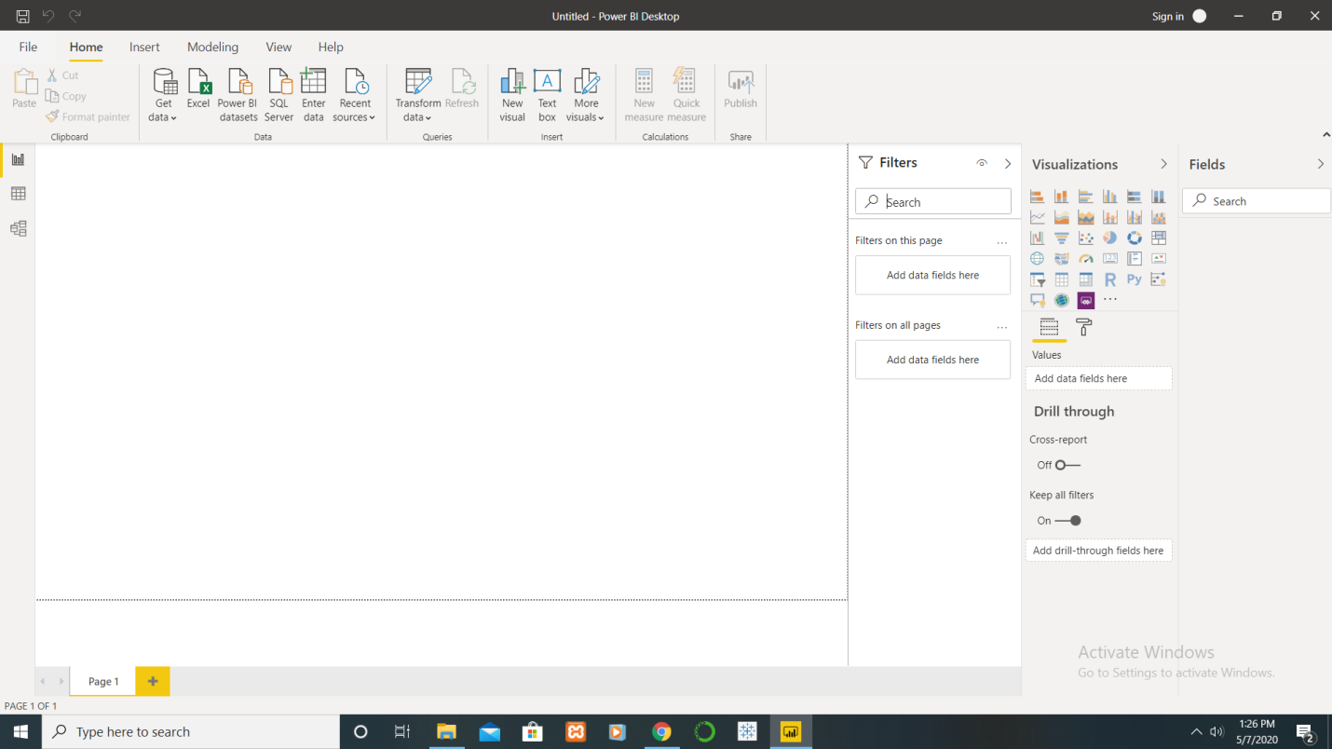

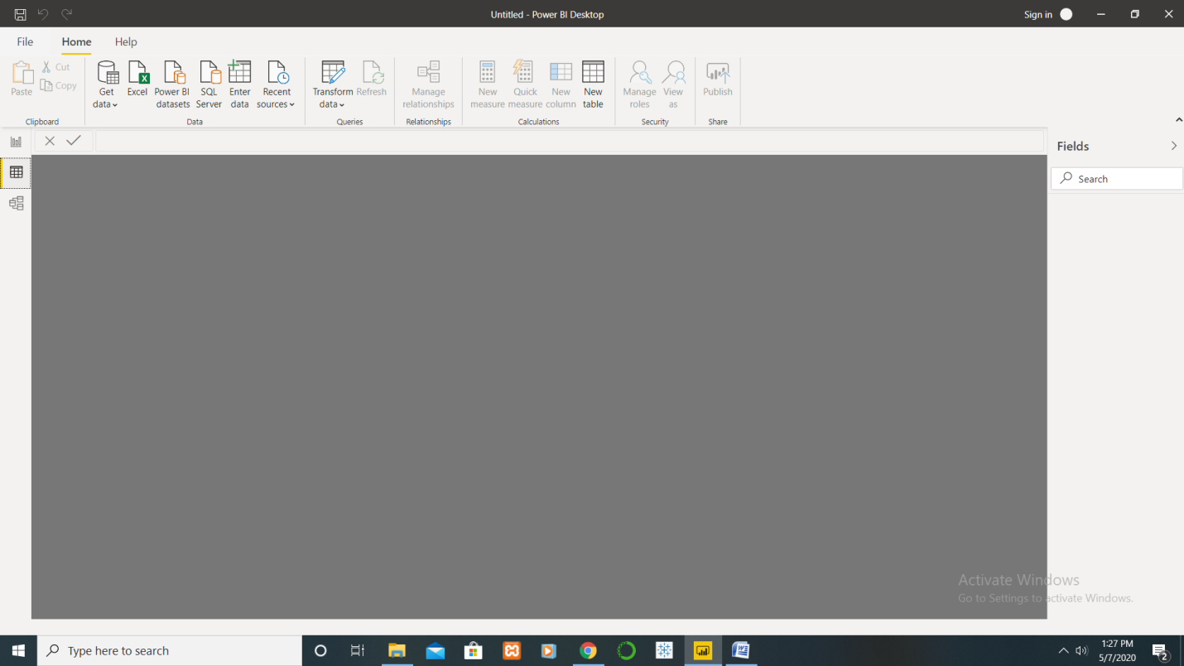

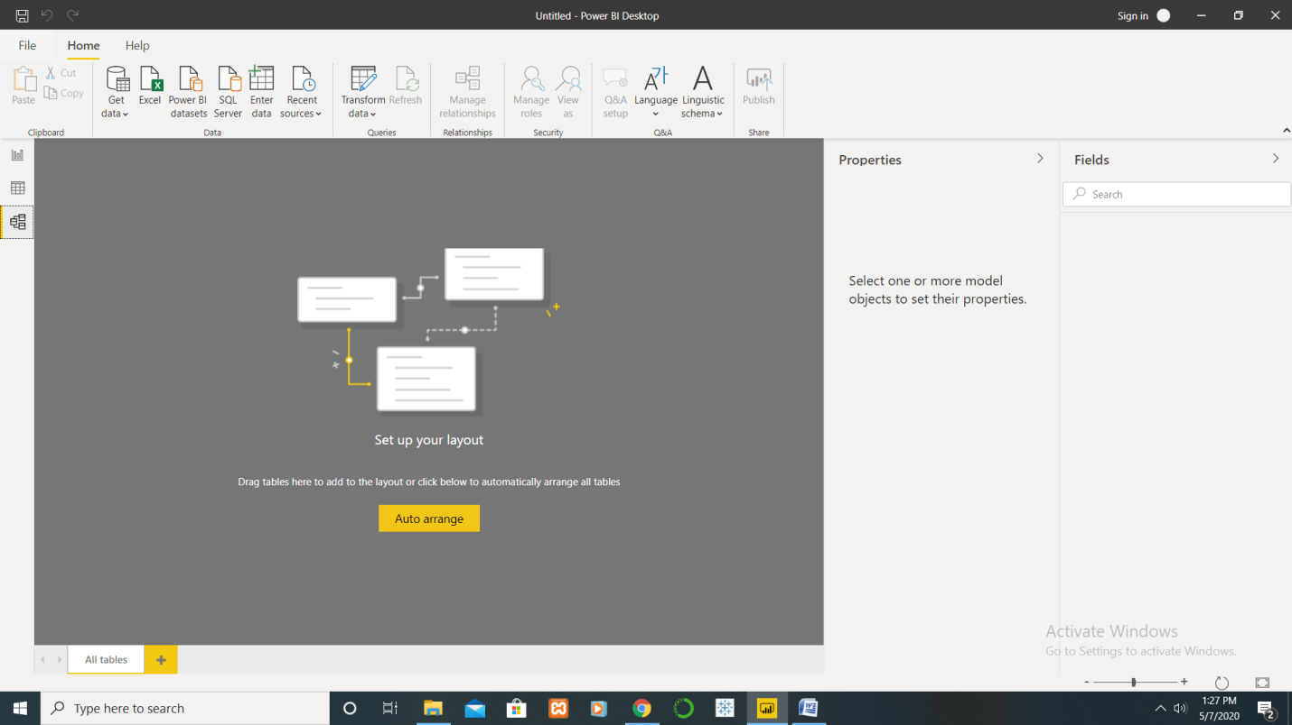

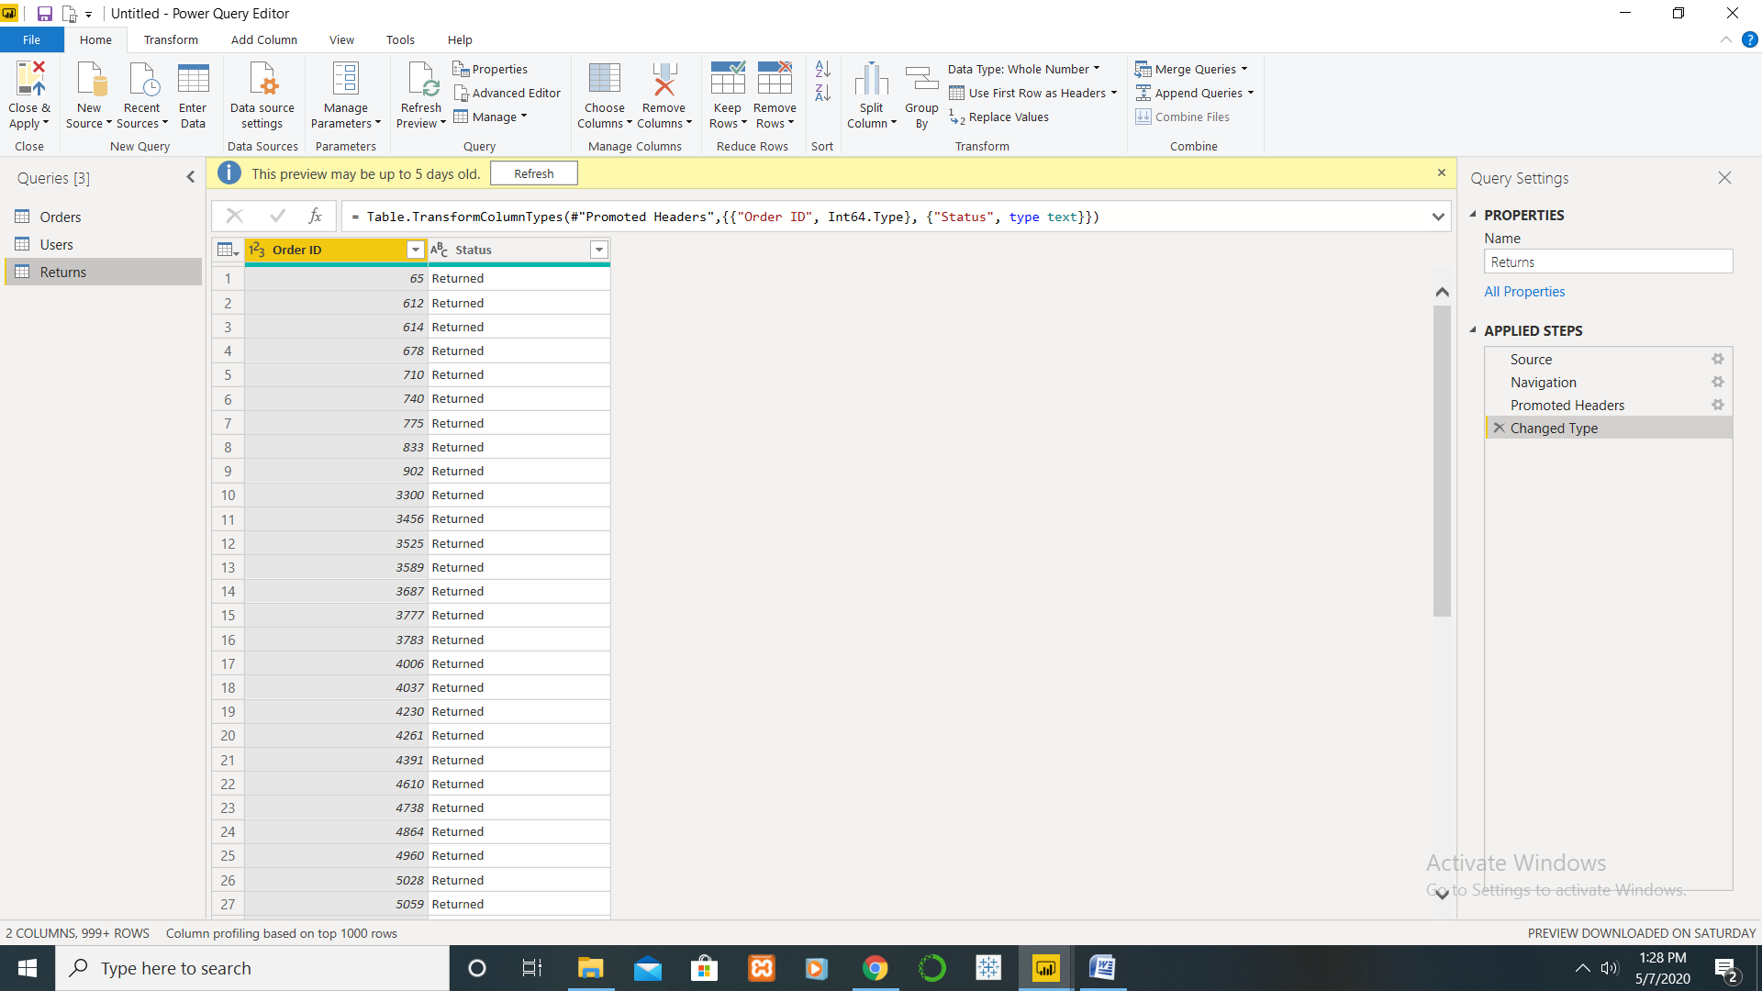

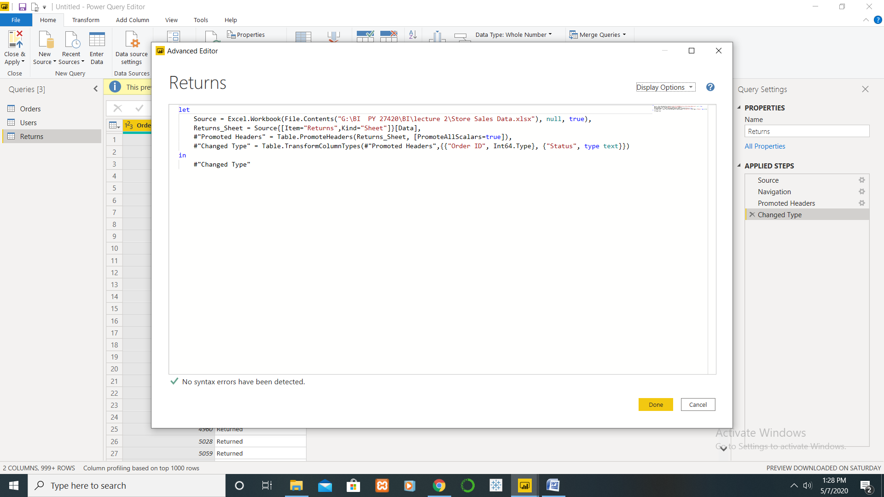

Power BI has three pricing plans:

Power BI Desktop:

This offering is free to any single user and includes data cleaning and preparation, custom visualizations and the ability to publish to the Power BI service.

Power BI Pro:

The Pro plan costs **$9.99**/user/month

Power BI Premium :

To publish content to **Premium** capacity, you must also have a **Power BI** Pro license. Therefore, the minimum **cost** of entry is $4,995 (P1) plus $9.99 (Pro) for a total of $5,004.99 per month.