HUMAN HEALTH PREDICTION

Aim: **Breast cancer prediction**

Introduction:

Basically they are 2 types of tumour:

1)Benign tumor

2)Malignant tumor

-Tumors can be called as Benign those tumors are doesn’t move to the other parts of the body.These are not much harmful .

-Where as Malignant tumors are those which have the capability to move to the other parts of the body.These are very harmful to the human body.

These malignant tumors are capability to move other parts of the body such as bones,brain,kidneys etc.

Here we need to determine whether that particular tumor is benign or malignant.

If it is benign tumor then there is nothing to worry about it.

But the tumor is malignant case then patient should need immediate treatment.Then that particular tumor has to be removed and there will be to treatment chemotheoraphy in radiations and so on.

In this we work on a data set which contains details about benign tumors and malignant tumors.we are going to classify these tumors.

**Work Flow:**

**Dataset🡪Data Processing🡪Train Test Split**

**DataSet:**

First we have to collect the dataset.

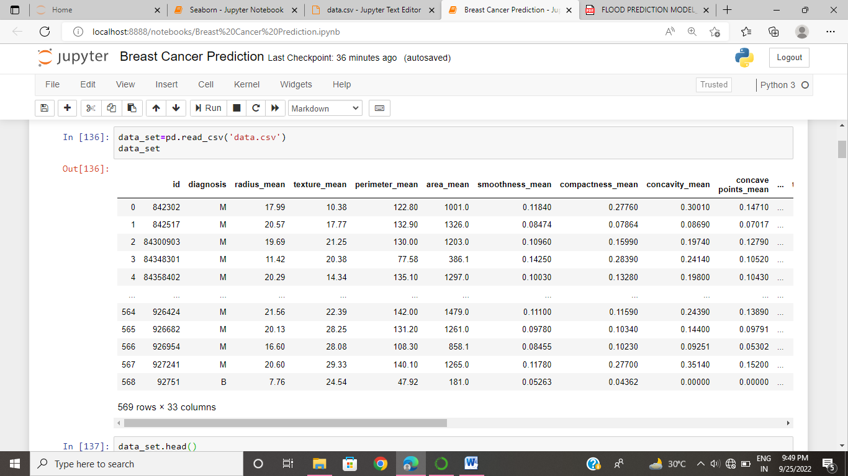

This is the data set. In this we have 33 columns and 569 rows

**LOGISTIC REGRESSION:**

Logistic regression is also used to estimate the relationship between a dependent variable and one or more independent variables, but it is used to make a prediction about a categorical variable versus a continuous one. It is used when our dependent variable is categorical or binary.

for example, A person will survive this accident or not, The student will pass this exam or not.

Before we create a Logistic Regression model we should do data preprocessing.

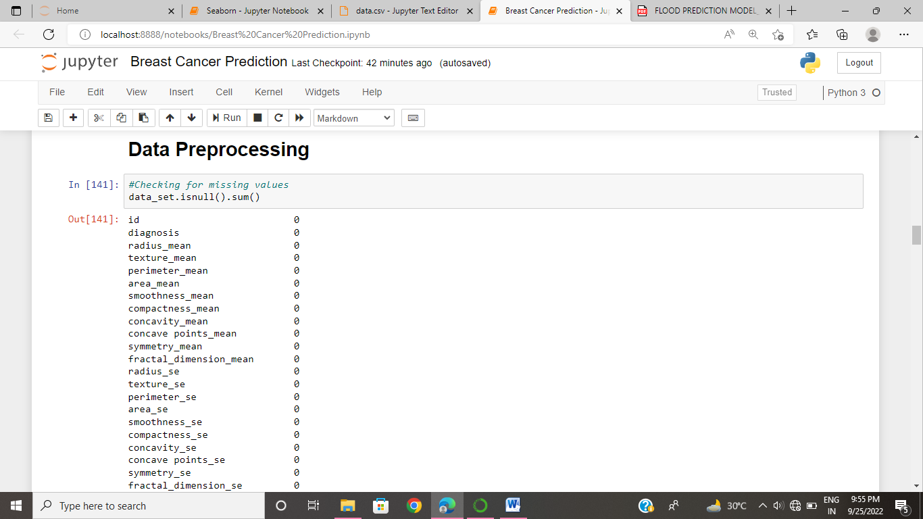

We have null values. So we need to preprocessing the data.

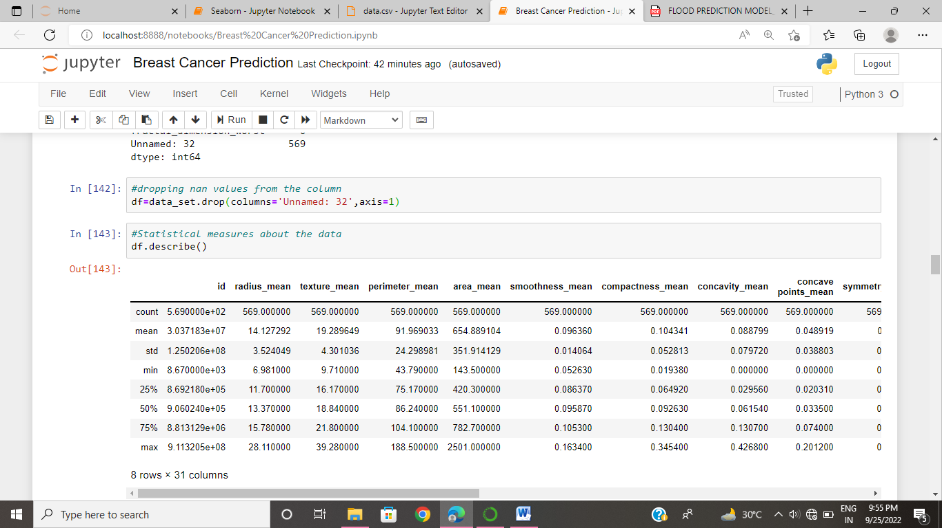

Our dependent variable have YES or NO these are object type so we want to chane the values into binary

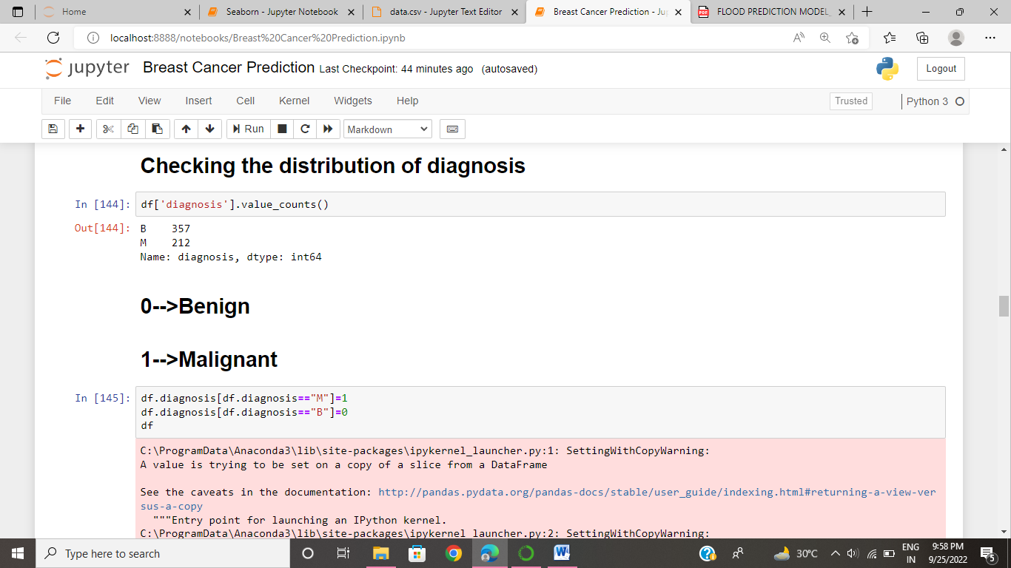

After this, the data looks like

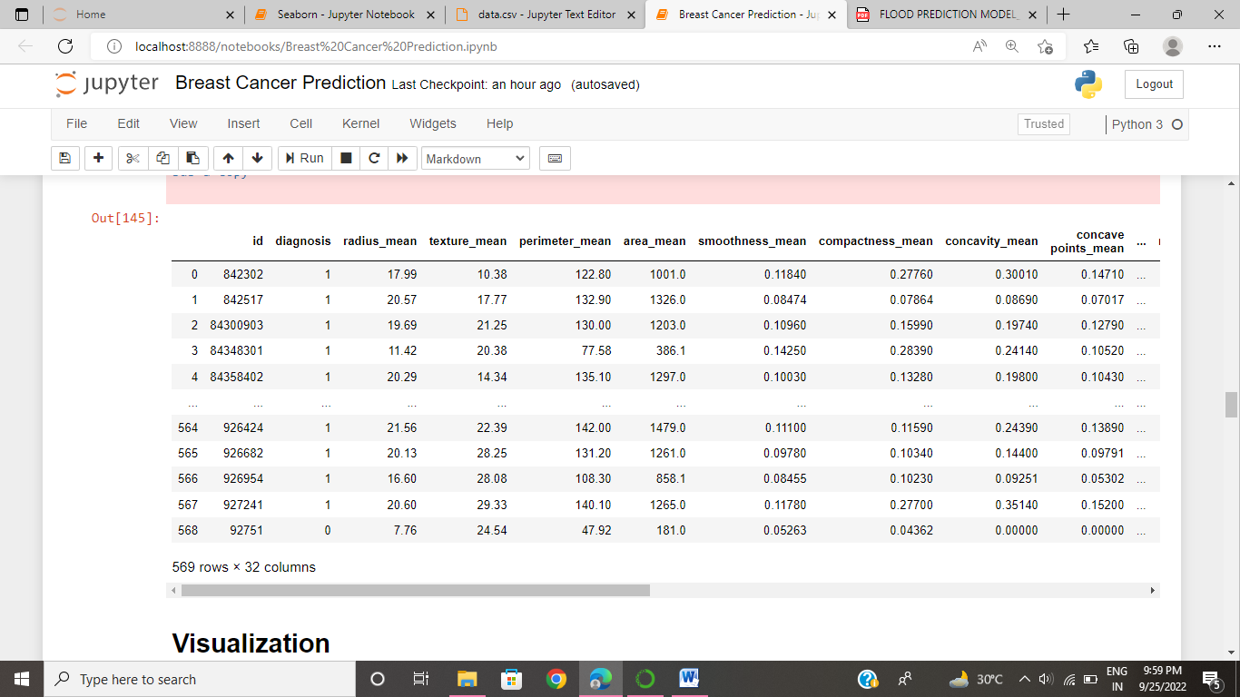

It change the M or B values into binary values.

Now our dataset is ready with not have any null values. So ,Now we create Logistic Regression Model. Before that we do some visualization

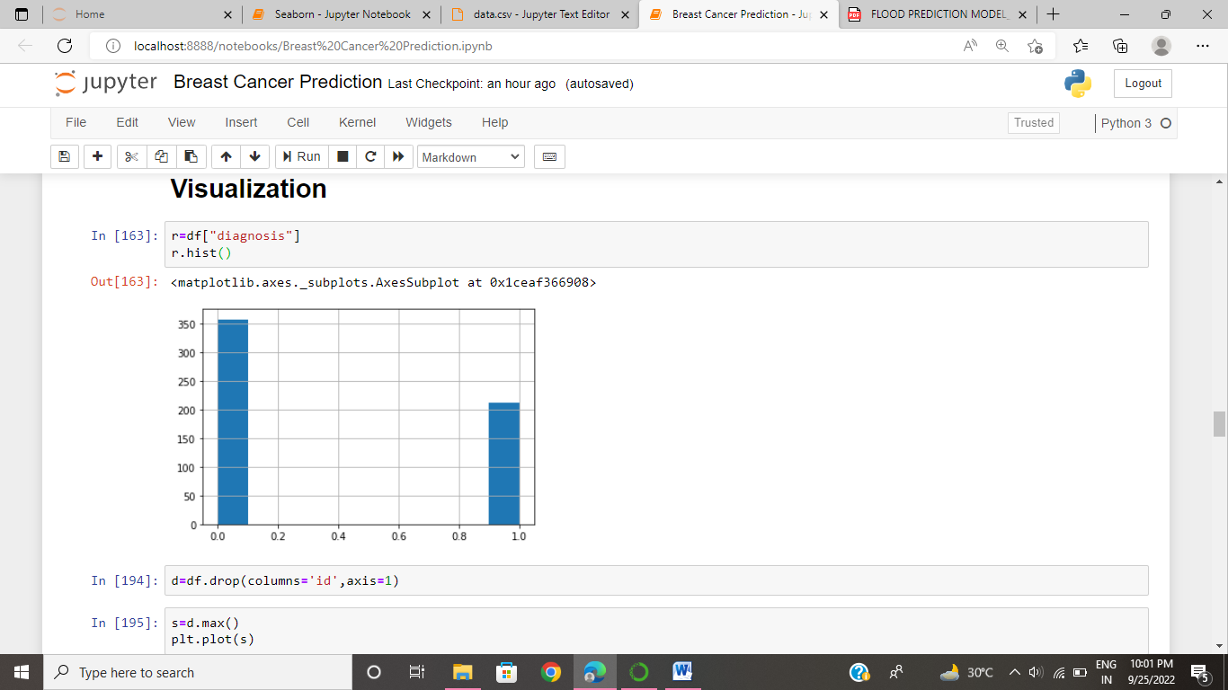

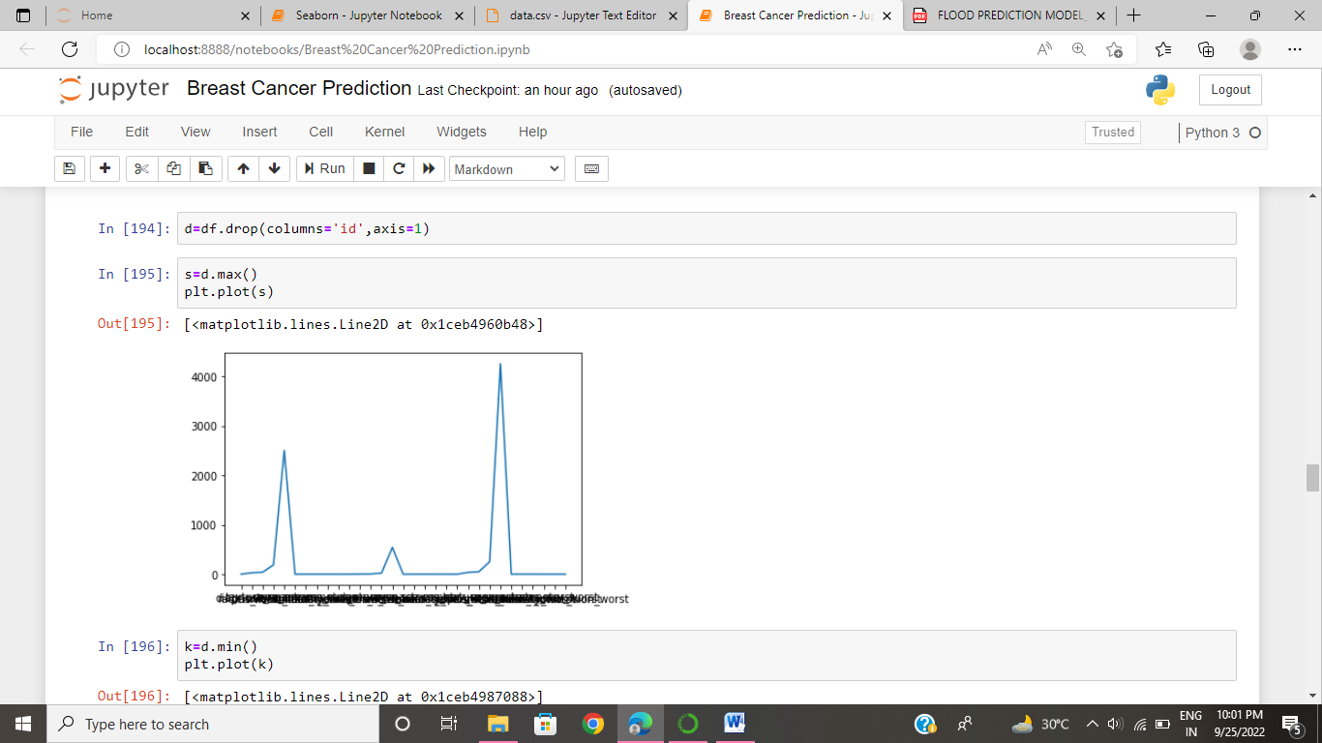

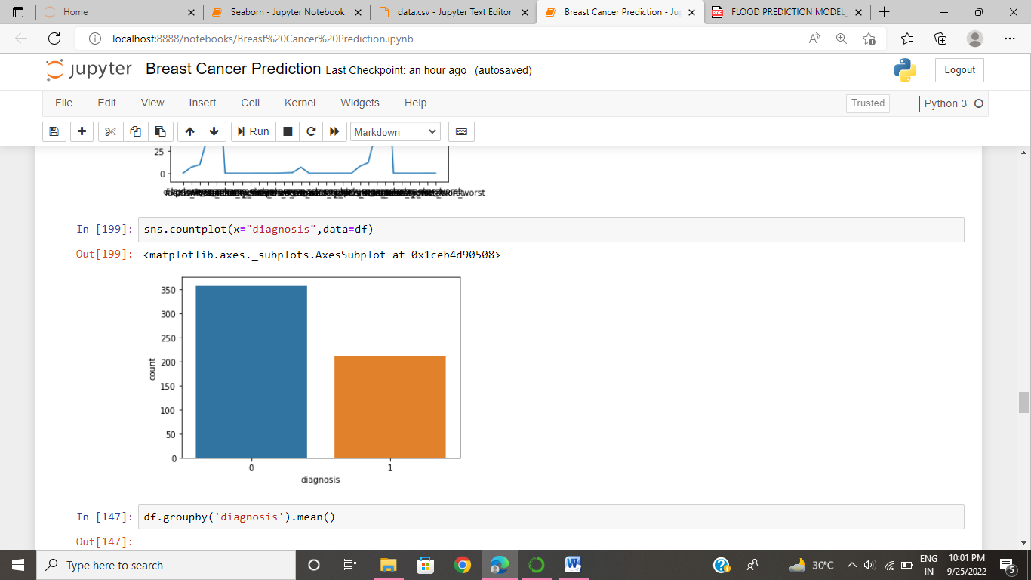

**CREATION OF MODEL:**

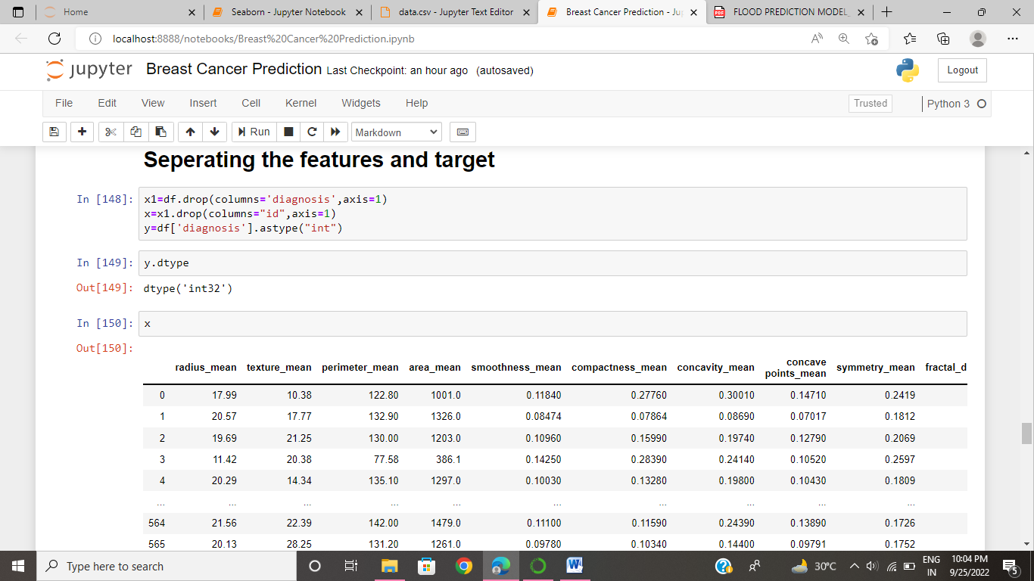

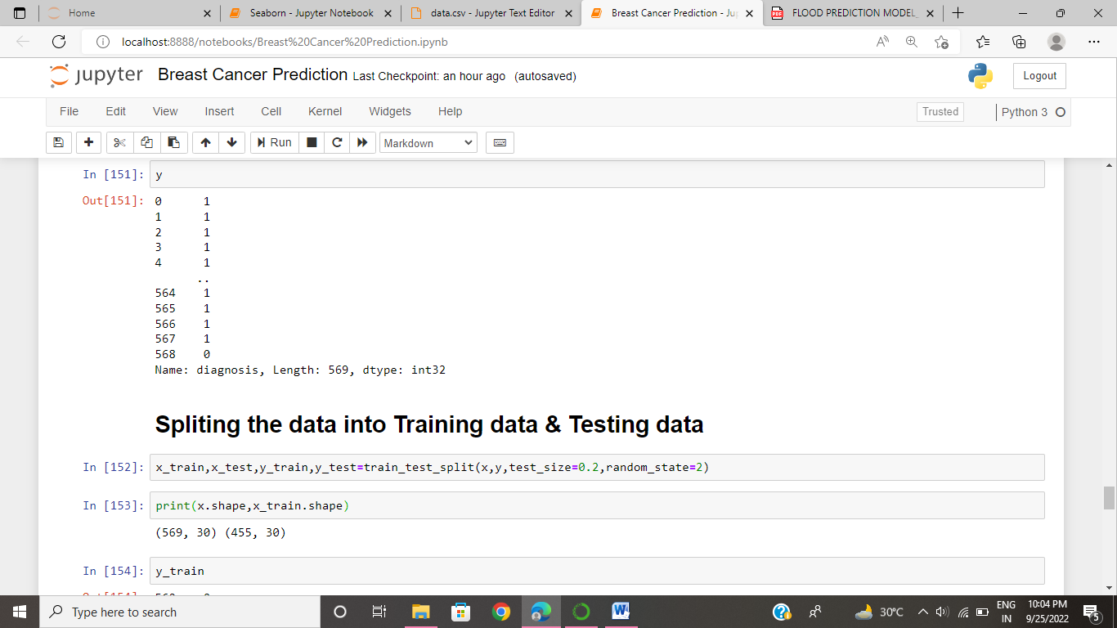

Next we import test and train split using this split the data into training data and testing data

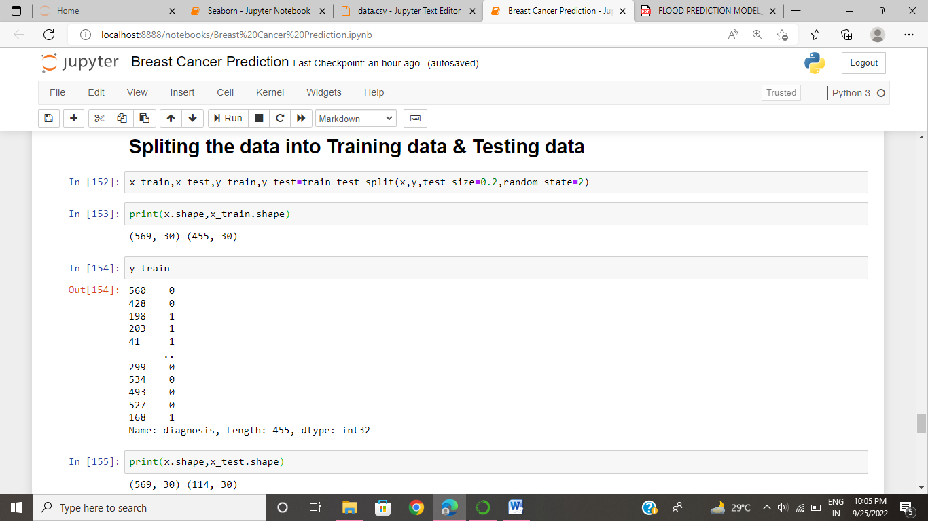

In this I give test_size=o.2 instead of that we give test size also.

So the data is divided into 80% for training data. 20% for testing data.

Model Evaluation:

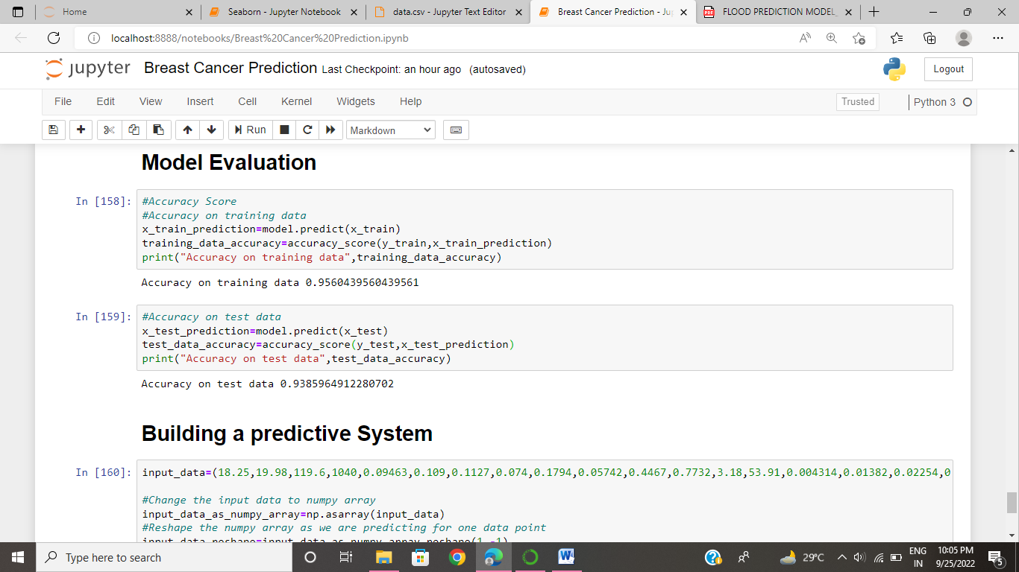

Logistic Regression model accuracy is 0.956 i.e 95% accuracy it have.

Now predict the Y values using New values:

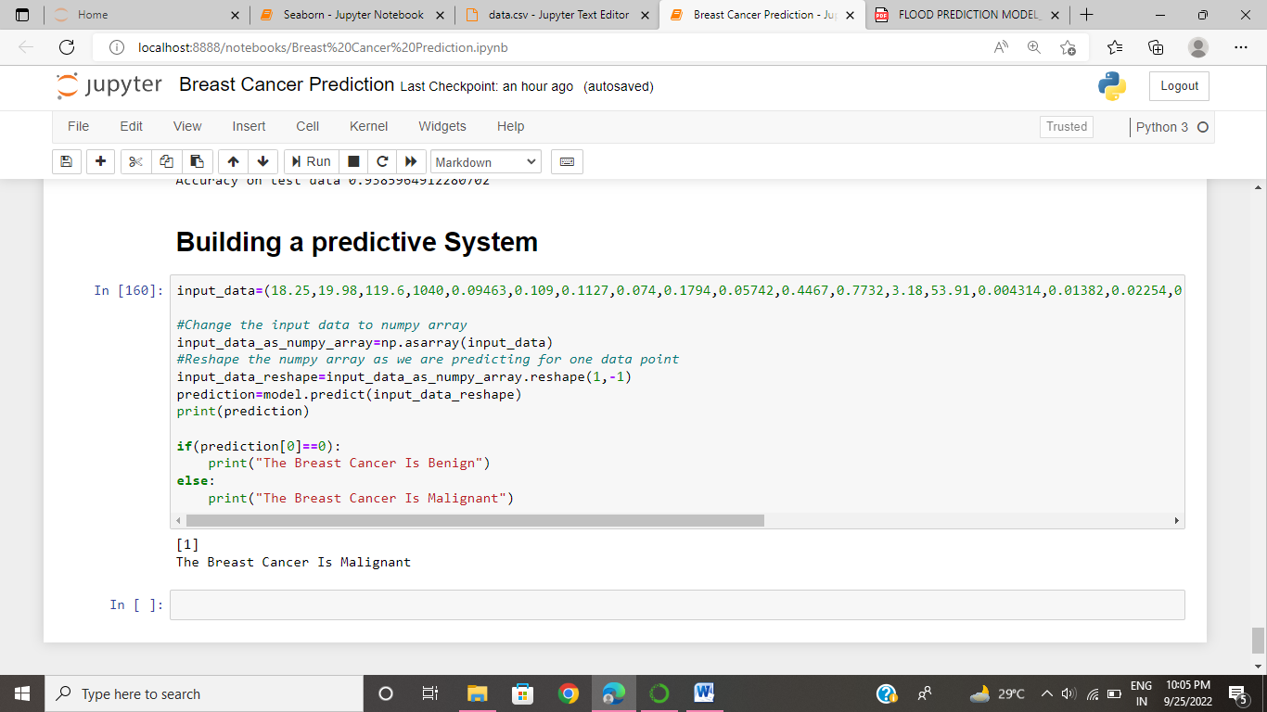

Here based on the input data to predict the given data is releted to which case i.e benign or malignant tumor.

new value –predicted value is 0 means the cancer is Benign, predicted value is 1 that means the cancer is Malignant.

In this way we our model work for Breast prediction.

THANK YOU

-P.Hema kanaka maha lakshmi

S180404

CSE-2E