PENETRATION TESTING REPORT
FOOTPRINTING & NETWORK SCANNING PHASES
W2-PM-FINAL | CYBERSECURITY | NETWORKWALKS
Pentester Name | Hema Latha
Program / Batch | B083 - NetworkWalks
Date | 18 September 2026
Modules Completed | W2-PM1 (Multiple Kali Tools) & W2-PM5 (Zenmap Scanning)
Target Domain | networkwalks.com
Target Subnet | 10.42.27.0/24

1. Project Title
Footprinting and Scanning using Kali Linux and Zenmap

2. Project Description
This project is part of an ethical hacking lab exercise. The main objective is to perform reconnaissance and scanning tasks to collect evidence about a target domain and subnet. Reconnaissance (information gathering) is the first step in penetration testing, while scanning helps identify live hosts and network topology.
The project is divided into two modules:
- Elective Module (Kali Linux Tools) → WHOIS, WhatWeb, Nslookup, Curl, WAFW00F, DNSRecon.
- Essential Module (Zenmap Scanning) → Ping Scan on subnet 10.42.27.0/24, host discovery, IP/MAC collection, and topology visualization.

3. Objectives
- Gather domain registration details.
- Detect web technologies and DNS records.
- Identify firewall presence.
- Discover live hosts in subnet.
- Collect IP and MAC addresses of hosts.
- Generate and save network topology PDF.
- Document all findings in a structured final report.

4. Methodology

4.1 Elective Module (Kali Linux) — W2-PM1
Ran WHOIS, WhatWeb, Nslookup, Curl, WAFW00F, and DNSRecon against the target domain networkwalks.com. Each output was saved into a .txt file for evidence.

4.2 Essential Module (Zenmap) — W2-PM5
- Task 1: Ran Ping Scan on subnet 10.42.27.0/24 using Zenmap.
- Task 2: Identified live hosts (IP + MAC addresses).
- Task 3: Generated topology view of the subnet.
- Task 4: Counted total live hosts in the subnet.
- Task 5: Listed all IP addresses of live hosts.
- Task 6: Listed all MAC addresses of live hosts.
- Task 7: Saved topology output as a PDF file with legend enabled.

4.3 Evidence Collection
Outputs were organized into folders for clarity:
- Module1_Elective → Kali Linux .txt outputs (WHOIS, WhatWeb, Nslookup, Curl, WAFW00F, DNSRecon)
- Module1_Essential → Zenmap .txt output + topology PDF
A final consolidated report (W2-PM-FINAL) was then prepared covering both modules.

5. Elective Module Evidence (W2-PM1 — Kali Linux Tools)

Task 1: WHOIS — Domain Registration Details
Command used:
$ whois networkwalks.com
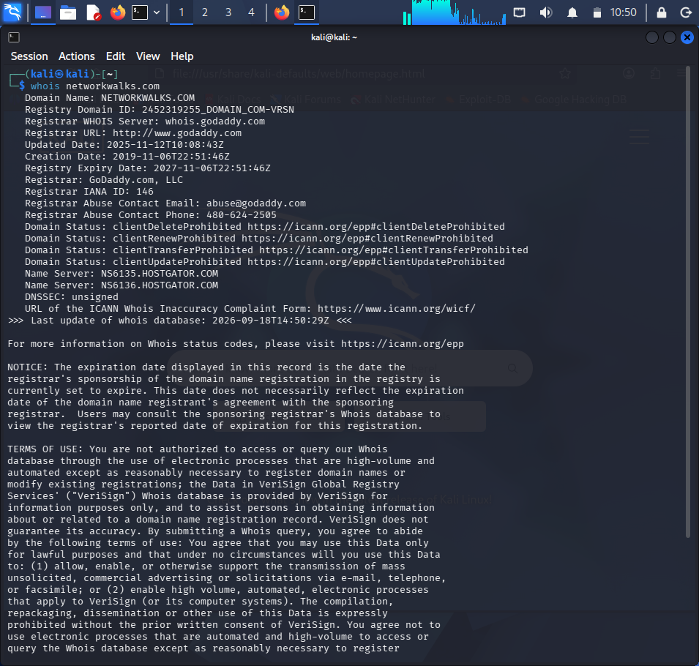
Finding: WHOIS revealed the domain registrar, registration/expiry dates, and name servers, which point to the hosting provider.

Task 2: WhatWeb — Web Technology Fingerprinting
Command used:
$ whatweb networkwalks.com

Finding: WhatWeb exposed the exact CMS, plugin versions, server IP, and an associated email address.

Task 3: Nslookup — DNS Resolution
Command used:
$ nslookup networkwalks.com
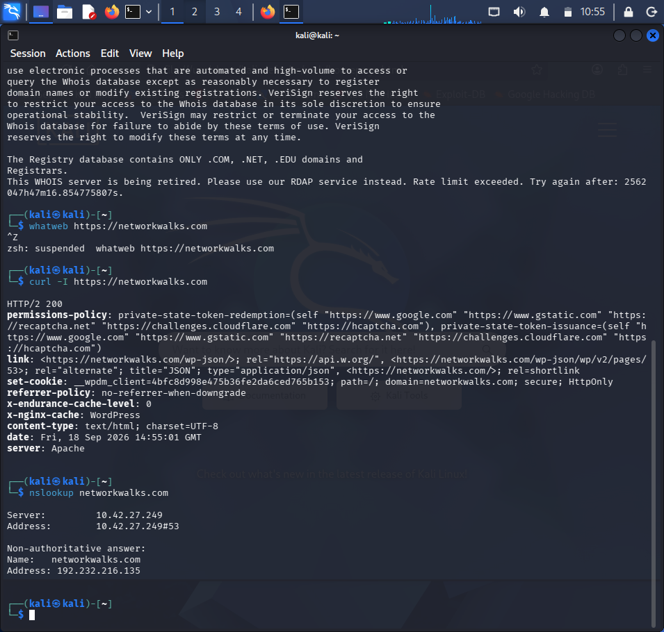
Finding: Nslookup resolved the domain to its real IP address, enabling direct server-level scanning.

Task 4: Curl — HTTP Response Headers
Command used:
$ curl -I https://networkwalks.com
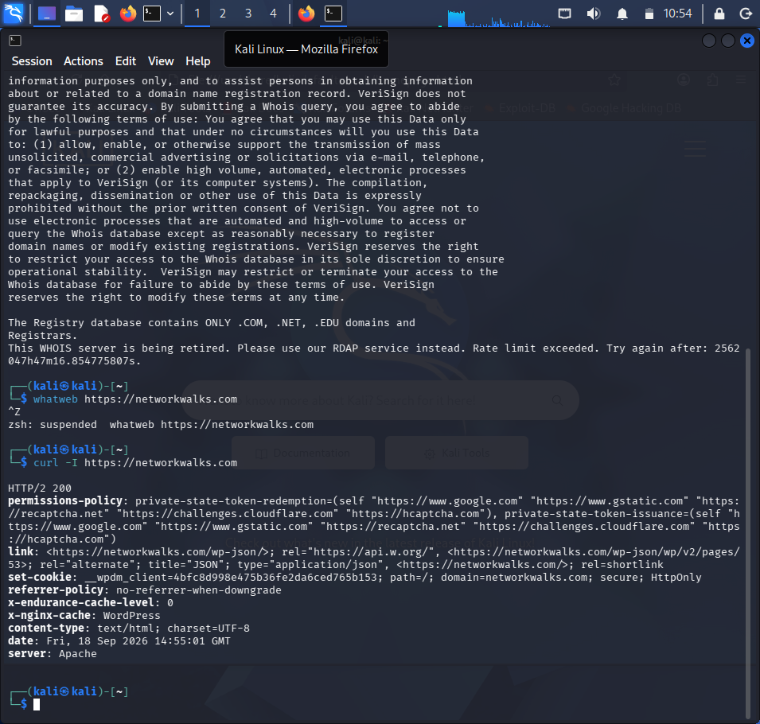
Finding: HTTP headers revealed the web server, caching layer, and hidden API endpoints.

Task 5: WAFW00F — Web Application Firewall Detection
Command used:
$ wafw00f networkwalks.com
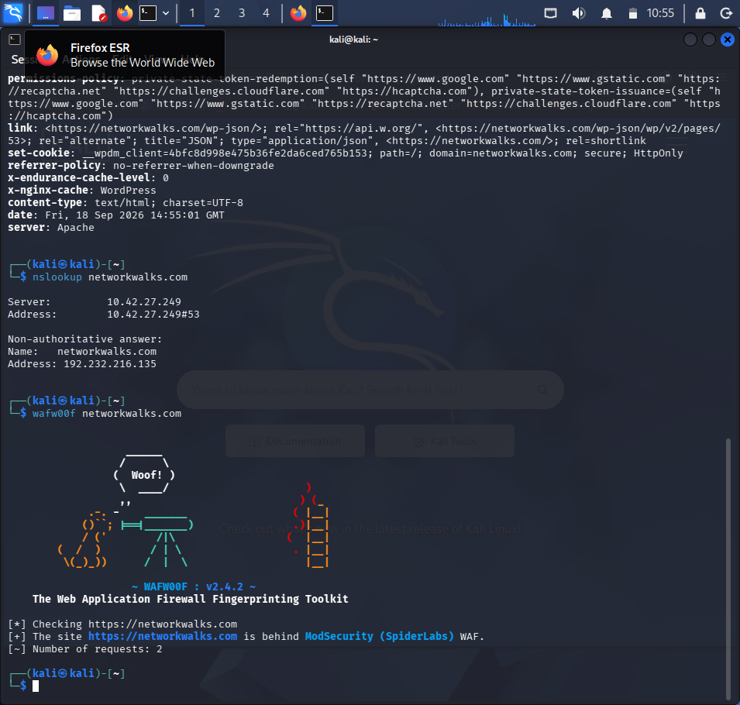
Finding: The target site was found to be protected by a Web Application Firewall (WAF).

Task 6: DNSRecon — DNS Record Enumeration
Command used:
$ dnsrecon -d networkwalks.com
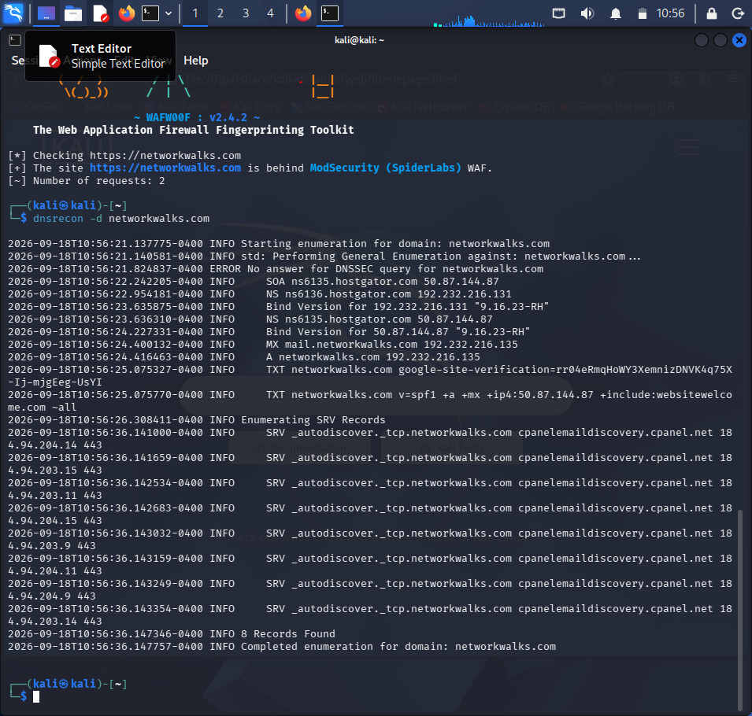
Finding: DNSRecon enumerated all DNS records including name servers, mail servers, SPF/TXT records, and service (SRV) records.

6. Essential Module Evidence (W2-PM5 — Zenmap Scanning)
Task 1 | Download & install Zenmap from the official website.
[Paste screenshot of Zenmap installed / opened]
Task 2 | Find local IP address & LAN subnet using ipconfig.
[Paste screenshot of ipconfig output]
Task 3 | Find the list of live hosts/PCs in the IP subnet (Ping Scan).
Command used:
nmap -sn 10.42.27.0/24
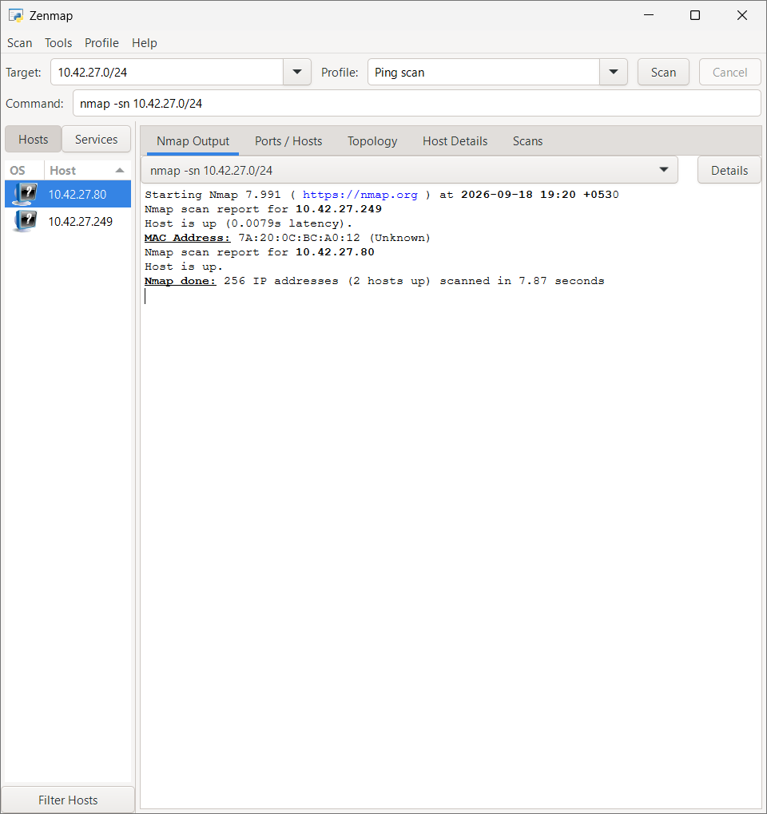
Task 4 | How many hosts are live in the subnet?
[Answer: [X] hosts are live (including my PC)]
Task 5 | What are the IP addresses of the live hosts?
[List the IP addresses found in your scan, e.g. 10.42.27.1, 10.42.27.4, ...]
Task 6 | What are the MAC addresses of the live hosts?
[List the MAC addresses found in your scan]
Task 7 | Display & save the output topology in PDF format.
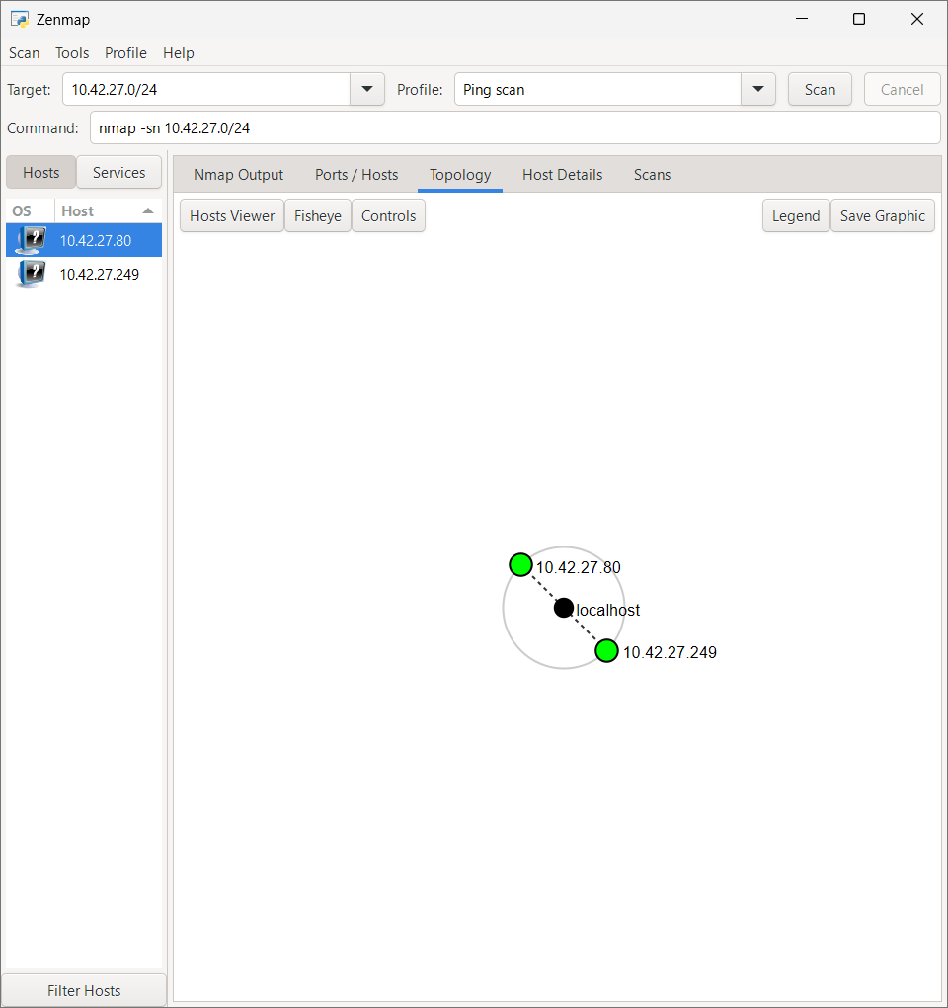
Finding: The Zenmap Ping Scan discovered all active hosts within the target subnet 10.42.27.0/24, and the topology view visualized their relationship to the local machine.

7. Results
- WHOIS revealed domain registration details.
- WhatWeb detected web technologies in use.
- Nslookup and DNSRecon enumerated DNS records.
- WAFW00F identified firewall presence protecting the target.
- Curl displayed HTTP response headers.
- Zenmap scanning discovered live hosts in subnet 10.42.27.0/24.
- IP and MAC addresses of all live hosts were collected.
- A topology PDF was generated to visualize the network structure.

8. Conclusion
The project successfully demonstrated reconnaissance and scanning techniques using Kali Linux and Zenmap. Evidence was collected, organized, and documented in this final report. This exercise provided practical, hands-on experience in ethical hacking fundamentals and network analysis, forming a strong foundation for later stages of the penetration testing lifecycle.

9. Disclaimer
This report was prepared strictly for educational and research purposes as part of the NetworkWalks Cybersecurity Internship Program. All reconnaissance and scanning activities were performed against a permitted lab target / self-owned environment. No unauthorized access or testing was performed against any external system without proper authorization.

