xplanations.

1. What is Swagger?
2. What are the features provided by Swagger?
3. What is API Testing?
4. What are the Benefits of API testing?
5. What are the types of API testing?
6. What are the protocols used in API Testing?
7. What is Swagger Editor?
8. How can we Add API in Swagger?
9. What is OpenAPI?
10. How can we send custom headers with requests in Swagger UI?
11. How should we generate static docs with swagger?
12. How do we import custom dashboards to grafana using helm?

What is Swagger?

Swagger is used in sharing documentation in the products, managers, testers and developers and also is used by vatious tools in automating API Related processes.It is also used in developing APIs through OpenAPI Specification(OAS), also consists of open source and professional tools.  
Swagger also helps in describing the structure of our APIs for reading by the machines.It does it by asking our API return YAML or JSON which contains deatiled discription of our API.  
  
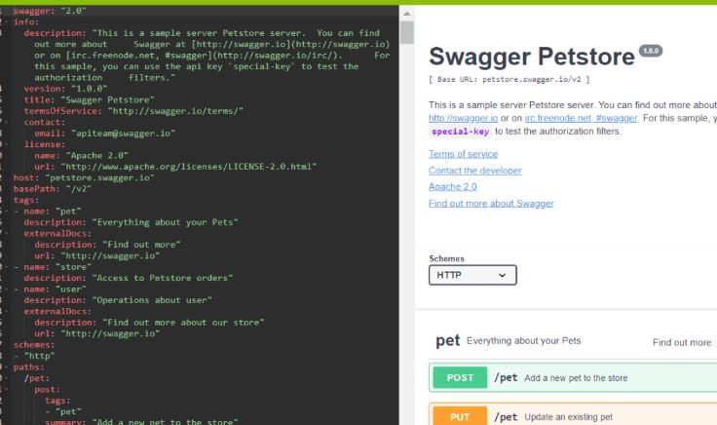

What are the features provided by Swagger?

* **Swagger Editor** used in writing OpenAPI Specs.
* **Swagger UI** helps in rendering OpenAPI Specs as an Interactive API Documentation.
* **Swagger Codegen** used in generating sever stubs and libraries from OpenAPI Spec.

What is API Testing?

API Testing helps in analyzing Application Program Interface in verifying its functionality, security, performance and reliability.It is performed by requesting it to one or more API Endpoints and also in comparing the response with the results.API Testing performs with critical layes such as Business, and in business logic processing it is carried out and all Transactions through the User Interface and Database Layers.  
  
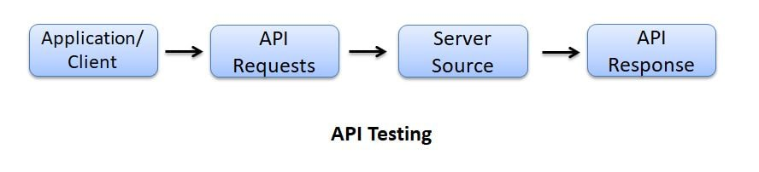

What are the Benefits of API testing?

Benefits of API Testing are as follows:

* Language Independent - used in language automation and also in structuring data, and making the verification and stable.
* GUI Independent - used in performing the app prior to GUI Testing and also can gives feedback and better team productivity.
* Improved Test Coverage - used in creating and allowing automated tests with high coverage.
* Faster Release - used in executing API Testing and testing, allowing the software development and releasing products faster.

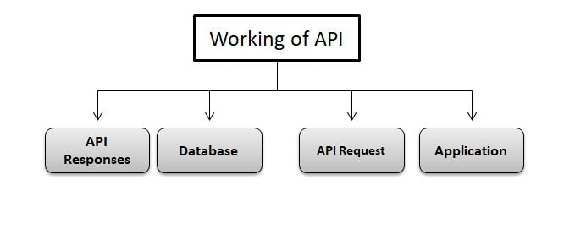

What are the types of API testing?

Types of API Testing are as follows:  
Unit Testing  
Functional Testing  
Load Testing  
Error Detection  
Security Testing  
UI Testing  
Penetration Testing  
Fuzz Testing

What are the protocols used in API Testing?

Protocols used by API Testing are as follows:  
HTTP  
REST  
SOAP  
JMS  
UDDI

What is Swagger Editor?

Swagger Editor is used in designing, defining and documenting RESTful APIs in Swagger Specification.It also helps in bringing the Swagger Editor, UI, Codegen Tools in cloud as an integrated API Design and Documentations which is built for API Teams working with OpenAPI Specification.

How can we Add API in Swagger?

We can add API in Swagger by using the following command:

/

@SWG\Resource(

apiVersion="1.0",

swaggerVersion="1.2",

description="SearchUsers"

)

/

What is OpenAPI?

OpenAPI is an API description format for REST APIs and also allows us in describing our entire APIsuch as Available Endpoints and Operations on each endpoint operations parameters like Input and Output for each operation.  
  
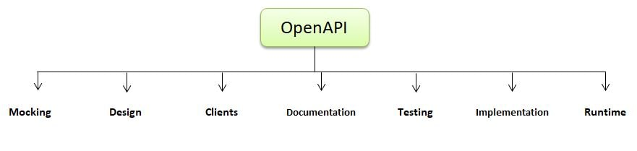

How can we send custom headers with requests in Swagger UI?

We can send custom headers by using the following command:

using System.collections.Generic;

using swashbuckle.AspNetCore.Swagger;

using swashbuckle.AspNetCore.SwaggerGen;

namespace api.infrastructure.filters

{

public class SwaggerSecurityRequirementsDocumentFilter : DocumentFilter

{

public void Apply(Swagger Document document, Document FilterContext context)

{

document.Security = new List<IDictionary<string, IEnumerable<documentstring>>>()

{

new Dictionary<string, IEnumerable<string>>()

{

{ "Bearer", newstring[]{ } },

{ "Basic", newstring[]{ } },

}

};

}

}

}

How should we generate static docs with swagger?

We can generate static documents by using the swagger codegen command:

swagger codegen generate --i <path used in swagger file> -l html2 -o <path used to output location>

How to define an enum in OpenAPI?

We can define an Enum in OpenAPI 2.0 by using the following command:

{

"in": "querys",

"name": "smple",

"description": "Sample parameter with enum value",

"type": "strings",

"enum": [ "5", "6"],

"required": true

}

What are the main components of Swagger?

The main components of Swagger are:

Swagger Editor: A web-based editor for designing API specifications.

Swagger UI: A web application for visualizing and interacting with API documentation.

Swagger Codegen: A tool for generating client SDKs and server stubs from API specifications.

Explain the difference between Swagger 2.0 and OpenAPI 3.0.

Swagger 2.0 is the predecessor of the OpenAPI Specification (OAS) 3.0. OAS 3.0 is the latest version of the specification, which is based on Swagger 2.0 but introduces several improvements and enhancements, including support for more data types, better security definitions, and improved validation.

How do you document a RESTful API using Swagger in a Java application?

To document a RESTful API using Swagger in a Java application, you would typically follow these steps:

Define API specifications using YAML or JSON files, describing endpoints, request/response formats, parameters, etc.

Integrate Swagger annotations (e.g., @ApiOperation, @ApiParam) into your Java code to provide additional metadata for Swagger.

Configure Swagger in your application to generate documentation and serve Swagger UI.

Access the Swagger UI to view and interact with the API documentation.

How do you integrate Swagger with Spring Boot?

To integrate Swagger with Spring Boot, you can use the springfox-swagger2 and springfox-swagger-ui libraries. Here's a basic configuration:

java

Copy code

@Configuration

@EnableSwagger2

public class SwaggerConfig {

@Bean

public Docket api() {

return new Docket(DocumentationType.SWAGGER_2)

.select()

.apis(RequestHandlerSelectors.basePackage("com.example.controllers"))

.paths(PathSelectors.any())

.build();

}

}

This configuration scans the specified package for Spring controllers and generates Swagger documentation.

How do you customize Swagger documentation in a Spring Boot application?

You can customize Swagger documentation in a Spring Boot application by adding additional metadata using Swagger annotations, configuring Docket beans with specific settings, and providing custom implementations for Swagger plugins such as security schemes, API info, etc.

Explain the role of Swagger annotations in Java code.

Swagger annotations in Java code provide additional metadata to describe APIs and their operations. Some common Swagger annotations include:

@Api: Describes a RESTful API.

@ApiOperation: Describes an operation (e.g., HTTP method, endpoint).

@ApiParam: Describes parameters of an operation.

@ApiResponse: Describes possible responses of an operation.

@ApiModel: Describes a data model used in the API.

How can Swagger help with API versioning in Java applications?

Swagger can help with API versioning by allowing you to document multiple versions of the API in the same Swagger specification. You can use Swagger annotations to mark endpoints or operations with version information and generate documentation accordingly.

How do you secure Swagger documentation in a Java application?

Swagger documentation can be secured in a Java application by configuring authentication and authorization mechanisms in the application and restricting access to the Swagger UI and API documentation endpoints based on user roles or permissions.

What are some best practices for using Swagger in Java development?

Some best practices include:

Keeping API specifications up-to-date with code changes.

Using descriptive annotations and comments to provide meaningful documentation.

Organizing API specifications into logical sections and components.

Validating API specifications against the OpenAPI schema.

Securing access to Swagger documentation endpoints in production environments.