6. FACE DETECTION METHOD IN OPENCV USING PYTHON

EX.N0 : 6 | LOAD AND IMPLEMENT THE FACE DETECTION METHOD IN OPENCV USING PYTHON
DATE : 04/03/2025

AIM:
To load and implement real-time face detection using OpenCV and Haar Cascade Classifier.

ALGORITHM:
Step 1: Import OpenCV library.
Step 2: Load the Haar cascade classifier for face detection. Step 3: Access webcam video using cv2.VideoCapture ().
Step 4: Read frames continuously and convert them to grayscale.

Step 5: Detect faces using detectMultiScale() method.

Step 6: Draw rectangles around detected faces and display the video

PROGRAM:
import cv2
face_cascade = cv2.CascadeClassifier(cv2.data.haarcascades + 'haarcascade_frontalface_default.xml')
cap = cv2.VideoCapture(0) while True:
ret, frame = cap.read() if not ret:
break
gray = cv2.cvtColor(frame, cv2.COLOR_BGR2GRAY)
faces = face_cascade.detectMultiScale(gray, scaleFactor=1.1, minNeighbors=5) for (x, y, w, h) in faces:

cv2.rectangle(frame, (x, y), (x + w, y + h), (0, 255, 0), 2) cv2.imshow("Face Detection", frame)
if cv2.waitKey(1) & 0xFF == ord('q'): break
cap.release() cv2.destroyAllWindows()

OUTPUT:

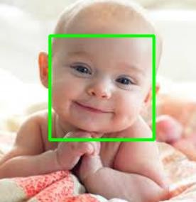

RESULT:

Thus the Program has been executed successfully and verified.

