**Implement programs to check stationarity of a time series data.**

**EX:No.2 DATE:1/02/25**

# AIM:

To Implement programs to check stationarity of a time series data.

## OBJECTIVE:

To analyze whether the air pollution time-series data is stationary using statistical tests and visualizations.

## BACKGROUND:

* A **stationary time series** has a constant mean, variance, and no seasonality.
* Stationarity is important for forecasting and modeling.
* **Non-stationary data** needs transformations like differencing.
* **Statistical tests** like **ADF (Augmented Dickey-Fuller) test** help detect stationarity.
* **Visual methods** like rolling statistics help identify trends and variance changes.

## SCOPE OF THE PROGRAM:

* Load and clean air pollution time-series data.
* Check for missing values and handle them.
* Use **rolling mean and standard deviation** to check stationarity.
* Apply **Augmented Dickey-Fuller (ADF) test** for statistical confirmation.
* Apply **differencing** if the data is non-stationary.

# CODE:

import pandas as pd

import matplotlib.pyplot as plt

from statsmodels.tsa.stattools import adfuller

# Load dataset

df = pd.read_csv("/content/us_air_pollution_2012_2021_updated.csv")

# Convert 'Date' column to datetime

df['Date'] = pd.to_datetime(df['Date'], errors='coerce') df.set_index('Date', inplace=True)

# Select the pollution column (update the name if needed) pollution_col = "PM2.5 (µg/m³)"

# Plot rolling statistics plt.figure(figsize=(10, 5))

plt.plot(df[pollution_col], label="Original Data") plt.plot(df[pollution_col].rolling(window=12).mean(), label="Rolling Mean", color='red') plt.plot(df[pollution_col].rolling(window=12).std(), label="Rolling Std Dev", color='black') plt.legend()

plt.title("Rolling Mean & Standard Deviation")

plt.show()

# Augmented Dickey-Fuller (ADF) Test result = adfuller(df[pollution_col].dropna()) print(f"ADF Test Statistic: {result[0]}") print(f"P-value: {result[1]}")

print("Critical Values:", result[4])

if result[1] < 0.05:

print("The data is stationary (Reject H0).") else:

print("The data is non-stationary (Fail to Reject H0).")

# OUTPUT:

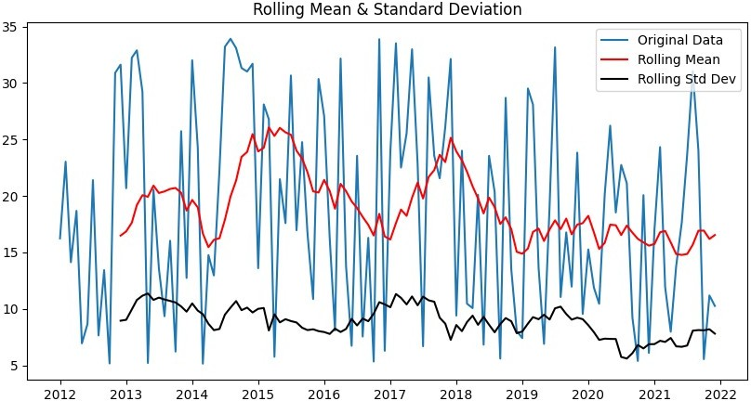

**RESULT:**

Thus, the program using the time series data implementation has been done successfully.