Execution Steps

* Unzip the AccountingSoftware.7z
* Import the AccountingSoftware maven project into InelliJ
* Right click on \src\test\java\Regression\ InvoiceTest.java

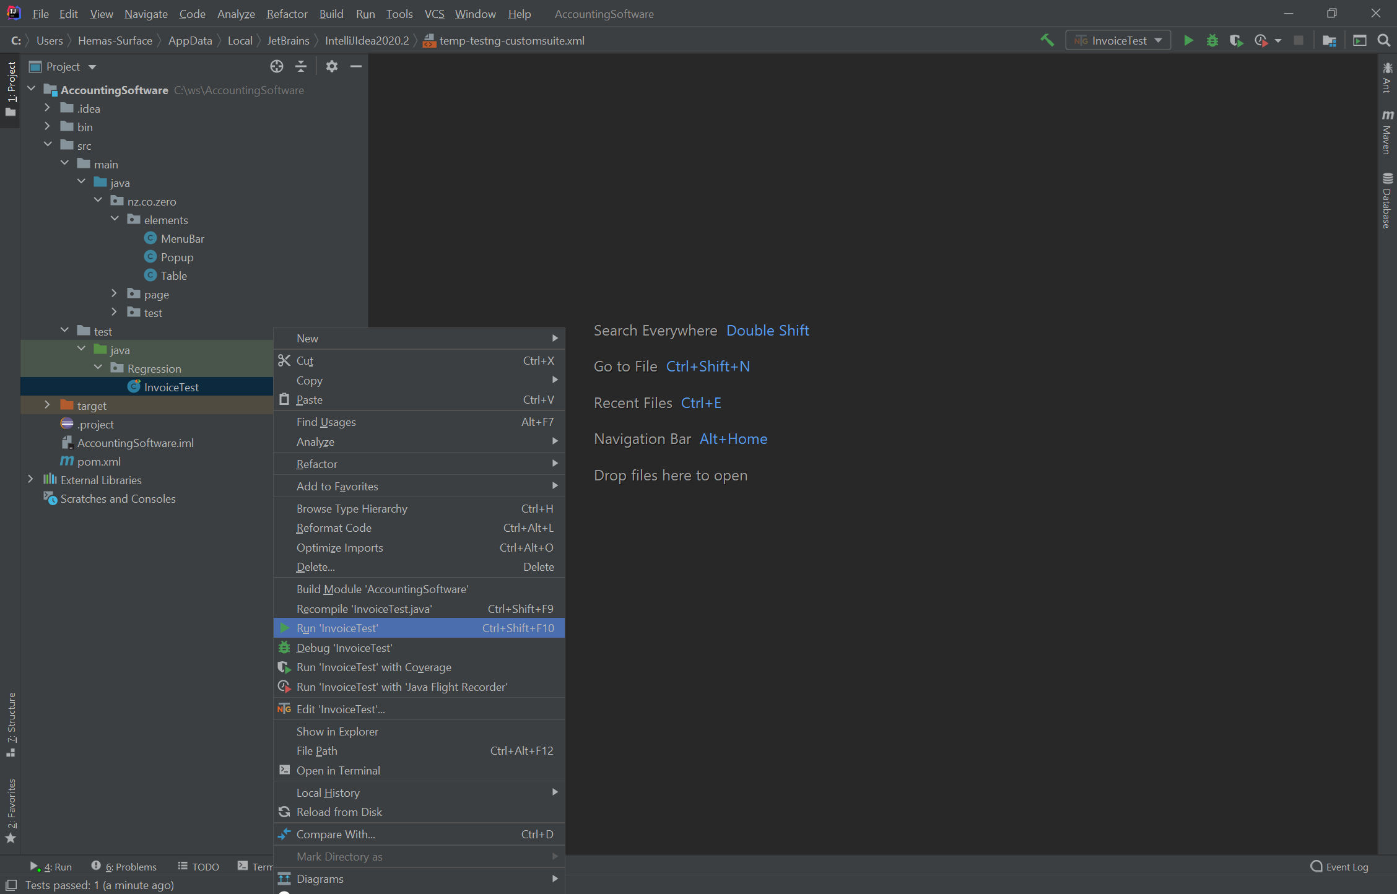

Create Invoice test completed successfully.

