EKRA: As-Built Architecture (prototype)
This document describes what was actually built. The production-scale target design is in [design.md](design.md). Every document, person, team, project and number in the prototype corpus is synthetic.

1. Architecture

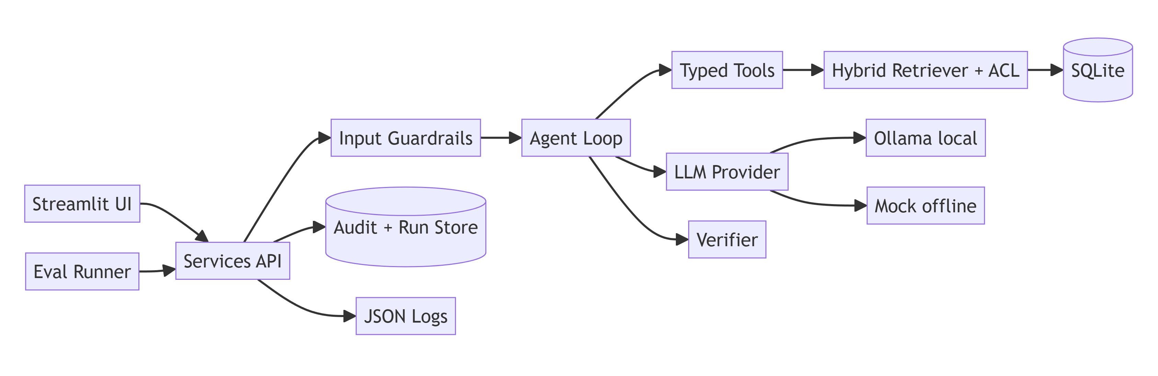

Component | File | Responsibility
UI (separate session) | app/main.py, app/pages/, app/ui/ | Ask, report, review, analytics, diagnostics pages
Services (the contract) | app/services/*.py | Only API the UI calls; Pydantic shapes in app/core/models.py
Input guardrails | app/guardrails/input.py, pii.py | Length/type checks, injection patterns, PII masking
Agent loop | app/agent/loop.py | Plan, act, observe, replan, synthesize, verify
Planner | app/agent/planner.py, timewin.py | Time window in code; LLM only proposes sub-queries
Budget | app/agent/budget.py | Step, time, token and tool-call caps; loop detection
Tools | app/tools/ | entity_lookup, list_documents, hybrid_search, fetch_document with validated schemas
Retriever | app/retrieval/index.py, acl.py | BM25 + vectors with RRF; ACL applied before ranking
Synthesizer | app/agent/synthesizer.py | Per-initiative claim extraction, summary, conflicts
Verifier | app/agent/verifier.py | Claim-to-passage grounding; live ACL re-check
LLM providers | app/llm/ | ollama (default, local), mock (offline). OpenAI is deliberately not supported
Store | app/core/db.py | SQLite, foreign keys on, CHECK constraints

2. Data flow (one question)
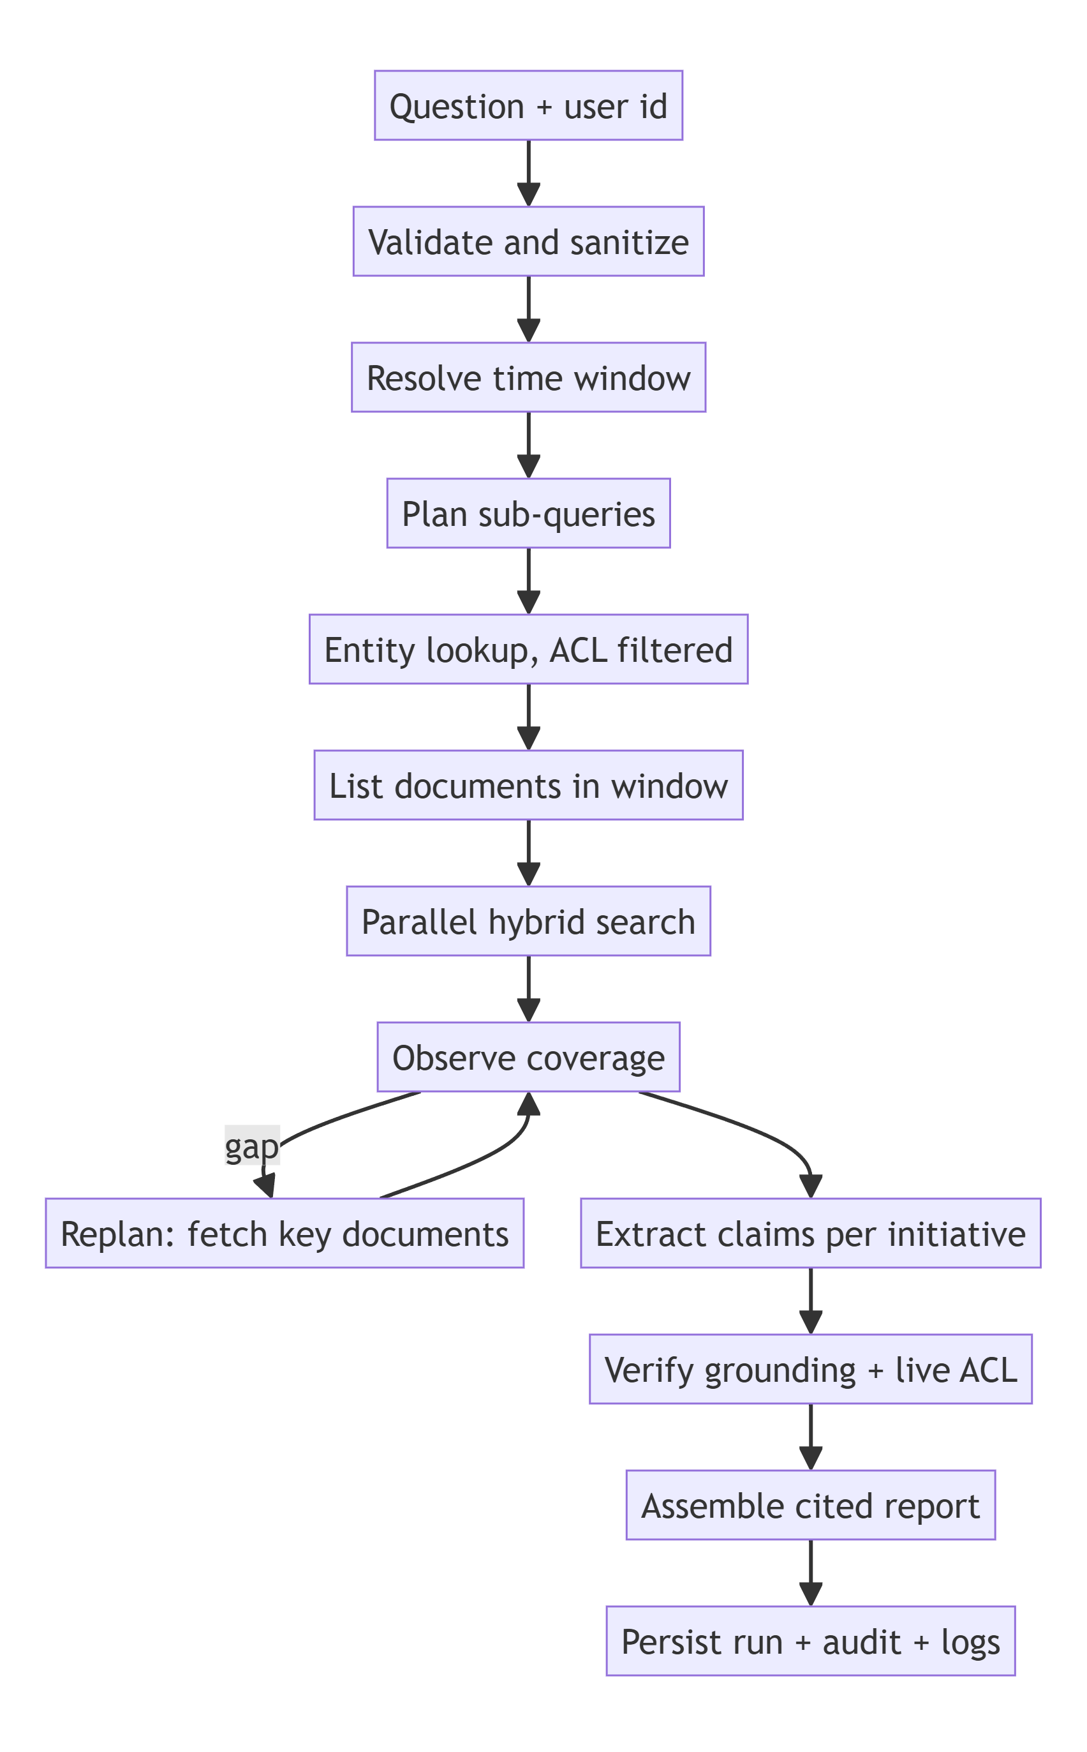

3. Request sequence

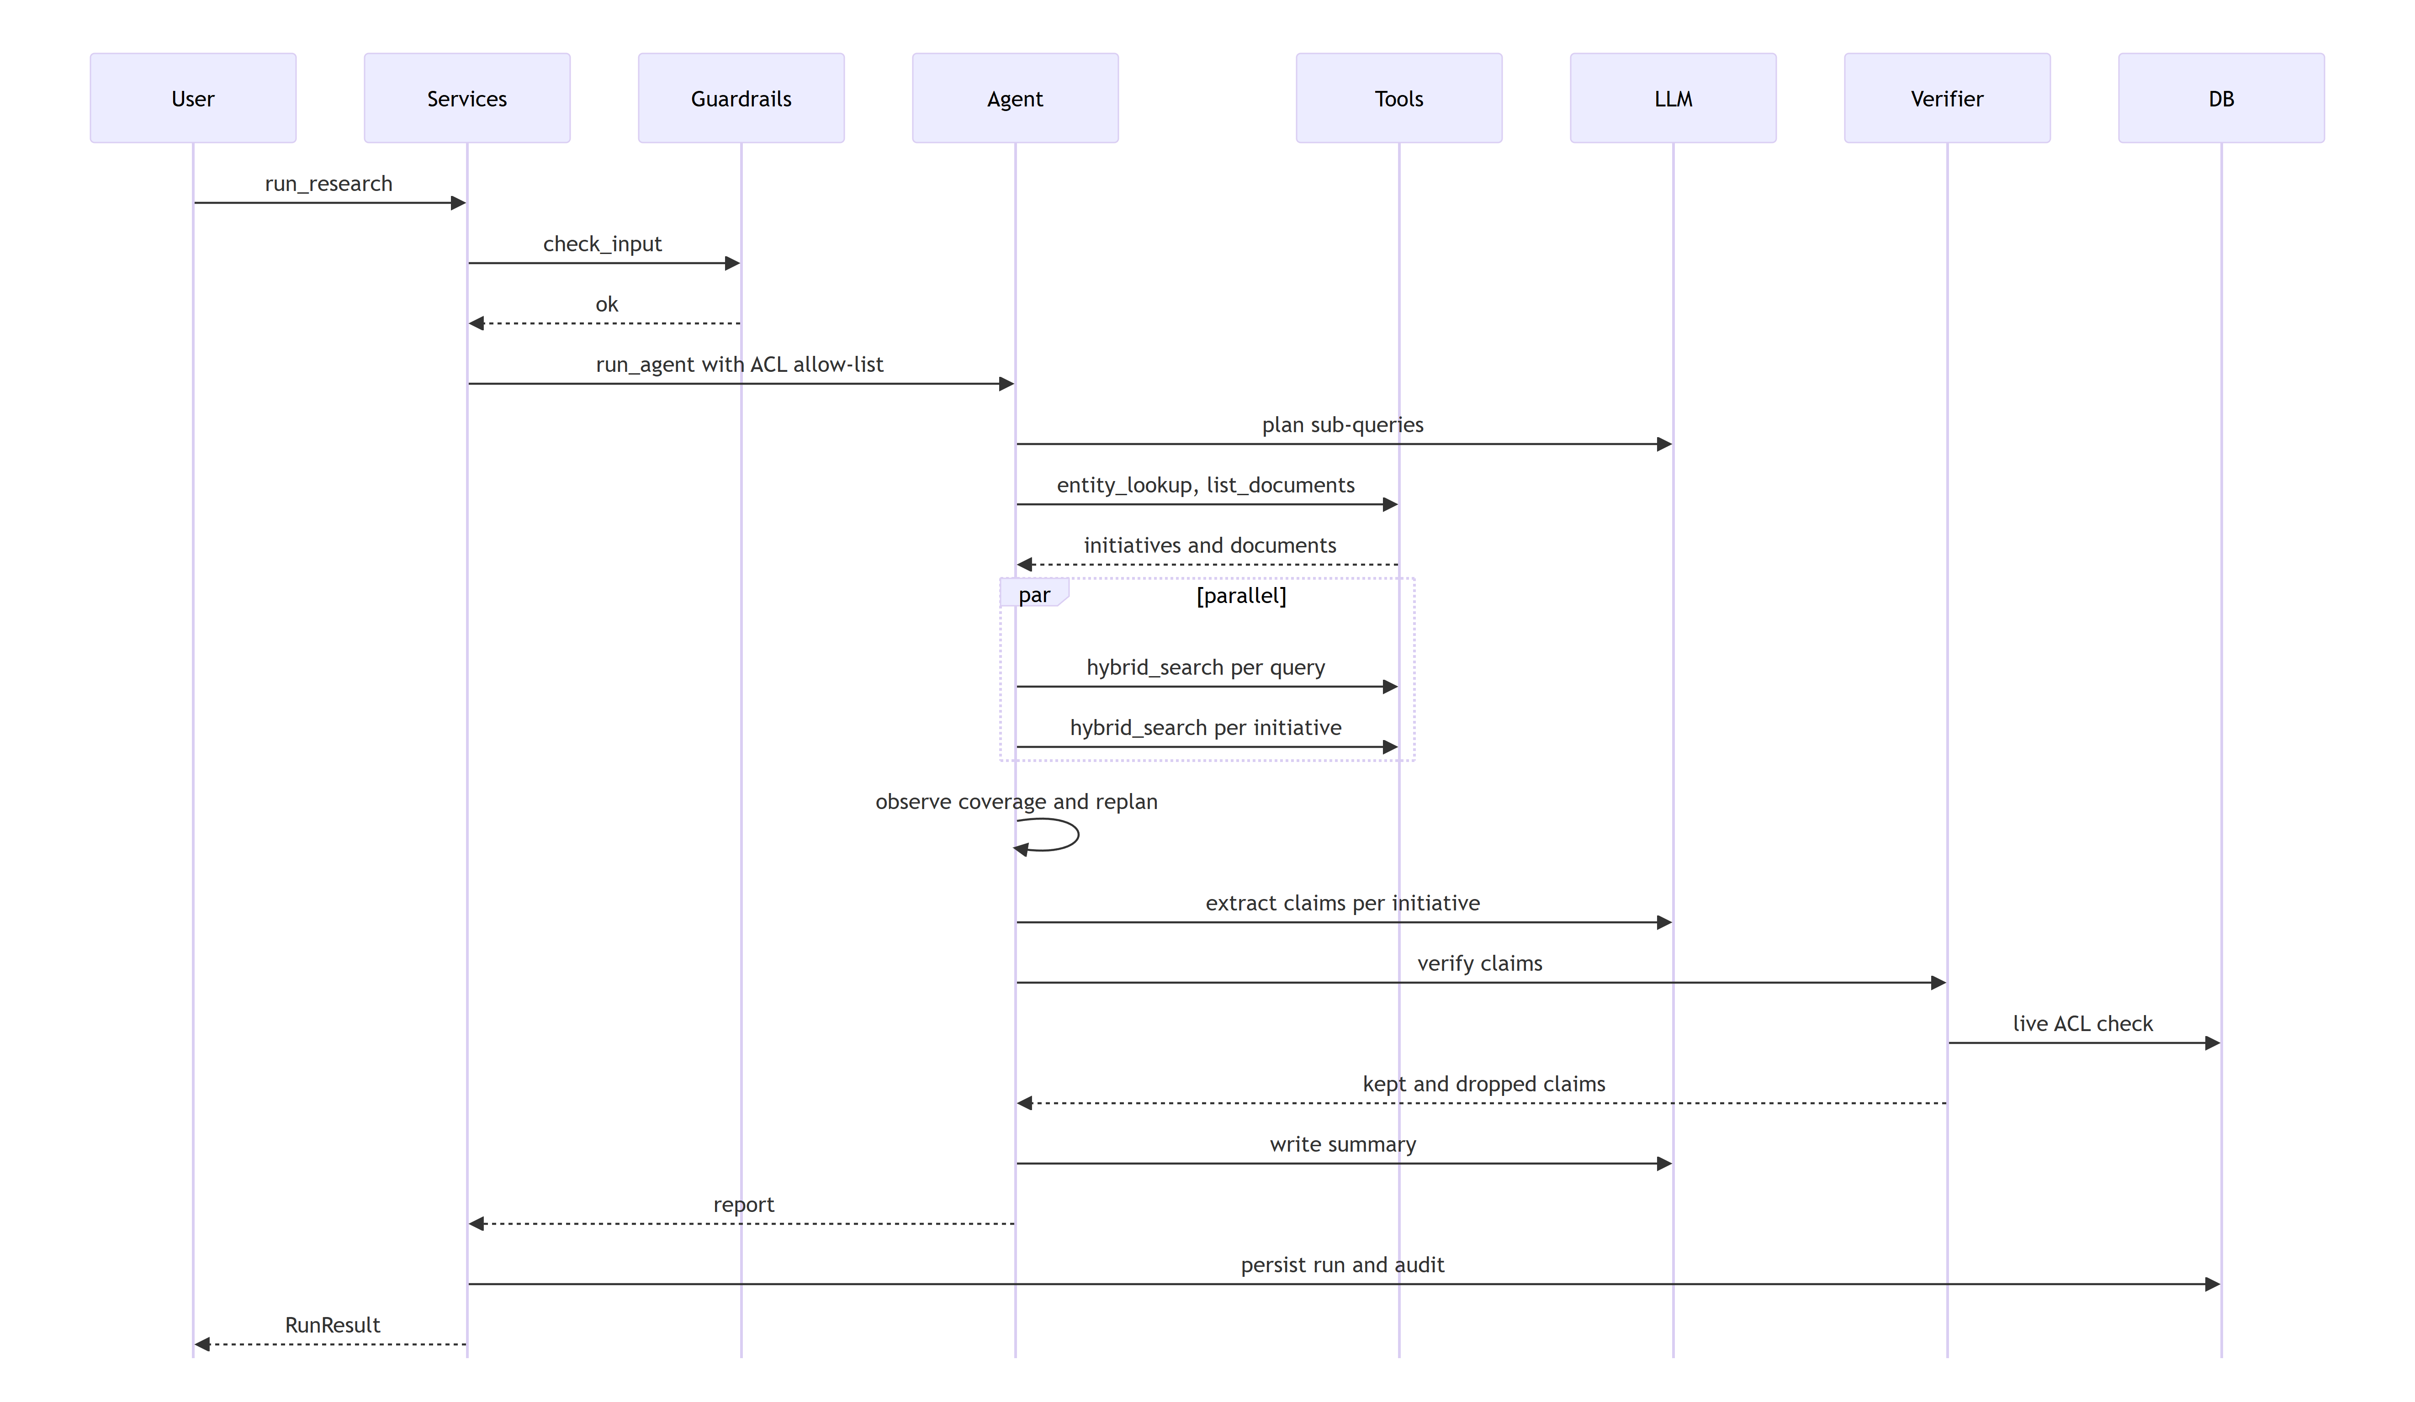

4. Data model

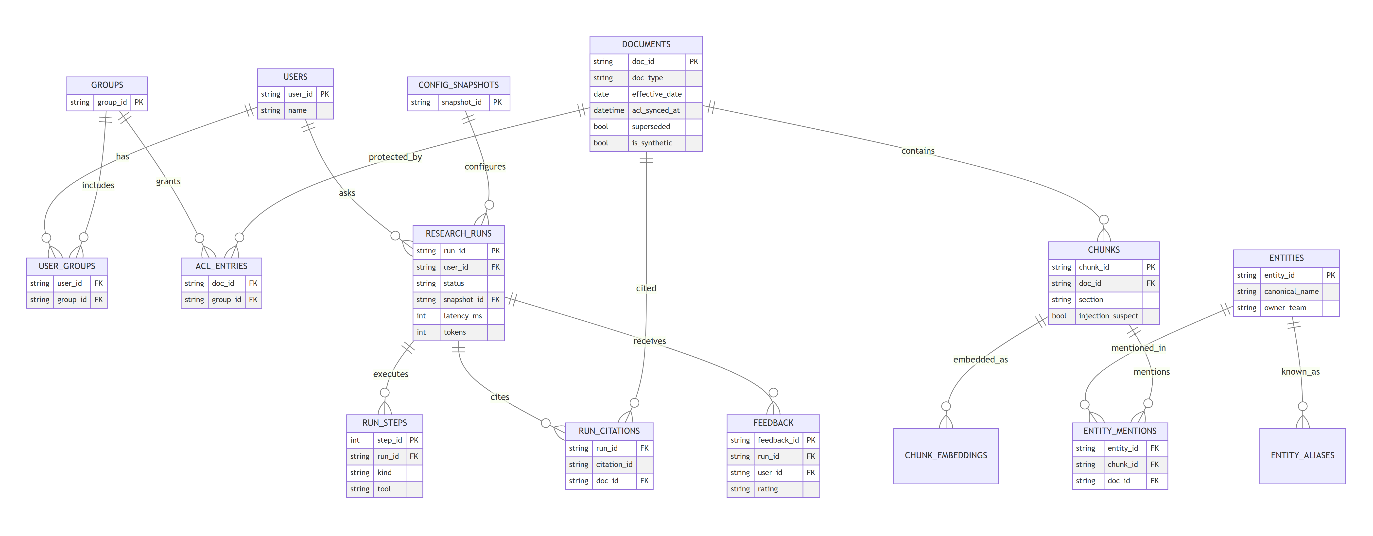

Additional tables not drawn: audit_log (who, what, when, model, request id), chunk_embeddings (cache), entity_aliases.

5. Key design decisions (with business why)
Decision | Why it matters to the business
ACL filter applied before ranking, then re-checked live before delivery | Leaders can trust that restricted material never appears in a summary
Initiative status derived by rules, not by the model | Status changes are auditable; a model cannot invent "shipped"
Time windows resolved in code against each document's effective date | "Last 2 years" means the same thing every time, even if a 2023 doc was edited in 2025
Every claim verified against its cited passage; invented numbers are dropped | Fewer wrong statements reach decision-makers
LLM output validated (JSON schema, retry once, rules-based fallback) | The assistant keeps working if the local model misbehaves
Local Ollama by default; OpenAI not supported | Company data stays on the machine; no per-query cost
One planner agent with parallel fan-out, not many agents | Simpler traces and fewer cascading errors
Clear autonomy boundary: the model chooses search terms, tools, documents to read and when to replan; code owns dates, permissions, status, conflicts and number checks | The agent adapts to each question, while the decisions that must be exact stay auditable (design.md 2.3.5)

6. Limitations of the prototype
- Entity tags and aliases are seeded by hand (a stand-in for an extraction pipeline). Initiatives that are not in the entity table cannot be summarized; the report says how many matching documents belong to initiatives outside the topic.
- Status rules cover the phrases in the synthetic corpus; real documents need broader patterns or a trained classifier.
- SQLite plus in-process vectors suit ~50 documents, not millions.
- Plans are built for list-all and single-initiative questions only. Timeline, comparison and "why" playbooks, reason extraction, clarifying questions and plan preview are designed (design.md 2.3.6, 2.8.1) but not built.
- Relevance relies on hard filters, entity match and question-aware extraction; there is no cross-encoder reranker or calibrated score cutoff (design.md 2.5.1).
- Demo identities replace SSO. There is no real connector, no async job queue and no long-term memory.

