Agentic AI Research Assistant: Enterprise System Design
Mode: design only. Author: Hema Chepuri. Date: 2026-11-08.
Running example: "Summarize all company initiatives related to personalization and recommendation systems from the last 2 years." This resolves to the window 2024-11-08 → 2026-11-08.
How this maps to the required submission:
Required item | Section
Architecture diagram | 2.1 (plus sequence, data-flow and ER diagrams in 2.4–2.5)
Written system design document | 1–2
Trade-off analysis | 3
Failure mode analysis | 4
Production operations discussion | 5–6

1. Requirements

1.1 Clarifying questions (with the answers assumed)
Question | Assumed answer
Who are the users? | Product managers, engineers, strategy and leadership staff, and new hires. All are employees signed in through SSO.
What decisions does it support? | Planning, avoiding duplicate work, finding prior art, briefing leadership. It informs people and never acts for them.
Which sources? | Confluence/wiki, SharePoint/Drive, Jira/epics, meeting transcripts and notes, project reports, PRDs/specs, roadmap decks.
Compliance? | Strict document-level permissions; PII and HR/legal content restricted; data residency; audit logs.
Write actions? | None in v0. The system is read-only.

1.2 Functional requirements
- FR1 Natural-language questions, including multi-hop, time-bounded and enumeration questions ("all initiatives…").
- FR2 The system plans its research on its own: it breaks the question into sub-queries, chooses tools, and replans when it finds gaps.
- FR3 It retrieves across all connected sources, limited to what the asking user is allowed to see.
- FR4 It synthesizes a structured answer: summary → findings (deduplicated by initiative) → timeline → conflicts → gaps, with every claim cited to an openable source (doc, section, date).
- FR5 It asks a clarifying question when the request is ambiguous (calendar or fiscal year? which business units?).
- FR6 Two modes: Quick answer (synchronous, streamed) and Deep research report (asynchronous, with progress updates and an exportable report).
- FR7 Feedback on the whole answer and on individual claims (wrong, outdated, missing source).
- FR8 Session follow-ups ("drill into the 2025 ones") and optional saved reports.

1.3 Non-functional requirements (all numbers illustrative)
Dimension | Target
Scale | 20k employees; 2k daily users; about 6k queries/day; peak 15 QPS
Corpus | About 5M documents, about 60M chunks, about 50k changed docs/day
Latency | Quick answer: first token under 3 s, p95 under 20 s. Deep report: p95 under 4 min
Freshness | Content indexed within 15 min (event-driven); ACL changes applied within 5 min, deny by default if stale
Availability | 99.5% for the answer path; degrade to search-only if LLMs are down
Quality | Faithfulness ≥ 95%; citation validity ≥ 98%; permission-leak rate = 0; enumeration recall ≥ 85%
Cost | About $0.05 per quick answer, about $0.60 per deep report; blended about $0.13 per query
Security | SSO (OIDC/SAML); encrypted at rest and in transit; zero-retention LLM contracts; full audit trail

1.4 What "done" means and success KPIs
- Done: a correct, grounded answer that the user is allowed to see, where every claim links to a source they can open, delivered within the latency target.
- Business KPIs: research time saved per query, weekly active users, the share of answers rated useful, and fewer duplicate initiatives found in planning reviews.

1.5 Never list (hard rules)
- NEVER retrieve, quote or cite a document the user can't open.
- NEVER state a claim that isn't grounded in a retrieved passage. Say "not found" instead.
- NEVER follow instructions found inside retrieved content.
- NEVER take a write or side-effect action without a human.
- NEVER let long-term memory override what the source documents say.

1.6 Top user journeys
- PM, landscape question: asks the example query → reviews the plan preview → gets a deep report with a timeline of initiatives → exports it to the planning doc.
- Engineer, prior art: "Did we ever try two-tower retrieval for the home feed?" → quick answer with 3 cited sources and an owner team to contact.
- Leader, follow-up: "Which of those were shut down and why?" → the session context carries over → the answer cites post-mortems and flags conflicting statuses.

2. Main System Components

2.1 Architecture diagram
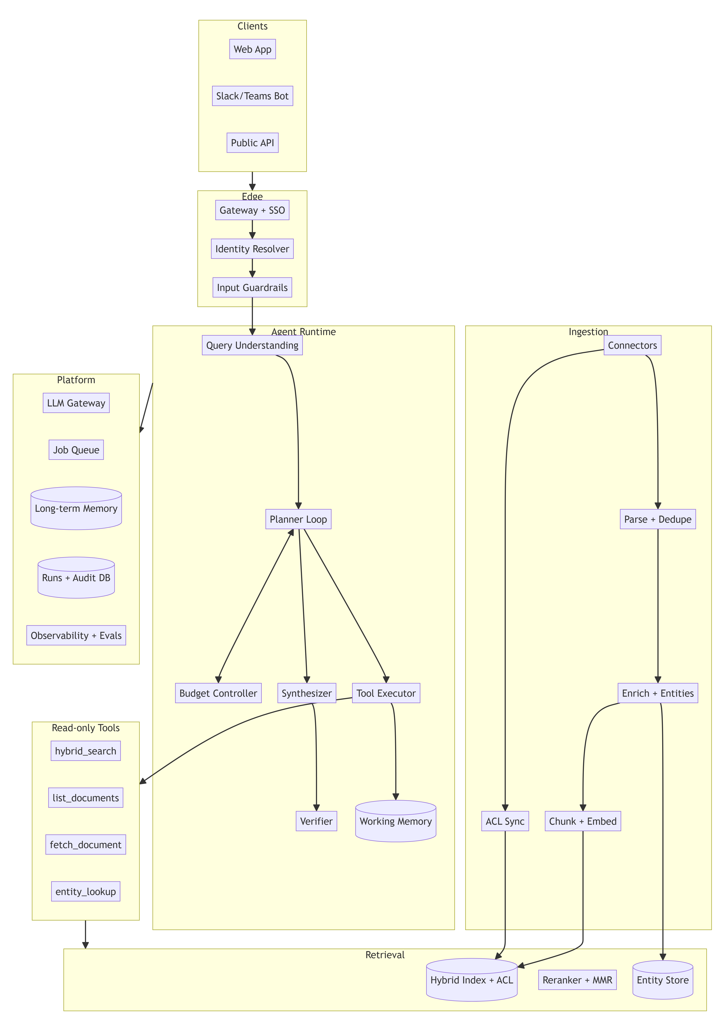

2.2 Components and why each exists
Component | Responsibility | Business why
Gateway, SSO and identity resolver | Authenticates the user and expands them into ACL principals (user ID plus group IDs), cached for 5 min | Every request carries identity, which makes leak-free answers possible and keeps security sign-off simple
Input guardrails | Length and type limits, prompt-injection heuristics plus a classifier, PII detection, restricted policy topics | Blocks misuse before any money is spent
Query understanding | Classifies intent (lookup / enumeration / comparison / timeline), resolves relative dates to absolute ones, extracts entities, decides quick vs deep, asks a clarifying question when confidence is low | Avoids confidently answering the wrong question
Planner (single agent) | Produces an upfront plan (sub-queries, tools, stop criteria), then runs Plan → Act → Observe with bounded replanning | Gives autonomy that can still be audited; the user can preview the plan
Tool executor | Runs typed, read-only tools in parallel with timeouts, retries and schema validation. Errors go back to the planner as observations | Most agents break at the tool boundary, so it is hardened here
Budget and loop controller | Caps steps (12), replans (3), tokens, dollars and wall-clock time; detects repeated identical calls | Predictable cost and latency
Synthesizer | Map: pulls structured records out of each evidence chunk. Reduce: resolves entities, orders the timeline, writes sections | Answers "all X" questions with full coverage, not just the top 5 chunks
Verifier | Checks every claim against its cited passage, checks that citations resolve and that the user can access them, drops or flags unsupported claims | Builds trust: no uncited claims ship
Retrieval layer | Query rewrite and synonyms → hybrid BM25 + vector with ACL pre-filter → cross-encoder rerank → MMR diversity → recency/authority boost | Internal jargon needs keyword search; paraphrases need vectors
Entity store | Initiatives, projects, teams and products with aliases ("RecSys v2" = "Project Compass"), built at ingestion | Makes enumeration and deduplication reliable
Ingestion pipeline | Connectors (webhook/CDC plus nightly reconciliation), parsing, minhash deduplication, metadata enrichment (doc type, effective date, owner, status), structure-aware chunking, embeddings | Messy sources become citable, time-aware evidence
LLM gateway | Model routing (small model for classify/extract, large for plan/synthesize), prompt caching, rate limits, provider failover, PII redaction in logs | Controls cost and availability; prompts and models are config
Memory | Working: per-run plan, evidence and scratchpad. Long-term: opt-in preferences and saved reports, with TTL and delete | Supports follow-ups without stale facts leaking in
Job queue | Deep research runs asynchronously with progress events (SSE) | Long reports don't time out chat clients
Observability and eval | OTel spans for every step, tool and LLM call; offline and online evals; feedback store | You can't debug reasoning you didn't trace

2.3 Retrieval and memory deep dive
Grounding over messy internal knowledge
- Parsing is aware of each format: slide decks keep slide titles, transcripts are split by speaker turn and agenda item, Jira keeps epic → story links.
- Chunking follows the document's own structure: headings, sections or slides, about 300–800 tokens each, with the parent heading path prepended.
- Every chunk stores doc_id, url, section_path, char_offsets, effective_date, doc_type, version, acl_principals[], so it can always be cited.
- Effective date ≠ modified date. At ingestion, a small model extracts the date the content refers to (e.g. an H1 2025 roadmap edited in 2026). Time filters use the effective date.
- Authority and freshness signals: docs marked superseded or archived are down-ranked, and the latest version of a page wins.
Permission-aware retrieval
- ACLs are synced from each source and stored on every chunk.
- Every search applies acl_principals ∩ user_principals ≠ ∅ as a pre-filter inside the index query, never as a post-filter only.
- Second check before delivery: the verifier re-checks access for each cited doc with a live source-system call or a fresh ACL cache entry.
- Deny by default when acl_synced_at is older than its SLA or the ACL is missing.
- Each run logs which doc IDs were retrieved for which user, so access can be audited.
Tool contracts (JSON schema, read-only, bounded outputs)
{ "name": "hybrid_search",
"args": { "query": "string(<=256)",
"filters": { "doc_type": ["roadmap","prd","report","meeting","wiki"],
"effective_date_from": "date", "effective_date_to": "date",
"entity_ids": ["string"] },
"top_k": "int(1..50)" },
"returns": [{ "chunk_id": "str", "doc_id": "str", "title": "str", "snippet": "str(<=1200)",
"effective_date": "date", "score": "float", "url": "str" }] }
- Other tools: list_documents (metadata-only scan for recall), fetch_document(doc_id, sections), entity_lookup(name|alias), org_directory(team).
- Failure handling: timeouts of 2–5 s, 2 retries with jittered backoff, and circuit breakers for each connector.
- An empty result or error comes back as {"status": "error|empty", "hint": ...}, so the planner can widen the query or switch tools instead of crashing.
Memory
- Short-term: the per-run evidence ledger (chunk_id → extracted facts), held to a token budget. Raw chunks are replaced by extracted facts once the map step has processed them. It is discarded when the run ends; only the final report and trace persist.
- Long-term: opt-in. It holds preferences and saved reports. TTL is 180 days, users can view and delete it, and it is never used as evidence. Saved reports are re-validated against ACLs when reopened.
Synthesis output schema
{ "summary": "string",
"time_window": {"from": "2024-11-08", "to": "2026-11-08"},
"findings": [{ "initiative": "string", "aliases": ["string"], "owner_team": "string",
"period": "string", "status": "active|shipped|paused|cancelled|unknown",
"claims": [{ "text": "string", "citations": ["c1","c4"], "support": "supported|partial" }] }],
"timeline": [{ "date": "date", "event": "string", "citations": ["c2"] }],
"conflicts": [{ "description": "string", "citations": ["c3","c7"] }],
"gaps": ["string"],
"citations": [{ "id": "c1", "doc_title": "string", "url": "string", "section": "string", "effective_date": "date" }] }

2.4 The example query, traced end to end

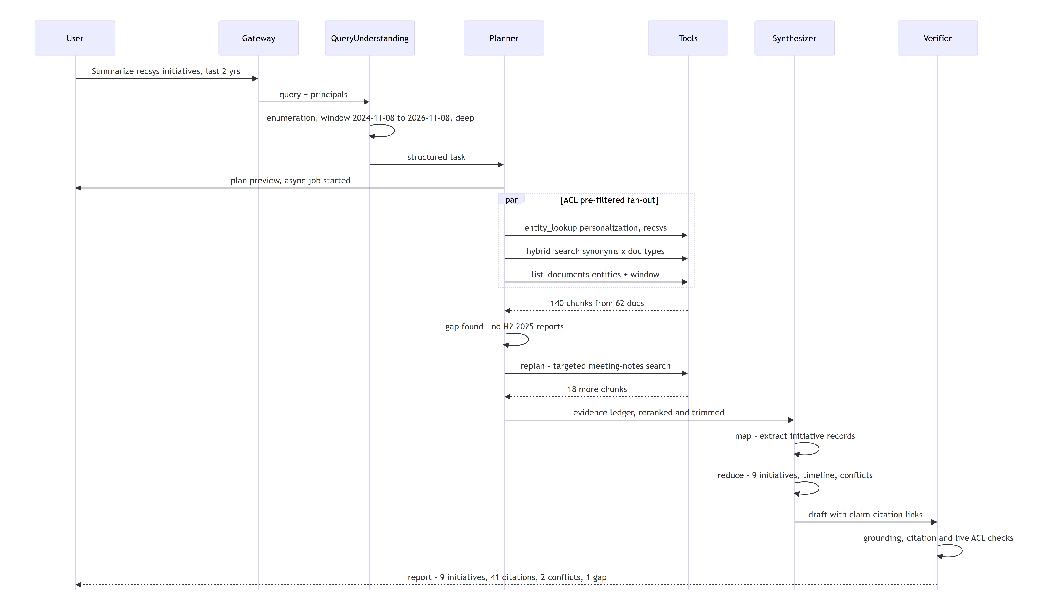

- Plan. Expand synonyms (personalization, recommendations, recsys, "for you", ranking, next-best-action, user embeddings). Target roadmaps, PRDs, project reports and meeting notes, filtered by effective date.
- Act. Run entity lookup, hybrid search and a metadata scan in parallel, all pre-filtered by ACL.
- Observe and replan. The coverage check (per quarter × source type) finds the hole in H2 2025 and runs a targeted query.
- Synthesize. Map-reduce extraction; entity resolution merges "Project Compass" and "RecSys v2"; build the timeline.
- Cite and deliver. Every claim links to a doc/section the user can open. Conflicts are shown (e.g. a roadmap says "shipped Q2" but the report says "paused"). Gaps are stated.

2.5 Data flow and data model

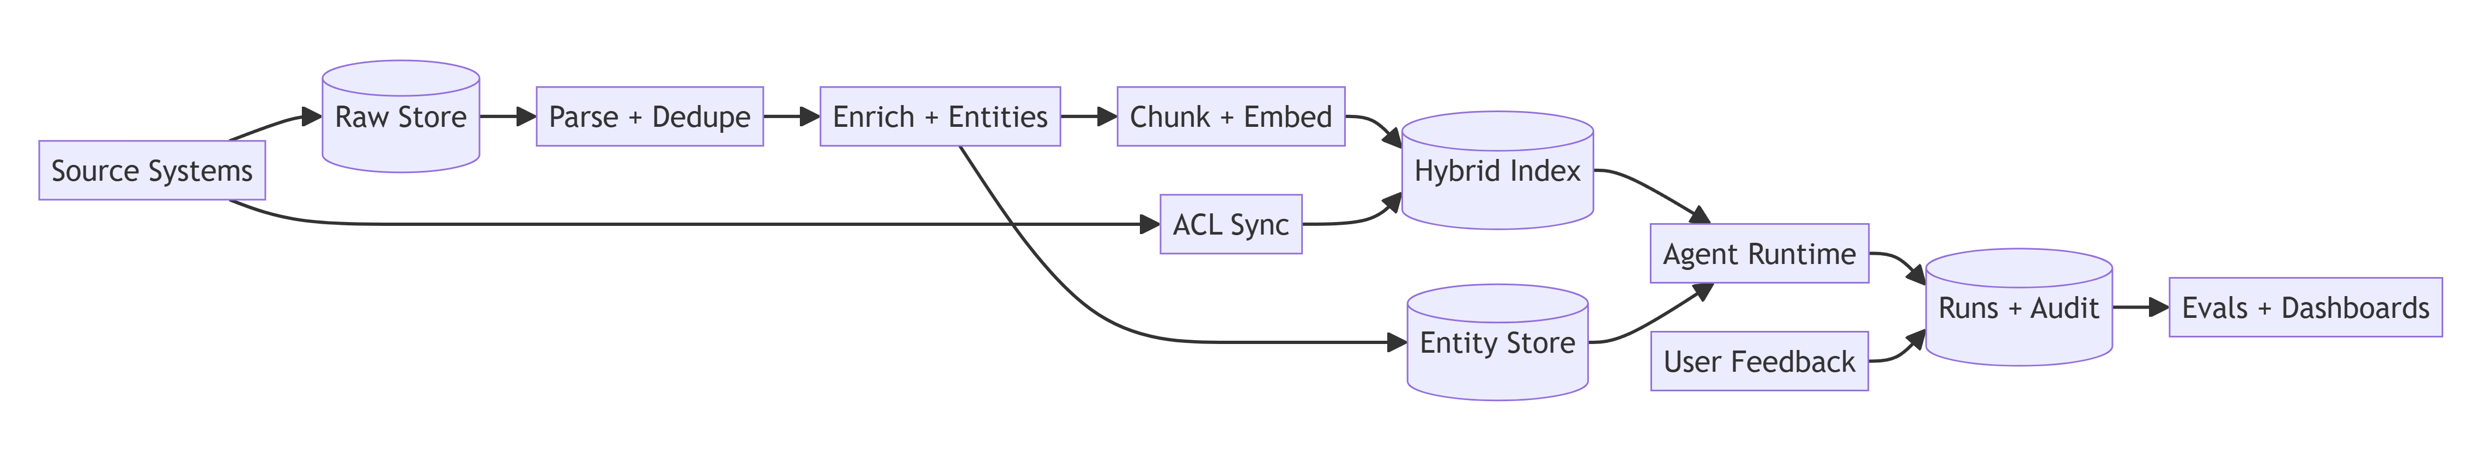

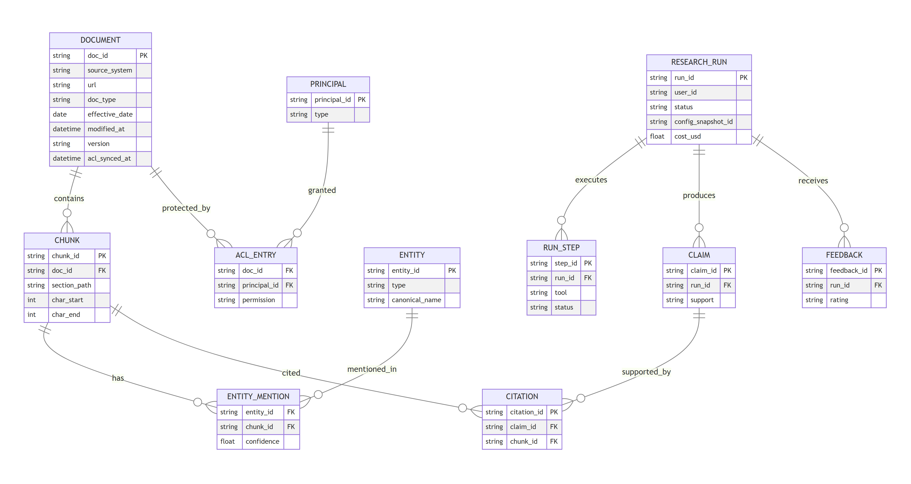

3. Trade-off Analysis

3.1 Trade-offs ledger
Tension | We lean | We gave up | Why it's right here
Planning: upfront plan vs purely reactive (ReAct) | Plan first, then bounded replanning | Some flexibility on odd queries | The user can preview the plan, cost is predictable, the plan is auditable; replanning still closes gaps
Orchestration: single vs multi-agent | Single planner + deterministic parallel workers | Specialist agents with separate personas | Fewer handoffs, fewer cascading errors, simpler traces, lower cost
Retrieval: vector only vs hybrid | Hybrid BM25 + vector + reranker, plus entity index and metadata scan | Simplicity; about 100 ms extra latency | Internal code names break pure embeddings; enumeration needs recall beyond top-k
Recall vs latency (enumeration) | Map-reduce over many candidates in deep mode | Speed: deep reports take minutes | Missing an initiative is worse than waiting 3 minutes
Freshness: index vs live query | Indexed (event-driven, 15 min SLA) with live fetch for final verification | Real-time content | Live querying of 6 source APIs is slow and rate-limited
Grounding: strict citation vs fluency | Strict: unsupported claims are dropped or flagged | Some smoothness and inferred insight | Leaders act on these reports; a wrong uncited claim costs more trust than a terse answer
Permissions: pre-filter vs post-filter | Pre-filter in the index + re-check before delivery | Index complexity; ACL sync infrastructure | A post-filter alone leaks through the summaries the LLM writes; leak rate must be 0
Cost: one big model vs routing and caching | Routing: small model for classify/extract/verify, large for plan/synthesize; caching | Some peak quality on extraction | Extraction is about 70% of tokens; routing cuts cost about 3–4×
Interaction: sync chat vs async jobs | Both: quick mode streams, deep mode runs async | Simplicity of a single path | Matches the job: a quick lookup vs a landscape report
Build vs buy | Managed search + LLM via a multi-provider gateway | Fine-grained control | Faster time to value; provider choice stays open
Long-term memory | Opt-in, preferences only, never evidence | Personalization depth | Avoids stale or poisoned facts; simpler privacy review

3.2 Key decisions in more depth
- Why not plain RAG? Top-k retrieval answers "what is X" well but fails at "summarize all X over 2 years". That needs decomposition, coverage checks, cross-document deduplication and time ordering. Those are the steps that justify an agent.
- Why an entity store? The same initiative appears under 3–4 names across decks, Jira and meeting notes. Without canonical entities, the report double-counts or splits initiatives.
- Why a live ACL check before delivery? The index ACL can lag by up to 5 min. Checking the 20–50 cited docs live costs little and closes the lag window for the documents that actually reach the user.

4. Failure Mode Analysis

4.1 Agentic failure modes
# | Failure mode | Symptom | Detection | Mitigation
1 | Infinite or long loops | Repeated near-identical searches; latency blows up | Step counter; hash of (tool, args) repeated | Caps: 12 steps, 3 replans, 4 min; dedupe calls; graceful partial answer listing what wasn't covered
2 | Plan derailment | Drifts to general "ML infrastructure" | Each step scored for relevance against the goal | Goal re-statement each planner turn; prune off-topic steps; cap replans
3 | Context overflow | Truncated evidence, lost citations | Token budget monitor | Map step compresses chunks into facts; rerank and trim; hierarchical reduce
4 | Cascading errors | Bad tool output poisons synthesis | Schema validation fails; empty results | Validate every output; retry/fallback; fail closed for ACL errors
5 | Confident hallucination | Fluent claims with no or wrong citation | Verifier grounding score; citation-span match | Claim → passage entailment check; drop or flag; "not found" is a valid answer
6 | Cost runaway | $/request spikes | Per-run cost meter; spend alerts | Per-request token and $ caps; model routing; caching; deep mode only on explicit intent

4.2 Enterprise and RAG-specific failure modes
# | Failure mode | Impact | Mitigation
7 | Permission leak (stale or missing ACL) | Severe: security incident | Pre-filter + deny-by-default + live re-check + audit; leak canary tests in CI and production
8 | Prompt injection in documents | Data exfiltration, wrong answers | Retrieved text delimited as untrusted data; read-only tools; injection classifier; no outbound actions
9 | Stale or superseded content | Wrong decisions | Effective date + version + superseded signals; dates on every citation; conflicts flagged
10 | Low recall on enumeration | Missing initiatives | Synonym expansion, entity index, metadata scan, coverage grid; report states the searched scope
11 | Entity confusion (two projects named "Atlas") | Merged or misattributed findings | Resolution uses owner team + dates + context; low-confidence merges flagged
12 | Time misattribution | Out-of-window results | Effective-date extraction; filter on events, not edit timestamps
13 | Noisy meeting transcripts | Overstated claims | Source-type weighting; hedged language for meeting-only claims
14 | Connector or source outage | Partial coverage | Circuit breakers; answer notes which source was unavailable
15 | LLM provider outage or rate limit | Downtime | Gateway failover; queue deep jobs; degrade to cited search results
16 | Embedding model change | Index inconsistency | Versioned indexes; blue/green reindex; never mix embedding versions
17 | PII exposure in answers or logs | Compliance breach | Output PII detection; log/trace redaction; restricted collections excluded by policy

Human-in-the-loop points: confirming the plan for expensive deep runs; low-confidence entity merges; saving a report to a shared space; any future write tool (always requires approval).

5. Observability & Feedback Loops

5.1 Tracing (OpenTelemetry)
- One trace per run, with spans for query understanding → each plan step → each tool call → each LLM call → verifier.
- Captured per span: inputs/outputs (PII-redacted, stored by reference), tokens, model, latency, status, retrieved doc IDs and scores, prompt and config version.
- Correlation: request_id / run_id flows from the UI through connectors and into the audit log.

5.2 Metrics at each level
Level | Metrics
Request | p50/p95 latency (TTFT and total), success/error rate, $/request, tokens, abstain rate, partial-answer rate
Step | Tool error/timeout rate per tool, replans per run, steps per run, cache hit rate, retrieval empty rate
Quality | Faithfulness, citation validity, ACL-leak canary (must be 0), judge scores on sampled traffic
Data | Ingestion lag, ACL sync lag, connector health, % docs with an effective date, index drift
Business | WAU, queries per user, thumbs-up rate, reports exported, estimated time saved, top unanswered topics

5.3 Evaluation
- Golden set (offline, about 300 items, growing):
- Positive: single-hop, multi-hop, enumeration with a known complete list, timeline questions.
- Negative: the answer doesn't exist, so the system should abstain.
- Edge: ambiguous time ranges, aliases, conflicting sources, injection-laced docs.
- ACL tests: user A must not see doc X.
- Metrics: answer correctness, faithfulness, citation validity, enumeration recall/precision, ACL-leak rate, tool-call success, cost and latency.
- LLM-as-judge with known biases: position bias (randomize order), verbosity bias (length-normalize the rubric), self-preference (use a different model family as judge). Calibrate against about 100 human-labelled items; target judge-human agreement κ ≥ 0.7.
- Offline vs online:
- Offline gates releases (prompt, model, retriever changes) in CI.
- Online runs judges on about 5% of production traffic, plus canary leak probes and drift detection.

5.4 Feedback loops

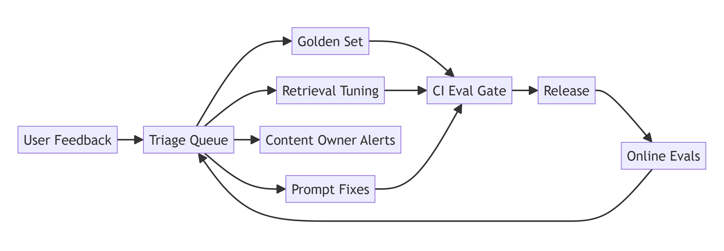

- Quality loop: flagged claims become golden items and reranker hard negatives.
- Content loop: repeated "outdated" flags on a doc notify its owner, so the knowledge base improves too.
- Coverage loop: clusters of "not found" and low-recall queries reveal missing connectors or alias gaps.

6. Productionization & Operations

6.1 Deployment and runtime
- Services: stateless agent workers on Kubernetes (autoscaled on queue depth and CPU); separate ingestion workers; managed search cluster; Postgres for metadata, runs and audit; Redis for cache and sessions; object store for raw docs.
- Invocation: quick mode streams over SSE. Deep mode is an async job with progress events, a cancel button and a notification when done.
- Where it breaks first (in order) and the response to each:
- LLM rate limits → gateway quotas, priority queues, multi-provider.
- Reranker latency → GPU pool, cap candidates at 100.
- ACL sync lag at large orgs → incremental events plus deny-by-default.
- Context window on huge enumerations → hierarchical reduce.

6.2 SLOs, alerts and on-call
SLO | Alert
Answer-path availability 99.5% | Error rate > 2% for 5 min
Quick p95 < 20 s; deep p95 < 4 min | p95 breach for 15 min
ACL leak = 0 | Any canary hit → page immediately, auto-disable the affected source
Ingestion lag < 15 min; ACL lag < 5 min | Lag breach per connector
Cost ≤ budget | Daily spend > 120% of forecast; per-user anomaly
Faithfulness ≥ 95% (online sample) | 24 h rolling drop > 3 points

Runbooks: provider outage (fail over, degrade to search-only); connector outage (circuit-break, banner); leak canary (kill switch per source, incident process); quality drop (roll back prompt/model version); cost spike (tighten caps, check for loops).

6.3 Change management: prompts and models are config
- Prompts, tool schemas, routing rules and thresholds live in a versioned config registry, with PR review and CI eval gates.
- Model upgrades: offline eval → shadow traffic → A/B at 5% → full rollout. Each run stores a config_snapshot_id for reproducibility.
- Index changes: blue/green reindex, with retrieval evals compared before cutover.

6.4 Cost model (illustrative)
Item | Estimate
Quick answer (about 3 small-model calls + 1 large call) | about $0.05
Deep report (about 40 extract calls on the small model + plan/synthesize/verify on the large model) | about $0.60
Blend: 85% quick / 15% deep, 6k queries/day | about $0.13 × 6k ≈ $800/day ≈ $24k/month in LLM spend, plus about $8–12k/month for infrastructure
Value check | 6k × 15 min saved × $80/h ≈ $120k/day in recovered time

Cost levers: model routing, prompt caching, an ACL-scoped semantic cache for repeat questions, extraction results cached per chunk version, deep mode only when the user asks for it.

6.5 Security and governance
- Audit trail: who asked, the query, docs retrieved and cited, model and config version, cost, timestamp. Retained for 1 year (configurable).
- Data governance:
- A data-sources register (owner, classification, connector, ACL model).
- Restricted collections opt in only.
- Right-to-delete propagates from source → index → caches → saved reports within 24 h.
- LLM vendor terms: zero data retention, no training on company data, regional endpoints for residency.
- Security review: pen test for injection and exfiltration paths; red-team suite in CI.

6.6 Roadmap (trust features ship first)
- v0 (one team, about 6 weeks): read-only; 2 sources (wiki + docs); quick mode; ACL pre-filter and citations from day one; golden set of 100; tracing.
- v1: all 6 source types; deep async reports; entity store; verifier; online evals; model routing; semantic cache; Slack bot.
- v2: saved and shared reports with ACL re-check; scheduled briefs; proactive conflict detection; human-approved write tools.

6.7 Risk register
Risk | Likelihood | Impact | Mitigation / owner
ACL leak | Low | Critical | Pre-filter + live re-check + canaries / Security
Low trust from early hallucinations | Medium | High | Strict grounding, visible citations, limited v0 / Product
Connector API limits and changes | High | Medium | Reconciliation jobs, circuit breakers / Platform
LLM cost overrun | Medium | Medium | Caps, routing, budgets / FinOps
Poor source quality (stale wikis) | High | Medium | Content-owner feedback loop, freshness signals / Knowledge mgmt
Adoption stalls | Medium | High | Slack integration, champions, measure time saved / Product

6.8 Assumptions and limitations
- Source systems expose ACLs and change events. If they don't, nightly sync is used, with a larger lag window and stricter deny-by-default.
- Answers can only be as good as the documents. The system reports gaps but cannot fill them.
- Effective-date and entity extraction are probabilistic, so low-confidence cases are flagged, not hidden.
- All numbers are illustrative and need validation in a pilot.

