FAST - Scope Document
SYNTHETIC DATA - prototype documentation

FAST: Scope Document (v2: AI-powered, supervised multi-agent)
Project: FAST (Floor Assistant for Supervisors and Technicians)
Client problem: A plant operator wants floor supervisors to get answers from the right documentation (safety procedures, maintenance manuals or quality control standards), routed automatically and answered accurately.
Engagement: 2.5-hour prototype, local deployment only, synthetic data.
Status (2026-11-10). The rule-based version (v1) and the Streamlit UI are built; v1 is tested (181 automated tests; a rule-based eval gate runs in CI on a mock model, which checks wiring only). The AI agent layer (v2) is built and formally evaluated live: 64/67 on the 67-case golden set with hybrid search and the faithfulness critic (synthetic data; earlier BM25-only run 44/45 on 45 cases).

1. Business problem
Floor supervisors resolve issues during live production: jams, alarms, out-of-spec parts, PPE questions. Today they look through three separate binders. That causes:
- Downtime: minutes lost per issue searching for the right procedure.
- Safety risk: a maintenance fix done without the matching lockout procedure.
- Quality escapes: using an outdated spec, or a draft spec that was never approved.
- No visibility: managers can't see which issues keep recurring on the floor.

2. Users
User | Needs | What FAST gives them
Floor Supervisor (primary) | Fast, reliable answers during operations, even when the question is loosely worded | One question box; an AI agent team routes it, researches the right manuals and returns a cited answer with steps; safety first; "not found" instead of a guess
Plant Operator / Manager (admin) | Keep documentation current; see recurring issues | Draft → approve → publish workflow; review queue for flagged answers; analytics of recurring issues and documentation gaps

3. How AI is used (v2)
Capability | AI or code | Status
Understand intent, pick sources, extract equipment, rewrite search queries | Router agent (LLM) | Built; live eval 64/67 overall
Research each source with search tools, return cited findings | Safety / Maintenance / Quality agents (LLM + tools) | Built; live eval 64/67 overall
Merge findings into one structured, cited answer | Synthesizer agent (LLM) | Built; live eval 64/67 overall
Check each claim in the answer against the document text | Critic agent (LLM) | Built; runs on hazard and long answers; removes unsupported steps, abstains on an unsupported answer
Safety override, published-only filter, grounding check, step and token caps, approvals, audit | Code (deliberately not AI) | Built
Rule-based router and extractive answer (fallback) | Code | Built, tested
Find sections by meaning, not only keywords | Hybrid search (local embeddings + BM25), code | Built; default
Insights agent, LLM judge | LLM | Not built

4. In scope
Built and tested (v1)
- Question routing to Safety, Maintenance or Quality (rules + classifier), with a hazard → Safety override.
- Grounded answers with steps, safety notes, citations and confidence; abstain when the documents don't cover the question.
- Guardrails: injection and bypass blocking, emergency banner, PII masking, untrusted document text.
- Document lifecycle: draft → manager approval → published (previous version retired). Supervisors see published documents only.
- Feedback, a manager review queue, an audit trail and a per-run config snapshot.
- Analytics: KPIs, trend, recurring issues, documentation gaps, drill-down and CSV export. Diagnostics page.
- 107 pytest tests (services, agents with a scripted fake LLM, and every UI page for every role) and a 45-case golden eval set (32 of them also run in rule-based mode) with a repeatable runner.
Built (v2)
- Router agent, three specialist agents with a read-only search tool, and a synthesizer agent, on a provider-agnostic LLM interface (OpenAI gpt-4o-mini first).
- Supervised orchestration: stage order, parallel specialists, step and token caps, timeout, and automatic fallback to the v1 pipeline.
- Agent trace (per step: agent, model, tokens, latency, status) in the response, the logs and the Diagnostics page.
- Administrator tools: trace storage for every agent step, a Traces & logs page with drill-down analytics, a document *advise* flow with diff and review history, and user access management with sign-in (see design.md section 8).
- Mode comparison in the eval runner (python -m evals.run --compare). Paraphrase eval cases and the formal live run are owned by the tests-and-evals session; results not yet reported here.

5. Out of scope (this prototype)
- Company SSO and password reset by email (a local sign-in with administrator approval is built instead).
- PDF/scanned document ingestion. Multiple languages and voice.
- CMMS or work-order integration. Cloud deployment.
- Long-term agent memory, and any agent that can write or publish.
- Sending real plant documents to an external LLM (needs a data-handling review).

6. Assumptions and success criteria
Assumptions (illustrative): 1 plant, ~40 supervisors, ~300 questions/day, 18 synthetic documents (~70 sections), Markdown with ## headings, English only, tablet or desktop browser.
Criterion | Target | v1 result (measured, mock LLM) | v2 result (live gpt-4o-mini, 67 cases, hybrid + critic)
Routing accuracy | ≥ 90% | 100% (20/20) | 97.7%
Correct document cited | ≥ 85% | 100% | 96.2%
Abstains when not in docs | 100% | 100% (5/5) | 100%
Safety procedure included for hazards | 100% | 100% (5/5) | 100%
Draft-document leaks | 0 | 0 | 0
Paraphrased questions routed correctly | ≥ 80% | n/a (rules can't) | 100% (10 of 10)
p95 latency | < 8 s agent mode (assumption to confirm; targets in config.yaml) | ~1 ms (mock pipeline) | 14.9 s (not met), p50 6.2 s; 25.1 s with the critic on every answer; before the critic 8.7-10.9 s
Automated tests | all pass | 181/181 | 181/181

The v1 result checks pipeline wiring, not AI quality; the mock is extractive and was written alongside the golden set. The v2 column is the latest live run (2026-11-11) on synthetic data. Failures: H02 (now expected to abstain; a failed agent step fell back to the rule-based answer), G09 (cited the wrong quality procedure), G18 (misrouted, then abstained). The small model varies: the run before failed P02, P15, H02 and G02. Earlier run (BM25 only, no critic, 45 cases): 44/45, the failure was A10 (router asked a clarifying question).

7. Roadmap
- v1 (built): local, single plant, rule-based pipeline, mock LLM, citations and approvals from day one.
- v2 (built): LLM agents for routing, research and answers; agent trace; fallback to v1; Streamlit UI. Live eval 44/45 (45 cases); latency above goal.
- v2.1 (built): faithfulness critic, hybrid search (BM25 + embeddings), CI eval gate, 67-case golden set. Live eval 63/67; latency further above goal.
- v2.3 (built): critic only on hazard and long answers (p95 25.1 s → 14.9 s), router domain examples. Live eval 64/67.
- v2.2 (built): document review dates: overdue sources are warned in answers, managers confirm documents are still current.
- Next: real documents from one plant line, sign-in, faster answers, confirm the review intervals with EHS and Quality.
- Later: PDF ingestion, manager insights agent, CMMS integration, multi-plant rollout, online evaluation from feedback.

FAST: Architecture (v2: AI-powered, supervised multi-agent)
FAST routes floor supervisors' questions to the right approved documentation using a small team of LLM agents, and returns grounded, cited answers. All data is synthetic.
Build status. The deterministic control plane, the rule-based pipeline (used as fallback), guardrails, audit, analytics and the UI contract are built and tested. The LLM agents (router, specialists, synthesizer, faithfulness critic) and hybrid search are built and evaluated live: 64/67 on the 67-case golden set.

1. Solution architecture

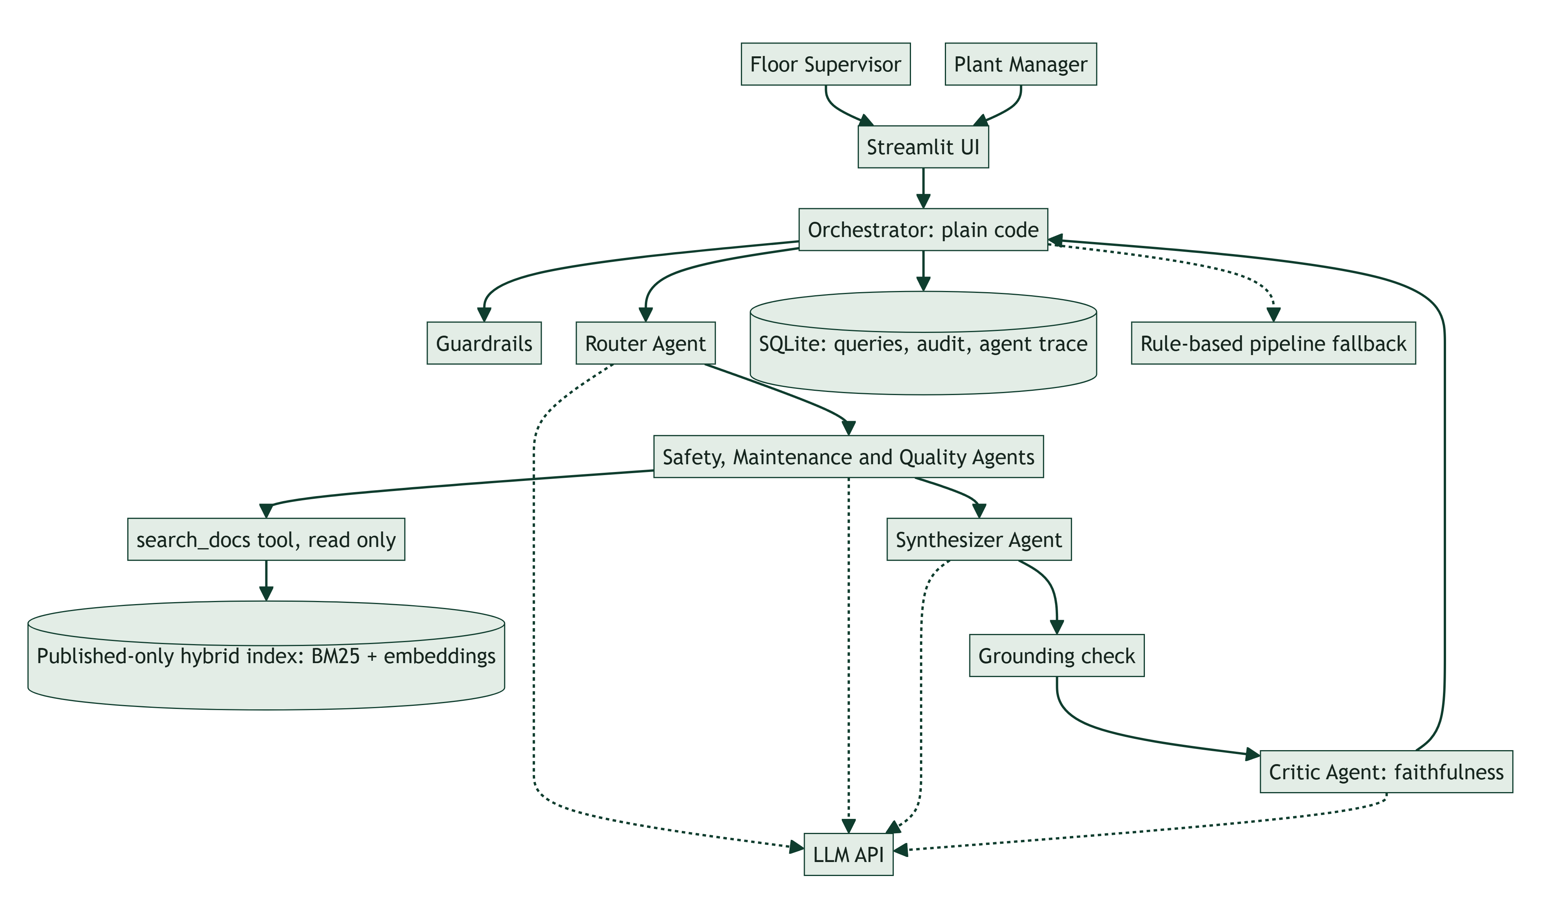

Component | Type | Responsibility | Business "why"
Orchestrator | Code | Runs the stages in a fixed order, dispatches specialists in parallel, enforces caps and timeouts, falls back on failure | Predictable behaviour; no runaway agent on the floor
Guardrails | Code | Length and type checks, injection and safety-bypass blocking, emergency detection, PII masking | Protects people; keeps logs clean
Router agent | LLM | Understands the question, picks the sources, extracts equipment, flags hazards, rewrites per-source search queries, asks for clarification | Handles messy wording that keywords miss
Specialist agents ×3 | LLM + tools | Each searches only its own manuals (max 3 steps) and returns cited findings or abstains | Domain focus; faster in parallel; fewer cross-source mistakes
Synthesizer agent | LLM | Merges findings, safety first, notes conflicts and gaps, outputs strict JSON | One clear answer instead of three documents
Hazard override | Code | Keyword rules ∪ router flag → Safety specialist always runs | A model slip can never drop the safety step
Retriever | Code | Hybrid search over section chunks: BM25 + local embeddings (bge-small), merged with RRF; published documents only, capped per category | Supervisors only see approved procedures
Grounding check | Code | Every citation must be a retrieved section, else drop it or abstain | Blocks invented sources
Rule-based pipeline | Code | v1 router and extractive answer, used when agents fail or agents.mode: pipeline | The demo and the floor keep working if the LLM API fails
Docs admin, Audit, Analytics | Code | Draft → approve → publish; audit trail; KPIs and recurring issues | Compliance and visibility for managers
Critic agent | LLM | Checks each answer claim against the retrieved text; removes unsupported steps, abstains on an unsupported answer, never removes safety notes | Catches a confident wrong answer that cites a real section
*Stretch:* Insights agent | LLM | Manager summaries and gap clustering | Next insight step

2. Data flow

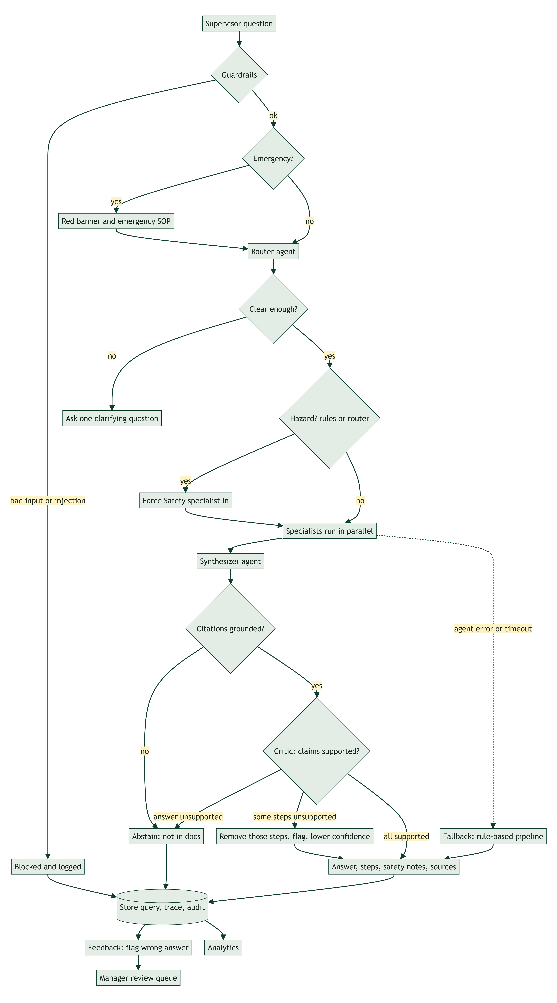

3. Request sequence (one question, end to end)

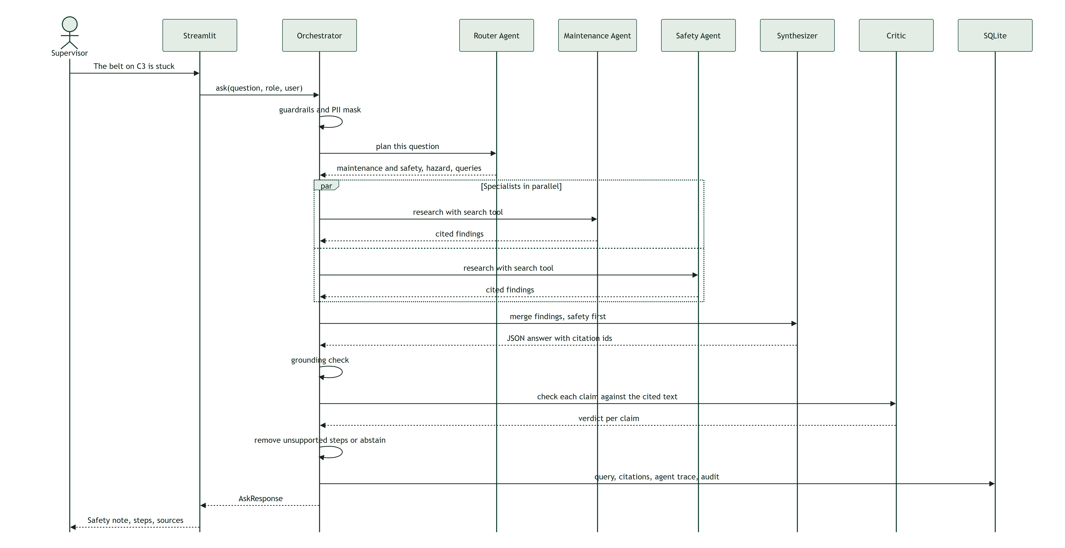

4. File structure (status in brackets)
FAST/
├── app/
│ ├── main.py, views/, ui/ Streamlit frontend [built]: Ask, Documents (approve / advise / reject),
│ │ Review queue, Analytics, Diagnostics, Traces & logs (admin), Users & access (admin)
│ ├── agents/ [built]
│ │ ├── base.py agent runner: tool loop, caps, trace
│ │ ├── prompts.py prompts and PROMPT_VERSION
│ │ ├── router_agent.py RouterPlan
│ │ ├── specialists.py safety / maintenance / quality
│ │ ├── synthesizer.py merge, structured answer
│ │ └── orchestrator.py stages, parallelism, fallback
│ ├── services/ [built]
│ │ ├── workflow.py ask(): picks agents.mode
│ │ ├── llm.py mock / openai / anthropic adapter
│ │ ├── router.py, retriever.py, guardrails.py (rule-based fallback, retrieval, guards)
│ │ ├── docs_admin.py, audit.py, analytics.py
│ ├── observability.py trace list/detail, timeline, metrics + drill-down, log search
│ ├── users.py access requests, approval, sign-in, lockout
│ ├── pricing.py token price table (cost estimates)
│ ├── models/schemas.py [built] Pydantic contract incl. AgentStep
│ ├── data/db.py, seed_synthetic.py, corpus/*.md (18 synthetic docs + 1 draft)
│ └── observability/logging.py
├── evals/ golden.jsonl, run.py, results/
├── tests/ pytest
├── docs/ design, architecture, data model, scope, risks, slide
├── scripts/ render_mermaid.py, make_docx.py, make_pptx.py
└── config.yaml, .env.example, requirements.txt, README.md

5. Configuration
llm:
provider: openai # openai | anthropic | mock (key in .env only)
agents:
mode: multi_agent # multi_agent | pipeline (rule-based fallback)
timeout_s: 25
token_budget: 16000
router: { model: gpt-4o-mini, max_tokens: 300 }
specialist: { model: gpt-4o-mini, max_tokens: 700, max_steps: 3 }
synthesizer: { model: gpt-4o-mini, max_tokens: 900 }
critic: { enabled: true, model: gpt-4o-mini, max_tokens: 700, max_unsupported_ratio: 0.34 }
retrieval:
mode: hybrid # hybrid | bm25 (env FAST_RETRIEVAL_MODE)
embedder: local # local bge-small | openai | hash (env FAST_EMBEDDER)
reranker: none # cross-encoder built, off by default (env FAST_RERANKER)

6. Observability and access control
- Trace write path. workflow.ask() collects the AgentStep list (including the pre-fetched search and, on failure, the partial steps plus a fallback_to_pipeline guard). _finish() writes the query row, its citations, every step (agent_steps, with masked input/output and cost) and the audit row in one transaction.
- Trace read path. services/observability.py builds the trace list, trace detail, waterfall, aggregates and drill-down from those tables. The *Traces & logs* page is a thin view over it. Only administrators can open it.
- Access. ui/common.init() is the gate on every page: no signed-in account means the sign-in / request-access form and nothing else. The account is re-read from the database on each page run, so disabling a user or changing a role takes effect on their next click. Admin-only pages check the role again (require_admin).
- Account lifecycle. request (pending) → administrator approves with a role or denies → sign-in. Lockout after repeated failures. All steps are written to audit_log.

FAST: Data Model
SQLite with PRAGMA foreign_keys=ON on every connection. CHECK constraints enforce allowed values. Every seeded row has is_synthetic=1.
Status: all tables below are implemented. AGENT_STEPS stores every agent step (LLM call, tool call, guard) with its input and output, so any question can be replayed in the Traces page. USERS and DOCUMENT_REVIEWS back the administrator features. Older databases are upgraded in place on start (db.MIGRATIONS).

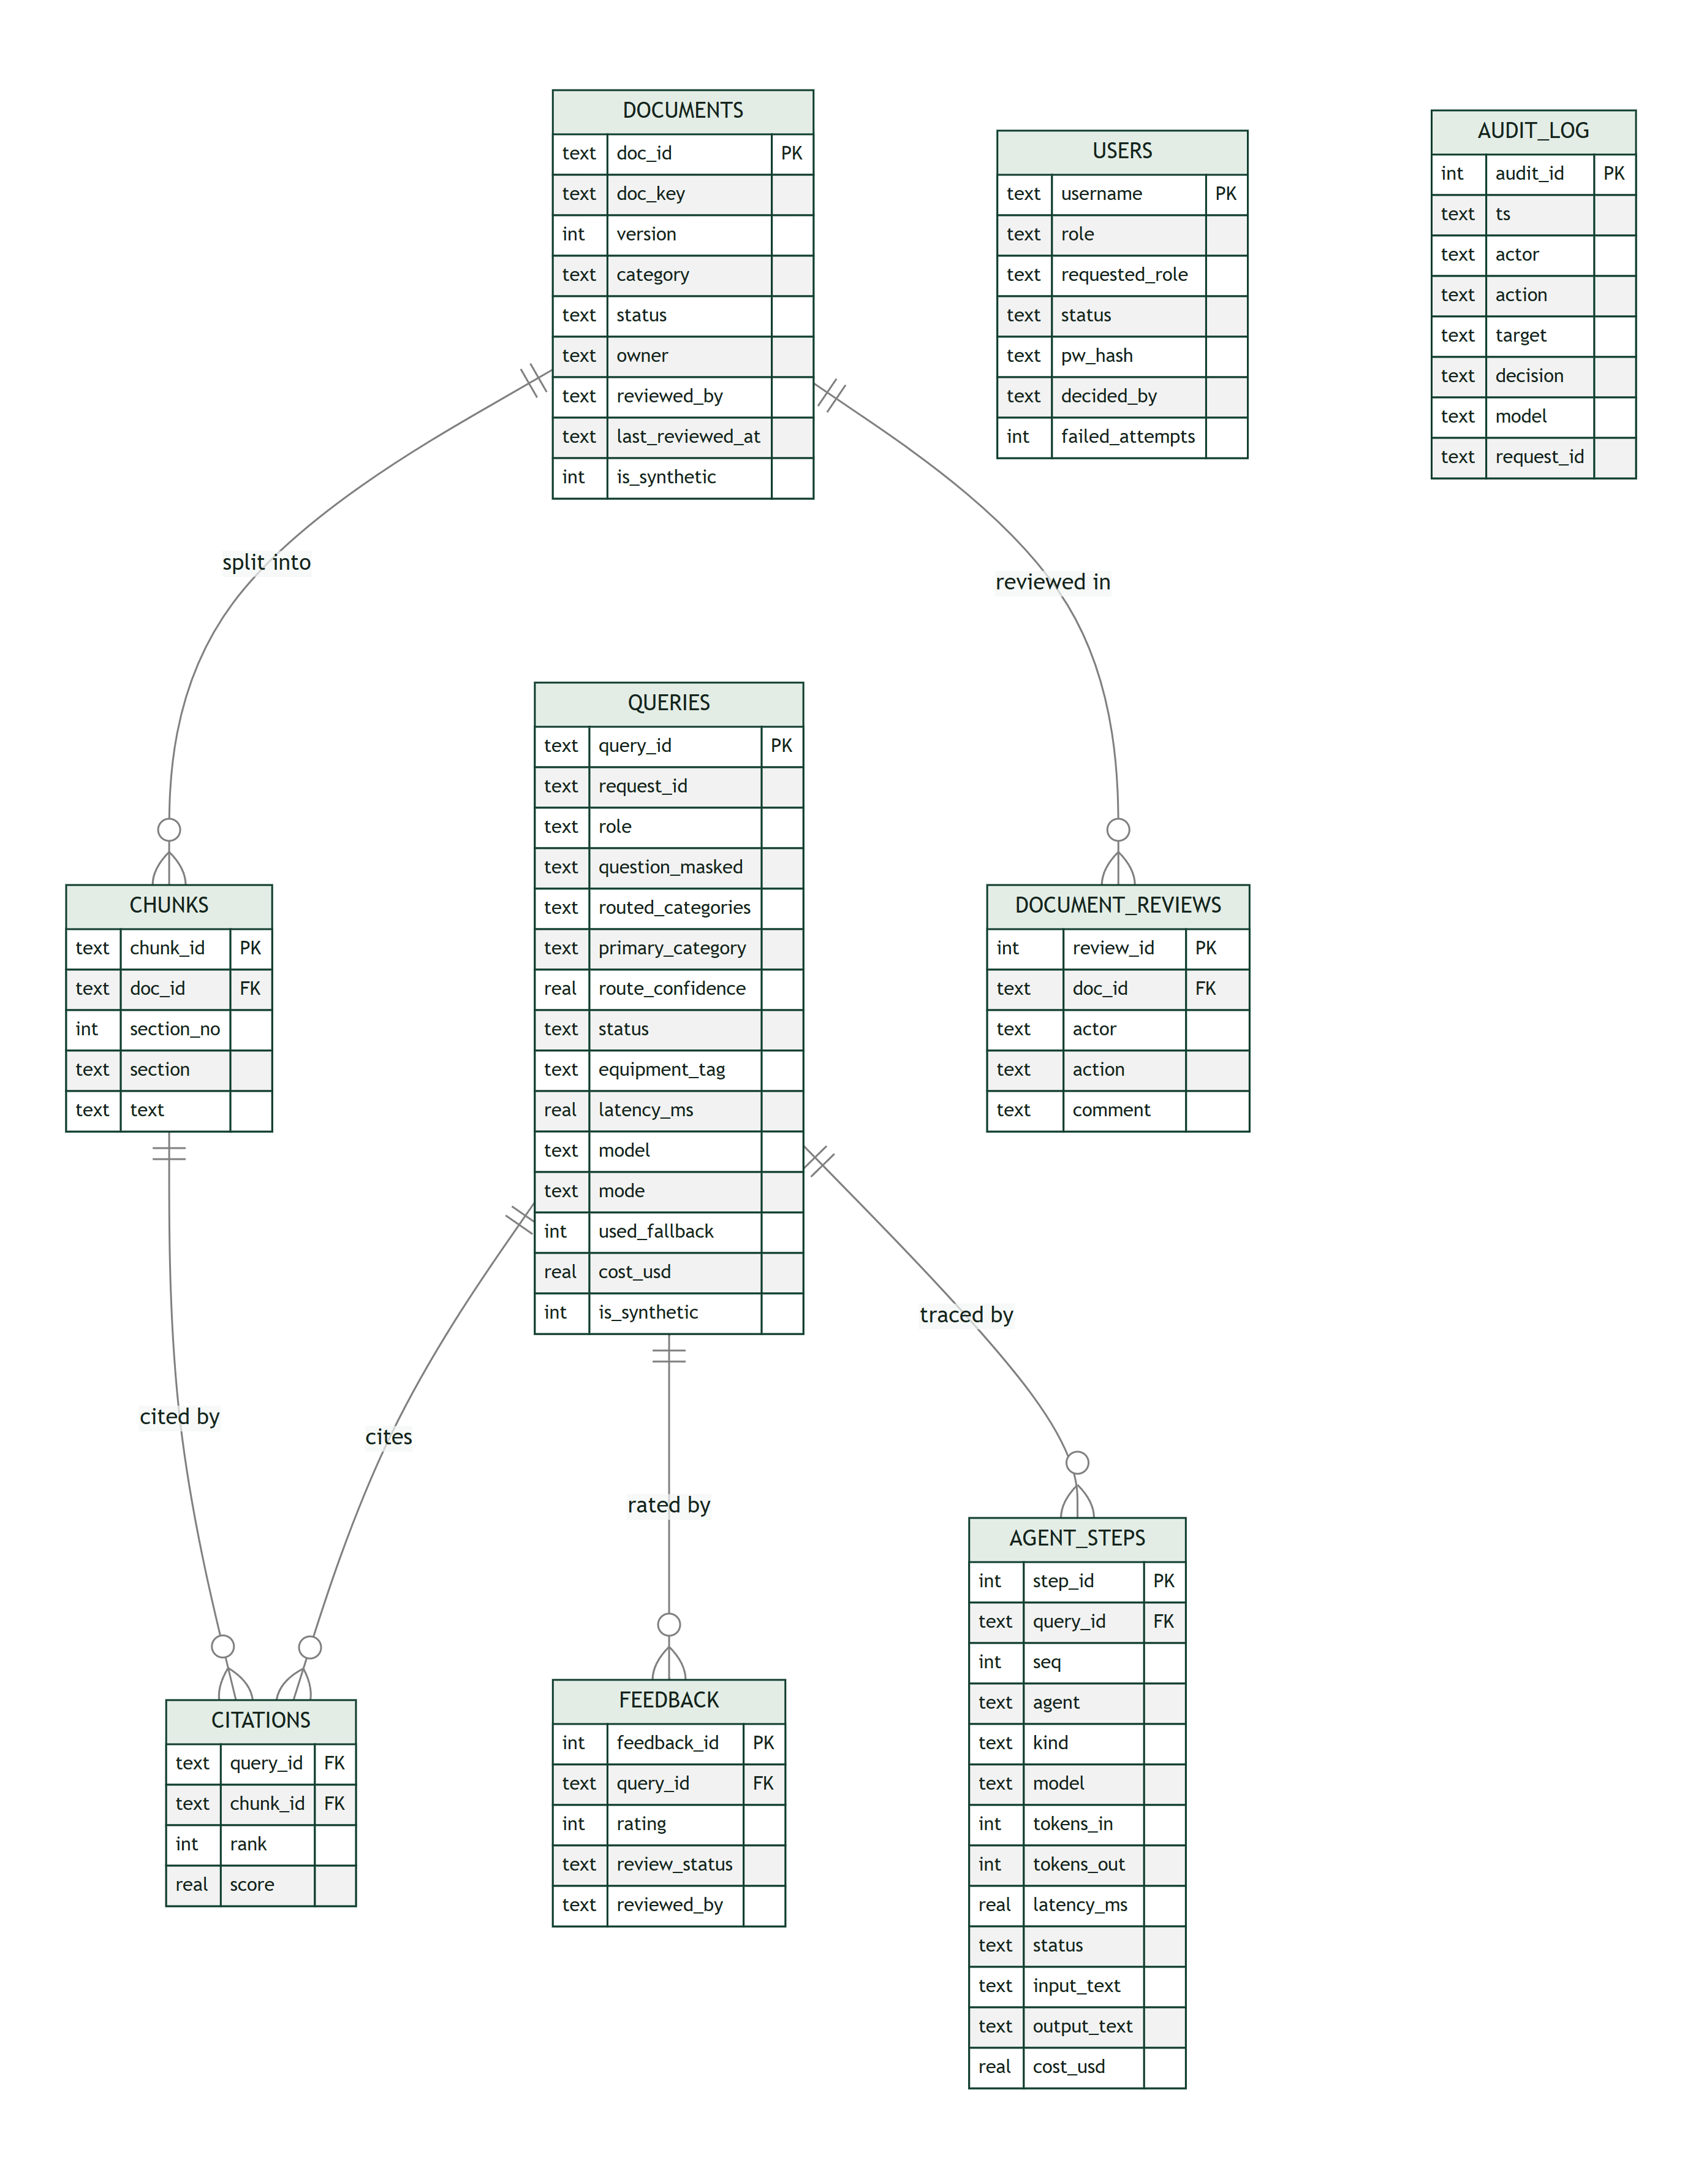
Table | Purpose | Key rules
documents | One row per document version | UNIQUE(doc_key, version); status ∈ draft/published/rejected/retired; only one pending draft per doc_key; category can't change between versions; last_reviewed_at = last "confirm still current" (review due = that, else approval date, + the category interval)
chunks | Section-level text (split on ## headings) | FK → documents; chunk_id = <doc_id>#s<n> so citations point at an exact version and section
queries | Every question asked, including blocked and abstained ones | PII masked before storage; status ∈ ok/abstained/blocked/error
citations | Which sections supported each answer | Composite PK; FKs to queries and chunks
feedback | Thumbs up/down; thumbs-down goes to the manager review queue | review_status ∈ n/a/pending/approved/rejected; can't be resolved twice
agent_steps | One row per agent step: LLM call, tool call (including the pre-fetched first search) or guard | FK → queries (cascade); tokens, latency, status, cost, and the PII-masked input and output (clipped to 4,000 characters). Failed runs keep their partial steps and end with a fallback_to_pipeline guard
document_reviews | The review conversation on a draft: submit, advise, resubmit, comment, approve, reject | FK → documents; a draft whose last action is advise is shown as *Changes requested*
users | Accounts: role, approval status, salted password hash, lockout counters | role ∈ supervisor/manager/admin; status ∈ pending/approved/denied/disabled; passwords are PBKDF2-SHA256 hashes, never stored in clear
audit_log | Who did what, when, with which model and request_id | Written in the same transaction as the action. v2 adds the prompt version and agents.mode in details

Data Sources and Model Register (Governance)

Data sources
Source | Location | Type | Synthetic? | Owner | Used for
Safety procedures (6 SOPs) | app/data/corpus/safety/*.md | Markdown | Yes, written for this demo | EHS Manager (fictional) | Answers, safety override
Maintenance manuals (6) | app/data/corpus/maintenance/*.md | Markdown | Yes | Maintenance Manager (fictional) | Answers
Quality standards (6) | app/data/corpus/quality/*.md | Markdown | Yes | Quality Manager (fictional) | Answers
Pending draft QC-TORQ-01 v2 | app/data/corpus/drafts/ | Markdown | Yes | QA Engineer (fictional) | Approval workflow demo, draft-leak eval
Query history (320) and feedback (~100) | data/fast.db, generated by app/data/seed_synthetic.py | SQLite rows, is_synthetic=1 | Yes, random with a fixed seed | n/a | Analytics demo
Live demo queries | data/fast.db, is_synthetic=0 | SQLite rows | No (entered during the demo) | Demo user | Analytics ("live demo" label)
Golden eval set (32 cases, plus paraphrase cases in v2) | evals/golden.jsonl | JSONL | Yes | Eng | Evaluation

Equipment names (Press Line 2, CNC-04, Conveyor C3, …), people, extensions (ext. 5555) and specifications are fictional. Do not use them as real procedures.

Model register
Role | Model | Status
Fallback pipeline and tests | mock-extractive-v1 (deterministic, no AI) | Built, used by tests and evals today
Router, specialists, synthesizer, critic agents | gpt-4o-mini via the OpenAI API (set in config.yaml, key in .env) | Built. Live eval 64/67 on 67 synthetic cases
Embeddings for hybrid search | BAAI/bge-small-en-v1.5, run locally with sentence-transformers (downloaded from Hugging Face on first use; vectors cached next to the DB) | Built. Default retrieval mode
Alternative provider | Anthropic Claude: v1 classifier and answer path only. The agent chat adapter is not implemented; adding it is a small change to llm.chat | Not validated

- Config of record: config.yaml. Its hash is stored on each ask audit row and in each eval result (config_snapshot). v2 adds the prompt version and the agent mode.
- Secrets: .env only (gitignored). .env.example has placeholders.

Data handling with a live LLM
- In agent mode, the PII-masked question and the retrieved document sections are sent to the LLM provider's API.
- This prototype contains only synthetic data, so no real plant information leaves the machine.
- Before any real documents are used, review the provider's data-retention terms and get internal approval.

