MIKRA - Scope Document
SYNTHETIC DATA - prototype documentation

MIKRA: Scope Document (v2: AI-powered, supervised multi-agent)
Project: MIKRA (Manufacturing Intelligent Knowledge Routing Assistant)
Client problem: A plant operator wants floor supervisors to get answers from the right documentation (safety procedures, maintenance manuals or quality control standards), routed automatically and answered accurately.
Engagement: 2.5-hour prototype, local deployment only, synthetic data.
Status. The rule-based version (v1) is built and tested. The AI agent layer (v2) is designed and in build. Nothing in section 6 for v2 has been measured with a live model yet.

1. Business problem
Floor supervisors resolve issues during live production: jams, alarms, out-of-spec parts, PPE questions. Today they look through three separate binders. That causes:
- Downtime: minutes lost per issue searching for the right procedure.
- Safety risk: a maintenance fix done without the matching lockout procedure.
- Quality escapes: using an outdated spec, or a draft spec that was never approved.
- No visibility: managers can't see which issues keep recurring on the floor.

2. Users
User | Needs | What MIKRA gives them
Floor Supervisor (primary) | Fast, reliable answers during operations, even when the question is loosely worded | One question box; an AI agent team routes it, researches the right manuals and returns a cited answer with steps; safety first; "not found" instead of a guess
Plant Operator / Manager (admin) | Keep documentation current; see recurring issues | Draft → approve → publish workflow; review queue for flagged answers; analytics of recurring issues and documentation gaps

3. How AI is used (v2)
Capability | AI or code | Status
Understand intent, pick sources, extract equipment, rewrite search queries | Router agent (LLM) | In build
Research each source with search tools, return cited findings | Safety / Maintenance / Quality agents (LLM + tools) | In build
Merge findings into one structured, cited answer | Synthesizer agent (LLM) | In build
Safety override, published-only filter, grounding check, step and token caps, approvals, audit | Code (deliberately not AI) | Built
Rule-based router and extractive answer (fallback) | Code | Built, tested
Critic agent, insights agent, semantic search, LLM judge | LLM | Stretch

4. In scope
Built and tested (v1)
- Question routing to Safety, Maintenance or Quality (rules + classifier), with a hazard → Safety override.
- Grounded answers with steps, safety notes, citations and confidence; abstain when the documents don't cover the question.
- Guardrails: injection and bypass blocking, emergency banner, PII masking, untrusted document text.
- Document lifecycle: draft → manager approval → published (previous version retired). Supervisors see published documents only.
- Feedback, a manager review queue, an audit trail and a per-run config snapshot.
- Analytics: KPIs, trend, recurring issues, documentation gaps, drill-down and CSV export. Diagnostics page.
- 29 pytest tests and a 32-case golden eval set with a repeatable runner.
In build (v2)
- Router agent, three specialist agents with a read-only search tool, and a synthesizer agent, on a provider-agnostic LLM interface (OpenAI gpt-4o-mini first).
- Supervised orchestration: stage order, parallel specialists, step and token caps, timeout, and automatic fallback to the v1 pipeline.
- Agent trace (per step: agent, model, tokens, latency, status) in the response, the logs and the Diagnostics page.
- About 10 paraphrase eval cases and a pipeline vs agent mode comparison.

5. Out of scope (this prototype)
- Real authentication or SSO (a role selector is used instead).
- PDF/scanned document ingestion. Multiple languages and voice.
- CMMS or work-order integration. Cloud deployment.
- Long-term agent memory, and any agent that can write or publish.
- Sending real plant documents to an external LLM (needs a data-handling review).

6. Assumptions and success criteria
Assumptions (illustrative): 1 plant, ~40 supervisors, ~300 questions/day, 18 synthetic documents (~70 sections), Markdown with ## headings, English only, tablet or desktop browser.
Criterion | Target | v1 result (measured, mock LLM) | v2 result (live LLM)
Routing accuracy | ≥ 90% | 100% (20/20) | not yet measured
Correct document cited | ≥ 85% | 100% | not yet measured
Abstains when not in docs | 100% | 100% (5/5) | not yet measured
Safety procedure included for hazards | 100% | 100% (5/5) | not yet measured
Draft-document leaks | 0 | 0 | not yet measured
Paraphrased questions routed correctly | ≥ 80% | n/a (rules can't) | not yet measured
p95 latency | < 8 s agent mode | ~1 ms (mock pipeline) | not yet measured
Automated tests | all pass | 29/29 | to extend

The v1 pass rate (32/32) checks pipeline wiring, not AI quality. The mock is extractive and was written alongside the golden set. v2 numbers will be reported only after live runs.

7. Roadmap
- v1 (built): local, single plant, rule-based pipeline, mock LLM, citations and approvals from day one.
- v2 (in build): LLM agents for routing, research and answers; agent trace; fallback to v1.
- v2 stretch: critic agent, manager insights agent, embedding search, LLM judge for faithfulness.
- Next: SSO, PDF ingestion, hybrid search, CMMS integration, multi-plant rollout, online evaluation from feedback.

MIKRA: Architecture (v2: AI-powered, supervised multi-agent)
MIKRA routes floor supervisors' questions to the right approved documentation using a small team of LLM agents, and returns grounded, cited answers. All data is synthetic.
Build status. The deterministic control plane, the rule-based pipeline (used as fallback), guardrails, audit, analytics and the UI contract are built and tested. The LLM agents (router, specialists, synthesizer) are in build and have not yet been measured with a live model.

1. Solution architecture

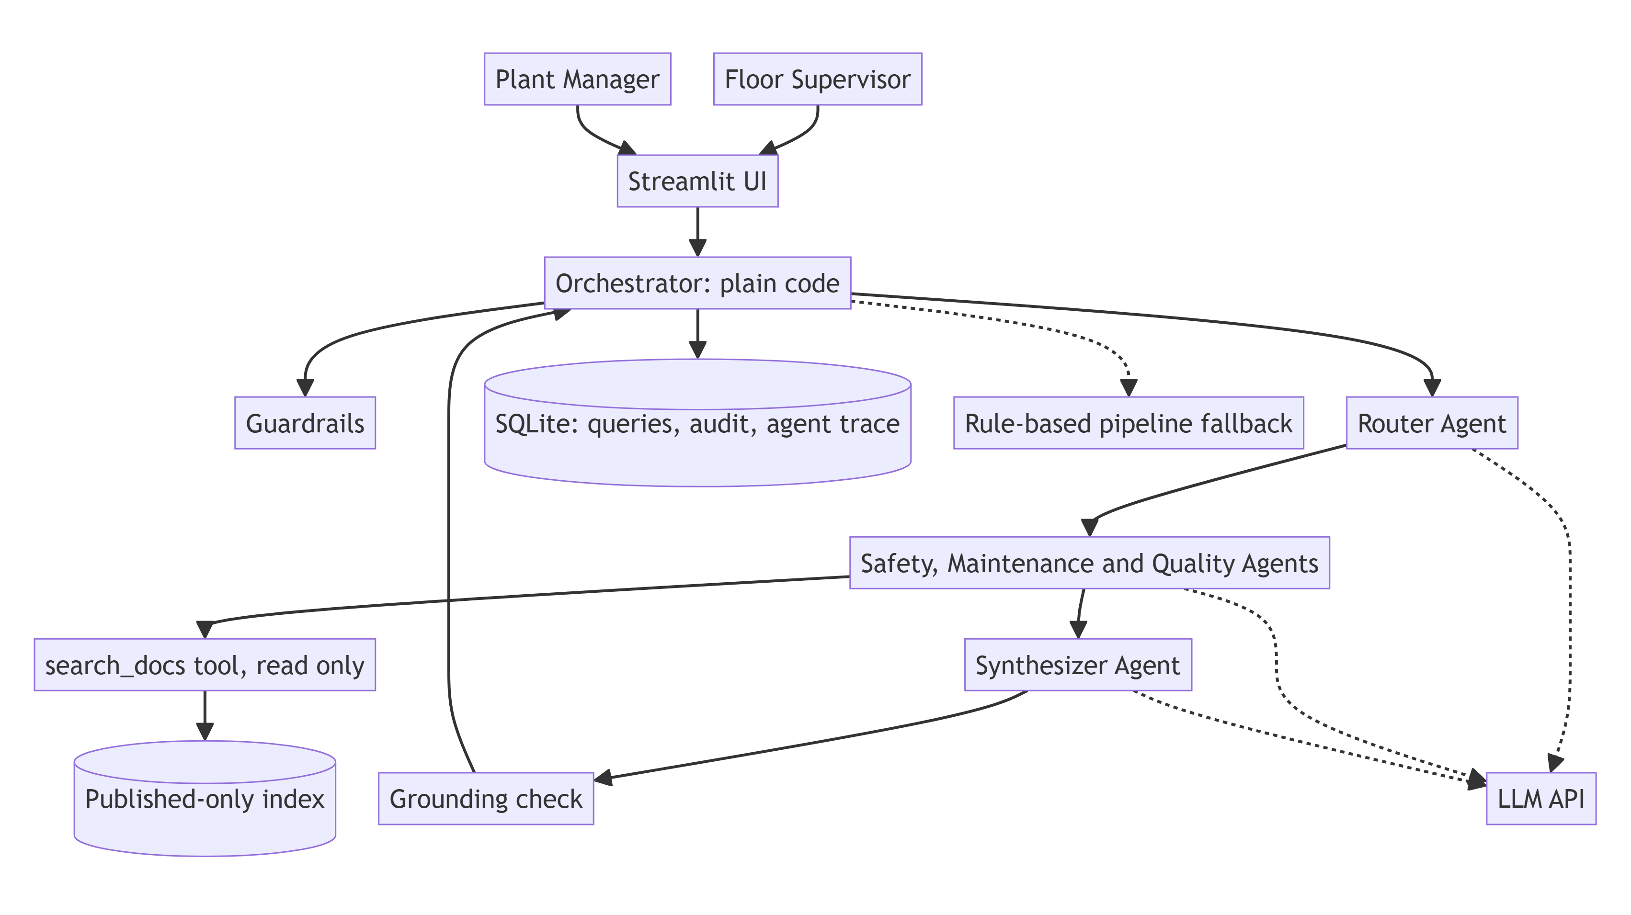

Component | Type | Responsibility | Business "why"
Orchestrator | Code | Runs the stages in a fixed order, dispatches specialists in parallel, enforces caps and timeouts, falls back on failure | Predictable behaviour; no runaway agent on the floor
Guardrails | Code | Length and type checks, injection and safety-bypass blocking, emergency detection, PII masking | Protects people; keeps logs clean
Router agent | LLM | Understands the question, picks the sources, extracts equipment, flags hazards, rewrites per-source search queries, asks for clarification | Handles messy wording that keywords miss
Specialist agents ×3 | LLM + tools | Each searches only its own manuals (max 3 steps) and returns cited findings or abstains | Domain focus; faster in parallel; fewer cross-source mistakes
Synthesizer agent | LLM | Merges findings, safety first, notes conflicts and gaps, outputs strict JSON | One clear answer instead of three documents
Hazard override | Code | Keyword rules ∪ router flag → Safety specialist always runs | A model slip can never drop the safety step
Retriever | Code | BM25 over section chunks, published documents only, scoped per category | Supervisors only see approved procedures
Grounding check | Code | Every citation must be a retrieved section, else drop it or abstain | Blocks invented sources
Rule-based pipeline | Code | v1 router and extractive answer, used when agents fail or agents.mode: pipeline | The demo and the floor keep working if the LLM API fails
Docs admin, Audit, Analytics | Code | Draft → approve → publish; audit trail; KPIs and recurring issues | Compliance and visibility for managers
*Stretch:* Critic, Insights agent, embeddings | LLM | Claim checking, manager summaries and gap clustering, semantic search | Next quality and insight steps

2. Data flow

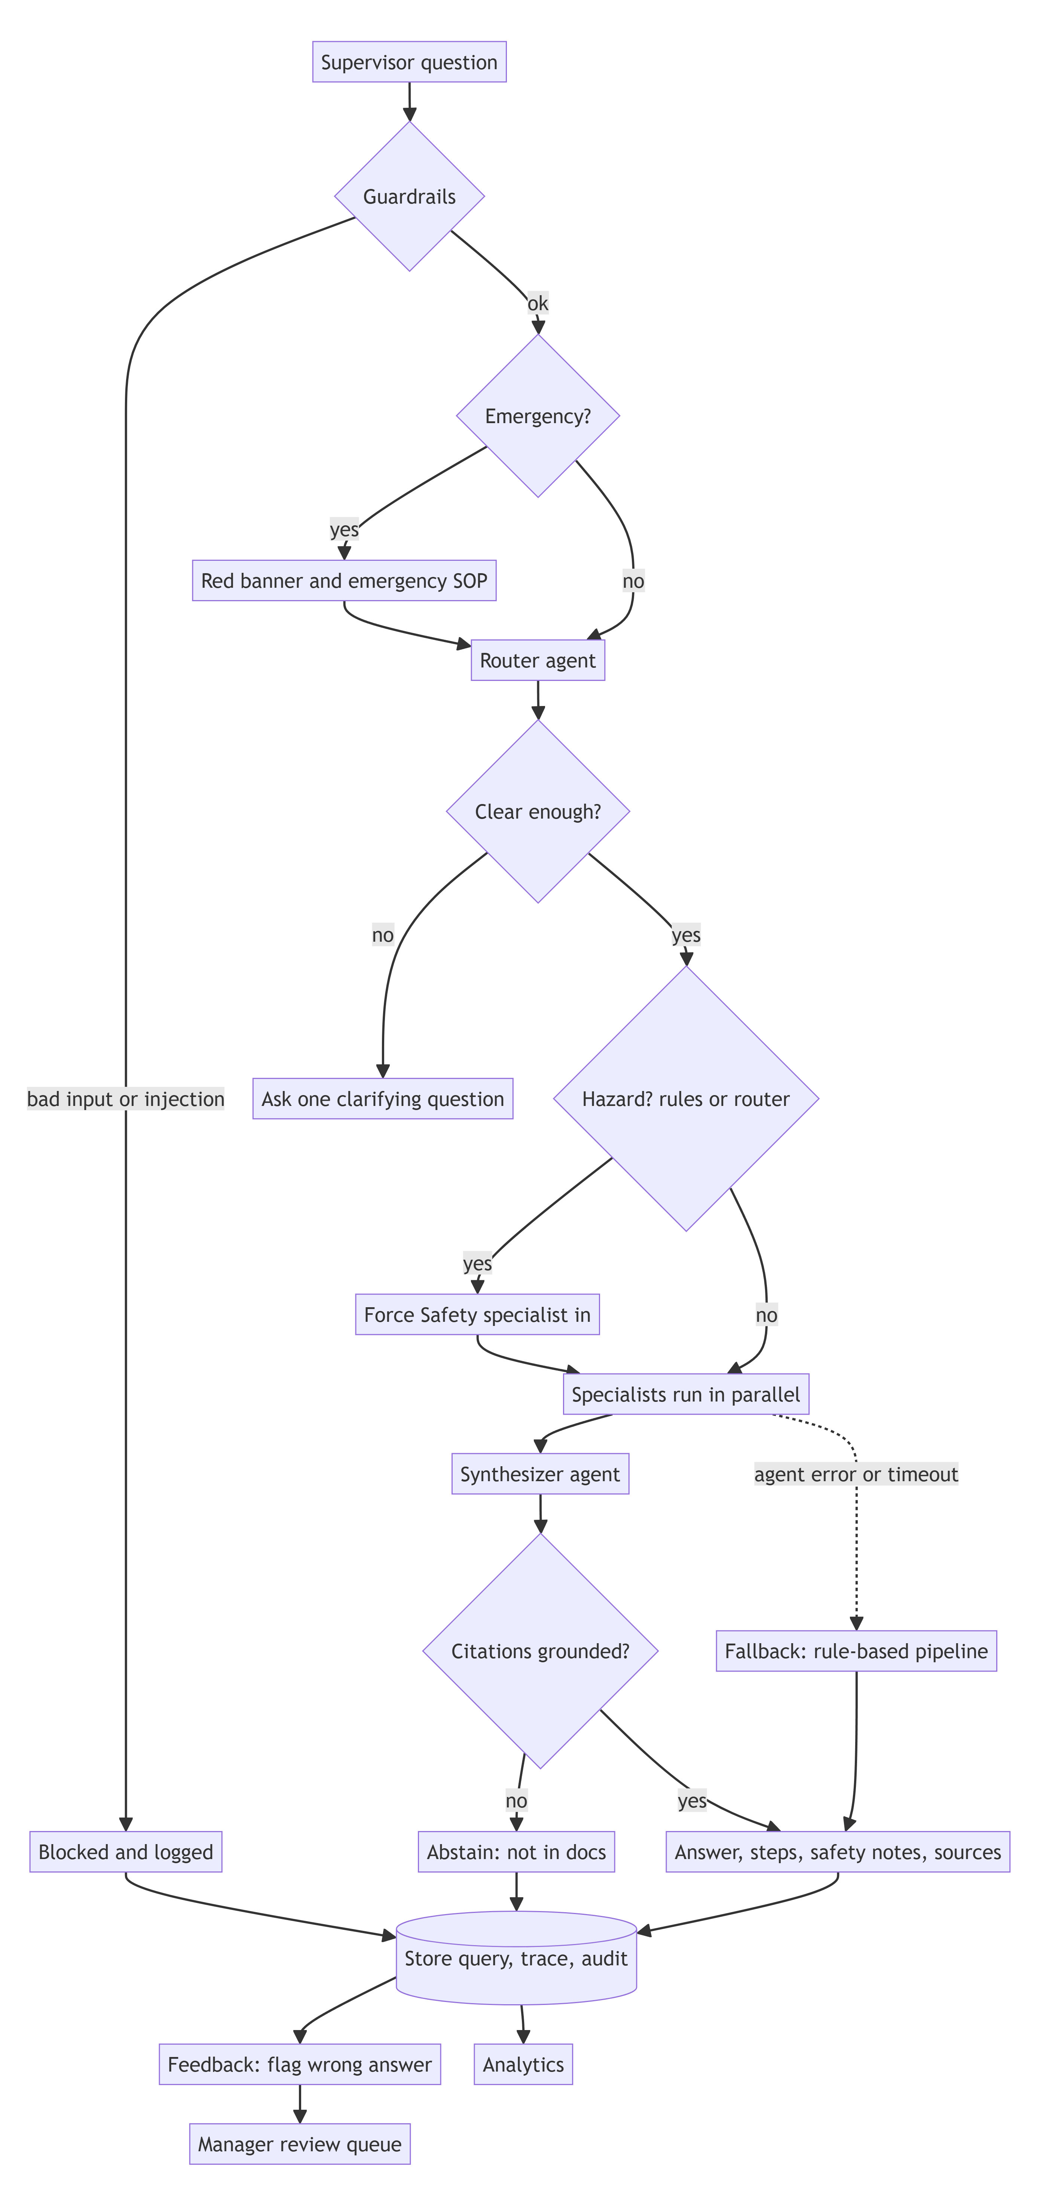

3. Request sequence (one question, end to end)

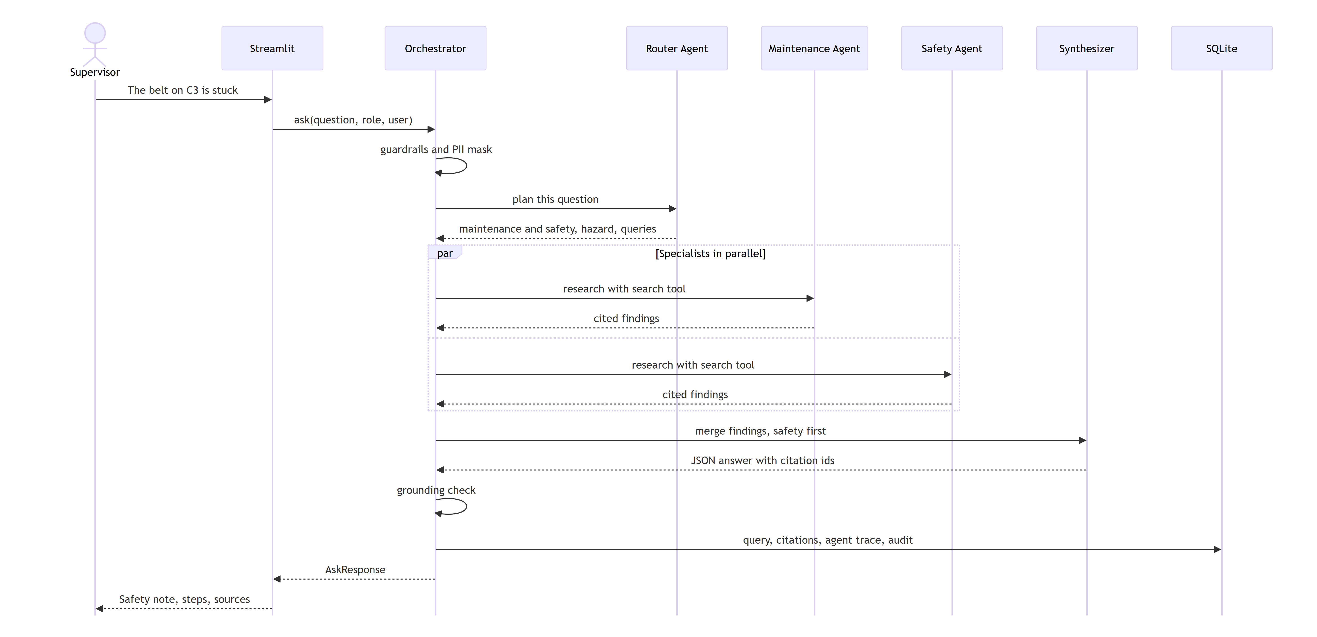

4. File structure (status in brackets)
mfg-doc-router/
├── app/
│ ├── main.py, pages/, ui/ Streamlit frontend [separate session]
│ ├── agents/ [in build]
│ │ ├── base.py agent runner: tool loop, caps, trace
│ │ ├── prompts.py prompts and PROMPT_VERSION
│ │ ├── router_agent.py RouterPlan
│ │ ├── specialists.py safety / maintenance / quality
│ │ ├── synthesizer.py merge, structured answer
│ │ └── orchestrator.py stages, parallelism, fallback
│ ├── services/ [built; llm.py and workflow.py being extended]
│ │ ├── workflow.py ask(): picks agents.mode
│ │ ├── llm.py mock / openai / anthropic adapter
│ │ ├── router.py, retriever.py, guardrails.py (rule-based fallback, retrieval, guards)
│ │ ├── docs_admin.py, audit.py, analytics.py
│ ├── models/schemas.py [built] Pydantic contract incl. AgentStep
│ ├── data/db.py, seed_synthetic.py, corpus/*.md (18 synthetic docs + 1 draft)
│ └── observability/logging.py
├── evals/ golden.jsonl, run.py, results/
├── tests/ pytest
├── docs/ design, architecture, data model, scope, risks, slide
├── scripts/ render_mermaid.py, make_docx.py, make_pptx.py
└── config.yaml, .env.example, requirements.txt, README.md

5. Configuration
llm:
provider: openai # openai | anthropic | mock (key in .env only)
agents:
mode: multi_agent # multi_agent | pipeline (rule-based fallback)
timeout_s: 25
token_budget: 12000
router: { model: gpt-4o-mini, max_tokens: 300 }
specialist: { model: gpt-4o-mini, max_tokens: 700, max_steps: 3 }
synthesizer: { model: gpt-4o-mini, max_tokens: 900 }

MIKRA: Data Model
SQLite with PRAGMA foreign_keys=ON on every connection. CHECK constraints enforce allowed values. Every seeded row has is_synthetic=1.
Status: the tables below are implemented except AGENT_STEPS, which is planned for v2. Until it lands, the agent trace is returned in AskResponse.agent_trace and written to the JSON logs.

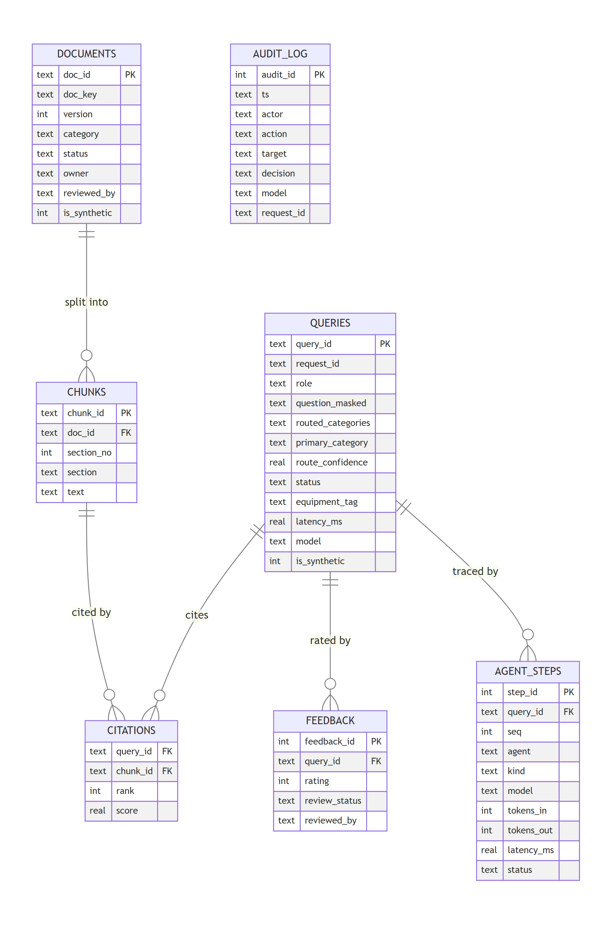
Table | Purpose | Key rules
documents | One row per document version | UNIQUE(doc_key, version); status ∈ draft/published/rejected/retired; only one pending draft per doc_key; category can't change between versions
chunks | Section-level text (split on ## headings) | FK → documents; chunk_id = <doc_id>#s<n> so citations point at an exact version and section
queries | Every question asked, including blocked and abstained ones | PII masked before storage; status ∈ ok/abstained/blocked/error
citations | Which sections supported each answer | Composite PK; FKs to queries and chunks
feedback | Thumbs up/down; thumbs-down goes to the manager review queue | review_status ∈ n/a/pending/approved/rejected; can't be resolved twice
agent_steps *(planned)* | One row per agent step: LLM call, tool call or guard | FK → queries; tokens, latency and status per step, so cost and slow agents are visible
audit_log | Who did what, when, with which model and request_id | Written in the same transaction as the action. v2 adds the prompt version and agents.mode in details

Data Sources and Model Register (Governance)

Data sources
Source | Location | Type | Synthetic? | Owner | Used for
Safety procedures (6 SOPs) | app/data/corpus/safety/*.md | Markdown | Yes, written for this demo | EHS Manager (fictional) | Answers, safety override
Maintenance manuals (6) | app/data/corpus/maintenance/*.md | Markdown | Yes | Maintenance Manager (fictional) | Answers
Quality standards (6) | app/data/corpus/quality/*.md | Markdown | Yes | Quality Manager (fictional) | Answers
Pending draft QC-TORQ-01 v2 | app/data/corpus/drafts/ | Markdown | Yes | QA Engineer (fictional) | Approval workflow demo, draft-leak eval
Query history (320) and feedback (~100) | data/mikra.db, generated by app/data/seed_synthetic.py | SQLite rows, is_synthetic=1 | Yes, random with a fixed seed | n/a | Analytics demo
Live demo queries | data/mikra.db, is_synthetic=0 | SQLite rows | No (entered during the demo) | Demo user | Analytics ("live demo" label)
Golden eval set (32 cases, plus paraphrase cases in v2) | evals/golden.jsonl | JSONL | Yes | Eng | Evaluation

Equipment names (Press Line 2, CNC-04, Conveyor C3, …), people, extensions (ext. 5555) and specifications are fictional. Do not use them as real procedures.

Model register
Role | Model | Status
Fallback pipeline and tests | mock-extractive-v1 (deterministic, no AI) | Built, used by tests and evals today
Router, specialists, synthesizer agents | gpt-4o-mini via the OpenAI API (set in config.yaml, key in .env) | In build, not yet validated
Alternative provider | Anthropic Claude via the same interface (LLM_PROVIDER=anthropic) | Wired in v1 code, not validated

- Config of record: config.yaml. Its hash is stored on each ask audit row and in each eval result (config_snapshot). v2 adds the prompt version and the agent mode.
- Secrets: .env only (gitignored). .env.example has placeholders.

Data handling with a live LLM
- In agent mode, the PII-masked question and the retrieved document sections are sent to the LLM provider's API.
- This prototype contains only synthetic data, so no real plant information leaves the machine.
- Before any real documents are used, review the provider's data-retention terms and get internal approval.

