Architecture

Design principle
The LLM proposes; Python disposes. The model is used only where language understanding is needed (picking a category from a closed list, extracting facts from messy text). Every output is parsed and validated with Pydantic, retried with the validation error on failure, and then all policy decisions (required attributes, prohibited terms, price, PII, injection, confidence threshold, routing, publish gate) are made by deterministic Python. The LLM is never asked "is this compliant?".

1. System architecture
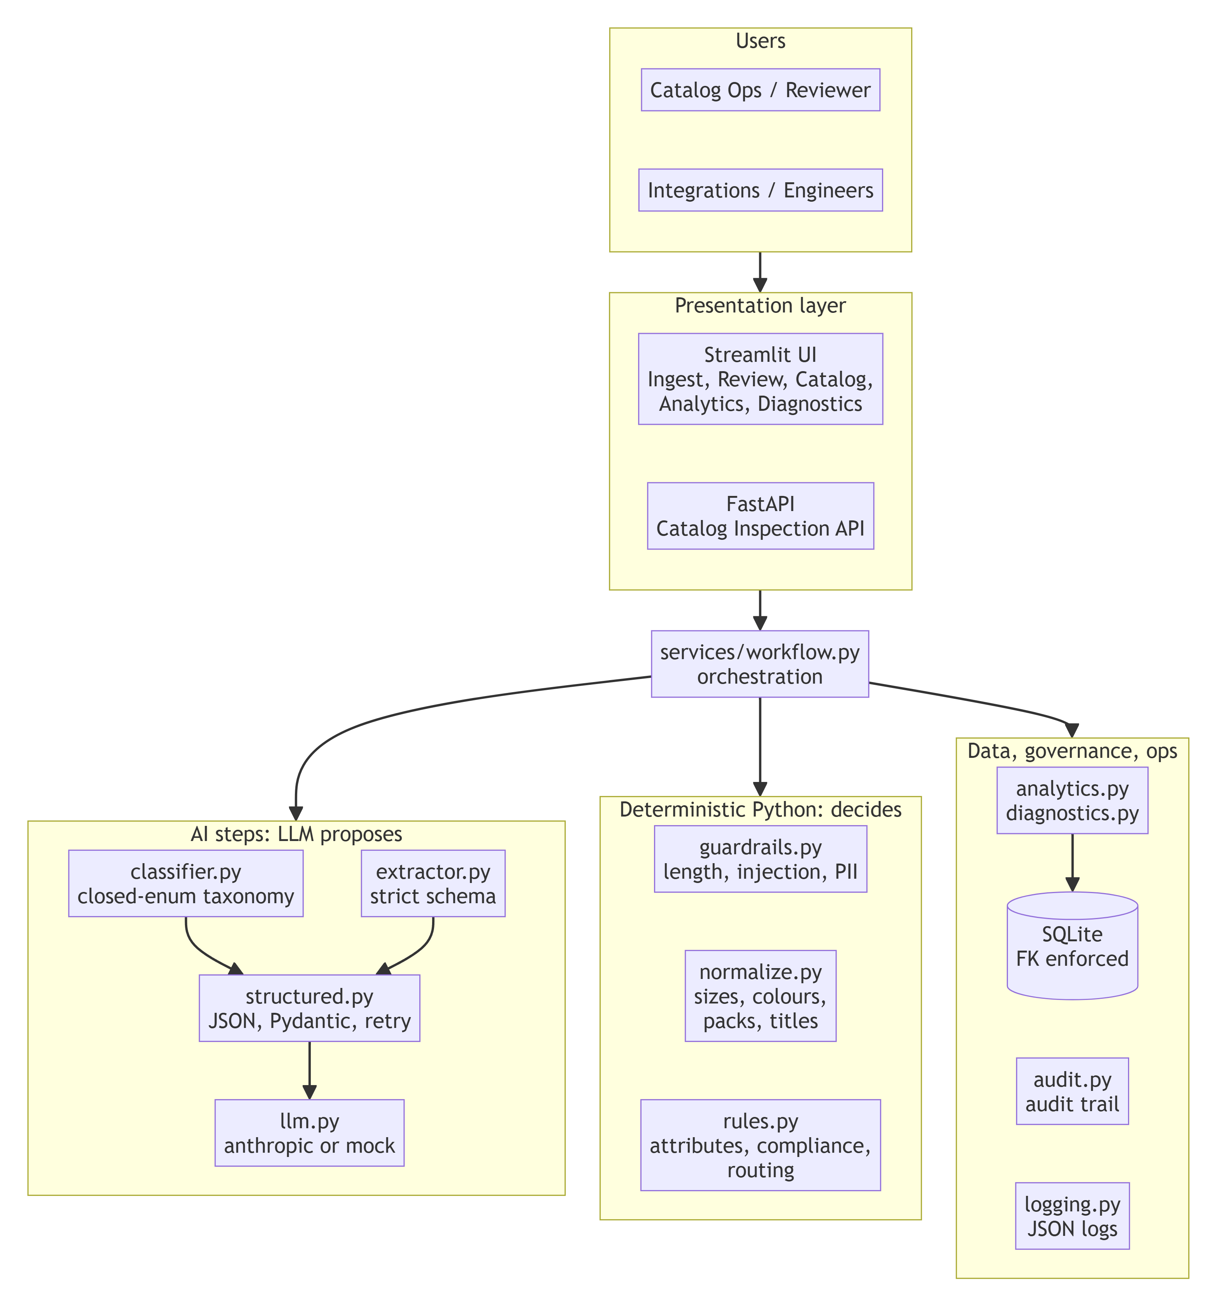

2. Data flow
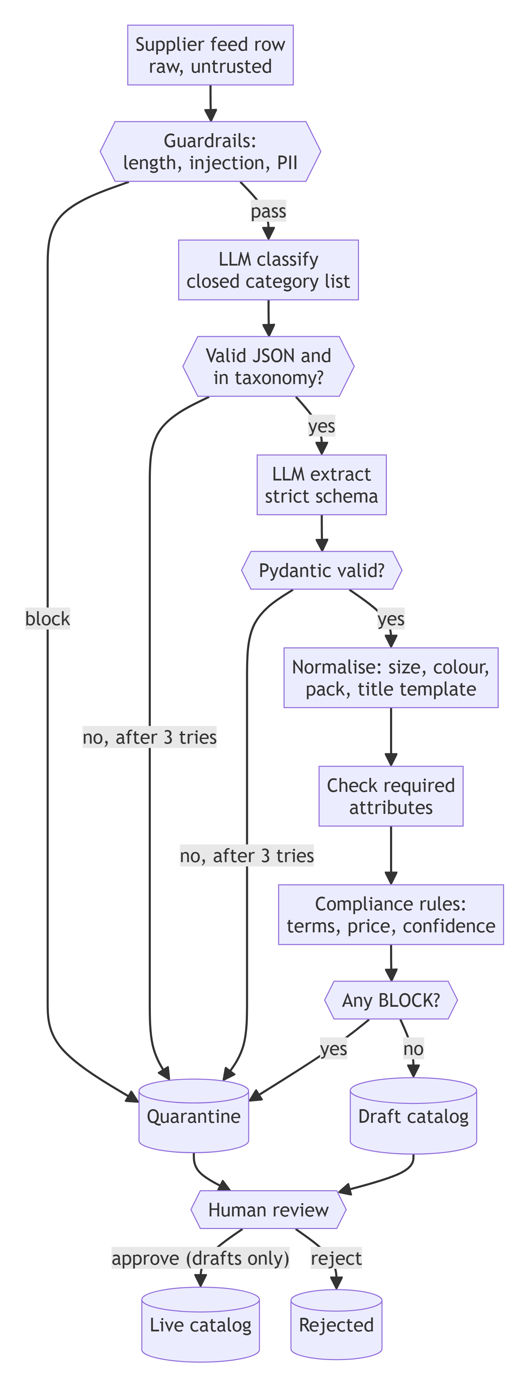

3. Process sequence

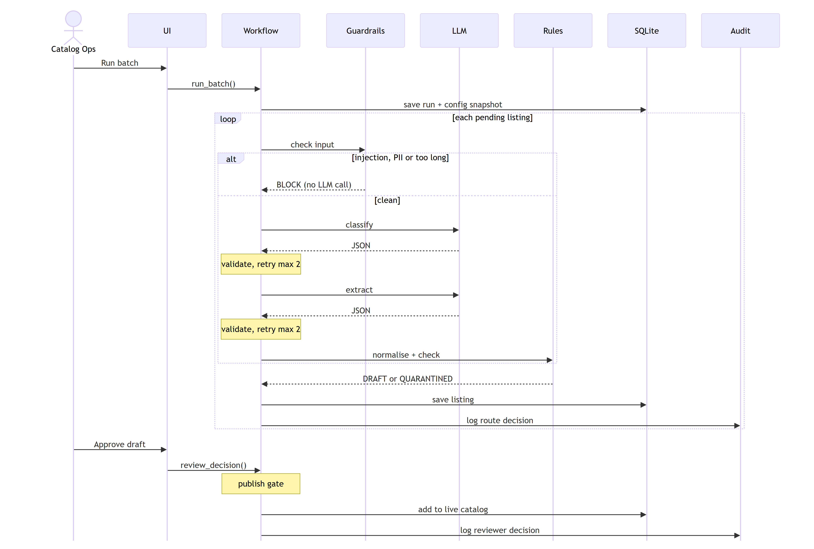

Key decisions
Decision | Why
Classify first, then extract with the category's attribute spec | Extraction prompt asks only for the attributes that category needs; fewer hallucinated fields.
Two validation layers (structural vs semantic) | Structural failure = model problem -> retry. Semantic failure (missing size) = supplier data problem -> quarantine with reason code, no wasted retries.
Dynamic Pydantic model from required_attributes_json | Taxonomy owners change requirements in data, not code.
Canonical title built from a template, not LLM free text | Titles are consistent and can't carry injected or prohibited text from the model.
Guardrail BLOCK short-circuits the LLM | Injection attempts never reach the model; saves tokens.
Humans cannot approve quarantined listings | Compliance is a hard gate; reviewers can only reject or ask the supplier to fix.
mock provider default | Tests/evals/demos run offline and deterministically; the mock injects malformed JSON to exercise the retry path.
SQLite + FastAPI + Streamlit | Simplest stack meeting the requirements; same service layer serves UI and API.

