Main Files:

MerchantsController : Created Web API with CRUD Operations.

BusinessServices: Created business services to separate logic from Controller. So that can unit test and maintain the code easily. For unit testing created Constructor injection of service in Controller. So that can inject mock service for writing Unit Tests

MerchantContext : Created CodeFirst Approach using entityFramework 6. Accessed this Context in Business services and did all the CRUD Operations. Also mention any constraints by overriding DBcontext methods.

Model: Create necessary models by creating any relations if exists. In our case just merchant and address.

Process for configuration:

Get the project and add web api as virtual directory in local. Mentioned below screenshots can help in coonfiguring.

Also Install Nuget Package for EntityFramework 6 version

In my local used below urls for all the operations

GET:

<http://localhost/MerchantWebAPI/api/Merchants>

<http://localhost/MerchantWebAPI/api/Merchants?id=1>

<http://localhost/MerchantWebAPI/api/Merchants?status=active>

<http://localhost/MerchantWebAPI/api/Merchants?status=Inactive>

POST,PUT:

<http://localhost/MerchantWebAPI/api/Merchants>

DELETE:

<http://localhost/MerchantWebAPI/api/Merchants?id=1>

Below screenshots and attached Fidller Logs for Dev Reference

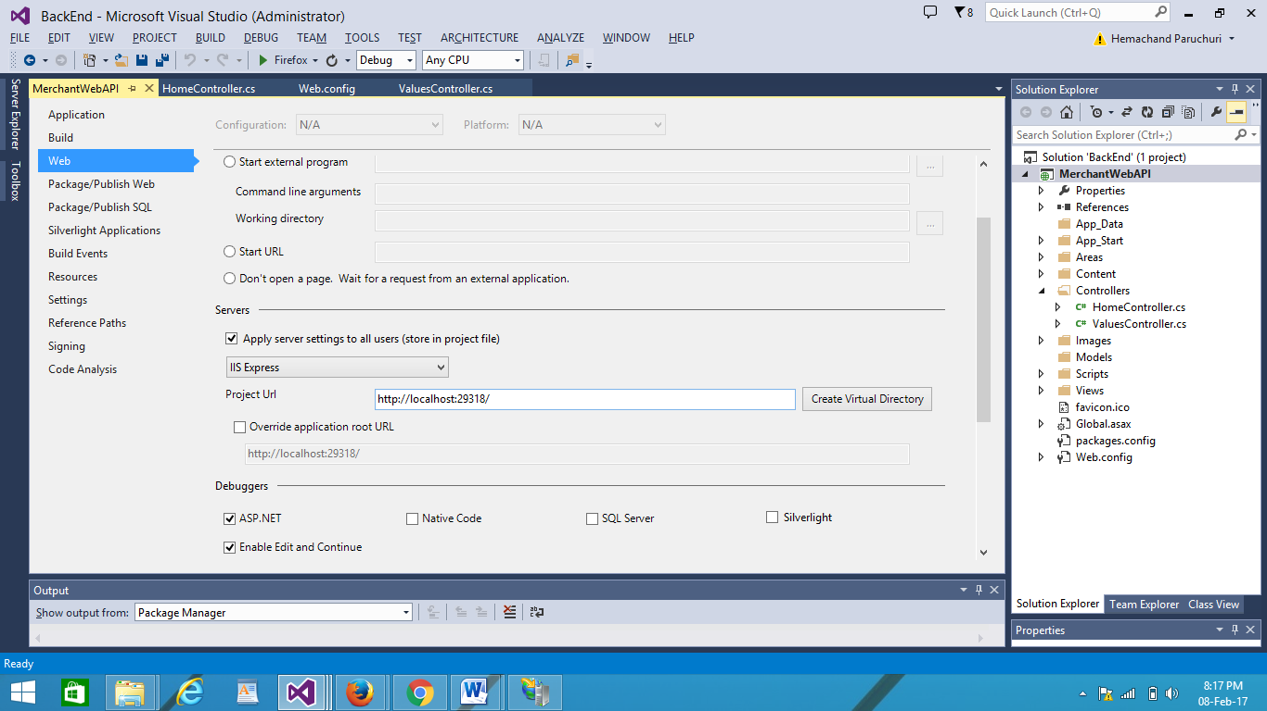

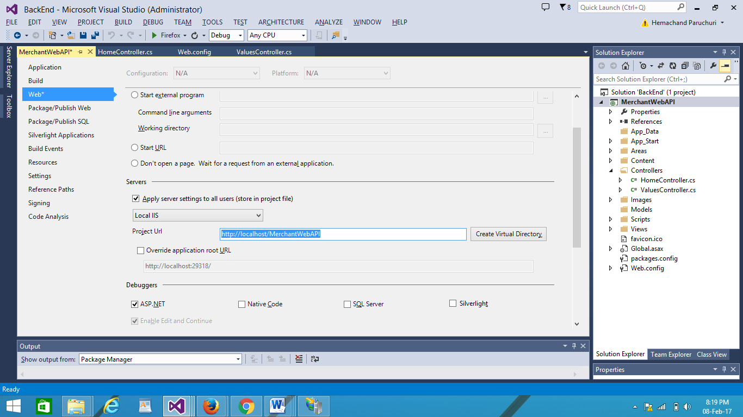

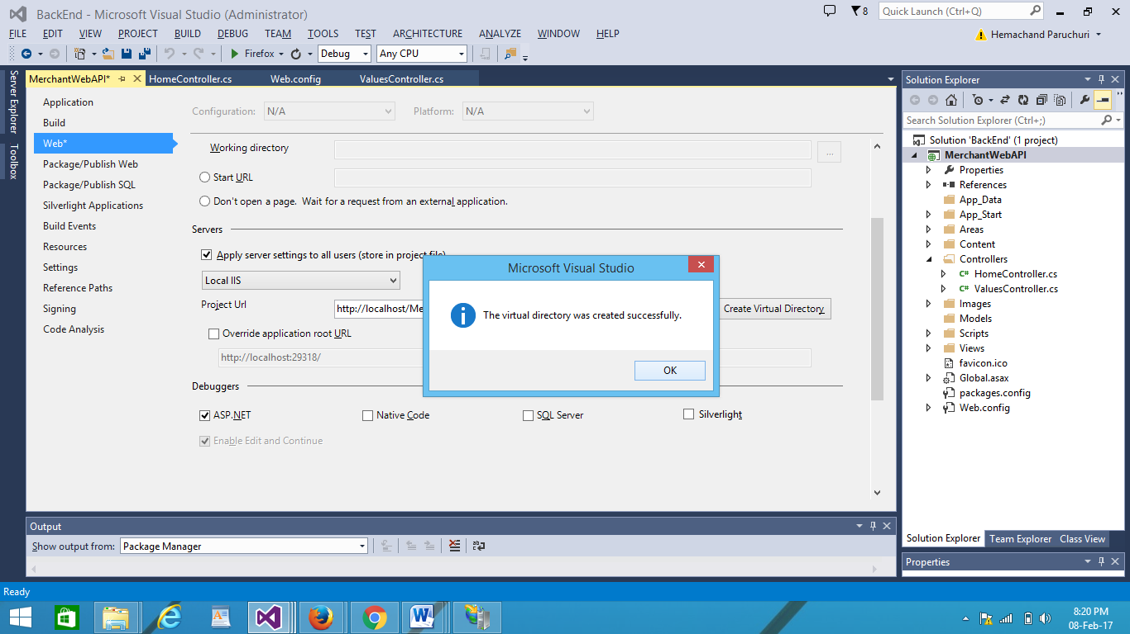

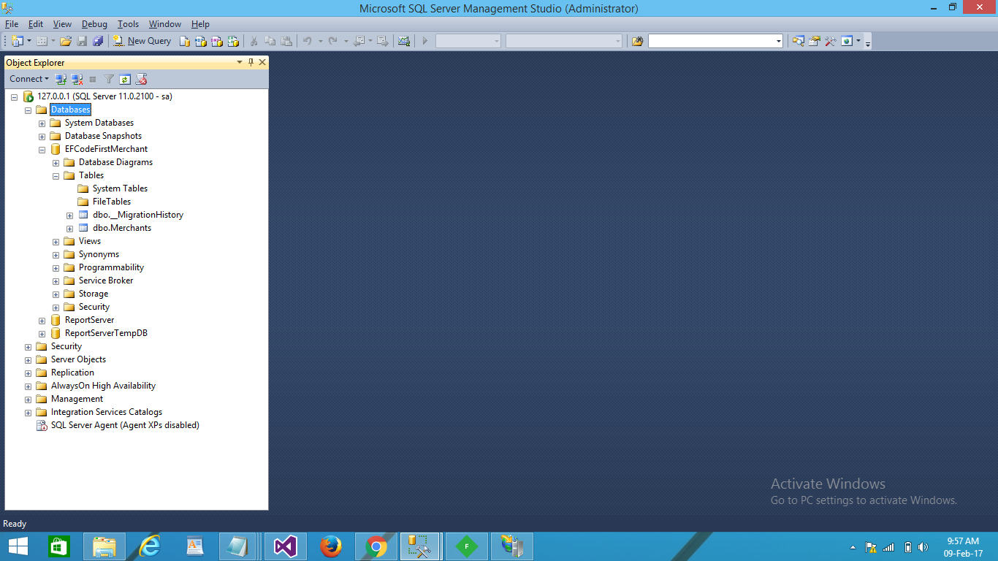

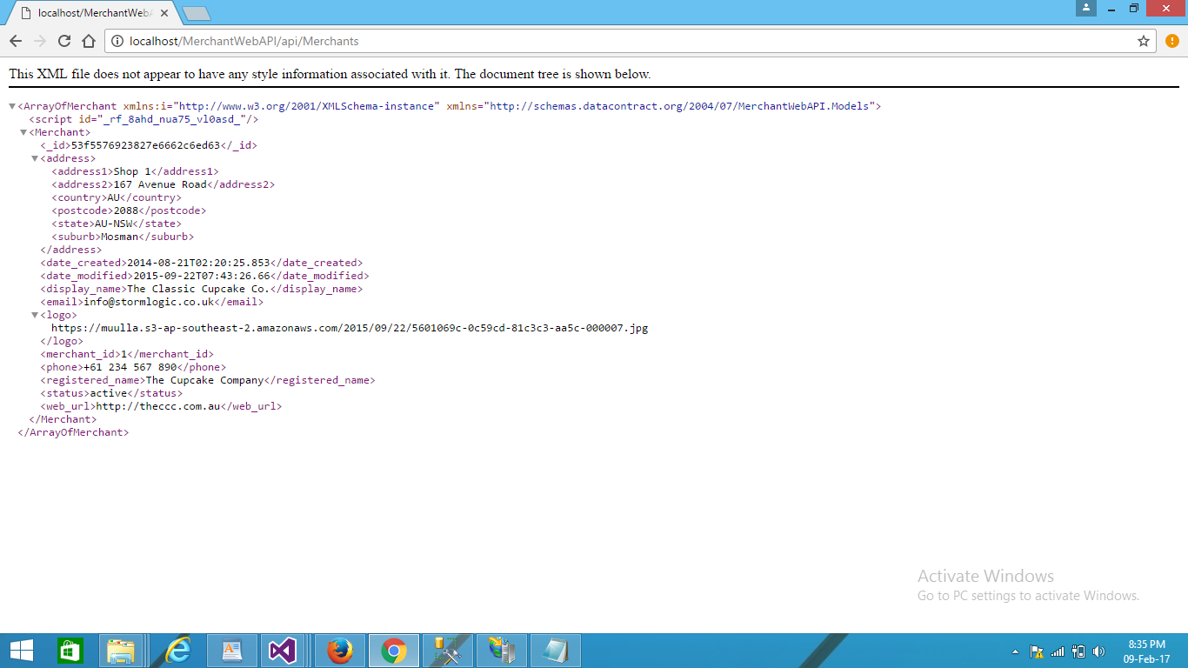

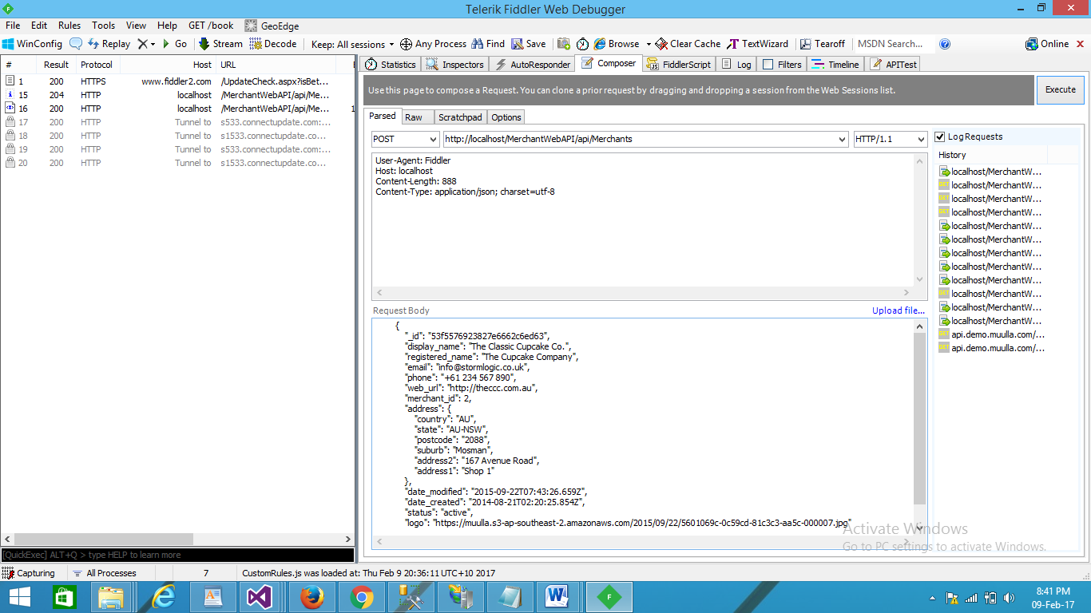

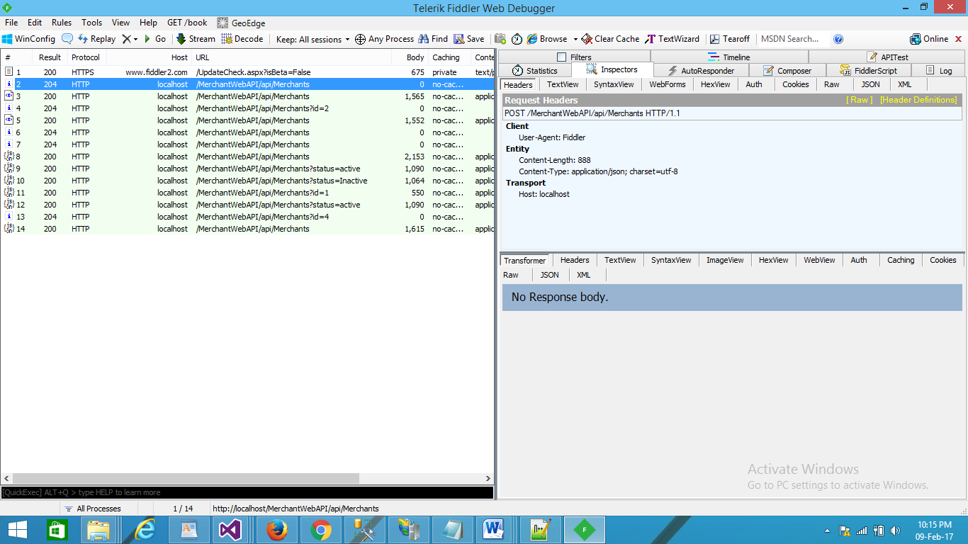

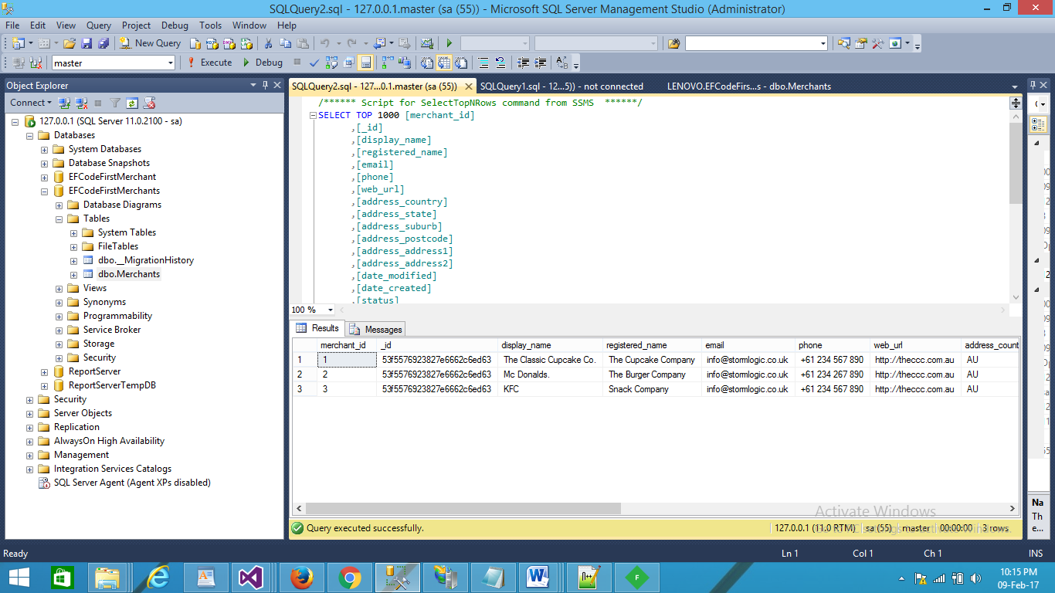d