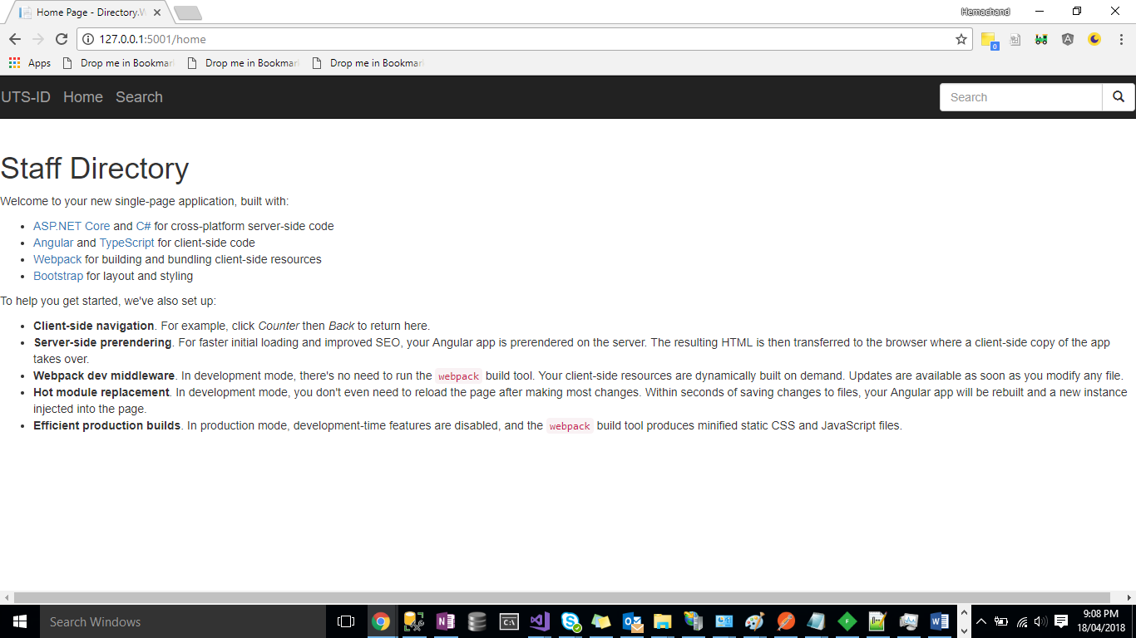

2. Hem reports to John, So Hem manager is displayed as john

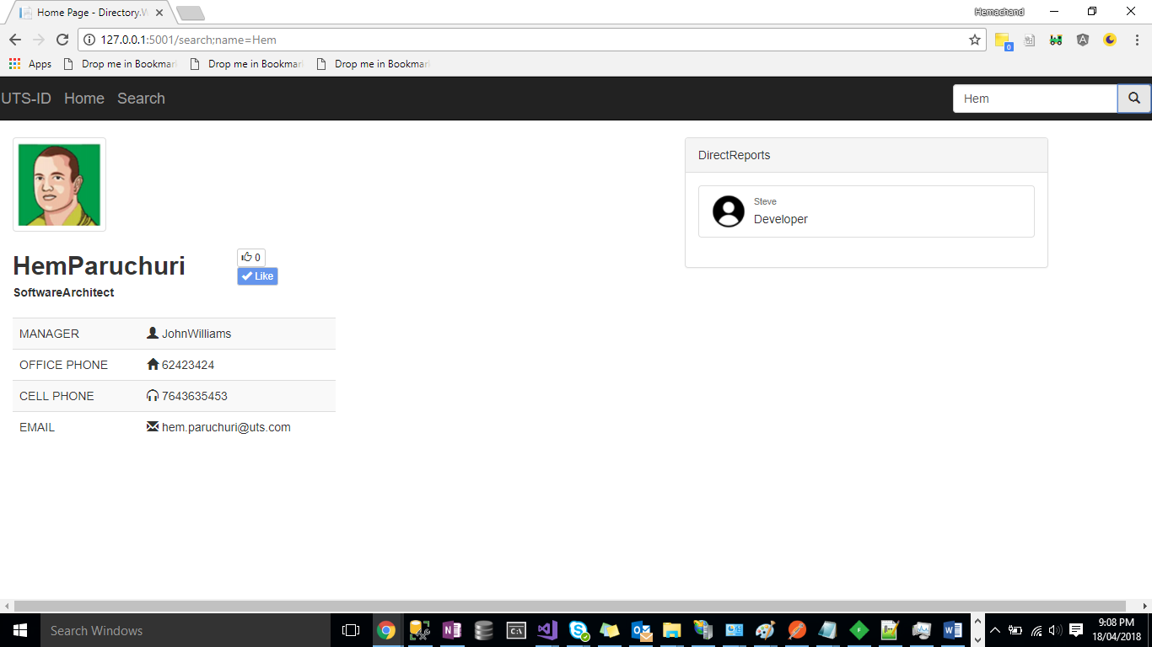

3. John is Manager and he not reporting to anyone . So manager is not displayed.

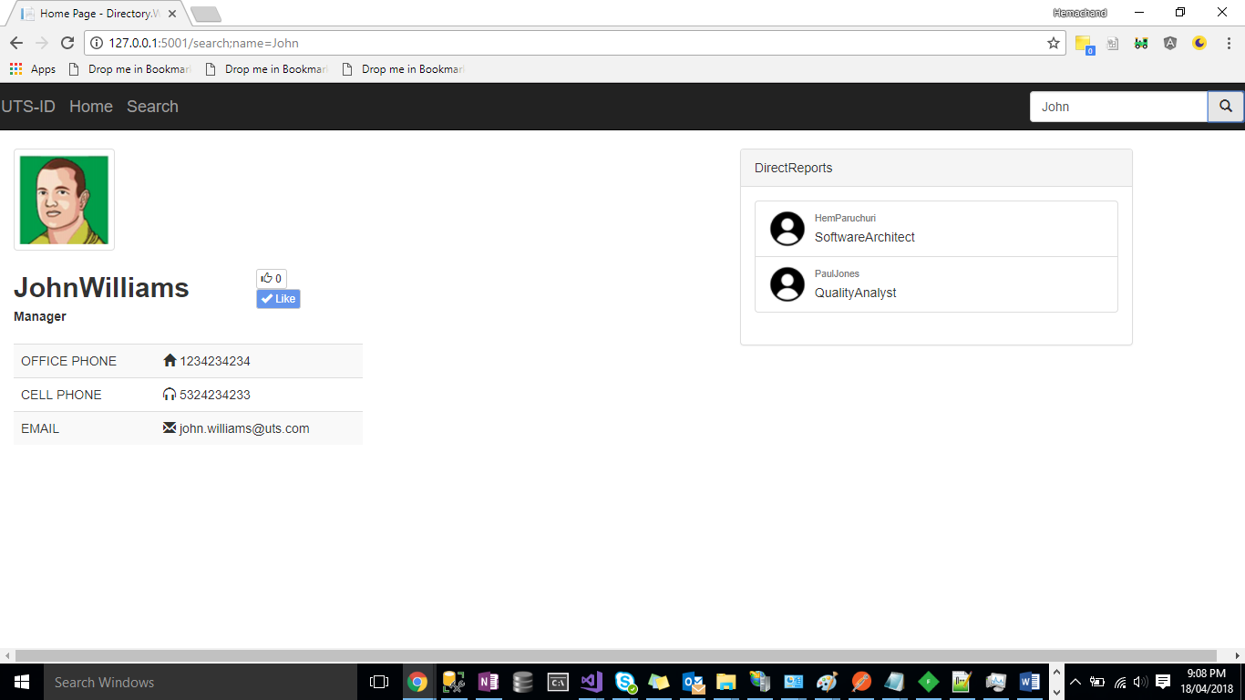

4. Paul has no reportess. Hence the list is empty.

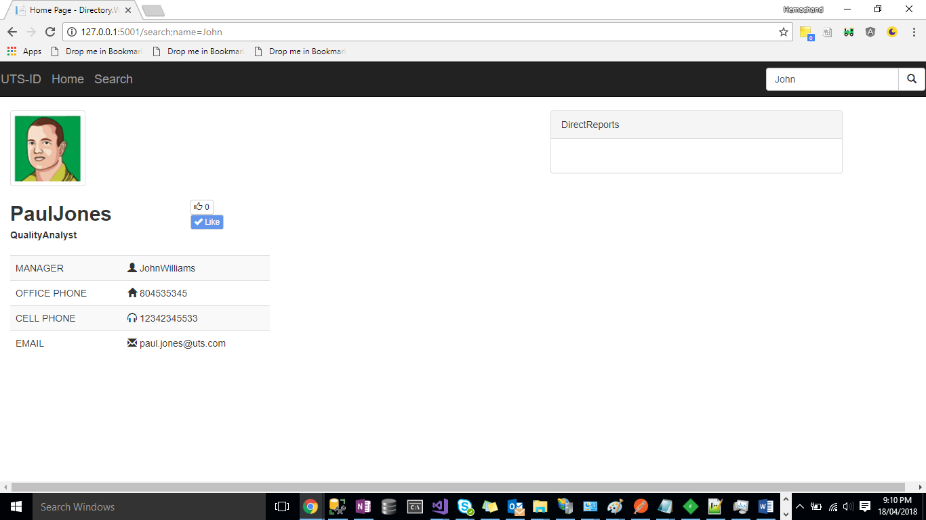

5. Screenshot which shows the entries inside DB.

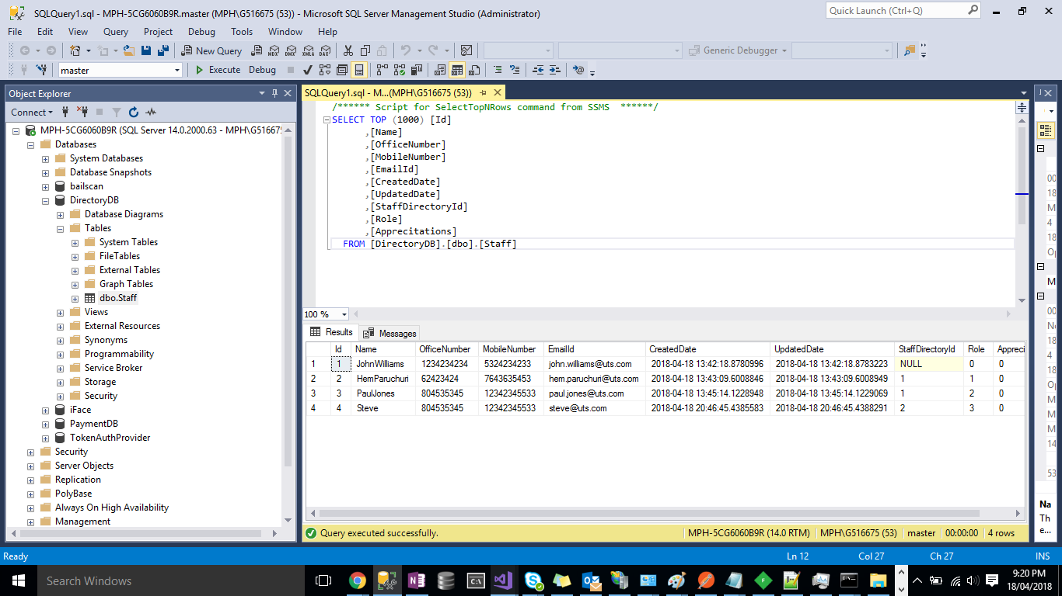

5. Can use postman to check quick JSON Post and get

