Pre-processing :

There are no missing values in the dataset. So, we can proceed with the feature engineering.

Step 1:

Instead of the column - “Date of Birth”, ages of the individuals are calculated and inserted into the dataframe.

Step 2:

On analysing the data, we found that the no of days prior which the booking was done is inversly correlated to the “Fare”. This seems obvious because, the more prior the booking is, the lesser the “fare” will be.
Hence, we have calculated the difference between “Flight Date” and “Booking Date” as “Prior_booking_days” and added it to the dataframe.

Step 3:

Gender is extracted from the name of the person.

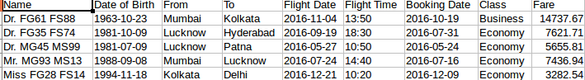
We assumed that the starting letter of the encrypted name is the gender of the person. For example, “Dr. FG61 FS88” is female and “Mr. MG93 MS13” is male etc.,

Also, we have added the column, “is_doctor” to know if the person holds a doctorate or not.

After extracting the information from the column “Name”, we have dropped it.

Step 4:

Different cities are given different identifiers as follows:

'Mumbai' : 1; 'Lucknow':2; 'Kolkata':3; 'Chennai':4; 'Delhi':5; 'Patna':6 'Hyderabad':7

Both the columns “From” and “To” are retained but with the new representation.

Step 5:

For the sake of making processing easier, we have replaced the column “Flight Date” with the month of the “Flight Date”, as all the dates were from same year.
We have retained the column “Flight Date” because, we felt that different months of the year will have different demands for transport. For example, festive seasons have more demand and people might be willing to pay more in that season.
Step 6:

“Flight Time” was given in hh:mm format. We have replaced it with the hour.

Normalization:

We have normalized the following columns:

'age', 'prior_booking_days', 'Flight Date Month', 'Flight Time'

If data from different columns is in different scales, then theirs impact on the target column, “Fare” won’t be uniform. So, we have normalized them such that their values will be between 0 and 1.

Correlation:

To reduce the number of features, we have found the correlation heat map, which calculates the correlation between every pair of columns.

By calculating this, we found that “Booking Date”, “To” and “Flight Time” have less correlation with “Fare”. So, we have dropped them.

Finding the best regression model:

We have run different regression models like LinearRegression, Lasso, ElasticNet, KNeighborsRegressor, DecisionTreeRegressor and GradientBoostingRegressor on the preprocessed dataset.

We calculated the negative mean squared error of each run and found that GradientBoostingRegressor outperforms the remaining models.

Hence, we have built the regression algorithm using the GradientBoostingRegressor and tested with a few n_estimators using GridSearchCV function. We found that the n_estimator configuration, 400 is the best for our dataset.

Building the model:

We have divided the training data into train and test data using k-fold cross validation and trained the regression model.

We have obtained a mean squared error of 0.047.

Then, we have predicted the “Fare” for test.csv using the model built.

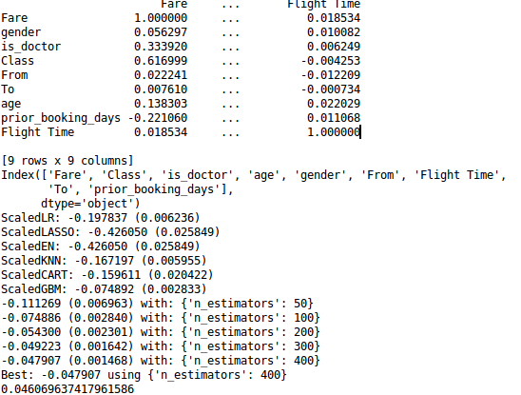
Results: The first table is the correlation matrix.

