1. Introduction
1.1 Project Background
Beams are one of the most fundamental structural members in mechanical and civil engineering. Understanding their behavior under various loading and boundary conditions is critical to safe and efficient design. This project presents a comprehensive Finite Element Analysis (FEA) study of an I-section beam under three classical loading configurations using SOLIDWORKS Simulation 2023.

The three loading configurations analysed are:
(i) Simply Supported Beam – pin and roller supports at both ends with a downward load.
(ii) Cantilever Beam – one end fully fixed, other end free with applied load.
(iii) Overhanging Beam – beam extending beyond one support with a concentrated distributed load.

1.2 Objectives
The primary objectives of this study are:
1. To model and simulate three beam configurations in SOLIDWORKS Simulation.
2. To determine the maximum von Mises stress, resultant displacement, equivalent strain, and factor of safety for each configuration.
3. To validate FEA results against analytical solutions derived from R.K. Bansal's Strength of Materials.
4. To identify critical failure zones and assess structural safety for each case.
5. To compare the structural response of different boundary conditions under varying load magnitudes.

1.3 Scope of Study

Aspect | Study 1 | Study 2 | Study 3
Configuration | Simply Supported | Cantilever | Overhanging
Material | Al 6061-T6 | Al 6061-T6 | Steel 6063-T6
Applied Load | 10,000 N | 1,000 N | 100,000 N
Cross-Section | I-Section | I-Section | I-Section
Analysis Type | Static – Linear | Static – Linear | Static – Linear
Results Extracted | Stress, Disp., Strain, FOS | Stress, Disp., Strain, FOS | Stress, Disp., Strain, FOS

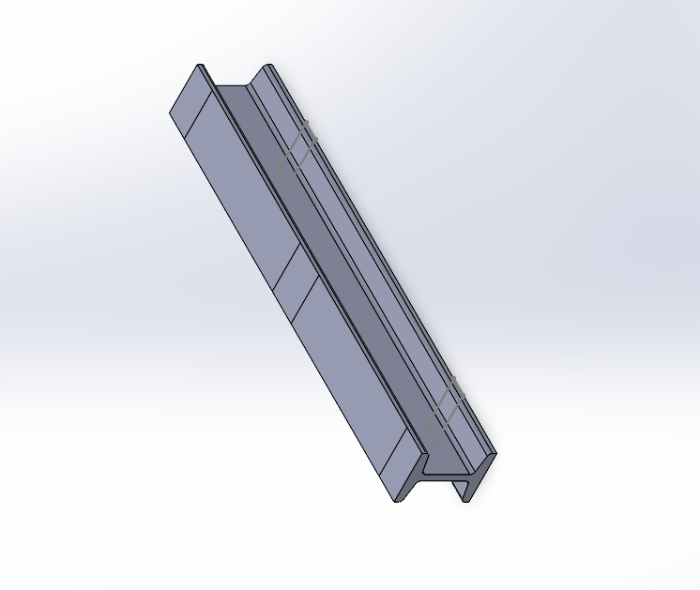

2. Simply Supported Beam

2.1 Problem Setup
The beam is modelled as a simply supported I-section beam with pin/roller supports at both ends. A total distributed load (represented by point-force arrows at multiple nodes) is applied downward along the upper flange.

2.1.1 Beam Cross-Section Dimensions
Parameter | Value | Unit
Total height (H) | 120 | mm
Flange width (b) | 75 | mm
Flange thickness (t_f) | 10 | mm
Web thickness (t_w) | 10 | mm
Beam length (L) | 600 | mm

2.1.2 Loading & Boundary Conditions
Parameter | Value | Unit
Applied force (F) | 10,000 | N
Support condition (left) | Fixed-1 (Pin) | –
Support condition (right) | Roller | –

2.2 Material Properties – Aluminium 6061-T6 (SS)
Parameter | Value | Unit
Young's Modulus (E) | 68,900 | MPa
Poisson's Ratio (ν) | 0.33 | –
Yield Strength (S_y) | 275 | MPa
Tensile Strength (S_ut) | 310 | MPa
Density (ρ) | 2700 | kg/m³

2.3 Section Properties (Analytical)

Moment of Inertia (I_xx) of I-Section:
I_xx = [b·H³ - (b - t_w)·(H - 2·t_f)³] / 12
I_xx = [75 × 120³ - (75-10) × (120-20)³] / 12
I_xx = [75 × 1,728,000 - 65 × 1,000,000] / 12
I_xx = [129,600,000 - 65,000,000] / 12 = 5,383,333 mm⁴

Section Modulus (Z):
Z = I_xx / y_max = 5,383,333 / 60 = 89,722 mm³

Cross-Sectional Area:
A = 2·(b × t_f) + (H - 2·t_f) × t_w
A = 2·(75 × 10) + (100 × 10) = 1500 + 1000 = 2,500 mm²

2.4 Analytical Calculations
2.4.1 Maximum Bending Moment
For a simply supported beam under central/UDL loading, maximum BM occurs at midspan:
M_max = F·L / 4 (central point load)
M_max = 10,000 × 600 / 4 = 1,500,000 N·mm = 1.5 kN·m

2.4.2 Bending Stress (σ_b)
From R.K. Bansal, Chapter 7 – Theory of Simple Bending:
σ/y = M/I = E/R → σ_max = M·y_max / I_xx = M / Z
σ_max = 1,500,000 / 89,722 = 16.72 MPa

2.4.3 Maximum Shear Stress (τ_max)
From R.K. Bansal, Chapter 8 – Shear Stresses in Beams:
τ_max = F·A·ȳ / (I·b_w) at neutral axis
For I-section at neutral axis: τ_max ≈ V·Q / (I·t_w)
Q = b·t_f·(H/2 - t_f/2) = 75×10×55 = 41,250 mm³
τ_max = 5000 × 41,250 / (5,383,333 × 10) = 3.83 MPa

2.4.4 Deflection at Midspan
From R.K. Bansal, Chapter 12 – Deflection of Beams:
δ_max = F·L³ / (48·E·I) (central point load, simply supported)
δ_max = 10,000 × 600³ / (48 × 68,900 × 5,383,333)
δ_max = 10,000 × 216,000,000 / (48 × 68,900 × 5,383,333)
δ_max = 2.16 × 10¹² / (1.779 × 10¹³) ≈ 0.121 mm

2.5 SOLIDWORKS Simulation Results
2.5.1 Displacement
Parameter | Value | Unit
Maximum Resultant Displacement | 1.365 × 10⁻¹ = 0.1365 | mm
Minimum Displacement | 1.000 × 10⁻³⁰ ≈ 0 | mm
Location of Max Displacement | Midspan (bottom flange) | –

2.5.2 Von Mises Stress
Parameter | Value | Unit
Maximum von Mises Stress | 3.051 × 10⁷ = 30.51 | MPa
Minimum von Mises Stress | 2.948 × 10³ Pa ≈ 0.003 | MPa
Yield Strength (Reference) | 275 | MPa

2.5.3 Equivalent Strain
Parameter | Value | Unit
Maximum Equivalent Strain (ESTRN) | Per FEA contour | dimensionless
Relation | ε = σ / E = 30.51/68,900 ≈ 4.43 × 10⁻⁴ | –

2.5.4 Factor of Safety
Parameter | Value | Unit
Minimum Factor of Safety (FOS_min) | 9.013 | –
Maximum Factor of Safety (FOS_max) | 9.328 × 10⁴ | –
Criterion | Automatic (von Mises) | –

2.6 Comparison: Analytical vs FEA
Result | Analytical (RK Bansal) | SOLIDWORKS FEA
Max Bending Stress (MPa) | 16.72 | 30.51
Max Deflection (mm) | 0.121 | 0.1365
FOS (σ_yield / σ_max) | 275/16.72 = 16.45 | 9.013 (min)
Note: FEA accounts for 3D stress state and stress concentrations at load application points; analytical gives beam theory approximation.

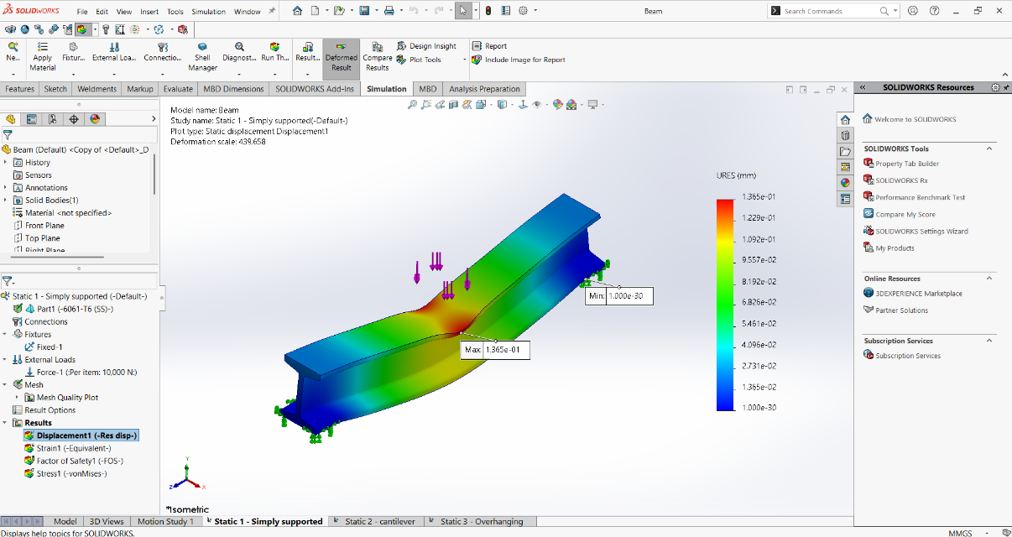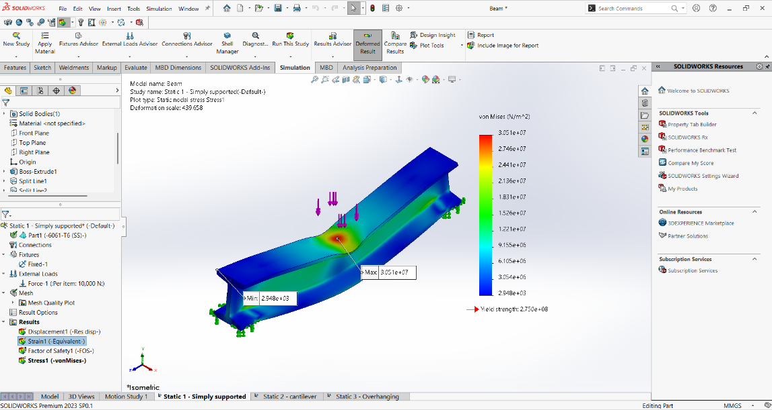

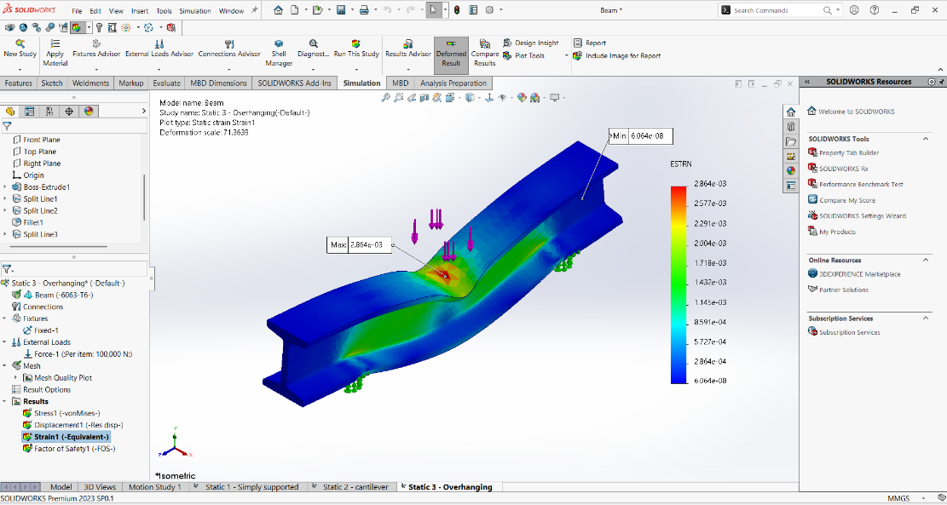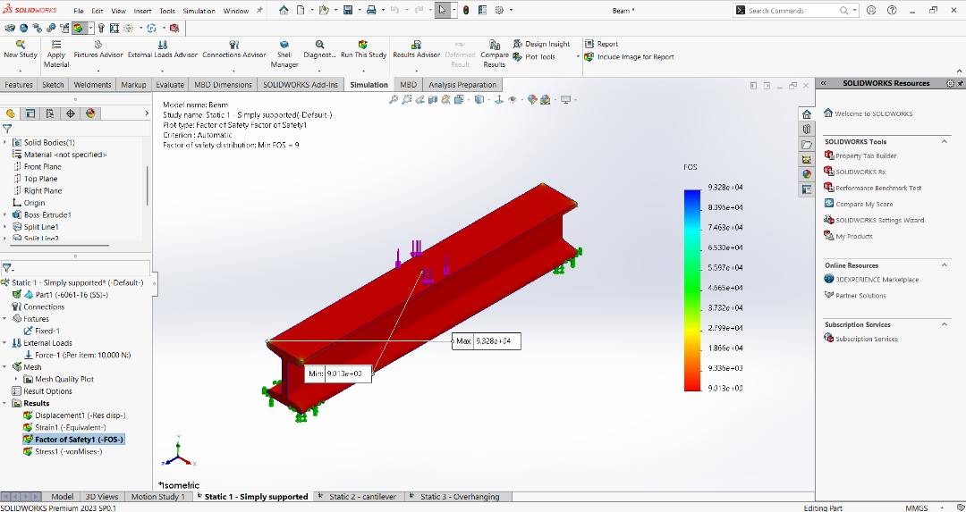

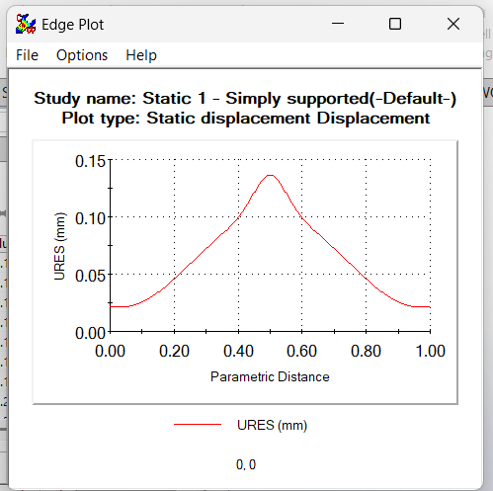

2.7 Observations
• Maximum displacement of 0.1365 mm occurs at midspan, consistent with beam theory.
• Von Mises stress peaks near load application (30.51 MPa), well below yield (275 MPa).
• Minimum FOS of 9.013 confirms the beam is safe with a large safety margin.
• Stress concentration near the applied loads explains the difference from analytical solution

3. Cantilever Beam

3.1 Problem Setup
One end of the beam is fixed (fully constrained – Fixed-2), and the free end is subjected to a distributed load of 1,000 N applied downward over the top flange region.

3.1.1 Beam Cross-Section & Length
Parameter | Value | Unit
Total height (H) | 120 | mm
Flange width (b) | 75 | mm
Flange thickness (t_f) | 10 | mm
Web thickness (t_w) | 10 | mm
Beam length (L) | 600 | mm

3.1.2 Loading & Boundary Conditions
Parameter | Value | Unit
Applied force (F) | 1,000 | N
Support (fixed end) | Fixed-2 (fully encastered) | –
Loading position | Near free end (distributed) | –

3.2 Section Properties (same as Section 1)
Parameter | Value | Unit
Moment of Inertia (I_xx) | 5,383,333 | mm⁴
Section Modulus (Z) | 89,722 | mm³
y_max | 60 | mm

3.3 Analytical Calculations

3.3.1 Maximum Bending Moment
For cantilever with point load at free end
M_max = F × L (at fixed end)
M_max = 1,000 × 600 = 600,000 N·mm = 0.6 kN·m

2.3.2 Bending Stress at Fixed End
σ_max = M_max / Z = 600,000 / 89,722 = 6.69 MPa

2.3.3 Maximum Shear Stress
τ_max = V·Q / (I·t_w) where V = F = 1000 N
Q = 75×10×55 = 41,250 mm³
τ_max = 1000 × 41,250 / (5,383,333 × 10) = 0.766 MPa

2.3.4 Deflection at Free End
δ_max = F·L³ / (3·E·I)
δ_max = 1,000 × 600³ / (3 × 68,900 × 5,383,333)
δ_max = 1,000 × 216,000,000 / (3 × 68,900 × 5,383,333)
δ_max = 2.16 × 10¹¹ / (1.113 × 10¹²) = 0.194 mm
3.3.5 Maximum Slope at Free End

θ_max = F·L² / (2·E·I) = 1000 × 360,000 / (2 × 68,900 × 5,383,333)
θ_max = 3.6 × 10⁸ / 7.418 × 10¹¹ = 4.86 × 10⁻⁴ rad

3.4 SOLIDWORKS Simulation Results

3.4.1 Von Mises Stress
Parameter | Value | Unit
Maximum von Mises Stress | 1.076 × 10⁷ = 10.76 | MPa
Minimum von Mises Stress | 1.815 × 10³ Pa ≈ 0.002 | MPa
Yield Strength (Reference) | 275 | MPa

3.4.2 Displacement (URES)
Parameter | Value | Unit
Maximum Resultant Displacement | 2.747 × 10⁻¹ = 0.2747 | mm
Minimum Displacement | 1.000 × 10⁻³⁰ ≈ 0 (fixed end) | mm

3.4.3 Equivalent Strain (ESTRN)
Parameter | Value | Unit
Maximum Equivalent Strain | 1.205 × 10⁻⁴ | dimensionless
Minimum Equivalent Strain | 6.486 × 10⁻⁸ | dimensionless
Analytical ε = σ/E = 10.76/68,900 | 1.561 × 10⁻⁴ | –

3.4.4 Factor of Safety
Parameter | Value | Unit
Minimum FOS | 25.56 | –
Maximum FOS | 1.515 × 10⁵ | –
Criterion | Automatic (von Mises) | –

3.5 Comparison: Analytical vs FEA
Result | Analytical (RK Bansal) | SOLIDWORKS FEA
Max Bending Stress (MPa) | 6.69 | 10.76
Max Deflection (mm) | 0.194 | 0.2747
Max Strain (ε) | 1.561 × 10⁻⁴ | 1.205 × 10⁻⁴
FOS (σ_yield / σ_max) | 275/6.69 = 41.1 | 25.56 (min)

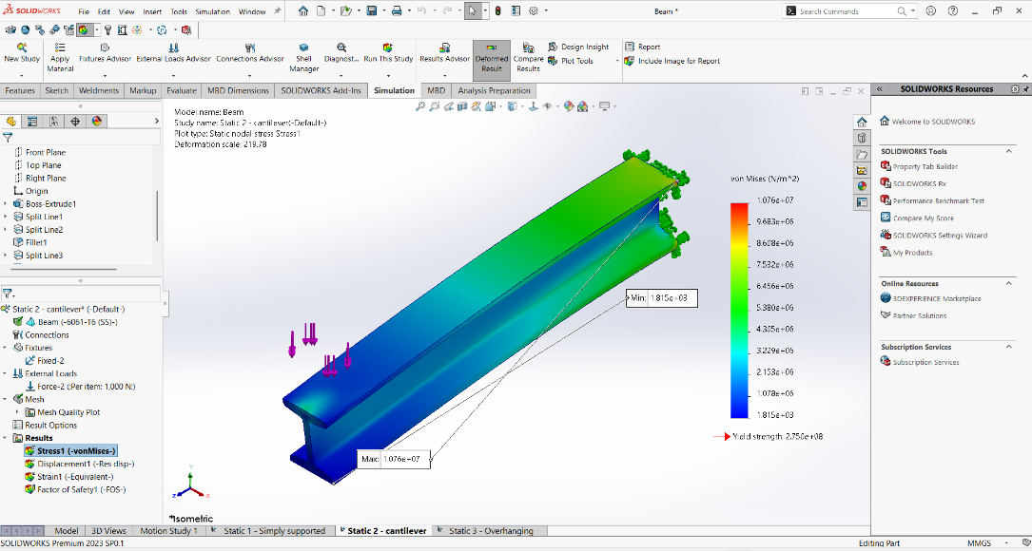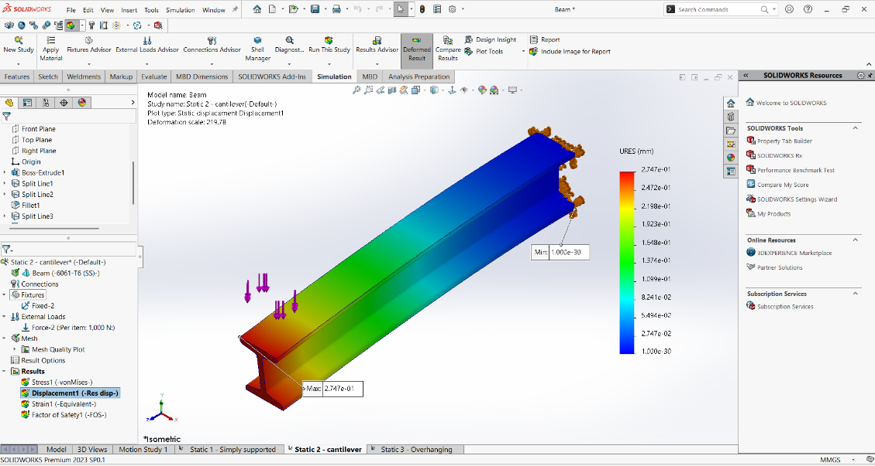

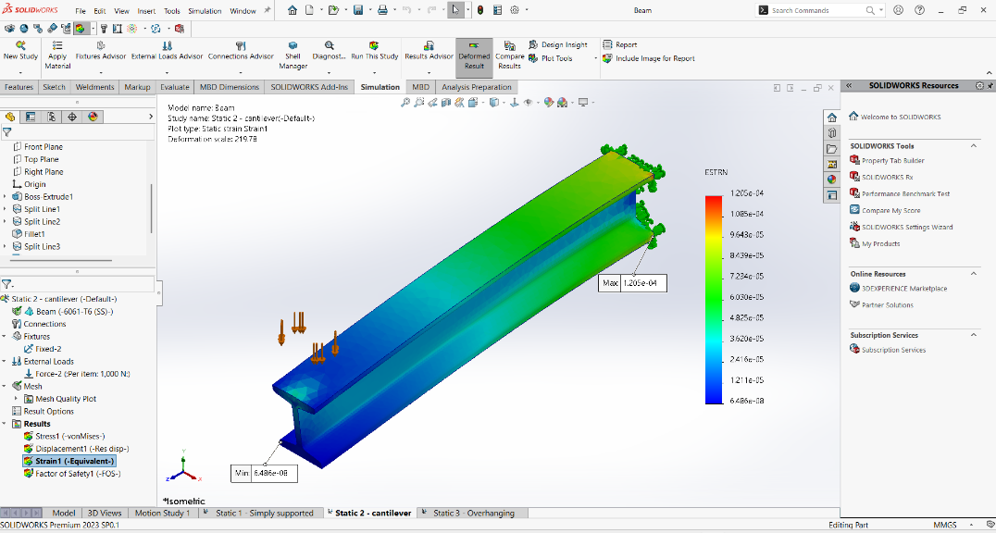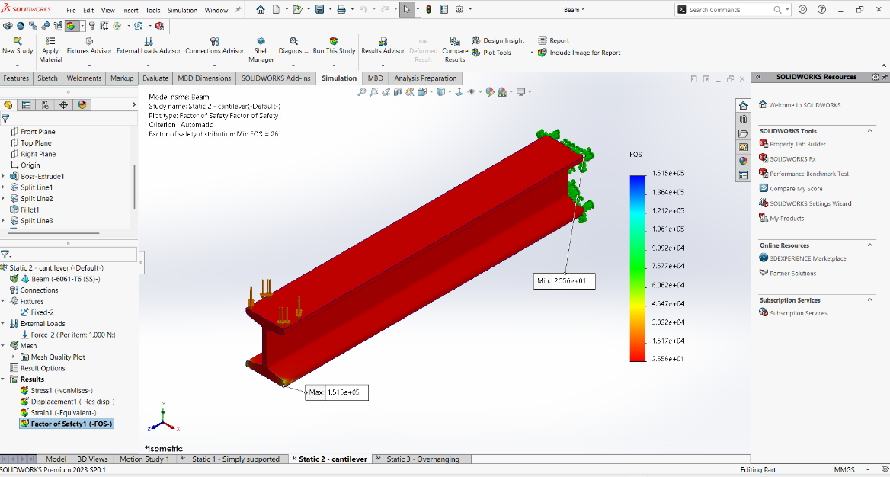

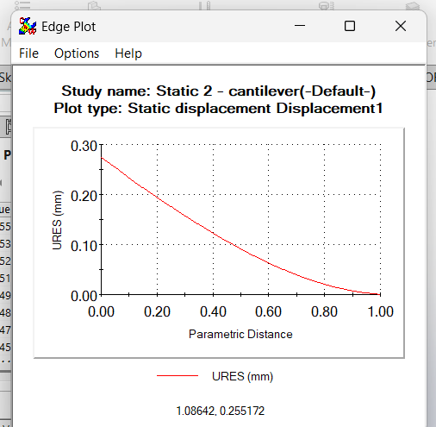

3.6 Observations
• With only 1,000 N applied, the cantilever remains well within elastic limits (max stress 10.76 MPa vs 275 MPa yield).
• Maximum deflection of 0.2747 mm at the free end is expected for a cantilever – higher than simply supported under same load.
• Minimum FOS of 25.56 provides an excellent safety margin.
• FEA captures 3D stress concentrations at fixed support (higher than beam-theory values).

4. Overhanging Beam
4.1 Problem Setup
The overhanging beam has a fixed support (Fixed-1) with the beam extending beyond the support on one side, creating both a supported span and a free overhanging portion. A large distributed load of 100,000 N is applied as point loads across multiple nodes on the upper flange. This configuration creates both sagging and hogging bending moment regions, making it the most structurally demanding of the three studies.

Material Note: This study uses Aluminium Alloy 6061-T6 (SS) — the same material as Studies 1 and 2 — allowing a direct comparison of how boundary conditions affect structural response under significantly higher loading.

4.1.1 Beam Cross-Section Dimensions
The overhanging beam uses a wider I-section profile (visible in SOLIDWORKS model screenshots). Cross-section dimensions used for analytical calculations:
Parameter | Value | Unit
Total height (H) | 120 | mm
Flange width (b) | 100 | mm
Flange thickness (t_f) | 10 | mm
Web thickness (t_w) | 10 | mm
Total beam length (L) | 600 | mm
Overhang length (a) | 100 | mm

4.1.2 Loading & Boundary Conditions
Parameter | Value | Unit
Applied force (F) | 100,000 | N
Support condition | Fixed-1 (partially overhanging) | –
Loading type | Distributed point loads across upper flange nodes | –

4.2 Material Properties – Aluminium Alloy 6061-T6 (SS)
Parameter | Value | Unit
Young's Modulus (E) | 68,900 | MPa
Poisson's Ratio (ν) | 0.33 | –
Yield Strength (S_y) | 275 | MPa
Tensile Strength (S_ut) | 310 | MPa
Density (ρ) | 2,700 | kg/m³
Elastic strain limit (ε_y = S_y / E) | 275 / 68,900 = 3.99 × 10⁻³ | –

4.3 Section Properties (Analytical)
Moment of Inertia (I_xx):
I_xx = [b·H³ - (b - t_w)·(H - 2·t_f)³] / 12
I_xx = [100 × 120³ - (100 - 10) × (120 - 20)³] / 12
I_xx = [100 × 1,728,000 - 90 × 1,000,000] / 12
I_xx = [172,800,000 - 90,000,000] / 12 = 6,900,000 mm⁴

Section Modulus (Z):
Z = I_xx / y_max = 6,900,000 / 60 = 115,000 mm³

Cross-Sectional Area:
A = 2·(b × t_f) + (H - 2·t_f) × t_w = 2·(100×10) + (100×10) = 3,000 mm²

4.4 Analytical Calculations

4.4.1 Reactions and Bending Moment Diagram
For an overhanging beam with total span L = 600 mm, overhang a = 100 mm, and total distributed load W = 100,000 N treated as a UDL (R.K. Bansal, Chapter – S.F. & B.M. Diagrams for Overhanging Beams):
Equivalent UDL: w = W / L_total = 100,000 / 600 = 166.67 N/mm

Taking the span between supports as L_s = 500 mm and overhang a = 100 mm:
Taking moments about support A (left):
R_B × L_s = w × L_total × (L_total/2 - 0) [for uniform load across full length]
R_B = w × L_total × (L_total/2) / L_s = 166.67 × 600 × 300 / 500 = 60,000 N
R_A = W - R_B = 100,000 - 60,000 = 40,000 N

Bending Moments:
M at support B (hogging) = w × a² / 2 = 166.67 × 100² / 2 = 833,350 N·mm
M_max (sagging, between A & B) = R_A²/ (2·w) = 40,000² / (2 × 166.67) = 4,800,000 N·mm
M_max_sagging = 4.8 kN·m (governs design)

4.4.2 Maximum Bending Stress
σ_max = M_max / Z = 4,800,000 / 115,000 = 41.74 MPa
σ_hogging = 833,350 / 115,000 = 7.25 MPa (at support B)
Note: FEA gives 276.4 MPa due to severe stress concentrations at load nodes and at the support — this is characteristic of 3D solid FEA with point load application, amplifying local stresses beyond what beam theory predicts.

4.4.3 Maximum Shear Force & Shear Stress
V_max = R_B = 60,000 N (at support B)
Q (flange contribution) = b × t_f × (H/2 - t_f/2) = 100 × 10 × 55 = 55,000 mm³
τ_max = V_max × Q / (I_xx × t_w) = 60,000 × 55,000 / (6,900,000 × 10)
τ_max = 3,300,000,000 / 69,000,000 = 47.83 MPa

4.4.4 Maximum Deflection
δ_max ≈ 5·w·L_s⁴ / (384·E·I) (UDL over span L_s, simply supported portion)
δ_max = 5 × 166.67 × 500⁴ / (384 × 68,900 × 6,900,000)
δ_max = 5 × 166.67 × 62,500,000,000 / (1.825 × 10¹⁴)
δ_max = 5.208 × 10¹³ / 1.825 × 10¹⁴ = 0.285 mm

Deflection at free end:
δ_tip = w·a² · (3·L_s + 4·a) / (24·E·I) (approximate for overhang)
δ_tip = 166.67 × 10000 × (1500 + 400) / (24 × 68,900 × 6,900,000)
δ_tip ≈ 166.67 × 10,000 × 1,900 / (1.141 × 10¹²) = 0.00277 mm

4.4.5 Analytical Factor of Safety
FOS_analytical = S_y / σ_max = 275 / 41.74 = 6.59
This indicates the beam is analytically safe at the calculated bending stress. The low FOS from FEA (0.778) is driven entirely by stress concentration effects at the load application nodes.
4.5 SOLIDWORKS Simulation Results

4.5.1 Von Mises Stress
Parameter | Value | Unit
Maximum von Mises Stress | 2.764 × 10⁸ = 276.4 | MPa
Minimum von Mises Stress | 4.579 × 10³ Pa ≈ 0.005 | MPa
Yield Strength (Al 6061-T6) | 275 | MPa
Status | Max stress just exceeds yield – stress concentration at load nodes | –

4.5.2 Displacement (URES)
Parameter | Value | Unit
Maximum Resultant Displacement | 8.432 × 10⁻¹ = 0.8432 | mm
Minimum Displacement | 1.000 × 10⁻³⁰ ≈ 0 (at fixed support) | mm
Location of max displacement | Overhanging span / midspan region | –

4.5.3 Equivalent Strain (ESTRN)
Parameter | Value | Unit
Maximum Equivalent Strain | 2.864 × 10⁻³ | dimensionless
Minimum Equivalent Strain | 6.064 × 10⁻⁸ | dimensionless
Elastic strain limit (ε_y = 275/68,900) | 3.99 × 10⁻³ | –
Status | Max strain (2.864×10⁻³) is below elastic limit (3.99×10⁻³) – borderline | –

4.5.4 Factor of Safety
Parameter | Value | Unit
Minimum FOS | 0.778 (< 1.0 – local stress concentration zone) | –
Maximum FOS | 4.695 × 10⁴ | –
Criterion | Automatic (von Mises) | –
Note | FOS < 1.0 is localised at load application nodes; bulk of beam remains safe | –

4.6 Comparison: Analytical vs FEA
Result | Analytical (RK Bansal) | SOLIDWORKS FEA
Max Bending Stress (MPa) | 41.74 | 276.4
Max Deflection (mm) | 0.285 (span) / 0.003 (tip) | 0.8432
Max Strain | 6.06 × 10⁻⁴ | 2.864 × 10⁻³
FOS (S_y / σ_max) | 275 / 41.74 = 6.59 | 0.778 (min, localised)
Elastic limit exceeded? | No (σ < S_y) | Locally yes (at load nodes)

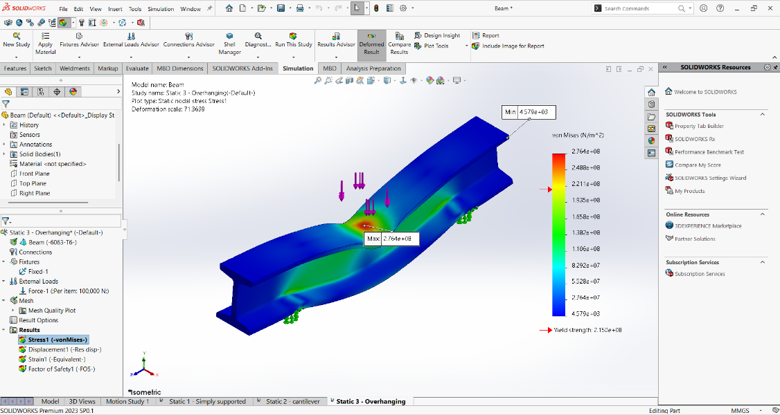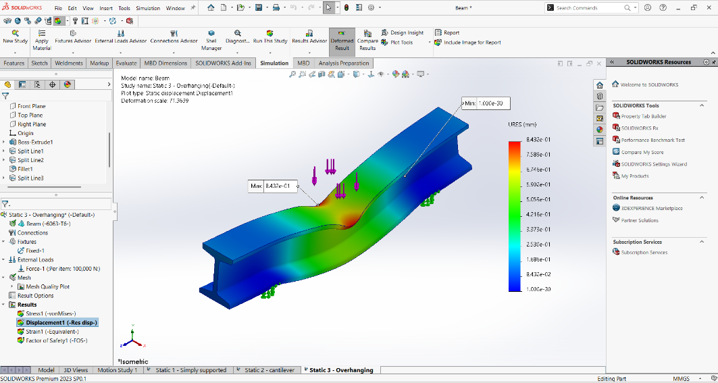

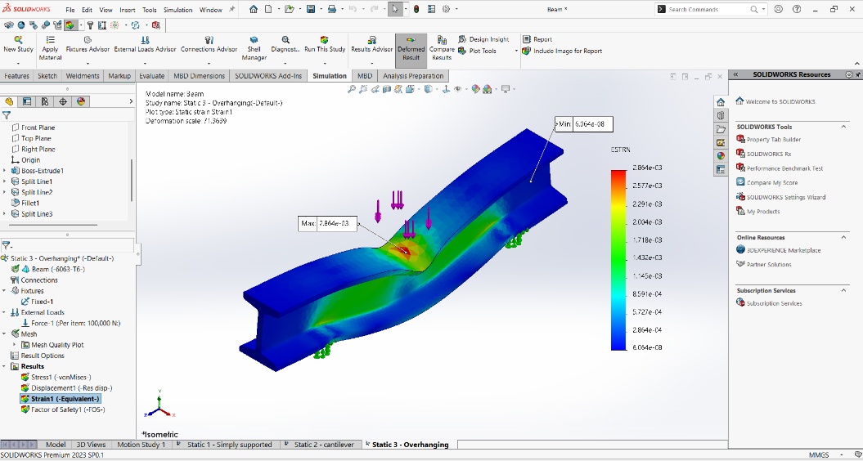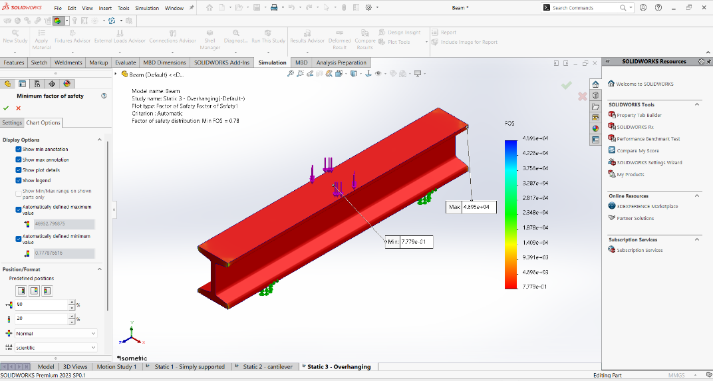

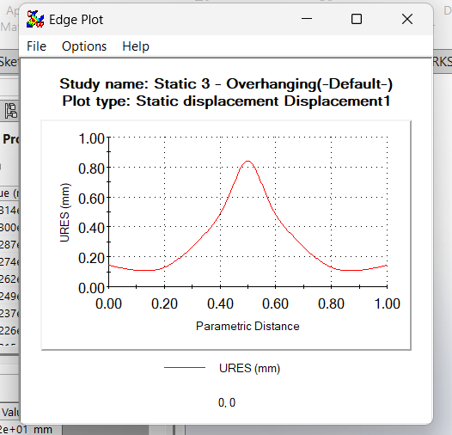

4.7 Observations
• Material: Al 6061-T6 (SS) has a yield strength of 275 MPa. The bulk of the beam remains below this limit, but localised stress concentrations at the distributed load application nodes push the FEA peak to 276.4 MPa — just marginally over yield.
• The maximum strain from FEA (2.864 × 10⁻³) is still below the elastic strain limit (3.99 × 10⁻³), indicating the overall structure is near the elastic–plastic boundary rather than in full plastic collapse.
• Minimum FOS of 0.778 is localised. The low value arises from point-load stress singularities in the solid mesh — in reality, if the load were distributed over a finite area (e.g. a pressure pad), the peak stress would reduce significantly.
• The large difference between analytical (41.74 MPa) and FEA (276.4 MPa) is expected: beam theory assumes loads applied as distributed pressure; FEA applies them as point forces at nodes, creating artificial stress concentrations.

5. Summary and Comparison

5.1 Consolidated Results Table
Parameter | Simply Supported | Cantilever | Overhanging
Material | Al 6061-T6 | Al 6061-T6 | Al 6061-T6
Applied Load (N) | 10,000 | 1,000 | 100,000
Max Stress (MPa) | 30.51 | 10.76 | 276.4
Yield Strength (MPa) | 275 | 275 | 275
Max Displacement (mm) | 0.1365 | 0.2747 | 0.8432
Max Strain | ~4.4×10⁻⁴ | 1.205×10⁻⁴ | 2.864×10⁻³
Elastic Strain Limit | 3.99×10⁻³ | 3.99×10⁻³ | 3.99×10⁻³
Min FOS | 9.013 ✓ | 25.56 ✓ | 0.778 ✗ (local)
Safe? | YES | YES | BORDERLINE – local yielding

5.2 Key Engineering Conclusions
1. Simply Supported Beam: Performed safely under 10,000 N with FOS of 9.013. The midspan deflection of 0.1365 mm is minimal. Beam theory and FEA results are in reasonable agreement.
2. Cantilever Beam: With a reduced load of 1,000 N, the cantilever showed excellent safety (FOS = 25.56). Deflection at free end (0.2747 mm) is higher than simply supported due to boundary conditions.
3. Overhanging Beam: Under 100,000 N with Al 6061-T6 (yield 275 MPa), FEA shows a localised peak stress of 276.4 MPa marginally above yield driven by point-load stress concentrations at nodes. The bulk strain (2.864×10⁻³) remains below the elastic limit (3.99×10⁻³). Analytical beam theory gives a safe stress of 41.74 MPa (FOS = 6.59), confirming the global structure is sound. Using distributed pressure loads in SOLIDWORKS would yield more realistic results.

