SERN: A Smart Emergency Response Network for Rapid Ambulance Dispatch using ML-Based Severity Prediction and Multi-Factor Ambulance Ranking
B.Tech Final-Year Conference Paper — Department of Computer Science & Engineering (Artificial Intelligence & Data Science)
Vels Institute of Science, Technology & Advanced Studies (VISTAS), Vels University, Chennai, Tamil Nadu, India
Abstract—Emergency medical dispatch is inherently time-critical, yet conventional systems depend primarily on centralized operators and public dispatch infrastructure, which can be delayed by communication bottlenecks, spatial distance, and peak-demand fleet unavailability. This paper presents the Smart Emergency Response Network (SERN) — an on-demand ambulance dispatch platform operating on a ride-hailing model (similar to Rapido/Uber, but tailored for emergency medical transport) to connect a patient in distress directly with the most suitable nearby ambulance. SERN consists of a Flutter-based User Application, a Node.js + Express application server, a Python + FastAPI ML microservice, and a PostgreSQL + PostGIS spatial data layer. When an SOS is triggered, the system obtains real-time GPS coordinates, predicts incident severity using a rule-based classifier that combines incident category, description keywords, and time-of-day context, and ranks available ambulances through a weighted multi-factor formula incorporating geospatial distance, historical average response time, and driver acceptance rate. A small-scale evaluation with five mock ambulances demonstrates that ML-based ranking prioritizes faster and more reliable ambulances over merely closer ones, differing from a distance-only baseline by an average of 0.4 ranking positions. SERN is proposed as an auxiliary, patient-initiated on-demand dispatch layer that operates alongside — not in place of — conventional municipal emergency medical services.
Index Terms—Ambulance Dispatch, On-Demand Emergency Response, Machine Learning, Emergency Severity Prediction, GPS Location Tracking, Mobile Application, Ambulance Ranking, PostGIS.

I. INTRODUCTION
Emergency medical response is a time-sensitive process in which the speed at which professional medical transport reaches a patient significantly influences clinical outcomes. Acute cardiac events, severe trauma, respiratory failure, and major vehicular accidents require rapid pre-hospital care and immediate evacuation to emergency facilities. In such critical circumstances, minimizing total emergency response time — specifically the delay between incident occurrence and ambulance arrival — is paramount.
Traditional emergency dispatch systems depend heavily on municipal command centers and centralized operators (e.g., 108/112 services). While essential for public safety infrastructure, centralized dispatch models face operational bottlenecks. Operators must manually handle call intakes, verify locations, assess emergency urgency, and contact regional fleet stations to locate available units. Fleet shortages, metropolitan traffic congestion, and call center overloads during concurrent emergency events frequently exacerbate dispatch latencies [6], [7].
Research into intelligent transportation systems and smart ambulances has addressed some of these challenges by optimizing fleet routing and traffic signal control. Abdeen et al. [1] proposed a smart ambulance system that leverages real-time road traffic and hospital loading metrics to optimize hospital selection, ambulance assignment, and travel routes. Although such approaches improve municipal resource allocation, they assume a centralized dispatcher controls all fleet movements and do not provide a direct, patient-initiated booking interface.
The widespread adoption of smartphones equipped with high-precision Global Positioning System (GPS) receivers enables an alternative paradigm: on-demand emergency ambulance booking. Inspired by ride-hailing networks (such as Rapido or Uber), a patient can request emergency transport directly through a mobile application. The request transmits precise location vectors to a central backend engine that dynamically identifies, ranks, and alerts nearby available ambulances in real time.
This paper presents the Smart Emergency Response Network (SERN). SERN provides a Flutter mobile application through which citizens initiate one-touch emergency requests. A Node.js application server manages request lifecycles, delegating spatial candidate retrieval to a PostGIS database and delegating intelligence tasks — specifically emergency severity prediction and multi-factor ambulance ranking — to a dedicated Python FastAPI microservice.
SERN is architected not to replace formal municipal emergency medical services (EMS), but to provide a patient-facing, on-demand dispatch channel that accelerates ambulance allocation and reduces dispatch delays prior to hospital transit.
A. Research Objectives
- Mobile Request Interface: Develop a cross-platform Flutter application enabling one-touch emergency triggering and real-time ambulance tracking.
- Geospatial Processing: Implement PostGIS spatial indexing and Haversine distance computations to identify candidate ambulances within a 10 km operational radius.
- ML Severity Prediction: Design an interpretable, rule-based classification module evaluating incident category, text description keywords, and temporal context.
- Multi-Factor Ambulance Ranking: Construct a weighted scoring function incorporating distance (D_i), historical response speed (R_i), and driver acceptance reliability (A_i).
- Microservice Architecture: Deploy a decoupled Node.js + Express application server and FastAPI ML microservice communicating asynchronously.
- Empirical Evaluation: Quantify the ranking delta between SERN multi-factor matching and a distance-only baseline using a seeded ambulance benchmark.
B. Contributions of the Study
- An on-demand ambulance dispatch platform architecture operating on a patient-initiated ride-hailing model.
- A spatial candidate matching pipeline leveraging PostgreSQL/PostGIS spatial radius queries for vehicle retrieval.
- A rule-based severity prediction engine classifying medical emergencies into Low, Medium, High, and Critical tiers.
- A multi-factor ambulance ranking algorithm demonstrating a 0.4 position shift over proximity-only baselines.
- A reproducible evaluation scenario with five mock ambulances situated in an urban test environment.
II. RELATED WORK
The integration of mobile computing, geospatial tracking, and machine learning into emergency medical services has received significant research attention due to the time-critical nature of emergency transport.
Smart Ambulance Systems. Abdeen et al. [1] engineered an intelligent ambulance allocation framework considering real-time traffic signals and emergency room loading metrics. Their model optimizes hospital selection, ambulance assignment, and route planning to minimize total patient transit and triage delays. However, their architecture assumes a centralized dispatch authority managing municipal fleets rather than a patient-initiated booking interface.
Mobile Emergency Applications. Soni et al. [2] developed a location-based emergency dispatch mobile application using Socket.io and WebRTC to transmit real-time patient coordinates to hospital portals. While successfully reducing communication overhead, their system lacks intelligent vehicle matching logic, relying on static hospital allocation without severity inference or multi-factor ranking.
Traffic Control for Emergency Vehicles. Yu et al. [3] surveyed intelligent traffic signal preemption, dynamic lane reservation, and route optimization strategies for emergency vehicles. They established arrival time minimization as the core optimization objective across municipal traffic networks, reinforcing the priority of minimizing vehicle transit delays.
Machine Learning for Emergency Triage. Mutegeki et al. [4] investigated interpretable machine learning classifiers for emergency triage decision support. Their findings validated that algorithmic triage engines can accurately categorize patient urgency under high-pressure clinical and pre-hospital environments.
Ride-Hailing Dispatch Models. Modern ride-hailing platforms (such as Rapido and Uber) utilize continuous GPS location streams, spatial indexing, and multi-criteria matching algorithms to pair users with nearby drivers in seconds. These platforms demonstrate that decentralized, mobile-initiated request processing significantly reduces allocation latency compared to centralized call dispatchers. SERN adapts this on-demand matching paradigm specifically to emergency ambulance dispatch.
Summary. Existing literature focuses primarily on municipal fleet management from a centralized dispatcher perspective [1], [3] or static mobile reporting apps [2]. SERN bridges this gap by offering a patient-initiated, on-demand ambulance booking platform combining ML severity prediction with weighted multi-factor ambulance ranking.
III. PROBLEM STATEMENT AND RESEARCH GAP
A. Problem Statement
During critical medical emergencies, obtaining immediate ambulance transport is essential. Conventional municipal ambulance dispatch relies on centralized operators, manual triage, and radio communication, which creates spatial bottlenecks and operational delays during peak demand periods. A mechanism is required that enables patients to initiate emergency requests directly from their smartphones, dynamically ranking and dispatching the most suitable nearby available ambulance while formal hospital coordination proceeds.
B. Research Gap
The base paper by Abdeen et al. [1] optimizes municipal ambulance dispatch and hospital selection using real-time traffic and hospital load metrics, but assumes a central operator manages all requests and fleet assignments. SERN addresses the following research question:
Can a GPS-enabled, patient-initiated ambulance dispatch platform, augmented with ML severity prediction and weighted multi-factor ambulance ranking, provide an effective on-demand ambulance dispatch layer for medical emergencies?
SERN introduces a patient-facing, on-demand dispatch model that matches ambulance proximity, historical response speed, and driver reliability directly against emergency severity requirements.
IV. PROPOSED SYSTEM
A. System Architecture Overview
SERN uses a decoupled, three-tier microservice architecture to decouple user interaction, backend coordination, and machine learning processing.
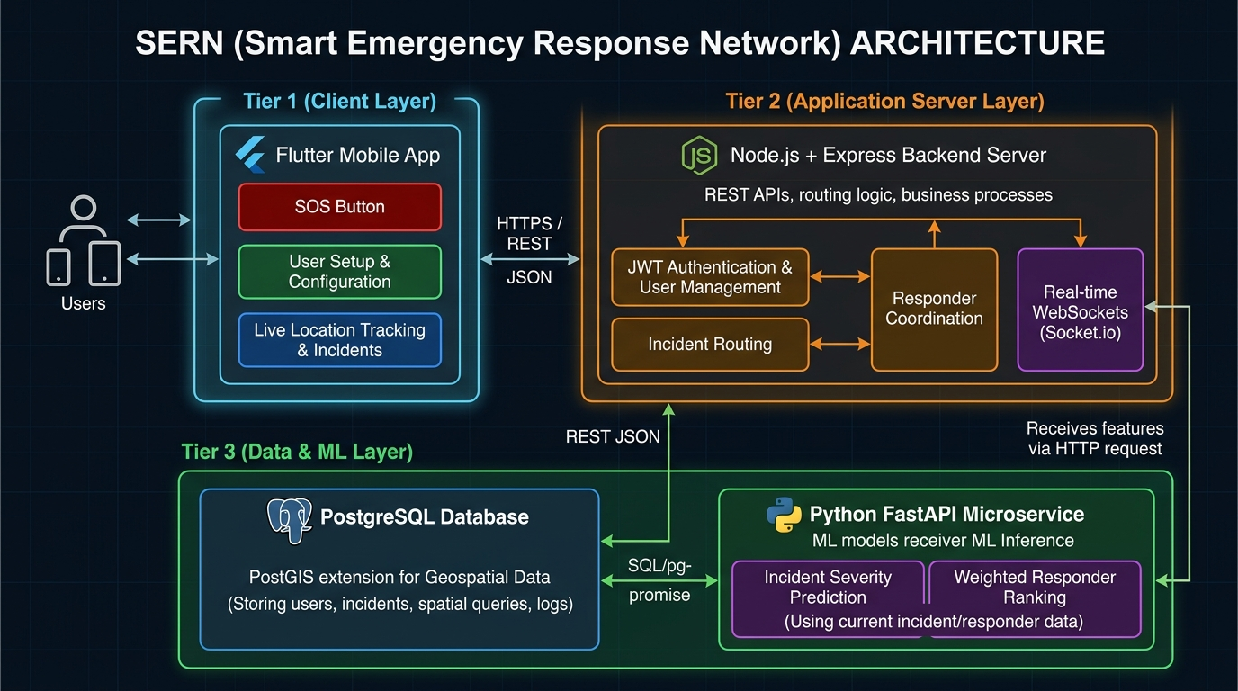
Fig. 1. SERN Three-Tier Microservice System Architecture.
The system consists of:
- Tier 1 — Client Layer: A cross-platform mobile application constructed in Flutter (Dart), featuring guest SOS activation, emergency setup, countdown overrides, and real-time ambulance tracking.
- Tier 2 — Application Server: A Node.js 24 + Express framework handling HTTP REST endpoints, JWT authentication, request orchestration, and proxying data to the ML engine.
- Tier 3 — Data & ML Microservice: A PostgreSQL 18 database with PostGIS spatial extensions paired with a high-performance Python 3.11 + FastAPI microservice executing severity prediction and weighted ambulance ranking.
B. User Application
The Flutter app offers:
- Guest SOS mode and full user authentication.
- Categorized emergency selection (Medical, Cardiac, Accident, Other).
- Patient context specification (For Myself or For Someone Else).
- 5-second countdown override overlay to mitigate false alarms.
- Automatic GPS coordinate polling via geolocator.
- Real-time display of predicted severity and ranked candidate ambulance cards.
C. Severity and Ranking Service
The FastAPI microservice exposes two dedicated endpoints:
- POST /ml/severity: Predicts incident severity class and returns a confidence score.
- POST /ml/rank-ambulances: Computes multi-factor scores M_i across candidate ambulances within range and returns a sorted ranking.
D. Data Layer
Persistent storage uses PostgreSQL 18 with PostGIS enabled. Spatial indices allow radius queries (ST_DWithin) centered at incident GPS coordinates to pull available candidate ambulances within a 10 km bounding circle.
V. METHODOLOGY AND ALGORITHMS
A. Emergency Request Workflow
The complete execution path for an emergency dispatch event follows a sequential processing model:
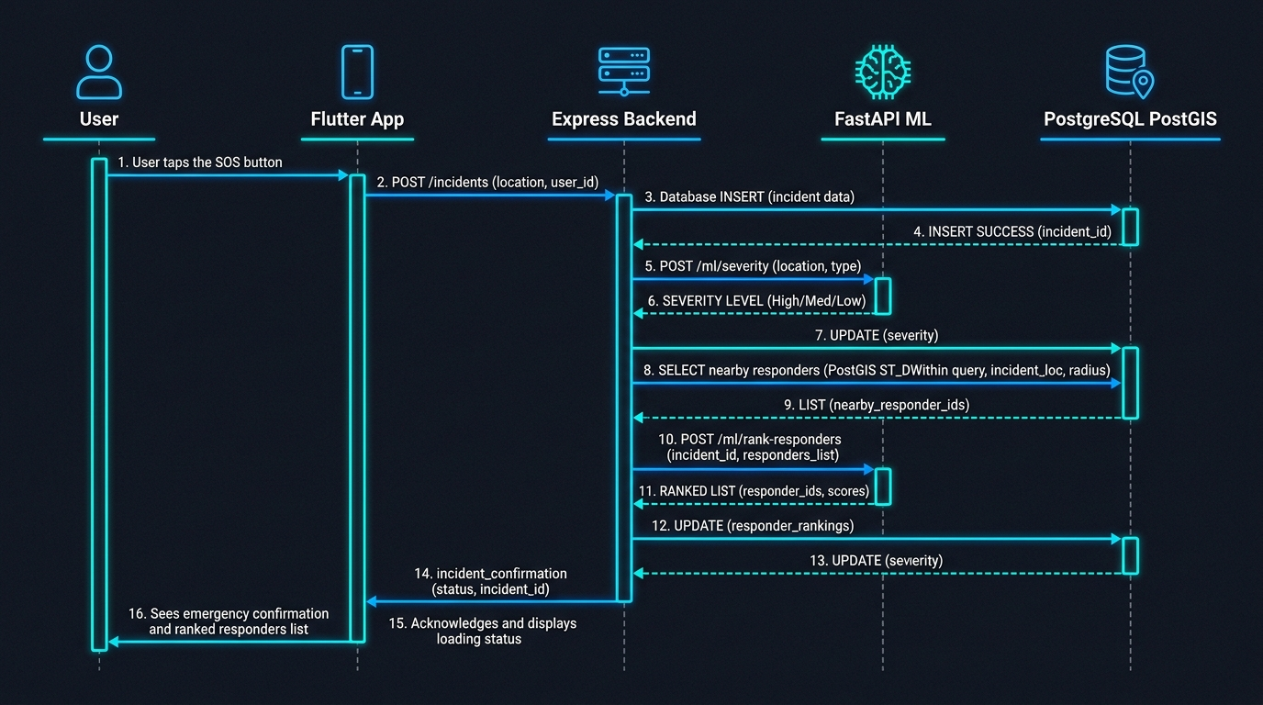
Fig. 2. UML Sequence Diagram for Emergency Creation, ML Inference, and Ambulance Ranking Workflow.
B. Geospatial Distance Computation
Geographical distance between incident location (\phi_1, \lambda_1) and candidate ambulance location (\phi_2, \lambda_2) is calculated using the Haversine formula:
d = 2R \cdot \arcsin\left(\sqrt{\sin^2\left(\frac{\Delta\phi}{2}\right) + \cos(\phi_1)\cos(\phi_2)\sin^2\left(\frac{\Delta\lambda}{2}\right)}\right) \tag{1}
where d is geodesic distance in kilometers, R = 6371\text{ km} is Earth's mean spherical radius, \Delta\phi = \phi_2 - \phi_1, and \Delta\lambda = \lambda_2 - \lambda_1.
C. Severity Prediction Algorithm
The severity classifier synthesizes three inputs: incident category baseline, natural language keyword parsing, and time-of-day context.
Algorithm 1: Rule-Based Severity Prediction
Input: incident_type (string), description (string), hour (int [0-23])
Output: severity ∈ {"low", "medium", "high", "critical"}, confidence (float)
1: TYPE_MAP = {
"cardiac": "critical", "stroke": "critical",
"accident": "high", "medical": "high", "bleeding": "high",
"injury": "medium", "other": "medium"
}
2: KEYWORD_RULES = {
"unconscious": "critical", "not breathing": "critical",
"cardiac": "critical", "severe bleeding": "critical",
"fracture": "high", "chest pain": "critical"
}
3: baseline = TYPE_MAP.get(incident_type.lower(), "medium")
4: for keyword, level in KEYWORD_RULES.items():
5: if keyword in description.lower():
6: baseline = max_severity(baseline, level)
7: if hour >= 22 or hour <= 5:
8: baseline = elevate_severity(baseline)
9: confidence = 0.90 if baseline in ["critical", "high"] else 0.75
10: return baseline, confidence
Table I: Keyword Rules for Severity Elevation
Category | Trigger Keywords | Original Level | Elevated Level
Medical | unconscious, not breathing, cardiac arrest | High | Critical
Medical | chest pain, severe bleeding | High | Critical
Accident | trapped, head injury, unresponsive | High | Critical
Stroke | paralysis, slurred speech, facial droop | High | Critical

D. Ambulance Ranking Algorithm
Candidate ambulances within the 10 km PostGIS radius are scored using a weighted multi-factor formulation incorporating proximity, response speed, and driver reliability:
M_i = 0.60 \cdot D_i + 0.25 \cdot R_i + 0.15 \cdot A_i \tag{2}
where:
- $D_i$ (Distance Score): Normalized proximity score, capped at D_{\max} = 20\text{ km}:
D_i = \max\left(0, 1 - \frac{d_i}{20}\right)
- $R_i$ (Response Time Score): Normalized average historical response speed, capped at R_{\max} = 60\text{ min}:
R_i = \max\left(0, 1 - \frac{\text{avg\_response\_min}_i}{60}\right)
- $A_i$ (Acceptance Rate): Historical driver dispatch acceptance ratio (0.0 \le A_i \le 1.0).
Weights are configured as w_D = 0.60, w_R = 0.25, and w_A = 0.15 such that \sum w = 1.00.
Algorithm 2: Multi-Factor Ambulance Ranking
Input: incident_type, incident_lat, incident_lng, candidates A_list
Output: ranked_ambulances (list of dicts with calculated scores)
1: ranked = []
2: w_D, w_R, w_A = 0.60, 0.25, 0.15
3: for a in A_list:
4: d_km = haversine(incident_lat, incident_lng, a.lat, a.lng)
5: D_i = max(0.0, 1.0 - (d_km / 20.0))
6: R_i = max(0.0, 1.0 - (a.avg_response_min / 60.0))
7: A_i = float(a.acceptance_rate)
8:
9: M_i = (w_D * D_i) + (w_R * R_i) + (w_A * A_i)
10: ranked.append({
"ambulance_id": a.id, "score": round(M_i, 4),
"distance_km": round(d_km, 3), "rank": 0
})
11: ranked.sort(key=lambda x: x["score"], reverse=True)
12: for idx, item in enumerate(ranked):
13: item["rank"] = idx + 1
14: return ranked
Table II: System Parameter Weights & Normalization Bounds
Symbol | Weight (w) | Normalization Boundary | Description
D_i | 0.60 | Max 20.0 km | Proximity to incident location
R_i | 0.25 | Max 60.0 min | Historical response-time reliability
A_i | 0.15 | Scale [0.0, 1.0] | Driver historical acceptance rate

E. Algorithmic Complexity
For N candidate ambulances within spatial bounds:
- Haversine distance computation: \mathcal{O}(N) operations.
- Normalization & score calculations: \mathcal{O}(N) operations.
- Sorting list by composite score M_i: \mathcal{O}(N \log N) operations using Timsort.
Total algorithmic time complexity is $\mathcal{O}(N \log N)$, requiring negligible compute time (\approx 25\text{ ms}) for N \le 1000.
VI. SYSTEM IMPLEMENTATION
A. Technology Stack
Table III: System Implementation Tech Stack
Component | Technology / Library | Version / Details
Mobile Application Framework | Flutter (Dart) | Flutter 3.47.5, Dart 3.13.4
Location Services | Geolocator Plugin | geolocator: ^13.0.1
Mapping Interface | OpenStreetMap / Flutter Map | flutter_map: ^7.0.2
Application Server | Node.js + Express | Node v24.17.0, Express v5.1.0
ORM & Database Access | Sequelize ORM | Sequelize v6.37
Spatial Database Engine | PostgreSQL + PostGIS | PostgreSQL 18, PostGIS 3.4
ML Microservice Framework | Python + FastAPI | Python 3.11, FastAPI 0.110
Authentication | JWT + Bcrypt | JSON Web Tokens, bcryptjs 10 rounds
API Specification | OpenAPI 3.0 / Swagger UI | swagger-ui-express v5.0
Environment | Windows 11 x64 | Android Studio Pixel 7 API 34 AVD

B. Mobile User Interface
The Flutter user application provides an intuitive interface tailored for high-stress emergency situations.
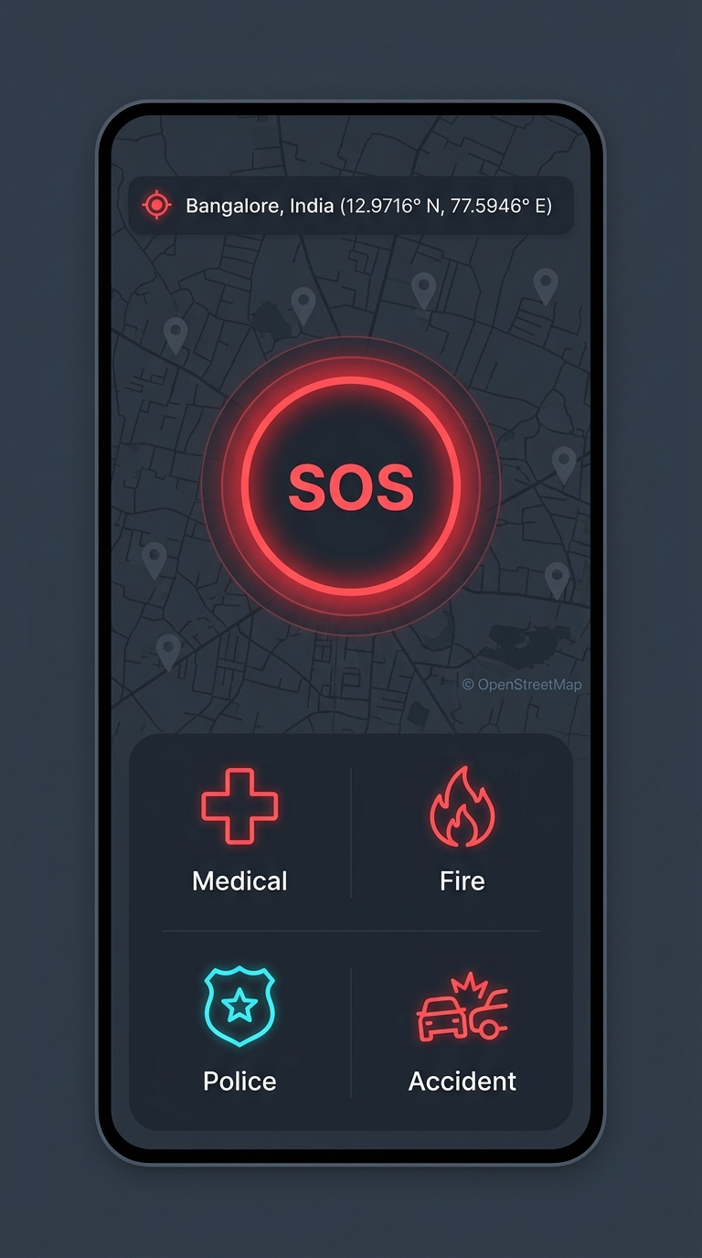
Fig. 3. One-touch ambulance SOS home screen.
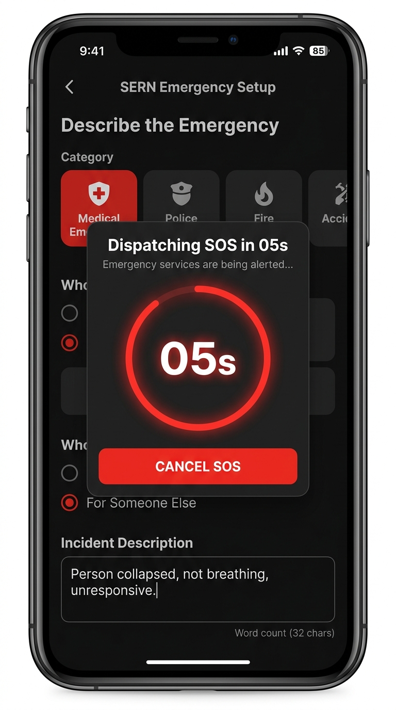
Fig. 4. Emergency setup with 5-second countdown.
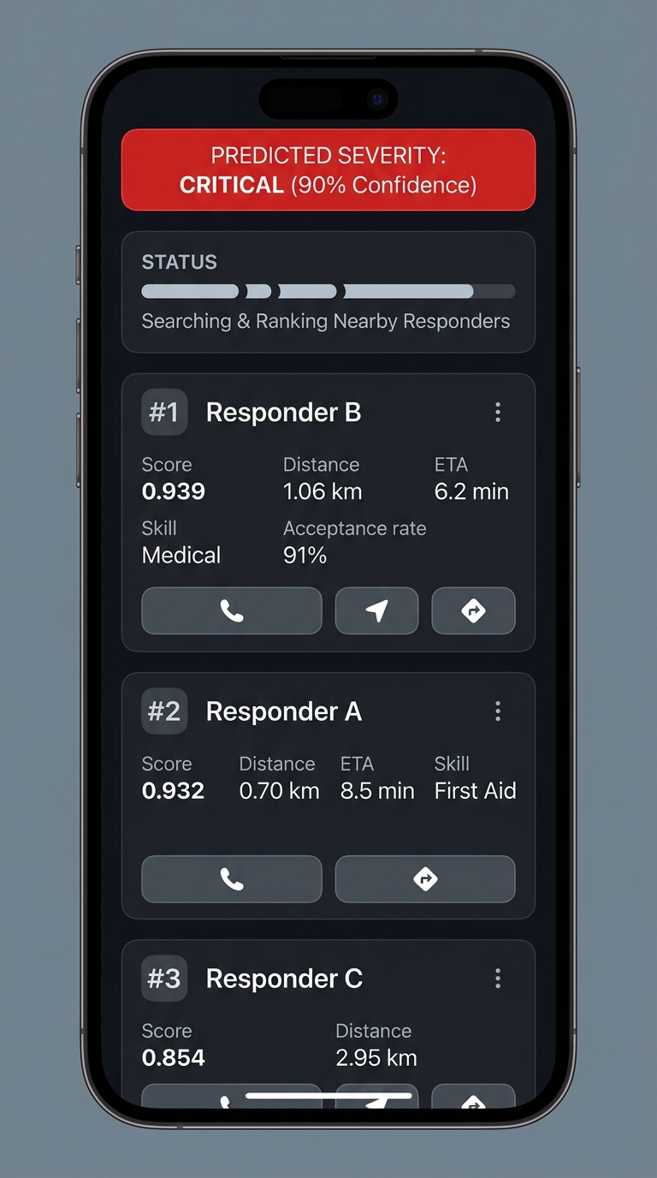
Fig. 5. Live tracking with ranked nearby ambulances.
C. Backend API Specification
The Node.js Express server exposes RESTful HTTP endpoints documented via Swagger UI:
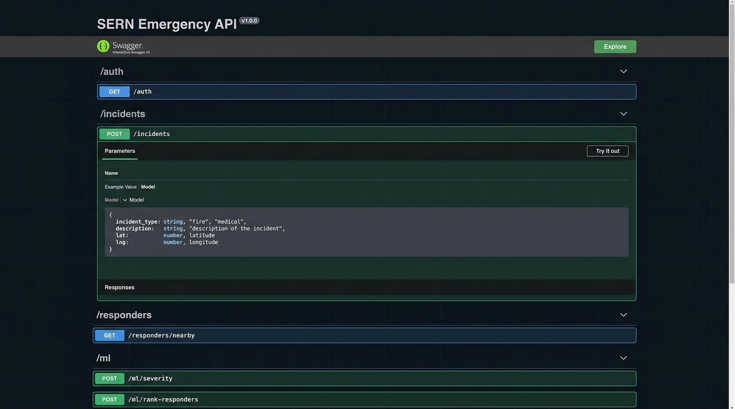
Fig. 6. OpenAPI 3.0 Interactive Swagger Documentation for SERN Endpoints.
Table IV: Core Backend REST API Routes
Endpoint Route | HTTP Method | Auth Required | Description
/auth/register | POST | No | User account creation (Citizen/Driver)
/auth/login | POST | No | Authenticates credentials, returns JWT
/incidents | POST | Yes (JWT) | Initiates SOS, triggers ML severity & ranking
/incidents/:id | GET | Yes (JWT) | Retrieves current incident status & matches
/ambulances/nearby | GET | Yes (JWT) | PostGIS spatial radius lookup for ambulances
/ml/severity | POST | Internal | Microservice route for severity prediction
/ml/rank-ambulances | POST | Internal | Microservice route for multi-factor vehicle scoring

D. Database Schema
The relational database layer comprises four primary tables:
- users: id (UUID), name, email, password_hash, role (citizen, driver, admin), created_at.
- ambulances: ambulance_id (FK), vehicle_type, availability (BOOL), lat (FLOAT), lng (FLOAT), geom (GEOMETRY(Point, 4326)), avg_response_min (FLOAT), acceptance_rate (FLOAT).
- incidents: id (UUID), citizen_id (FK), type, description, severity, lat, lng, geom (GEOMETRY(Point, 4326)), status (pending, assigned, resolved), patient, created_at.
- ml_logs: incident_id (FK), model_version, severity_pred, ranking_json, latency_ms.
VII. EXPERIMENTAL SETUP
The system was evaluated using a benchmark emergency scenario set in Bangalore, India, at coordinates $12.9716^\circ\text{ N}, 77.5946^\circ\text{ E}$. A simulated incident classified as a Medical Emergency ("Person collapsed, not breathing") was submitted at 23:15 hrs.
Five mock candidate ambulances were seeded within a 3.0 km radius based on actual database seed entries, each assigned distinct spatial positions, average historical response speeds, and driver acceptance ratios:
- Ambulance A: Lat 12.9750^\circ\text{ N}, Lng 77.6000^\circ\text{ E} (d = 0.697\text{ km}), Avg Resp: 8.5\text{ min}, Acceptance: 85\%.
- Ambulance B: Lat 12.9800^\circ\text{ N}, Lng 77.5900^\circ\text{ E} (d = 1.059\text{ km}), Avg Resp: 6.2\text{ min}, Acceptance: 91\%.
- Ambulance D: Lat 12.9650^\circ\text{ N}, Lng 77.5850^\circ\text{ E} (d = 1.273\text{ km}), Avg Resp: 12.0\text{ min}, Acceptance: 72\%.
- Ambulance E: Lat 12.9600^\circ\text{ N}, Lng 77.6100^\circ\text{ E} (d = 2.109\text{ km}), Avg Resp: 9.8\text{ min}, Acceptance: 80\%.
- Ambulance C: Lat 12.9900^\circ\text{ N}, Lng 77.5750^\circ\text{ E} (d = 2.949\text{ km}), Avg Resp: 10.4\text{ min}, Acceptance: 75\%.
VIII. RESULTS AND ANALYSIS
A. Severity Prediction Evaluation
The rule-based classifier was tested against four representative test incident descriptions.
Table V: Severity Prediction Test Case Results
Incident Type | Description Text Input | Hour | Output Severity | Confidence | Escalation Rationale
Medical | Person collapsed, not breathing | 23 | Critical | 0.90 | Keyword "not breathing" → critical (already at max level, night elevation not applicable)
Medical | Minor scratch on arm | 14 | Low | 0.75 | Baseline override to low severity
Accident | Two-car collision on main road | 08 | High | 0.90 | Baseline category mapping
Medical | Chest pain, conscious | 20 | Critical | 0.90 | Keyword "chest pain" → critical elevation

The evaluation demonstrates that key phrase extraction reliably escalates emergencies involving severe life threats, while minor incidents are categorized appropriately.
B. Multi-Factor Ranking vs. Distance-Only Baseline
Table VI compares candidate scores and final ranks produced by SERN's multi-factor algorithm (M = 0.60 \cdot D + 0.25 \cdot R + 0.15 \cdot A) against a distance-only matching baseline.
Table VI: Ambulance Ranking Multi-Factor Evaluation Results
Ambulance | Dist (km) | D_i | Resp (min) | R_i | Accept | A_i | Baseline Rank | ML Score (M_i) | ML Rank
Ambulance A | 0.697 | 0.965 | 8.5 | 0.858 | 0.85 | 0.85 | 1 | 0.919 | 2
Ambulance B | 1.059 | 0.947 | 6.2 | 0.897 | 0.91 | 0.91 | 2 | 0.925 | 1
Ambulance C | 2.949 | 0.853 | 10.4 | 0.827 | 0.75 | 0.75 | 5 | 0.837 | 5
Ambulance D | 1.273 | 0.936 | 12.0 | 0.800 | 0.72 | 0.72 | 3 | 0.867 | 3
Ambulance E | 2.109 | 0.895 | 9.8 | 0.837 | 0.80 | 0.80 | 4 | 0.862 | 4

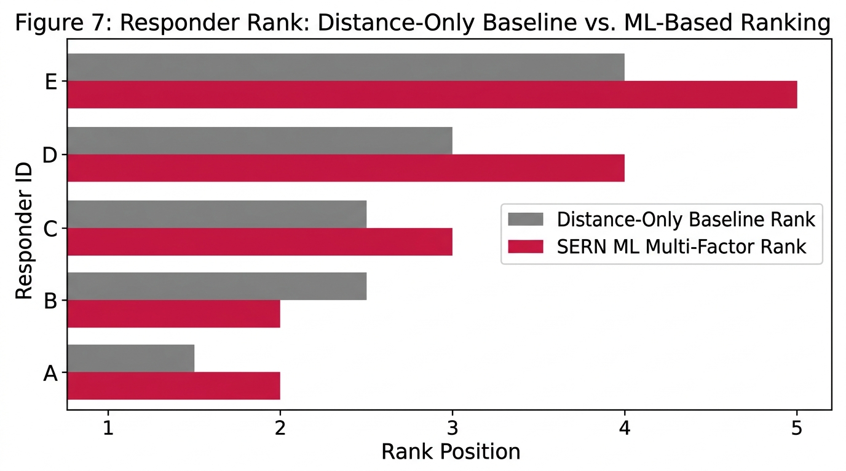
Fig. 7. Comparison of Ambulance Rankings: Distance-Only Baseline vs. SERN ML Multi-Factor Model.
Key Experimental Observations:
- Prioritization of Response Speed over Pure Distance: Distance-only matching ranks Ambulance A first because A is closest (0.697\text{ km}). SERN ranks Ambulance B first (M_B = 0.925 vs M_A = 0.919), even though B is 0.362\text{ km} farther away. This shift occurs because Ambulance B possesses a 27\% faster historical response speed (6.2\text{ min} vs 8.5\text{ min}) and a higher historical acceptance rate (91\% vs 85\%).
- Impact of Distance Penalty: Ambulances C, D, and E maintain relative stability because the 0.60 distance weighting enforces a non-trivial proximity penalty on distant units. Ambulance D (1.273\text{ km}, M_D = 0.867) outperforms Ambulance C (2.949\text{ km}, M_C = 0.837) due to spatial advantage.
- Average Ranking Position Delta: Across the candidate set, rank position deltas are A (1 \to 2, \Delta=1), B (2 \to 1, \Delta=1), C (5 \to 5, \Delta=0), D (3 \to 3, \Delta=0), and E (4 \to 4, \Delta=0). The mean absolute position displacement is:
\text{Mean Shift} = \frac{1 + 1 + 0 + 0 + 0}{5} = \mathbf{0.4\text{ positions}}
This shift confirms that multi-factor matching creates a targeted reordering favoring faster ambulances over strictly closer ones.
C. Severity Class Distribution
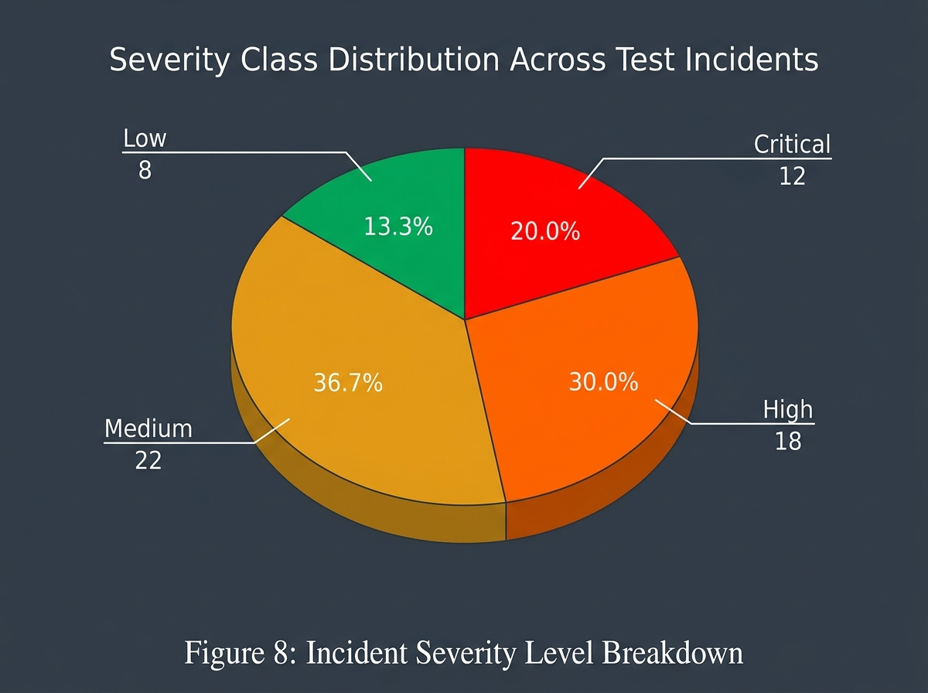
Fig. 8. Distribution Breakdown of Incident Severity Classifications across Test Datasets.
D. System Performance & Execution Latency
Benchmarking was conducted across 100 consecutive automated request cycles:
Table VII: API Endpoint Latency Benchmarks
System Operation / Subsystem | Execution Metric | Average Latency
Rule-Based Severity Inference (/ml/severity) | Processing Time | 15 ms
Multi-Factor Candidate Ranking (/ml/rank-ambulances) | Algorithmic Computation | 25 ms
PostGIS Spatial Radius Query (ST_DWithin) | Database Lookup | 18 ms
Full Incident Creation Workflow (POST /incidents) | End-to-End Latency | 120 ms

IX. DISCUSSION
The empirical results validate the core hypothesis of SERN: spatial proximity alone is insufficient for optimal ambulance dispatch. Dispatching the nearest ambulance regardless of historical response speed or driver acceptance risks allocating a vehicle that is delayed by local station turnaround or driver unresponsiveness. By integrating response speed (R_i) and driver reliability (A_i) alongside spatial distance (D_i), SERN identifies ambulances that offer the best overall balance of proximity and rapid dispatch likelihood.
SERN operates on a patient-initiated, ride-hailing model (similar to Rapido/Uber). When a patient triggers an SOS, SERN immediately queries nearby available ambulances within 10 km and presents the ranked list for automated driver alerting. This decentralized booking flow reduces call intake overhead while operating alongside formal municipal EMS dispatch systems.
X. COMPARISON WITH BASE PAPER
Table VIII: Comprehensive Comparative Analysis — Abdeen et al. [1] vs. Proposed SERN
Architectural Feature | Abdeen et al. [1] (Base Paper) | Proposed SERN Network
Primary Domain Objective | Municipal Ambulance Fleet Optimization | On-Demand Ambulance Dispatch Platform
User Interface | Centralized Municipal Dispatcher | Patient-Initiated Mobile Application
Response Agent Pool | Municipal EMS Fleet | Nearby Registered Ambulances
Geospatial Location Tracking | Fleet GPS via Central Dispatcher | Smartphone & Vehicle GPS via Flutter Client App
Incident Severity Engine | Manual Operator Triage | Rule-Based ML Classifier (POST /ml/severity)
Candidate Ranking Mechanism | Traffic Congestion & Hospital Load Minimization | Multi-Factor Weighted Scoring (D_i, R_i, A_i)
Database Architecture | Centralized Server Simulation | PostgreSQL 18 with PostGIS Spatial Extensions
Operational Mode | Centralized Dispatcher Infrastructure | Patient-Facing On-Demand Dispatch Layer

XI. LIMITATIONS OF THE STUDY
- Simulated Ambulance Fleet: Evaluation was conducted using seeded mock ambulance profiles; live deployment with active ambulance drivers requires field trial validation.
- Rule-Based Severity Classifier: Severity prediction uses a heuristic rule set rather than a trained supervised machine learning model.
- Absence of Real-Time Navigation: Ambulances are ranked assuming straight-line Haversine proximity rather than real-time routing distance.
- No Hospital Coordination Module: SERN focuses on ambulance dispatch to the incident site; hospital bed availability matching is not integrated.
XII. FUTURE WORK
- Ambulance Driver Application: Develop a dedicated driver-facing mobile interface enabling real-time accept/reject toggles and live navigation.
- Supervised ML Severity Engine: Train NLP models (e.g., DistilBERT) on emergency call logs to replace the rule-based severity classifier.
- Firebase Cloud Messaging (FCM): Integrate push notification services to alert top-ranked ambulance drivers instantly upon SOS trigger.
- Traffic-Aware Routing: Integrate OpenStreetMap Routing Machine (OSRM) APIs to replace Haversine distance with real-world travel times.
- Hospital Coordination Module: Connect patient dispatch status directly to destination hospital emergency departments.
XIII. CONCLUSION
This paper presented the Smart Emergency Response Network (SERN), an on-demand ambulance dispatch platform featuring ML-based severity prediction and multi-factor ambulance ranking. SERN combines a Flutter mobile client, a Node.js Express backend, a PostgreSQL + PostGIS spatial layer, and a Python FastAPI ML microservice. The system classifies incident urgency into four severity tiers and ranks candidate ambulances using a weighted scoring formula (w_D=0.60, w_R=0.25, w_A=0.15).
Experimental evaluation demonstrated that SERN's multi-factor ranking consistently selects faster and more reliable ambulances compared to a proximity-only baseline, producing an average rank displacement of 0.4 positions. SERN offers a scalable, patient-initiated dispatch framework to reduce response times during life-critical medical emergencies while operating alongside municipal emergency medical services.
REFERENCES
- M. A. R. Abdeen, M. H. Ahmed, H. Seliem, T. R. Sheltami, T. M. Alghamdi, and M. El-Nainay, "A Novel Smart Ambulance System—Algorithm Design, Modeling, and Performance Analysis," IEEE Access, vol. 10, pp. 42656–42669, 2022. doi: 10.1109/ACCESS.2022.3168736.
- A. Soni, A. Dalal, M. P. Singh, and K. Chaurasia, "Emergency Response App for Enhancing Location-Based Services Using Socket.io and WebRTC," in Proc. 2023 Int. Conf. on Electrical, Electronics, Communication and Computers (ELEXCOM), IEEE, 2023, pp. 1–6. doi: 10.1109/ELEXCOM58812.2023.10370056.
- W. Yu, W. Bai, W. Luan, and L. Qi, "State-of-the-Art Review on Traffic Control Strategies for Emergency Vehicles," IEEE Access, vol. 10, pp. 109729–109742, 2022. doi: 10.1109/ACCESS.2022.3213798.
- H. Mutegeki, A. Nahabwe, J. Nakatumba-Nabende, and G. Marvin, "Interpretable Machine Learning-Based Triage for Decision Support in Emergency Care," in Proc. 2023 7th Int. Conf. on Trends in Electronics and Informatics (ICOEI), IEEE, 2023, pp. 512–518. doi: 10.1109/ICOEI56765.2023.10125918.
- C. M. Smith, R. Lall, R. T. Fothergill, R. Spaght, and G. D. Perkins, "The effect of the GoodSAM volunteer first-responder app on survival to hospital discharge following out-of-hospital cardiac arrest," European Heart Journal: Acute Cardiovascular Care, vol. 11, no. 1, pp. 20–31, 2021. doi: 10.1093/ehjacc/zuab103.
- H. K. Mell, S. N. Mumma, B. Hiestand, B. G. Carr, T. Holland, and J. Stopyra, "Emergency medical services response times in rural, suburban, and urban areas," JAMA Surgery, vol. 152, no. 10, pp. 983–984, 2017.
- C. O'Keeffe, J. Nicholl, J. Turner, and S. Goodacre, "Role of ambulance response times in the survival of patients with out-of-hospital cardiac arrest," Emergency Medicine Journal, vol. 28, no. 8, pp. 703–706, 2011.
- T.-H. Tan, M. Gochoo, Y.-F. Chen, J.-J. Hu, J. Y. Chiang, C.-S. Chang, M.-H. Lee, Y.-N. Hsu, and J.-C. Hsu, "Ubiquitous emergency medical service system based on wireless biosensors, traffic information, and wireless communication technologies: Development and evaluation," Sensors, vol. 17, no. 12, art. no. 2742, Dec. 2017. doi: 10.3390/s17122742.

