AMTGC Traffic Controller
Task 5 – Verification and Validation Report
Self-checking Verilog testbench | Vivado 2022.2 / XSim

1. Objective
Task 5 verifies the integrated Adaptive Multi-Junction Traffic Grid Controller (AMTGC) using a unified, self-checking top-level testbench. Directed and deterministic pseudo-random stimulus exercises reset, adaptive green targets, green-wave coordination, pedestrian arbitration, emergency override, and recovery from a mid-run reset.

2. Design and Simulation Setup
The design under test is amtgc_top, integrating two junction controllers, pedestrian round-robin arbitration, and green-wave coordination. Simulation was run with Vivado 2022.2 / XSim. The testbench clock period is 10 ns.
Parameter | Value
MIN_GREEN_TIME | 3
MAX_GREEN_TIME | 10
GREEN_EXTENSION | 1
GREEN_WAVE_CYCLES | 5
Random seed | 0x51A7C0DE
Randomized stimulus | 300 cycles (as configured in testbench)

3. Final Verification Summary
The supplied final simulation transcript reports 361 checks, zero detected errors, 100 pedestrian grants for Junction A, 100 for Junction B, and emergency phase coverage of 8/8 FSM states. The final result is “PASS - ALL ENABLED CHECKS PASSED.” This result applies to the checks enabled in the testbench and is not a formal proof of all possible input sequences.
Test | Purpose | Observed result
1 | Initial reset sequence | PASS
2 | Adaptive green target calculation for density values 0–7 | Completed; no errors reported
3 | Green-wave activation and six density combinations | PASS
4 | Pedestrian arbitration fairness with both requests active | PASS; A=100, B=100
5 | Emergency override during all eight Junction A FSM states | PASS; coverage 8/8
6 | Rapid emergency toggling | Completed; no errors reported
7 | Mid-run reset recovery | PASS; both FSMs returned to WAIT
8 | Deterministic pseudo-random stimulus | Completed; no errors reported

4. Waveform Evidence
The following screenshots were supplied from the Vivado waveform viewer and simulation console. The screenshots provide visual evidence for normal controller activity, pedestrian arbitration/green-wave signals, emergency override, and the final test summary.
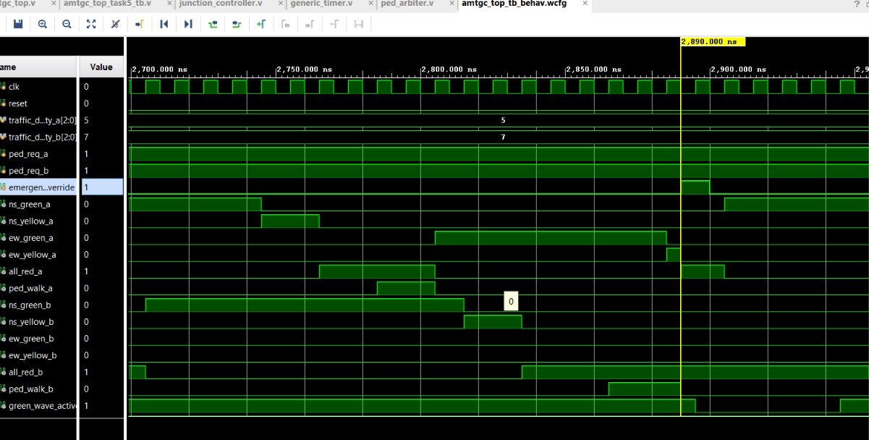
Figure 1. Normal traffic operation waveform. The waveform displays clock/reset, density inputs, pedestrian requests, junction traffic-light outputs, and green-wave activity.
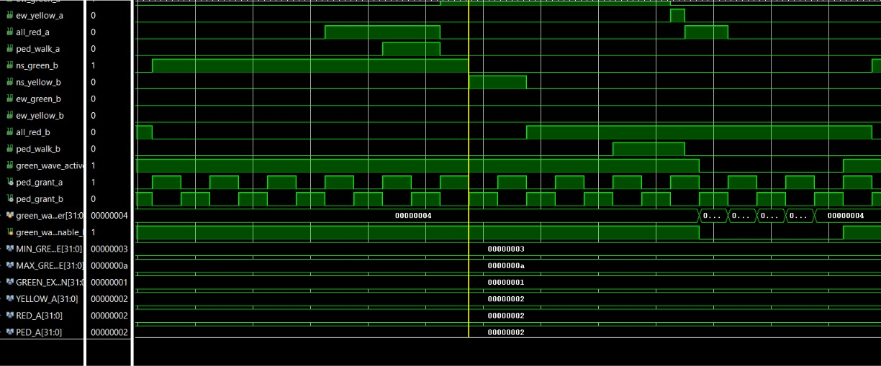
Figure 2. Pedestrian arbitration and green-wave coordination. The pedestrian grant signals alternate, and the waveform includes green-wave control and timing parameters.
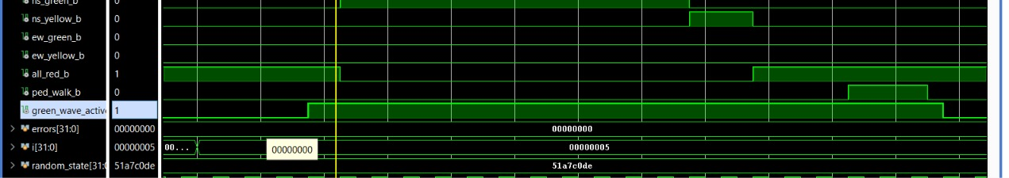
Figure 3. Additional waveform view showing junction B signals, all-red and pedestrian-walk outputs, green-wave activity, error counter, and deterministic random seed.
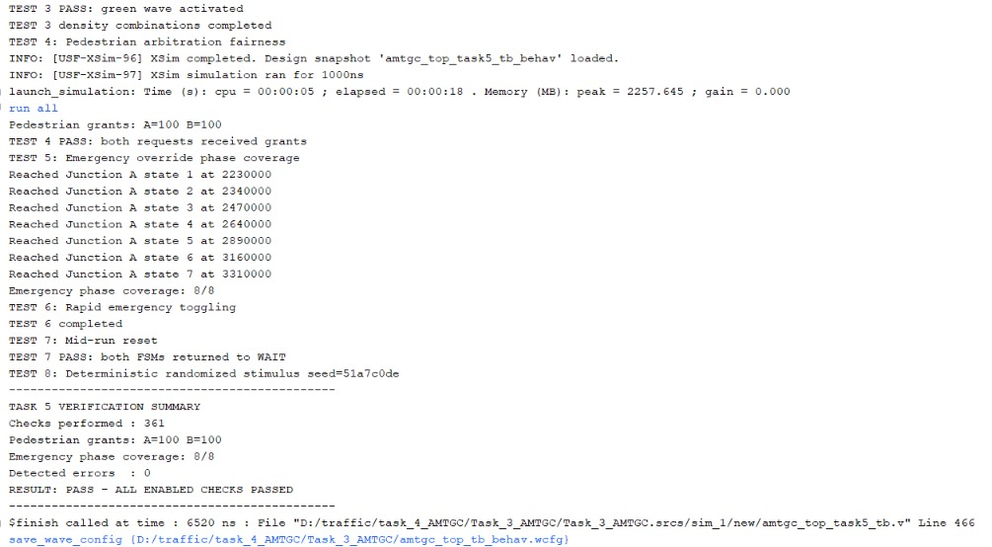
Figure 4. Final simulation console summary. The transcript reports 361 checks, 100 grants for each junction, 8/8 emergency phase coverage, zero detected errors, and PASS.
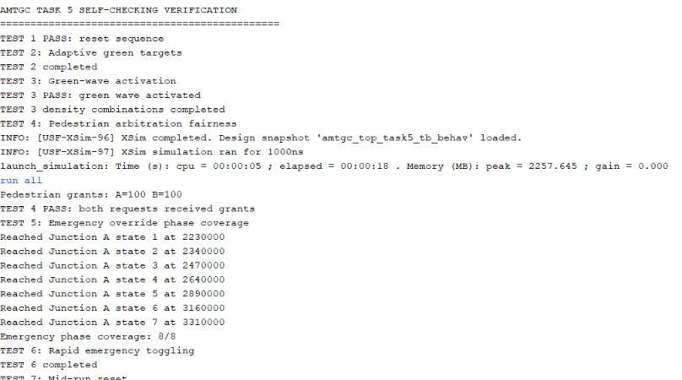
Figure 5. Task 5 test execution log showing reset, adaptive targets, green-wave activation, pedestrian fairness, emergency phase coverage, rapid emergency toggling, mid-run reset, and randomized stimulus.

5. Bug Log and Corrections
Issue | Cause | Correction / status
Testbench elaboration errors due to mismatched ports/signals | Testbench names did not match the actual top-module interface/hierarchy | Updated mappings to actual ports, including traffic_density_a/b, ns_green_a, and green_wave_active. Resolved.
Emergency phase coverage initially missed S_PED | Pedestrian requests were not held active long enough during the phase-coverage sequence | Kept pedestrian requests active during coverage; final run reached all eight states (8/8). Resolved.
These corrections address testbench wiring and stimulus. This report does not claim additional RTL modifications beyond those made and tested in the project.

6. Randomized Testing and Fairness
The deterministic pseudo-random test uses seed 0x51A7C0DE so the stimulus can be reproduced. It complements directed tests by varying traffic-density inputs, pedestrian requests, and emergency behavior in combinations that are not all individually selected in directed scenarios. The final log reports no detected errors.
For pedestrian arbitration fairness, both requests were exercised in the fairness test. The simulation reported 100 grants to Junction A and 100 grants to Junction B, demonstrating equal grant counts in the observed test window.

7. Coverage Statement and Limitations
The final log supports coverage of: initial reset; adaptive target calculation for density values 0–7; green-wave activation and six density combinations; pedestrian arbitration fairness; emergency override across all eight Junction A FSM states; rapid emergency toggling; mid-run reset; and deterministic pseudo-random stimulus. The reported summary is 361 checks and zero errors.
The supplied log confirms target-calculation testing, but it does not by itself prove that every actual green-phase duration was compared cycle-by-cycle against an independent reference model. A finite randomized run also cannot cover every possible input sequence. Insert Figure 6 before submission and check any additional coverage items required by the original assignment rubric.

8. Conclusion
The final XSim run completed with the self-checking testbench reporting PASS, 361 checks, zero detected errors, 100 pedestrian grants for each junction, and 8/8 emergency phase coverage. These results support correct behavior for the scenarios enabled in the testbench. The adaptive green timing screenshot remains intentionally reserved for insertion.

Appendix A — Final Simulation Log Summary
Checks performed : 361
Pedestrian grants: A=100 B=100
Emergency phase coverage: 8/8
Detected errors : 0
RESULT: PASS - ALL ENABLED CHECKS PASSED

