TASK 3 – SYSTEM INTEGRATION
Adaptive Multi-Junction Traffic Grid Controller (AMTGC)
Verilog HDL | Vivado 2022.2

1. Objective
Task 3 integrates the reusable RTL modules from the previous tasks into a complete Adaptive Multi-Junction Traffic Grid Controller (AMTGC). The system combines two parameterized junction controllers, generic timers, a shared pedestrian arbiter, green-wave coordination, and a system-wide emergency override.

2. Task Requirements
- Integrate Junction A and Junction B using the reusable junction_controller module.
- Use different parameter values for the two junctions.
- Integrate generic_timer modules through the junction controllers.
- Use a shared fair pedestrian arbiter for requests from both junctions.
- Implement a bounded system-wide emergency override that drives both junctions to all-red.
- Implement and verify the green-wave timing relationship in simulation.
- Maintain hierarchical modules and named port connections.
- Use a dedicated integration-level testbench.

3. System Architecture
amtgc_top
├── ped_arbiter
├── junction_controller A
│ └── generic_timer
└── junction_controller B
└── generic_timer
The top-level module coordinates the independent functional blocks. The pedestrian arbiter communicates only through request and grant signals and does not depend on internal junction states.

4. Integrated Modules
Module | Purpose | Key Interfaces
amtgc_top | Top-level integration and coordination | clk, reset, pedestrian requests, emergency override
junction_controller | Moore FSM for one junction | ped_grant, emergency_override, start_enable, traffic outputs
generic_timer | Reusable configurable timer | clk, reset, start, count_target, done
ped_arbiter | Fair pedestrian arbitration | ped_request_a/b, ped_grant_a/b
amtgc_top_tb | Integration verification | System inputs and observed outputs

5. Junction Parameters
Junction | GREEN | YELLOW | RED | PED
A | 3 | 2 | 2 | 2
B | 4 | 2 | 3 | 3
The same junction_controller RTL is reused with different parameter values, demonstrating genuine parameterization.

6. Pedestrian Arbitration
A shared pedestrian arbiter is used so simultaneous requests are resolved fairly rather than giving permanent priority to one junction.
Observed service sequence: A → B → A → B → A → B
The repeated alternating service demonstrates that neither junction is consistently starved.

7. Green-Wave Verification
The integration testbench measures the actual start times of the North-South green phases.
Measurement | Result
Junction A NS Green start | 5000 ns
Junction B NS Green start | 55000 ns
Measured delay | 50000 ns
Clock period | 10000 ns (10 ns)
Delay | 5 clock cycles
Required delay | 50 ns
Result | PASS
GREEN-WAVE MEASUREMENT
Junction A NS Green : 5000 ns
Junction B NS Green : 55000 ns
Green-wave delay : 50000 ns
Required delay : 50 ns
GREEN-WAVE RESULT: PASS

8. Emergency Override
The emergency_override input forces the junction controllers into an all-red emergency state. The simulation tested the override during normal operation.
EMERGENCY OVERRIDE ASSERTED at 550000 ns
Junction B ALL-RED at 555000 ns
EMERGENCY OVERRIDE ASSERTED at 750000 ns
Junction B ALL-RED at 755000 ns
The observed all-red transition occurred within the bounded response requirement used by the integration test.

9. Integration Testbench
- Normal simultaneous operation of both junctions.
- Repeated pedestrian requests and fair arbitration.
- Green-wave timing measurement using simulation timestamps.
- Emergency override during system operation.
- All-red response verification.

10. Simulation Results
The final XSim integration simulation completed successfully and reached the testbench completion point. The green-wave measurement returned PASS, pedestrian service alternated between the two junctions, and emergency override activity was observed.
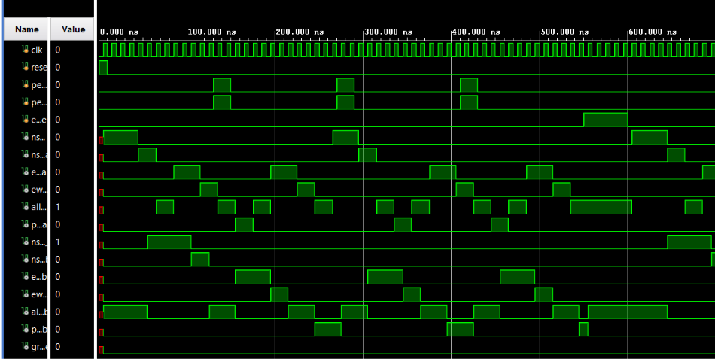
Figure 1. Final AMTGC integration waveform (0–600 ns view).

11. Coding and Design Practices
- Timing values are parameterized.
- Moore FSM structure is maintained.
- Sequential logic uses non-blocking assignments.
- Combinational logic uses blocking assignments.
- Case statements include default branches.
- Module instantiations use named port connections.
- Modules remain hierarchical and independently defined.
- Pedestrian arbitration does not access internal junction states.

12. Verification Summary
Verification | Result | Status
Junction integration | A and B operate together | PASS
Green-wave | 50 ns / 5 cycles | PASS
Pedestrian fairness | Alternating A/B service observed | PASS
Emergency override | All-red response observed | PASS
Integration testbench | Complete system simulated | PASS

13. Files Used
- amtgc_top.v
- junction_controller.v
- generic_timer.v
- ped_arbiter.v
- amtgc_top_tb.v
- amtgc_top_tb_behav.wcfg
- Final waveform screenshot

14. Tools and Environment
- Verilog HDL
- Xilinx Vivado 2022.2
- XSim simulator
- Simulation time resolution: 1 ps

15. Conclusion
Task 3 successfully integrates the traffic-control modules into an AMTGC system. Integration-level simulation verified reusable junction operation, fair pedestrian arbitration, measured green-wave coordination, and emergency override behavior. The measured green-wave delay was 50 ns, equal to five clock cycles, and the testbench reported PASS.

16. Final Checklist
☑ AMTGC top-level integration completed
☑ Two parameterized junction controllers integrated
☑ Generic timers integrated
☑ Shared pedestrian arbiter integrated
☑ Green-wave measured and PASS confirmed
☑ Emergency override tested
☑ Integration testbench completed
☑ Final waveform captured

