ADAPTIVE MULTI-JUNCTION
TRAFFIC CONTROLLER
(AMTGC)
TASK 6 — FINAL TECHNICAL REPORT
ElevanceSkills Internship Project | Verilog HDL | AMD Xilinx Vivado 2022.2

1. Abstract
The Adaptive Multi-Junction Traffic Controller (AMTGC) is a Verilog HDL digital design intended to coordinate traffic signals at two four-way junctions. The design description identifies reusable FSM-based junction controllers and a generic timer. Its principal features are traffic-density-based adaptive green timing, pedestrian request handling through shared arbitration, green-wave coordination between Junction A and Junction B, and an emergency override that forces vehicle green and yellow outputs low while asserting an all-red condition. The project was developed and evaluated using behavioral simulation in AMD Xilinx Vivado 2022.2.

2. Objectives
- Develop a modular, parameterized RTL design for two traffic junctions.
- Control North–South and East–West signal phases using finite-state machines.
- Adjust green duration according to traffic-density input within configured minimum and maximum limits.
- Coordinate pedestrian requests through a shared arbitration module.
- Provide timing coordination between Junction A and Junction B.
- Prioritize emergency override and enforce an all-red vehicle-signal condition.
- Verify behavior with testbenches and preserve simulation evidence for review.

3. System Architecture
The reported top-level module, amtgc_top, integrates two junction controllers. Each controller uses a generic timer for phase timing. A shared ped_arbiter coordinates pedestrian grants, while top-level logic distributes traffic-density inputs, start/coordination signals, and emergency override. The following diagram is a functional overview based on the module descriptions in the supplied report; the final RTL remains the authority for exact signal connectivity.
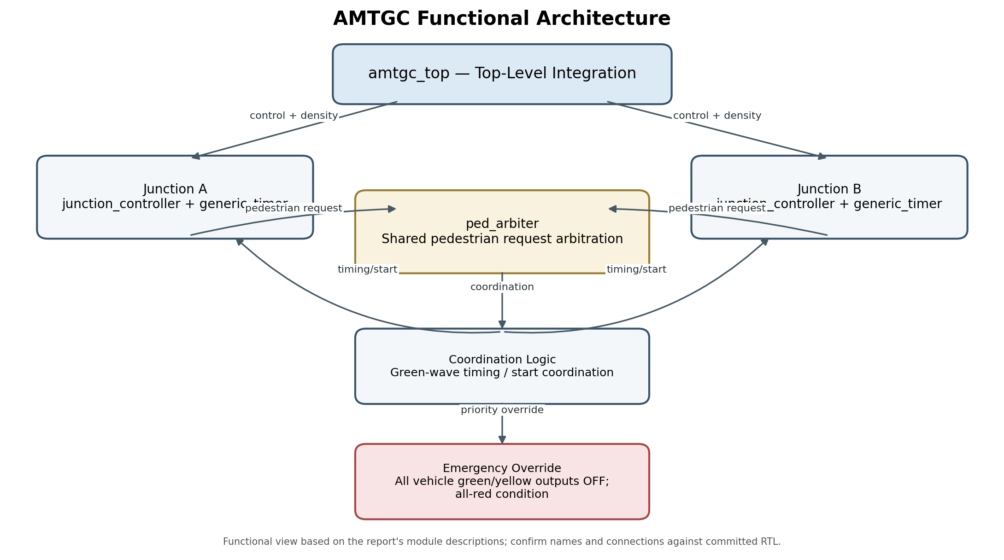

4. RTL Modules
Module / file | Responsibility | Notes
amtgc_top.v | Top-level integration | Connects the two junction controllers, pedestrian arbitration, coordination, and emergency control.
junction_controller.v | Signal sequencing FSM | Controls green, yellow, red-clearance, wait, and pedestrian states.
generic_timer.v | Reusable phase timer | Parameterized counter-based timing; preserve the exact version used in the passing verification run.
ped_arbiter.v | Pedestrian request arbitration | Coordinates pedestrian grants; fairness claims require supporting testbench evidence.
amtgc_top_tb.v / amtgc_top_task5_tb.v | Simulation verification | Applies test scenarios and checks expected behavior; use the committed Task 5 testbench for the reported result.

5. Junction Controller FS
The supplied report identifies eight states: S_WAIT, S_NS_GREEN, S_NS_YELLOW, S_RED_NS_EW, S_EW_GREEN, S_EW_YELLOW, S_RED_EW_NS, and S_PED. The normal sequence serves North–South traffic, transitions through yellow and red clearance, serves East–West traffic, and returns through red clearance. At a red-clearance decision, a pending pedestrian request can route the FSM to S_PED. After the pedestrian timer completes, the controller returns to the direction selected by ped_return_to_ns.
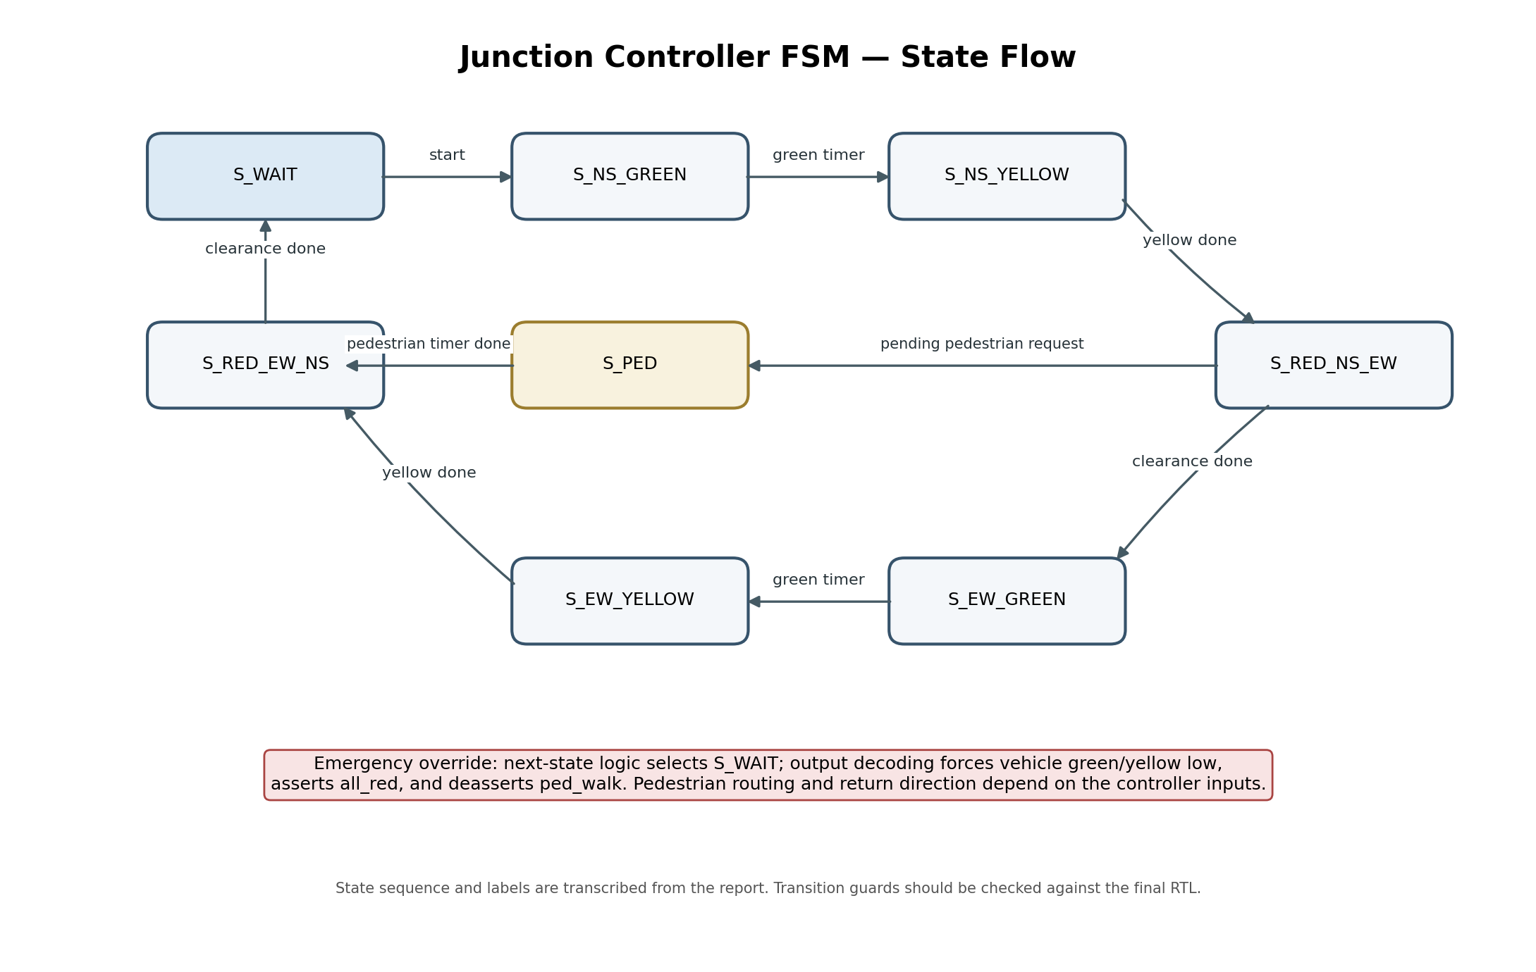
Emergency behavior described in the supplied report: when emergency_override is asserted, next-state logic selects S_WAIT and output decoding forces ns_green, ns_yellow, ew_green, and ew_yellow low; all_red is asserted and ped_walk is deasserted. Confirm the transition guards and exact return paths against the final committed RTL before delivery.

6. Adaptive Green Timing
The supplied report describes the green target as MIN_GREEN_TIME + traffic_density × GREEN_EXTENSION, clamped between MIN_GREEN_TIME and MAX_GREEN_TIME. The target is sampled as the controller enters a green phase and is used for either the North–South or East–West green interval. Yellow, red-clearance, and pedestrian phases use dedicated parameters. This behavior should be checked against the committed junction_controller.v and the matching testbench.
Separating timing into generic_timer promotes reuse and keeps timing logic distinct from state sequencing. The exact generic_timer source used for the recorded passing run should remain unchanged unless the full verification suite is rerun.

7. Pedestrian Handling
According to the supplied report, a granted pedestrian request is recorded in ped_pending. At a red-clearance state, the FSM checks for a pending request and enters S_PED when required. Once the pedestrian timer completes, the pending request is cleared and the controller resumes the appropriate traffic direction. The top-level ped_arbiter coordinates requests from both junctions. The recorded Task 5 summary reports 100 pedestrian grants for each junction; this count is a simulation result and does not, by itself, establish every possible fairness property.

8. Green-Wave Coordination
Green-wave coordination is intended to establish a configured timing relationship between compatible green phases at Junction A and Junction B. The earlier report mentioned a measured delay of 50,000 ns, but explicitly noted that the time units, clock period, and threshold required confirmation. Because the supplied evidence does not independently establish those details, this corrected report does not present 50,000 ns as a verified final measurement. Confirm the actual timing expression, units, and acceptance threshold in the final testbench before adding a numerical claim.
9. Emergency Override and Safety
The supplied report states that emergency override takes priority over normal output decoding. When active, vehicle green and yellow outputs are forced low, all_red is asserted, and ped_walk is disabled. It also states that timer reset is combined with emergency_override in the junction controller. The Task 5 test summary reported emergency phase coverage of 8/8. For final review, inspect waveforms to confirm both junctions enter the all-red condition and remain there for the full override interval.

10. Verification Strategy and Results
The recorded Task 5 simulation output shared during development reported 361 checks, zero detected errors, pedestrian grants of 100 for Junction A and 100 for Junction B, emergency phase coverage of 8/8, and simulation completion at 6,520 ns. These are recorded-run results; they should be associated with the exact committed RTL and testbench versions and the archived console log.
Metric | Recorded Task 5 result
Checks performed | 361
Pedestrian grants | Junction A = 100; Junction B = 100
Emergency phase coverage | 8/8
Detected errors | 0
Simulation result | PASS — ALL ENABLED CHECKS PASSED
Simulation finish time | 6,520 ns (as shown in the recorded console output)
Recommended final verification review:
- Inspect compile and simulation messages for errors or warnings affecting functionality.
- Review normal North–South/East–West sequencing and yellow/red-clearance phases.
- Check adaptive green duration at representative density values and at the configured limits.
- Check pedestrian requests at both junctions and confirm the reported grant counts.
- Check green-wave timing using the final testbench's exact units and threshold.
- Assert emergency_override and inspect all-red outputs at both junctions.
- Rerun verification after any RTL or testbench change and replace archived evidence if results change.

11. Debugging Notes and Design Trade-offs
During testbench development, the supplied report describes a recurring issue in which simulation ended before all planned density cases had completed. This highlights the need to consider stimulus duration, phase progression, and timeout settings together. A timeout should allow the planned sequence to complete while remaining finite enough to expose a stalled design. For timing measurements, stimulus should wait for the intended fresh green-phase edge and its corresponding end edge; density should be changed at a point where the controller samples it for the intended phase.
The green-wave test requires consistent units: measured delays and thresholds must use the same time scale, and the clock period and configured cycle count should be explicit. A PASS message should be interpreted together with the measured value and the comparison condition. The principal design trade-offs are modularity versus integration complexity, adaptive responsiveness versus predictable phase duration, and pedestrian responsiveness versus traffic-flow continuity.

12. Limitations and Future Improvements
- Validate the design on FPGA hardware before considering real-world deployment.
- Connect calibrated traffic sensors rather than relying only on externally supplied density values.
- Document the green-wave delay parameter and units explicitly at the top-level interface.
- Add assertions for mutually exclusive vehicle green signals and bounded emergency response.
- Expand boundary-value and randomized testing for density, reset, pedestrian requests, and emergency overlap.
- Add automated regression scripts and a consolidated pass/fail summary.
- Record a demonstration video showing normal traffic, adaptive timing, pedestrian handling, green-wave coordination, and emergency override.

13. Conclusion
AMTGC demonstrates a modular Verilog RTL approach to coordinating two traffic junctions using reusable FSM controllers and a generic timer. The reported capabilities include adaptive green timing, pedestrian request handling, green-wave coordination, and emergency all-red behavior. The recorded Task 5 verification completed 361 checks with zero detected errors and a PASS result for the enabled checks. A reliable handoff requires preserving the exact verified RTL, ensuring diagrams match the implementation, and archiving the testbench, logs, waveforms, and documentation in a clear repository.

Appendix A — Final Delivery Checklist
- `rtl/` contains the final verified RTL source files.
- `tb/` contains the final testbench files, including `amtgc_top_task5_tb.v`.
- `docs/` contains the reports, architecture diagram, FSM diagram, and this final technical report.
- `sim/` contains the final waveform screenshots, verification screenshots, and supporting logs.
- The root README describes the actual repository structure and gives reproducible Vivado steps.
- The delivered RTL is identical to the version used for the recorded passing Task 5 run.
- The demo video is recorded and linked or stored as required by the internship.
- The green-wave timing claim is only published numerically after the final testbench units and threshold are confirmed.

