ENVIRONMENT SETUP
Download Java 8 or 8+
https://www.oracle.com/java/technologies/javase/javase8u211-later-archive-downloads.html

Set JAVA_HOME and it to PATH variable

Download Maven binary
https://maven.apache.org/download.cgi

Set M2_HOME and it to PATH variable
.m2 folder will be created in your user directory wherein all the artifacts will be downloaded.
C:\Users\hemah\.m2\repository

For reference, https://mkyong.com/maven/how-to-install-maven-in-windows/

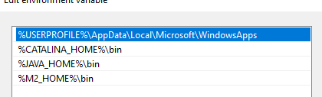

Download and install MySQL Server and SQL Yog client

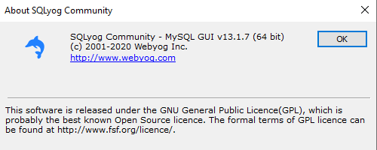
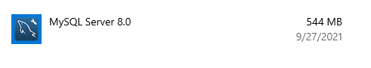

PROJECT SETUP
Go to https://start.spring.io/
Add the dependencies you need and download the project. I have added spring web and spring data
Download and import the project into eclipse
I am using mysql and so I have added the required dependency in pom.xml
<dependency>
<groupId>mysql</groupId>
<artifactId>mysql-connector-java</artifactId>
<scope>runtime</scope>
</dependency>

If you are using eclipse workspace for the first time, make sure java and maven configurations are correct.

DATABASE SETUP

Run the below sql in SQL yog client.

/*
SQLyog Community v13.1.7 (64 bit)
MySQL - 8.0.26 : Database - learning
*********************************************************************
*/

/*!40101 SET NAMES utf8 */;

/*!40101 SET SQL_MODE=''*/;

/*!40014 SET @OLD_UNIQUE_CHECKS=@@UNIQUE_CHECKS, UNIQUE_CHECKS=0 */;
/*!40014 SET @OLD_FOREIGN_KEY_CHECKS=@@FOREIGN_KEY_CHECKS, FOREIGN_KEY_CHECKS=0 */;
/*!40101 SET @OLD_SQL_MODE=@@SQL_MODE, SQL_MODE='NO_AUTO_VALUE_ON_ZERO' */;
/*!40111 SET @OLD_SQL_NOTES=@@SQL_NOTES, SQL_NOTES=0 */;
CREATE DATABASE /*!32312 IF NOT EXISTS*/`learning` /*!40100 DEFAULT CHARACTER SET utf8mb4 COLLATE utf8mb4_0900_ai_ci */ /*!80016 DEFAULT ENCRYPTION='N' */;

USE `learning`;

/*Table structure for table `department` */

DROP TABLE IF EXISTS `department`;

CREATE TABLE `department` (
`department_id` bigint NOT NULL,
`department_name` varchar(255) DEFAULT NULL,
PRIMARY KEY (`department_id`)
) ENGINE=InnoDB DEFAULT CHARSET=utf8mb4 COLLATE=utf8mb4_0900_ai_ci;

/*Data for the table `department` */

insert into `department`(`department_id`,`department_name`) values
(1,'HR'),
(2,'ENGG'),
(3,'DEV'),
(4,'SALES');

/*Table structure for table `employees` */

DROP TABLE IF EXISTS `employees`;

CREATE TABLE `employees` (
`employee_id` bigint NOT NULL AUTO_INCREMENT,
`employee_name` varchar(255) DEFAULT NULL,
`manager_id` bigint DEFAULT NULL,
`department_id` bigint DEFAULT NULL,
`salary` double DEFAULT NULL,
PRIMARY KEY (`employee_id`),
KEY `department_id` (`department_id`),
CONSTRAINT `employees_ibfk_1` FOREIGN KEY (`department_id`) REFERENCES `department` (`department_id`)
) ENGINE=InnoDB AUTO_INCREMENT=18 DEFAULT CHARSET=utf8mb4 COLLATE=utf8mb4_0900_ai_ci;

/*Data for the table `employees` */

insert into `employees`(`employee_id`,`employee_name`,`manager_id`,`department_id`,`salary`) values
(1,'Emp1',2,1,100),
(2,'Emp2',2,1,200);

/*!40101 SET SQL_MODE=@OLD_SQL_MODE */;
/*!40014 SET FOREIGN_KEY_CHECKS=@OLD_FOREIGN_KEY_CHECKS */;
/*!40014 SET UNIQUE_CHECKS=@OLD_UNIQUE_CHECKS */;
/*!40111 SET SQL_NOTES=@OLD_SQL_NOTES */;

application.properties has database details. If you dont want to test with database, remove the configurations in that file and comment DAO calls in service class. You can hardcode the objects for testing.

BUILD AND RUN
Run SpringDemoApplication as Java application.
Embedded Tomcat will start in port 8080

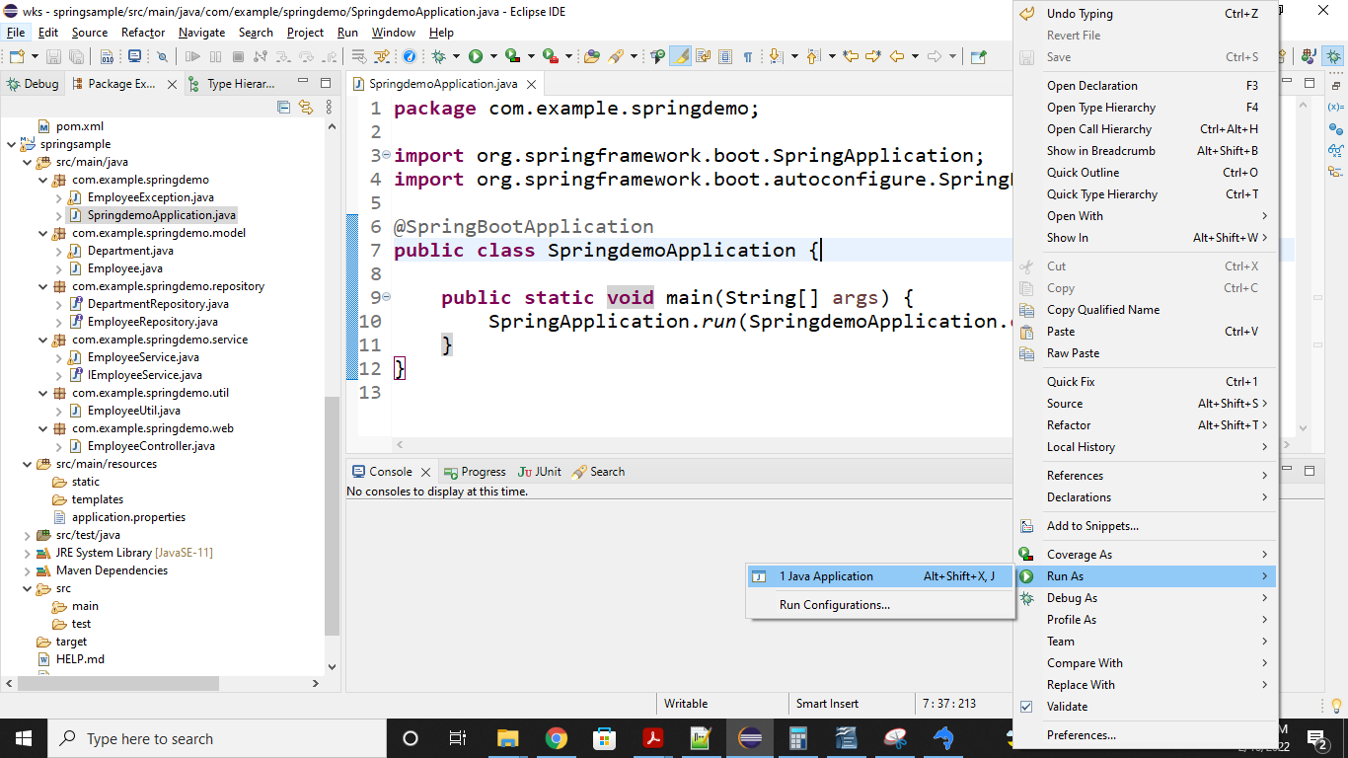

Hit http://localhost:8080/employees in the browser or use any rest client. If you have data in the database, it will be populated.

