GitHub

### **1. Navigating to the Directory**

* **Command**: cd C:
* **Explanation**: You successfully changed to the **C:/** directory.



### **2.Navigating to GitHub Directory**

* **Command**: cd GitHub
* **Explanation**: You navigated to the **GitHub** folder within the **C:/** drive.



### 3. **Initializing Git Repository**

* **Command**: git init
* **Output**: Initialized empty Git repository in C:/GitHub/.git/
* **Explanation**: You initialized a new Git repository in the current directory (C:/GitHub).



### 4. **Adding a File to Staging Area**

* **Command**: git add Firstcode.txt
* **Explanation**: You staged the file Firstcode.txt for commit.



### **5.Configuring User Identity**

* **Command**: git config --global user.email "[hemalatha.g343@gmail.com](mailto:hemalatha.g343@gmail.com)"
* **Command**: git config --global user.name "hemaguntipalli"
* **Explanation**: You set up your Git username and email for commits.

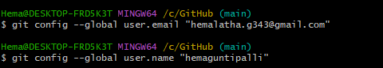

### **6. Adding Remote Repository**

* **Command**: git remote add origin <https://github.com/hemaguntipalli/Test.git>
* **Explanation**: You added a remote Git repository as the origin.



### **7. Changing Branch Name**

* **Command**: git branch -M main
* **Explanation**: You renamed the current branch to **main** (default branch name in many Git repositories).



### **8.First commit**

* **Command**: git commit -m "first commit"
* **Explanation**: This commit was successful, creating the initial commit in your Git repository.

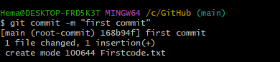

### **9. Push Command Success**

* **Command**: git push -u origin main
* **Explanation**: You successfully pushed the changes to the remote GitHub repository after the first commit. This uploaded your local changes to GitHub.

