**Name : Hemalatha Karumuri**

**Date : 27-12-23**

**SPARK CODING CHALLENGE**

**1-A)Implement Processing JSON file**

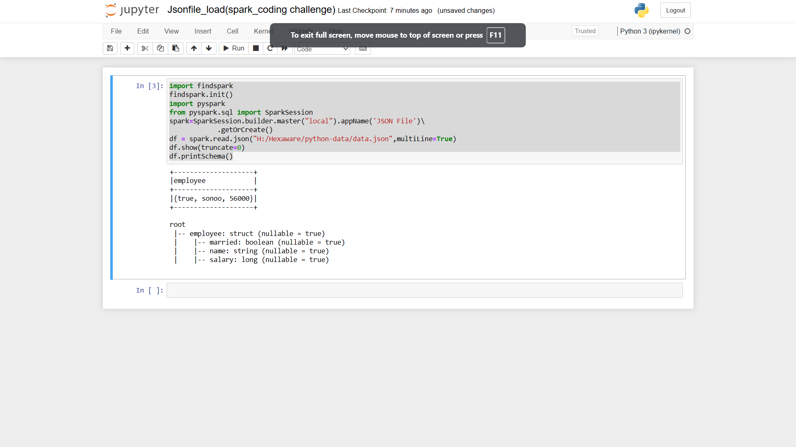

**1-b)Implement Processing CSV file data with Pyspark**

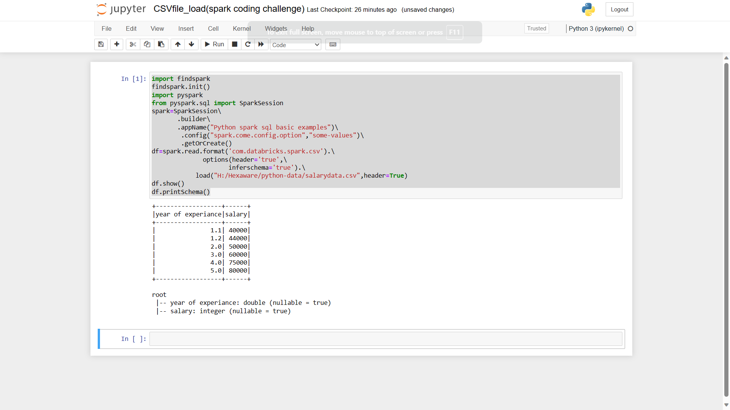

**2) Explain ETL (Extract, Transform, Load) with PySpark**

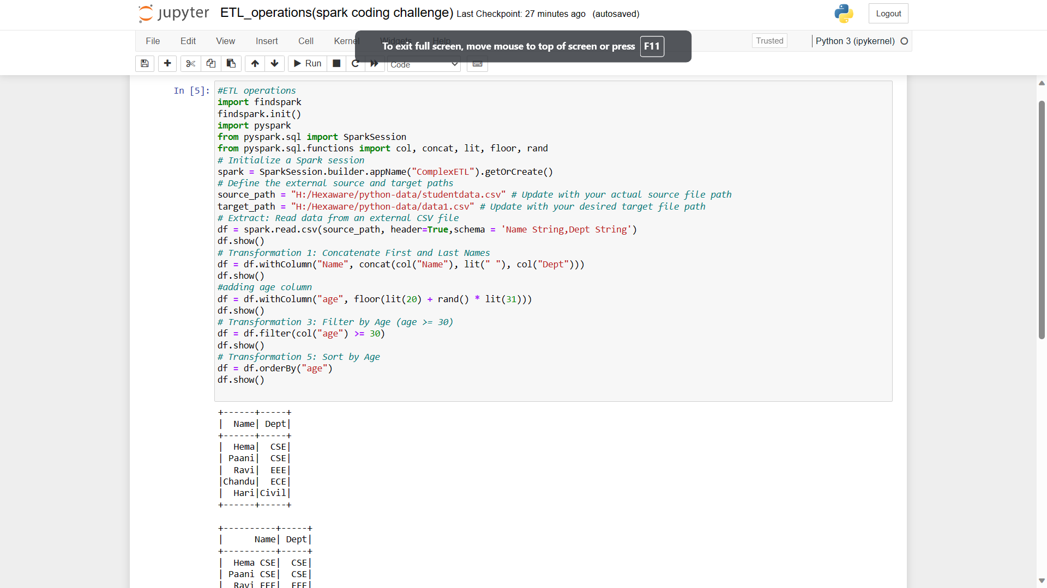

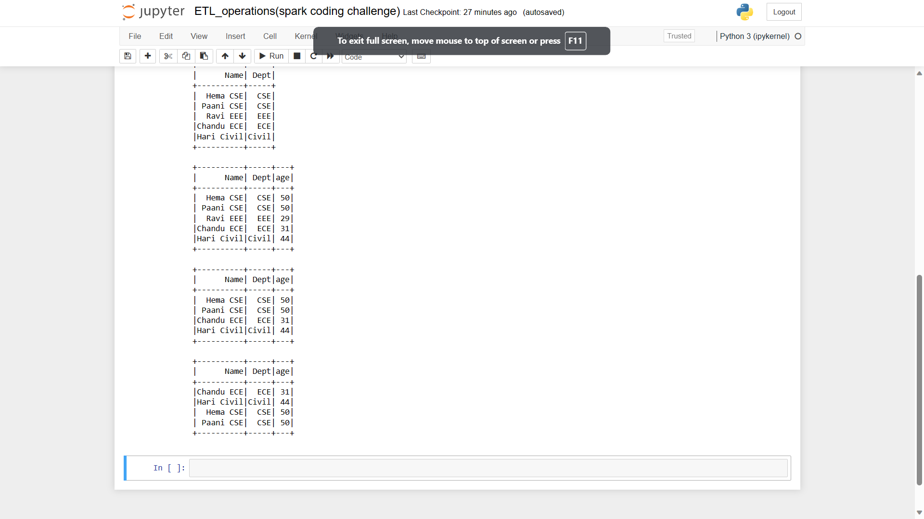

**3) Using Spark SQL - Creating databases, tables**

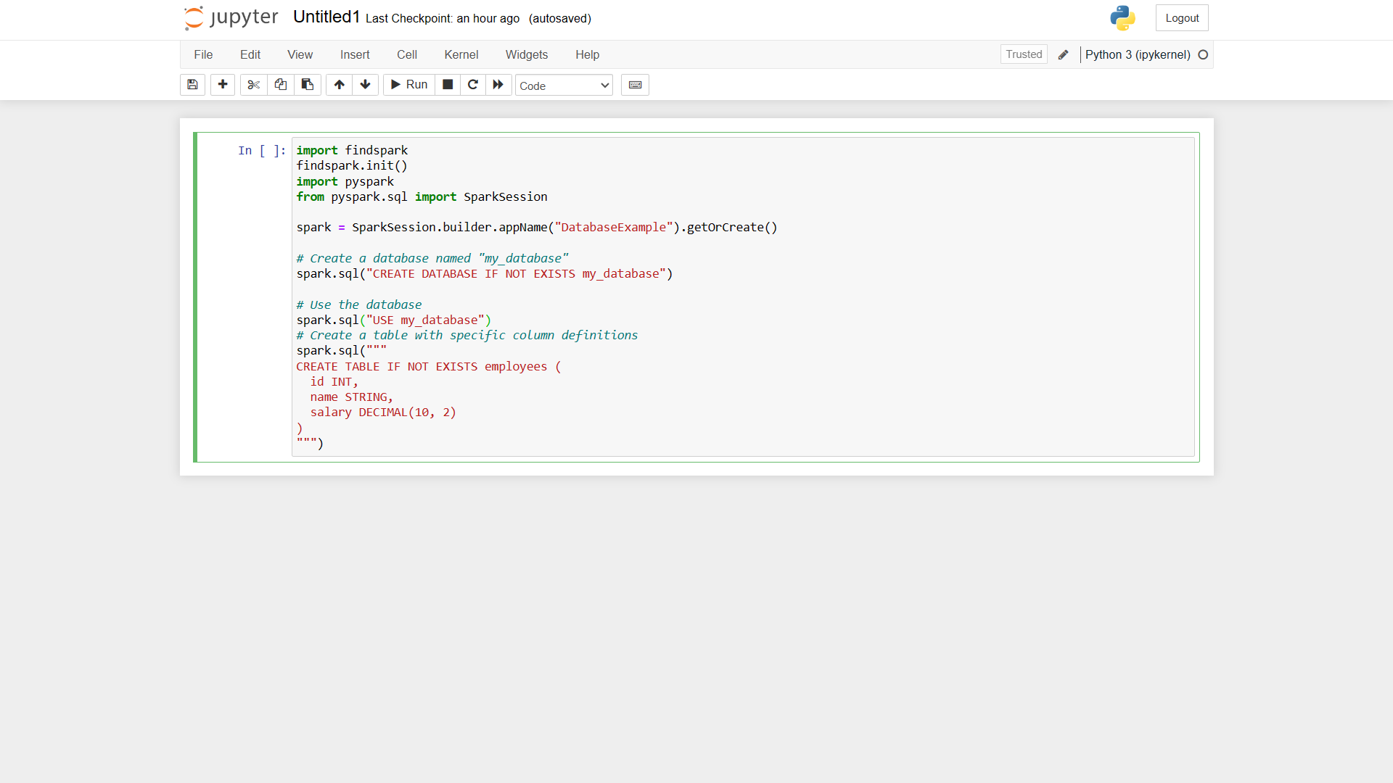

**4) Using Spark SQL - Transformations such as Filter, Join, Simple Aggregations, GroupBy.**

**Aggregate operations:**

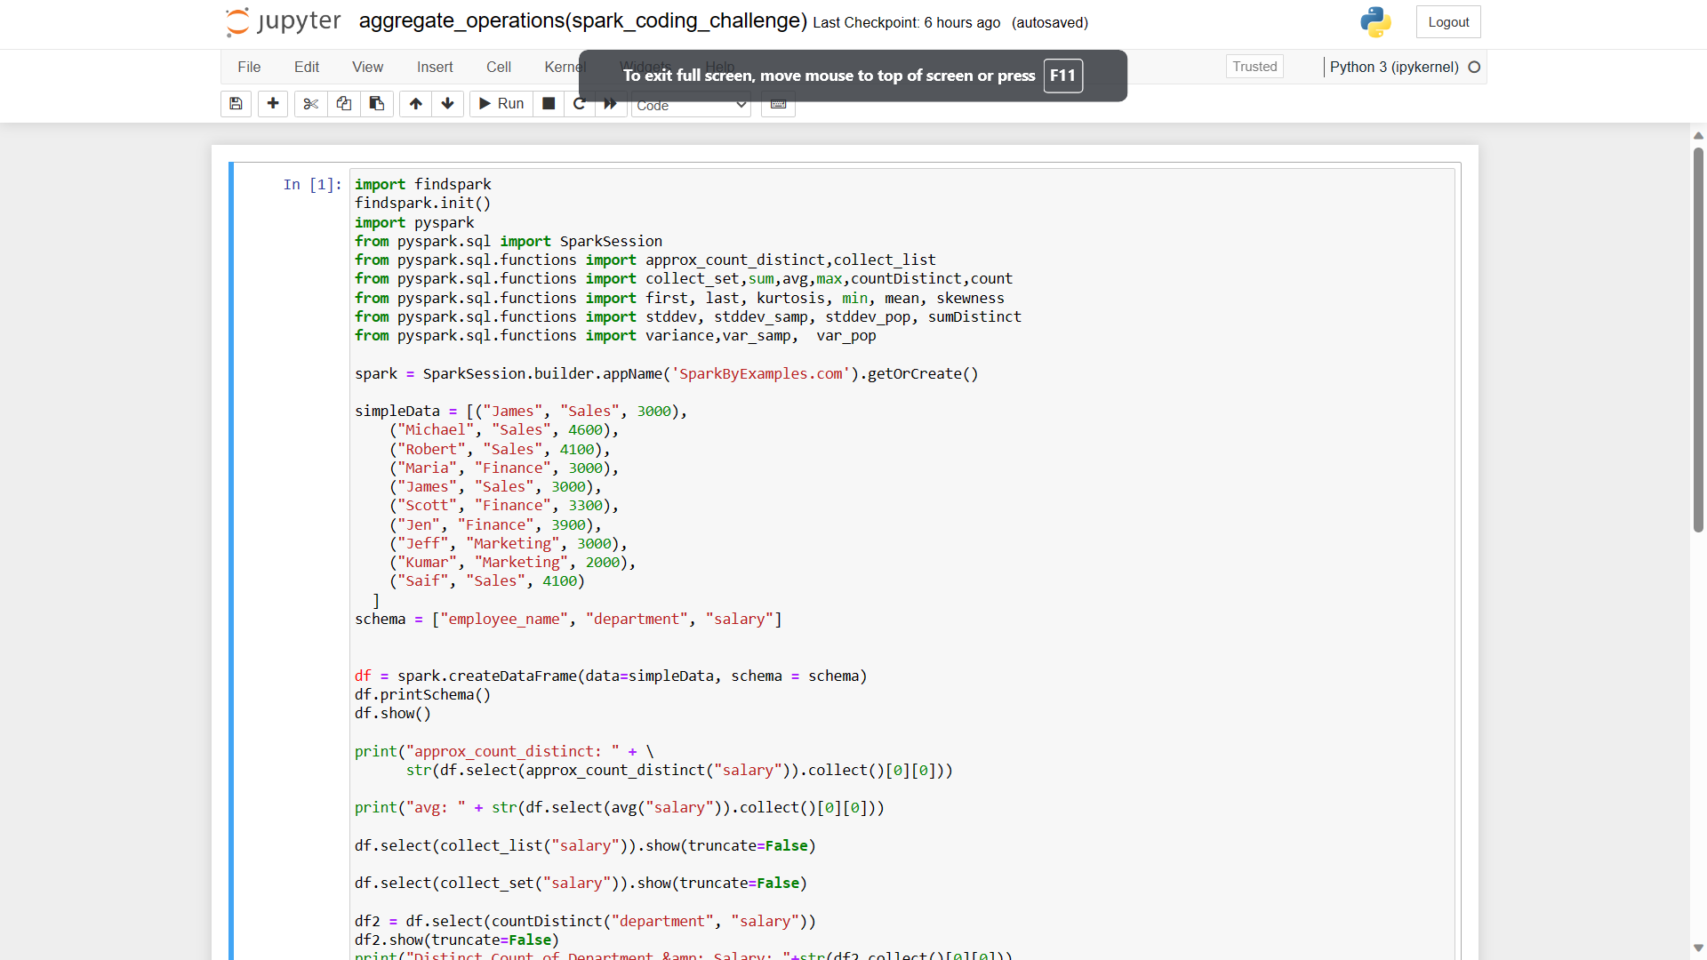

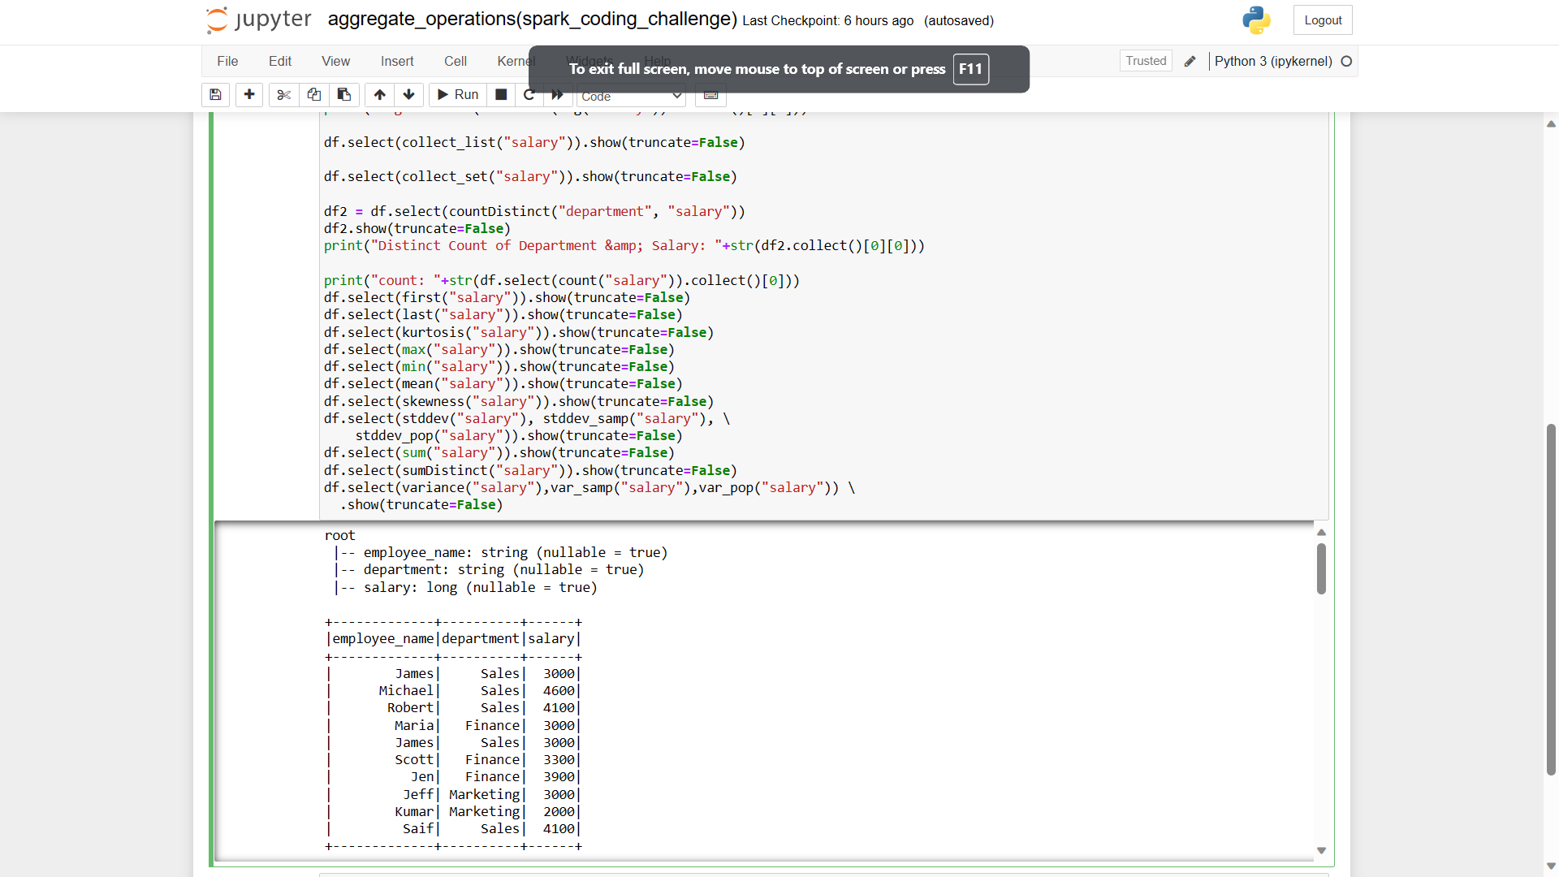

Using group by

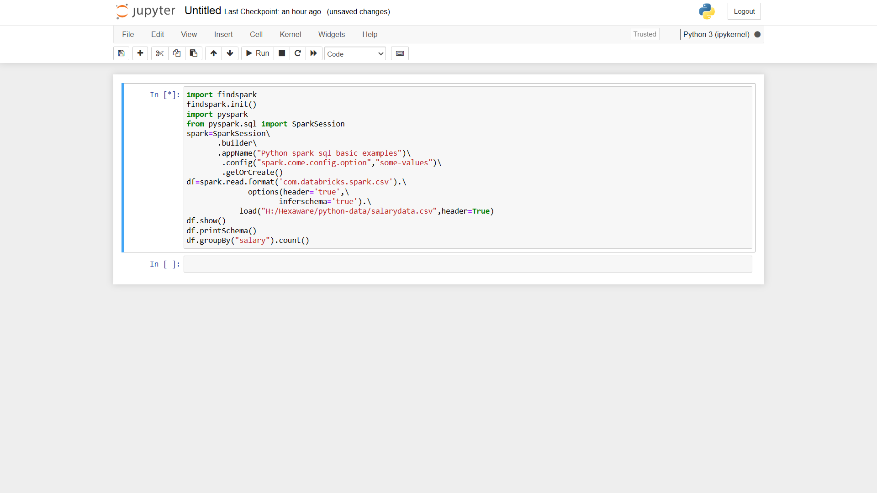

Using joins

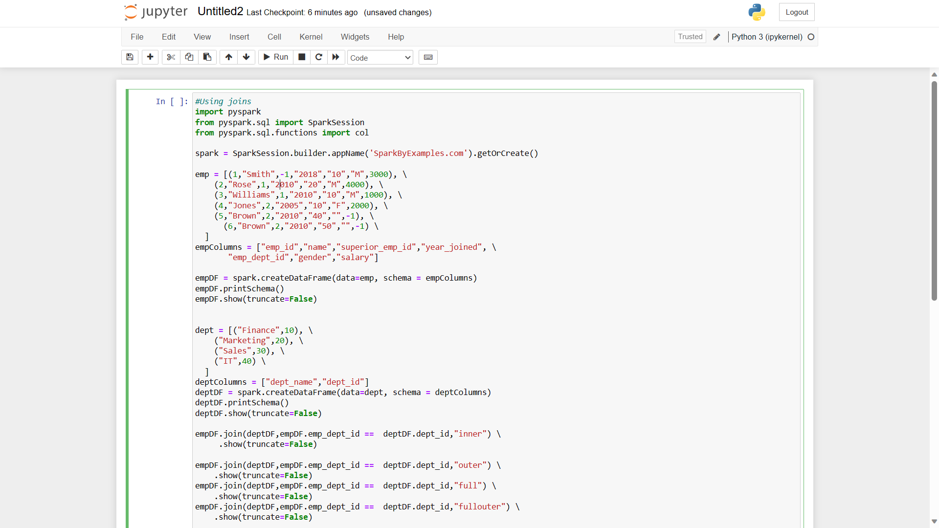

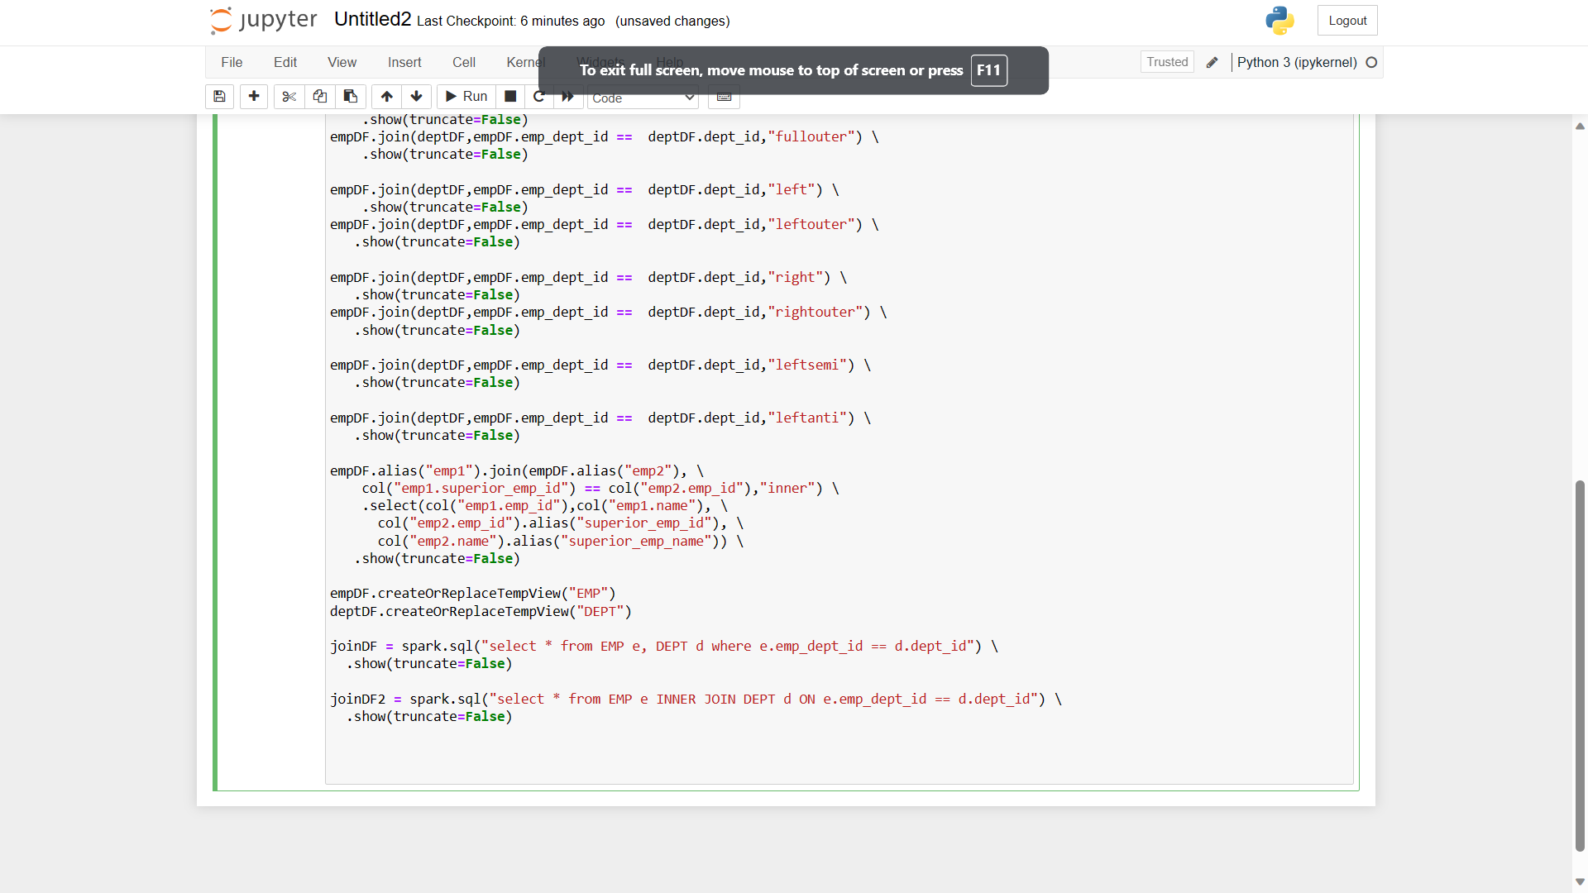

Using Filters

