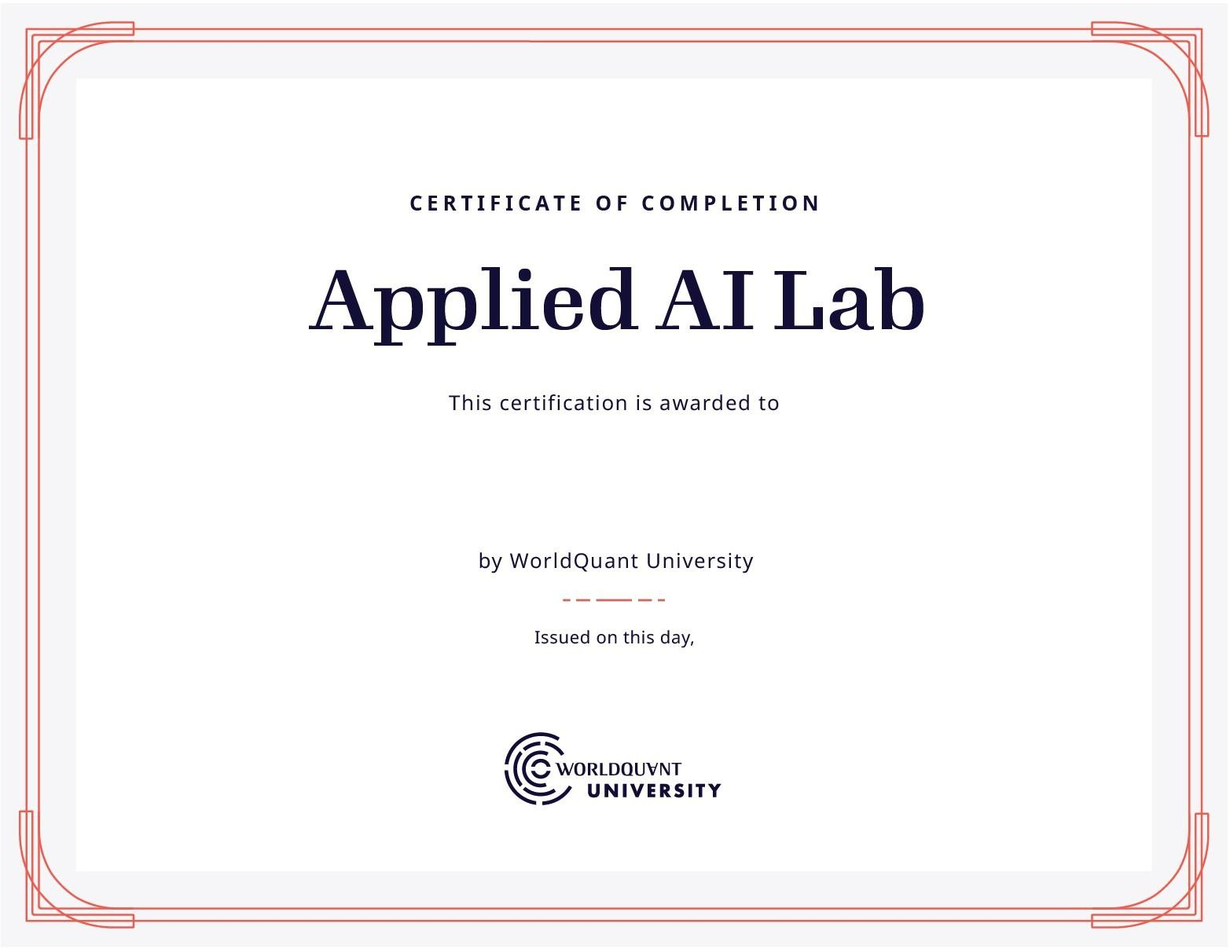

Hemakesh Reddy Muppidi

Apr 25, 2025