SOA Configuration Document

**Note: If the data source and JNDI already exist, please validate the properties.**

**Section 1: Creation of NonXAData-Source: APPSnonXA**

Note: Please don’t create this datasource if the JNDI “**jdbc/APPSnonXA**” exists in the server.

1. Go to Console and click on data source

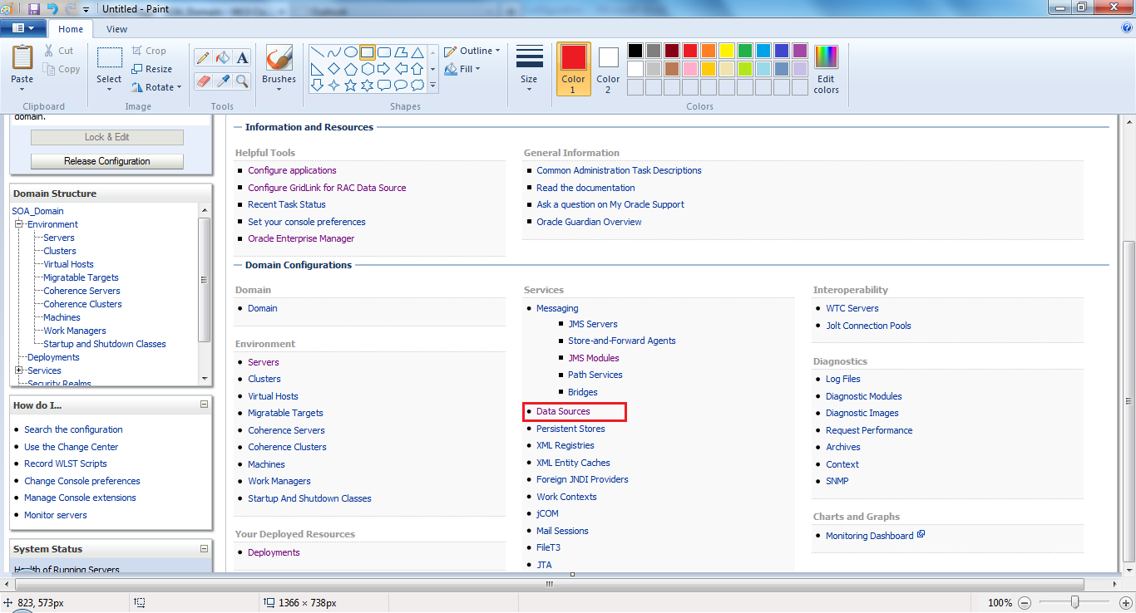

1. Click on New—GenericDataSource

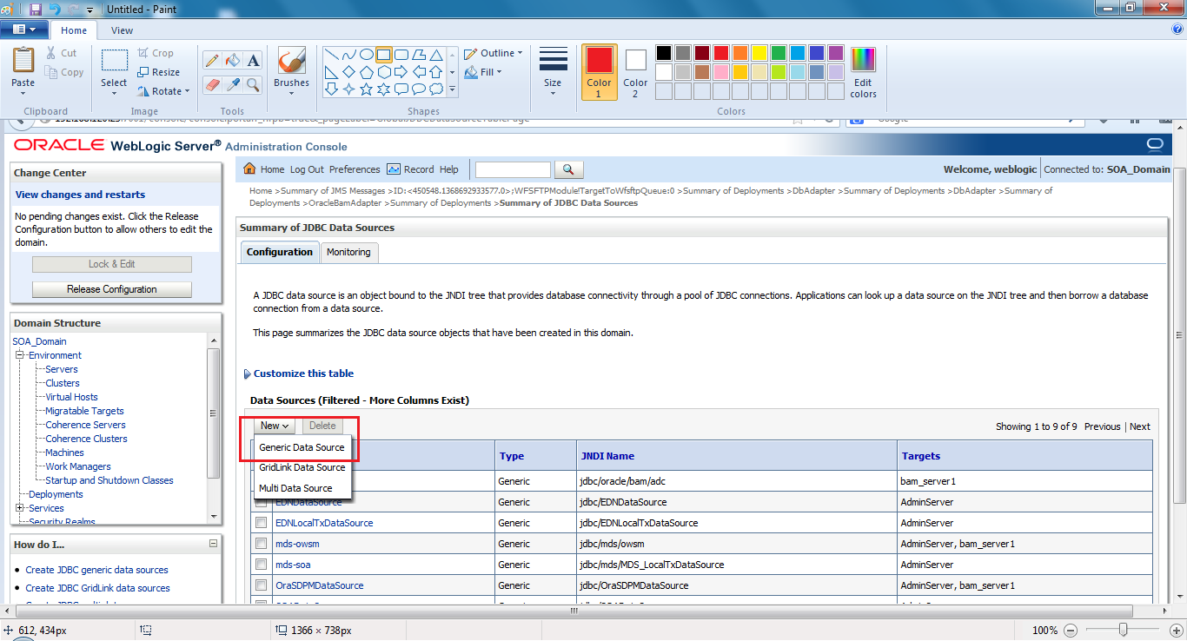

1. **Give Name – APPSnonXA and JNDI NAME as jdbc/APPSnonXA**

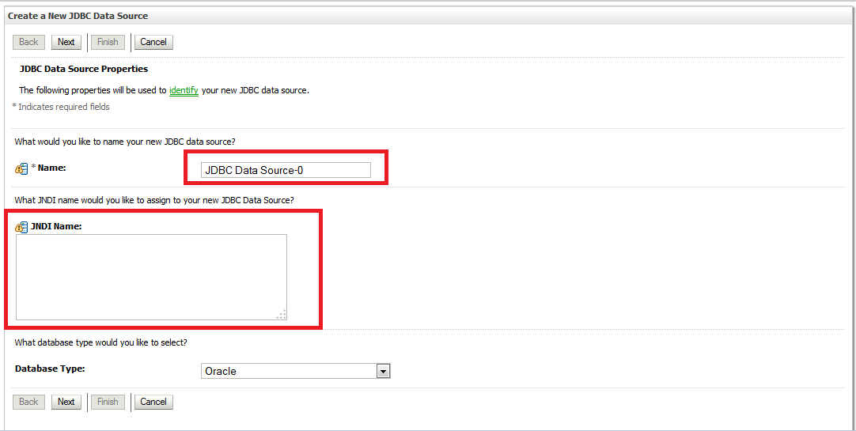

Click Next

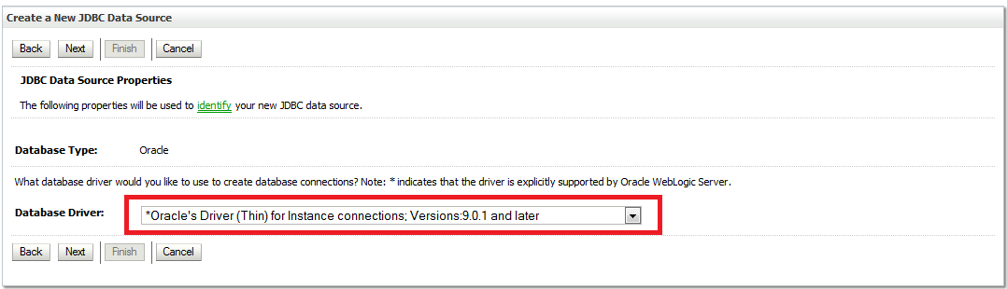

1. Click next

Uncheck supports Global Transactions

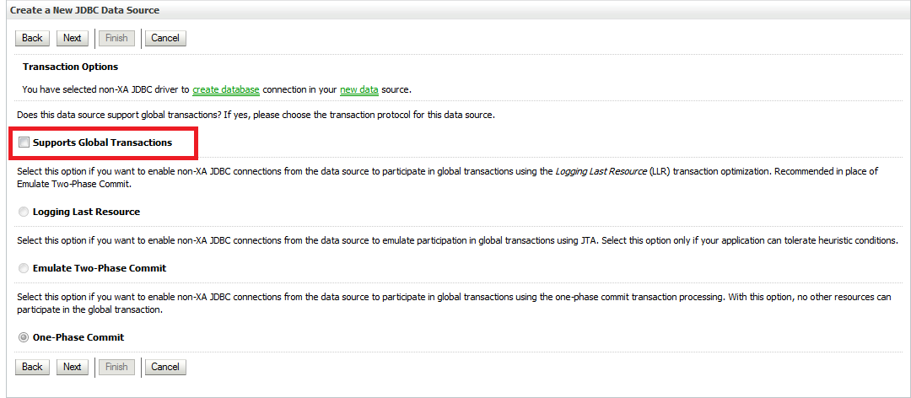

1. Click Next

**Provide the details of Database (APPS) as per the environment where Data Source is getting created**

**BASED ON THE ENVIRONMENT WE NEED TO CHANGE THE DETAILS LIKE**

* Database Name
* Hostname
* Port
* Username
* Password

**Example**

**Database Name**: dev2

**Hostname**: dev2db.wfs.com

**Port**: 1587

**Username**: apps

**Password**:

**and click** Next

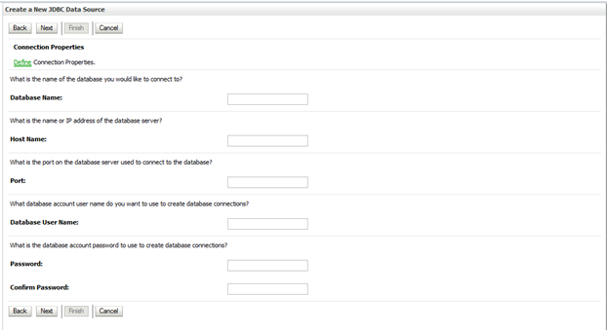

1. Click on test configuration

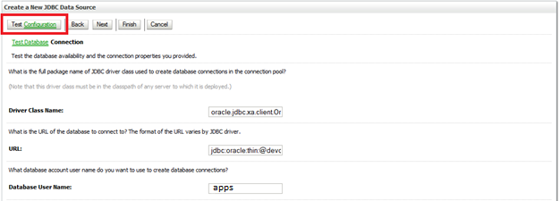

**Once connection gets succeed**

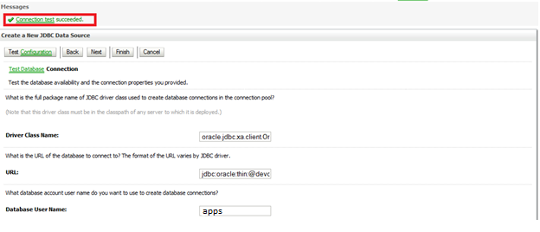

Click next and select Appropriate SOA Cluster.

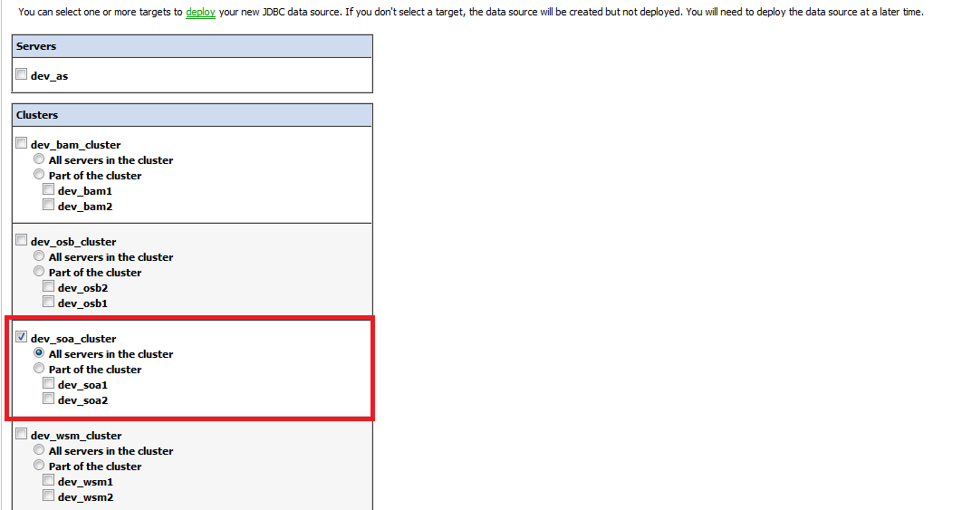

Click Finish.

**DB Adapter JNDI Configuration:** [**eis/DB/APPSnonXA**](http://egw-bpm1-dev.wfs.com:7001/console/console.portal?_nfpb=true&_pageLabel=ConnectorOutboundConnectionConfigPropertiesPage&ConnectorOutboundConnectionConfigPropertiesPortlethandle=com.bea.console.handles.ModuleDescriptorHandle%28%22com.bea%3AName%3DDbAdapter%2CType%3DAppDeployment%3BDbAdapter.rar%3Bjavax.resource.cci.ConnectionFactory%3Beis%2FDB%2FAPPSnonXA%3BConnectionInstanceBean%3BCONNECTOR%22%29)

1. Go to the weblogic Console.
2. Click on deployment under domain (left side).Click on DB Adapter.

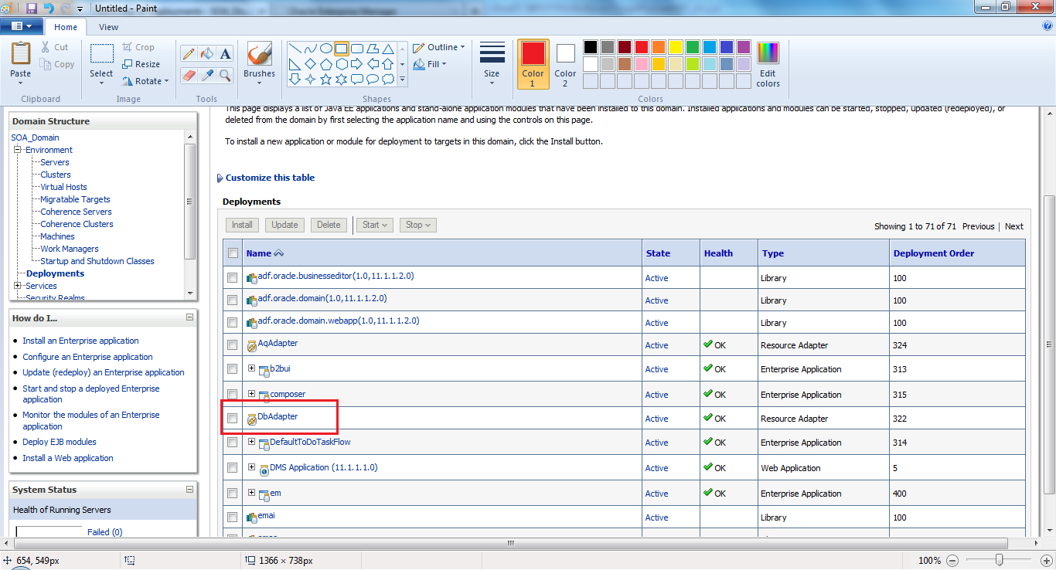

Click on **DbAdapter** 🡪 **Configuration** 🡪**Outbound Connection Pools**

Click on New

Select Outbound connection group

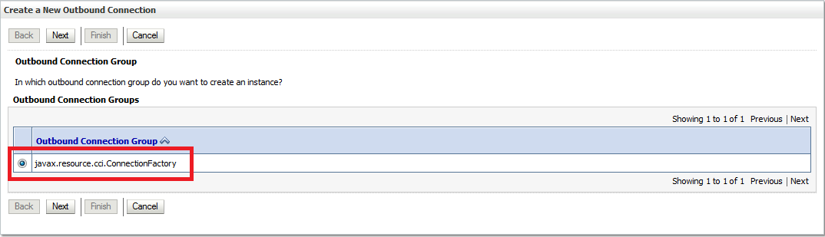

Click Next .Specify the JNDI [**eis/DB/APPSnonXA**](http://egw-bpm1-dev.wfs.com:7001/console/console.portal?_nfpb=true&_pageLabel=ConnectorOutboundConnectionConfigPropertiesPage&ConnectorOutboundConnectionConfigPropertiesPortlethandle=com.bea.console.handles.ModuleDescriptorHandle%28%22com.bea%3AName%3DDbAdapter%2CType%3DAppDeployment%3BDbAdapter.rar%3Bjavax.resource.cci.ConnectionFactory%3Beis%2FDB%2FAPPSnonXA%3BConnectionInstanceBean%3BCONNECTOR%22%29)

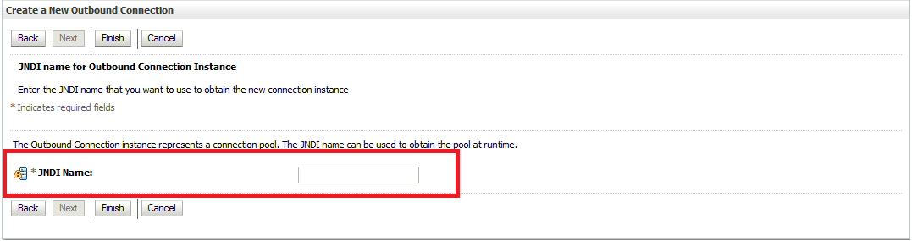

Click Finish.

JNDI created.

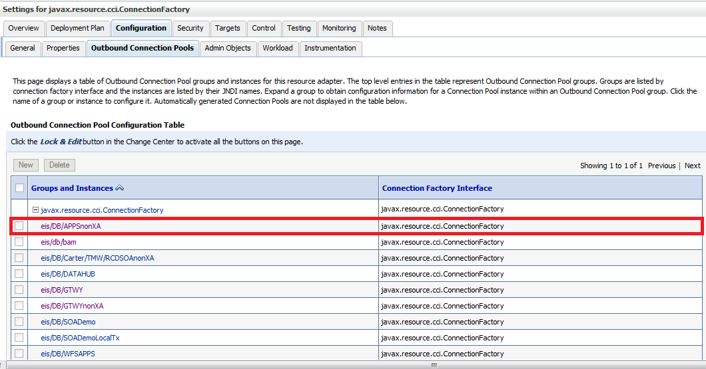

Now open the New created JNDI and specify the Datasource as **jdbc/APPSnonXA** and

sequencePreallocationSize as **50**

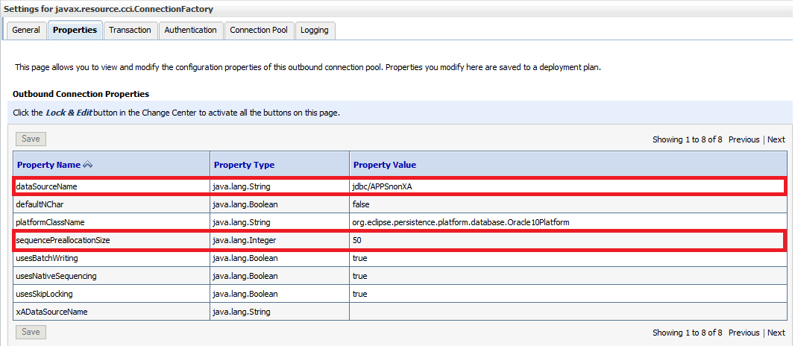

Click Save and Then activate the changes.

Now again go to deployment and select the DB adapter and click on update.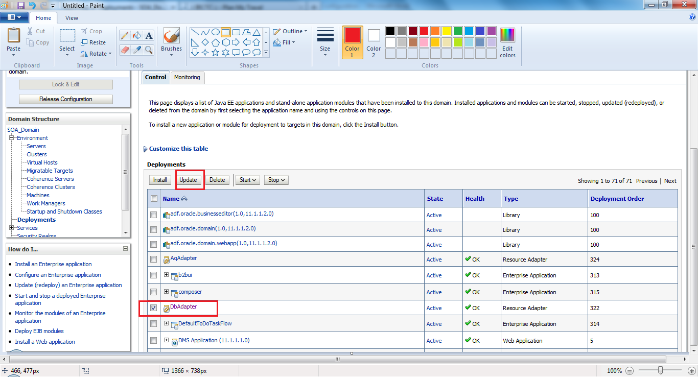

In the Update Application Assistant page, let the default be selected and click next.

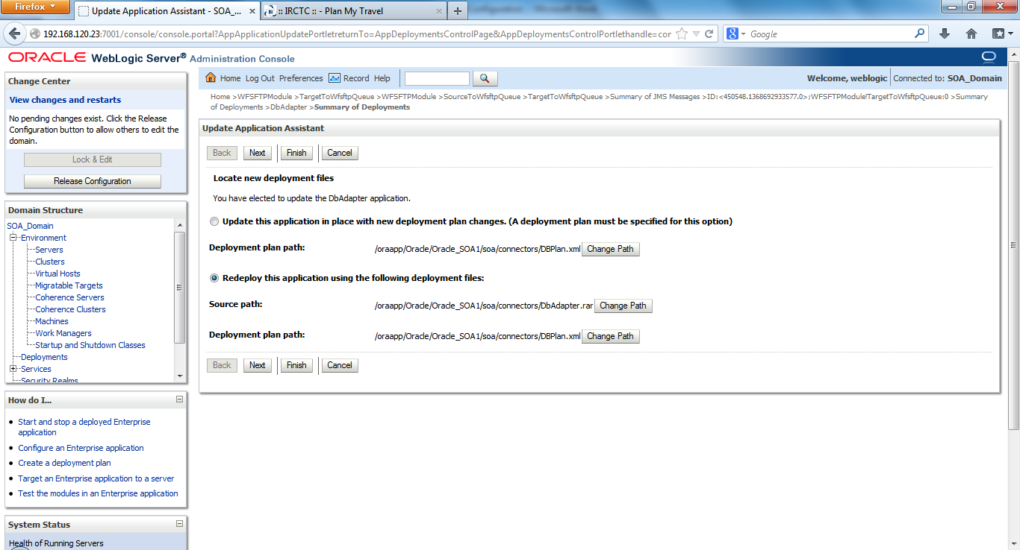

Click Finish.

Activate the changes.

**Validate the details in the JNDI** [**eis/DB/APPSnonXA**](http://egw-bpm1-dev.wfs.com:7001/console/console.portal?_nfpb=true&_pageLabel=ConnectorOutboundConnectionConfigPropertiesPage&ConnectorOutboundConnectionConfigPropertiesPortlethandle=com.bea.console.handles.ModuleDescriptorHandle%28%22com.bea%3AName%3DDbAdapter%2CType%3DAppDeployment%3BDbAdapter.rar%3Bjavax.resource.cci.ConnectionFactory%3Beis%2FDB%2FAPPSnonXA%3BConnectionInstanceBean%3BCONNECTOR%22%29) **again by clicking on its name.**

**Bounce both the manage server and admin server after making the changes.**