# FTP Adapter Configuration

**Section 1: Configuration for** [**eis/Ftp/FaxService**](http://soad2.wfs.com:7012/console/console.portal?_nfpb=true&_pageLabel=ConnectorOutboundConnectionConfigPropertiesPage&ConnectorOutboundConnectionConfigPropertiesPortlethandle=com.bea.console.handles.ModuleDescriptorHandle%28%22com.bea%3AName%3DFtpAdapter%2CType%3DAppDeployment%3BFtpAdapter.rar%3Bjavax.resource.cci.ConnectionFactory%3Beis%2FFtp%2FFaxService%3BConnectionInstanceBean%3BCONNECTOR%22%29)

1. Go to Weblogic console 🡪 Deployments 🡪 Click on FTP Adapter



1. Go to configuration 🡪 Outbound Connection Pools

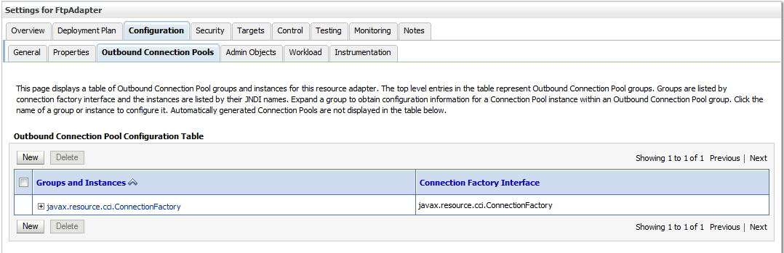

1. Click on New and select Connection Group

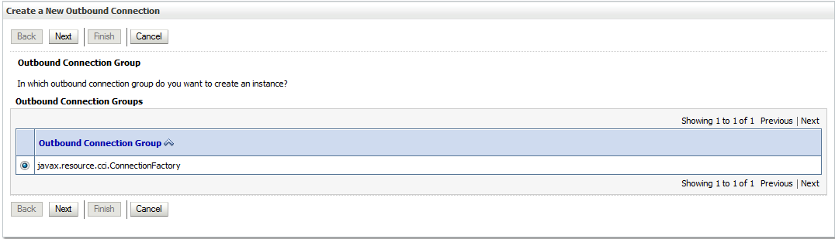

1. Provide JNDI Name as [**eis/Ftp/FaxService**](http://soad2.wfs.com:7012/console/console.portal?_nfpb=true&_pageLabel=ConnectorOutboundConnectionConfigPropertiesPage&ConnectorOutboundConnectionConfigPropertiesPortlethandle=com.bea.console.handles.ModuleDescriptorHandle%28%22com.bea%3AName%3DFtpAdapter%2CType%3DAppDeployment%3BFtpAdapter.rar%3Bjavax.resource.cci.ConnectionFactory%3Beis%2FFtp%2FFaxService%3BConnectionInstanceBean%3BCONNECTOR%22%29)

If JNDI name already exists, no need to create again and verify the configurations that are present.

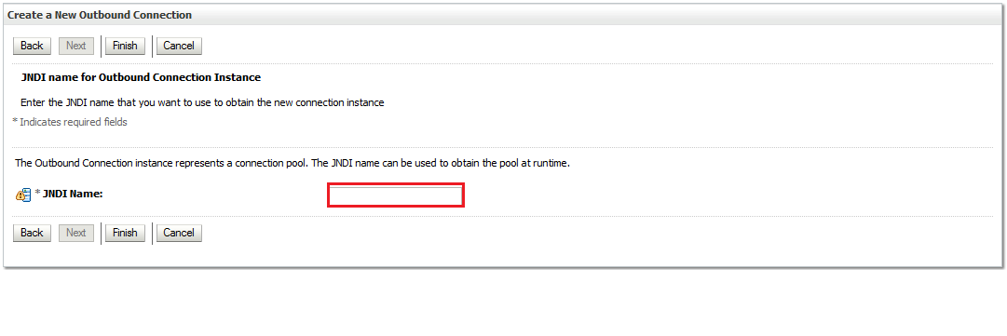

1. Click Finish .
2. Open the JNDI again [**eis/Ftp/FaxService**](http://soad2.wfs.com:7012/console/console.portal?_nfpb=true&_pageLabel=ConnectorOutboundConnectionConfigPropertiesPage&ConnectorOutboundConnectionConfigPropertiesPortlethandle=com.bea.console.handles.ModuleDescriptorHandle%28%22com.bea%3AName%3DFtpAdapter%2CType%3DAppDeployment%3BFtpAdapter.rar%3Bjavax.resource.cci.ConnectionFactory%3Beis%2FFtp%2FFaxService%3BConnectionInstanceBean%3BCONNECTOR%22%29) and update the information of FTP server.

Note: Based on the environment the FTP information will change.

For Example: (These details are only for reference)

**BPM DEV** will have Dev FTP information

**Host:** unixftpdev.wfs.com

**listParserKey:** WINDOWS

**password:**

**serverType:** win

**username:** svcunixftpdev@wfs.com

**recentDateFormat:** MM-dd-yy hh:mma

Note : Make the changes according to the screenshots.

**BPM MNADEV:**

**Host:** unixftpdev.wfs.com

**listParserKey:** WINDOWS

**password:**

**serverType:** win

**username:** [svcunixftpdev@wfs.com](mailto:svcunixftp@wfs.com)

**recentDateFormat:** MM-dd-yy hh:mma

**BPM TEST:**

**Host:** unixftptest.wfs.com

**listParserKey:** WINDOWS

**password:**

**serverType:** win

**username:** [svcunixftpdev@wfs.com](mailto:svcunixftp@wfs.com)

**recentDateFormat:** MM-dd-yy hh:mma

**BPM MNATEST:**

**Host:** unixftptest.wfs.com

**listParserKey:** WINDOWS

**password:**

**serverType:** win

**username:** [svcunixftpdev@wfs.com](mailto:svcunixftp@wfs.com)

**recentDateFormat:** MM-dd-yy hh:mma

**BPM QATEST:**

**Host:** unixftpqa.wfs.com

**listParserKey:** WINDOWS

**password:**

**serverType:** win

**username:** [svcunixftpdev@wfs.com](mailto:svcunixftp@wfs.com)

**recentDateFormat:** MM-dd-yy hh:mma

**BPM PSUP:**

**Host:** unixftppsup1.wfs.com

**listParserKey:** WINDOWS

**password:**

**serverType:** win

**username:** [svcunixftpdev@wfs.com](mailto:svcunixftp@wfs.com)

**recentDateFormat:** MM-dd-yy hh:mma

**BPM PROD1:**

**Host:** unixftp

**listParserKey:** WINDOWS

**password:**

**serverType:** win

**username:** [svcunixftp@wfs.com](mailto:svcunixftp@wfs.com)

**recentDateFormat:** MM-dd-yy hh:mma

**Note:** For passwords please contact Gapps Team.

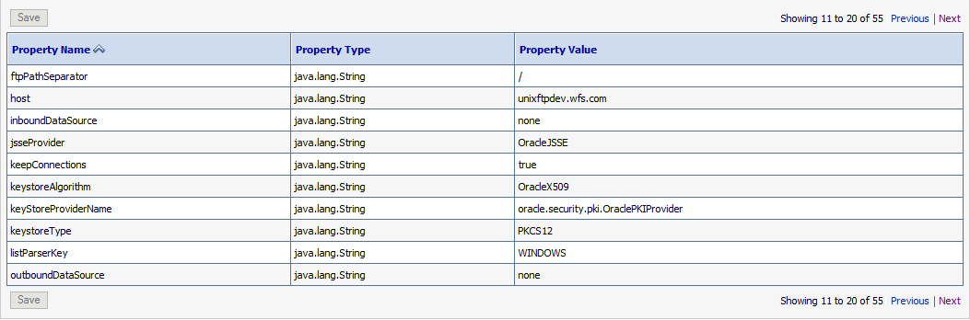

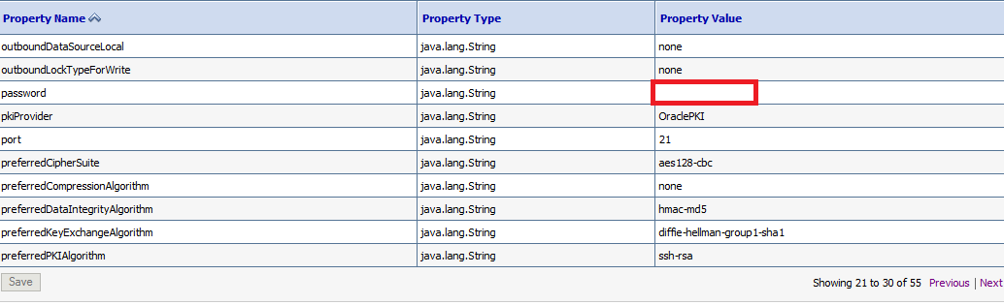

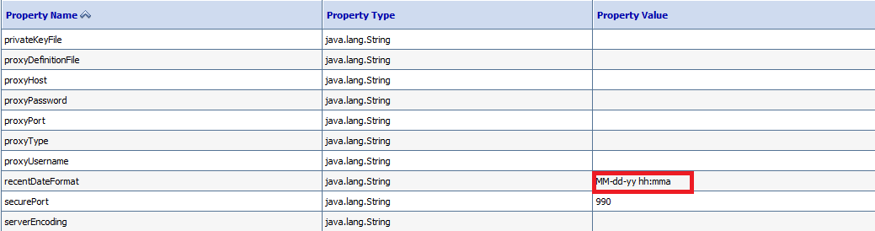

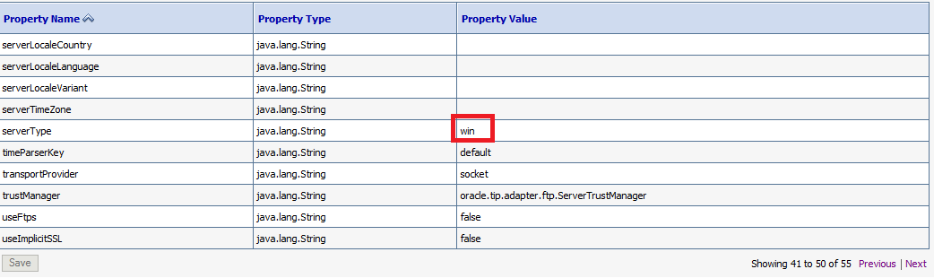

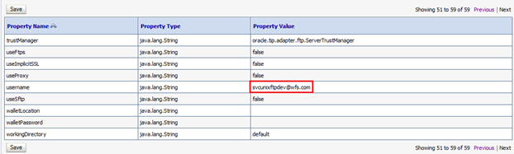

1. Save it. We can see the success message as shown.

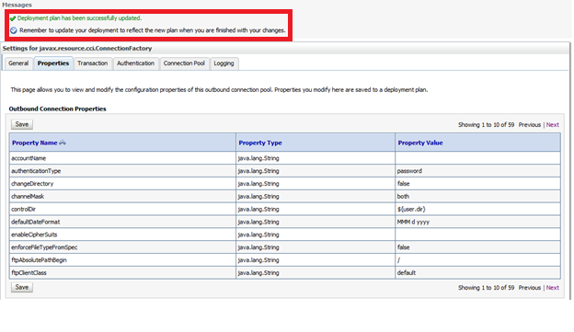

1. Now, go to Deployment page and select FTP Adapter .

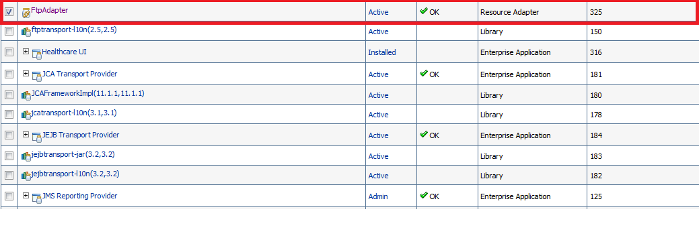

Click on Update.

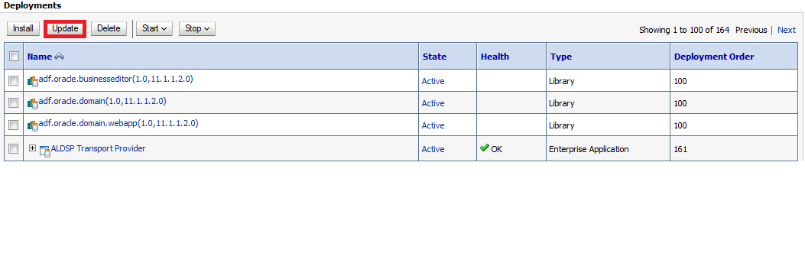

1. In the Update Application Assistant page, let the default be selected and click next.

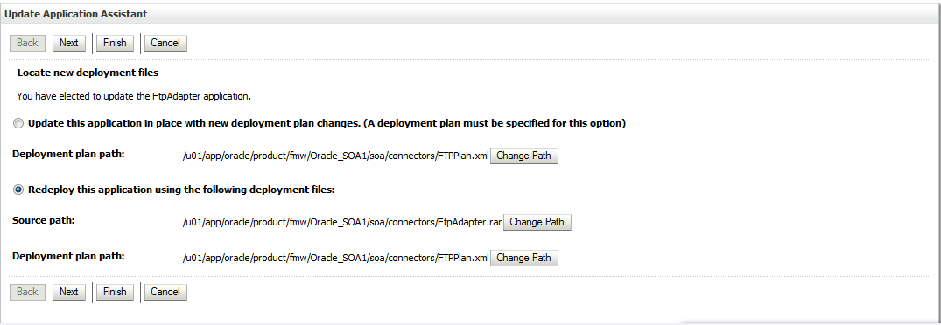

Click Finish.

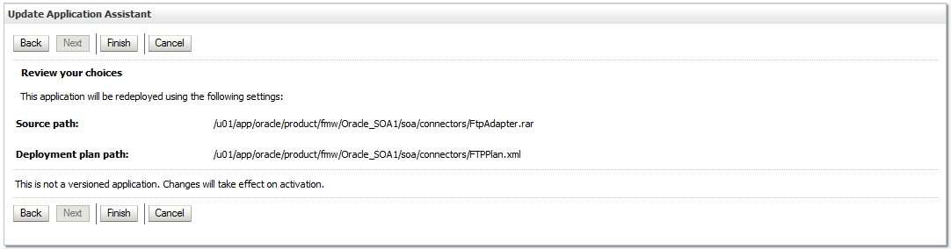

Click on Activate Changes.

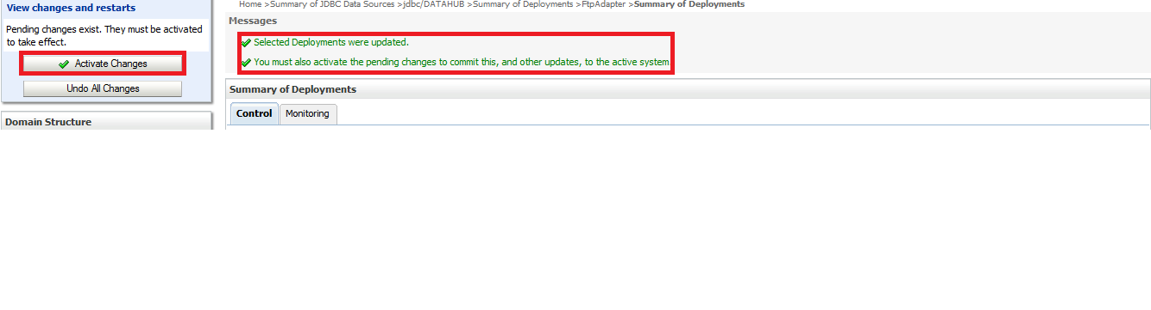

Note: Server restart is needed for SOA managed and admin servers after making the changes.