**Creating Partitions in EM Console**

1. Login into the EM console using the admin username and password. After successful log-in you will get the following screen.

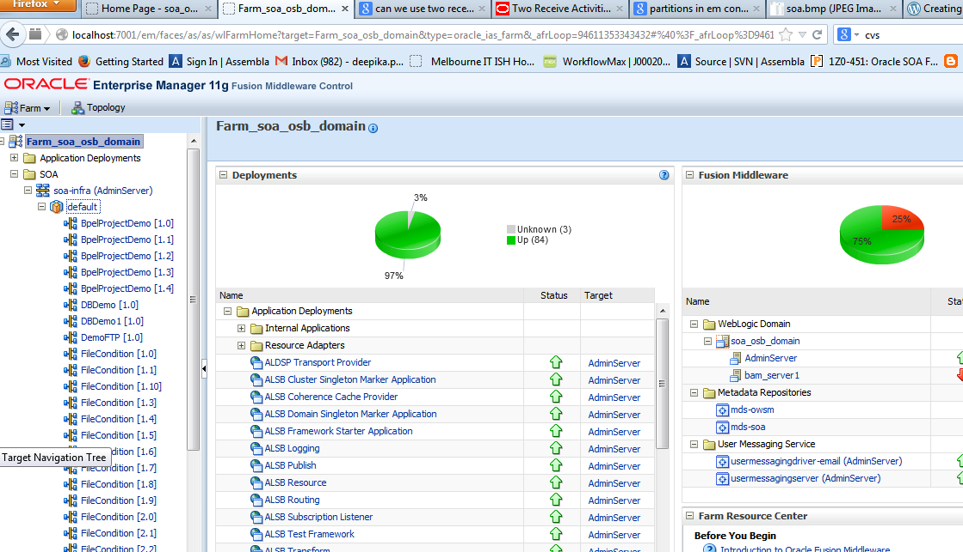

2.  Now go to the **“soa-infra”** under the **SOA** folder in the left side pane. Right click on the **soa-infra** and select manage partitions as shown in the screen below.

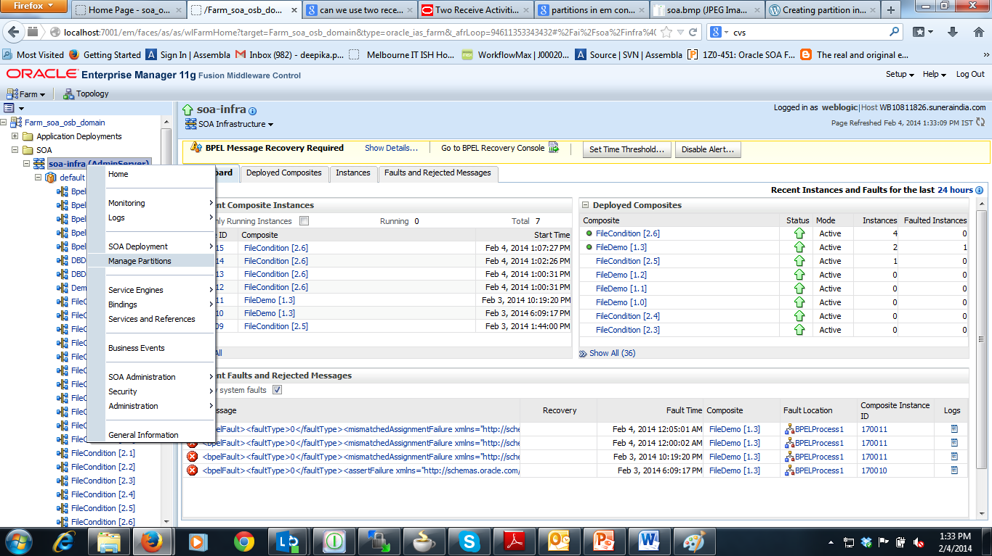

3. After clicking on the manage partitions, in the next screen we will see a create button in top-middle of the screen.  Refer to the screen shown below.

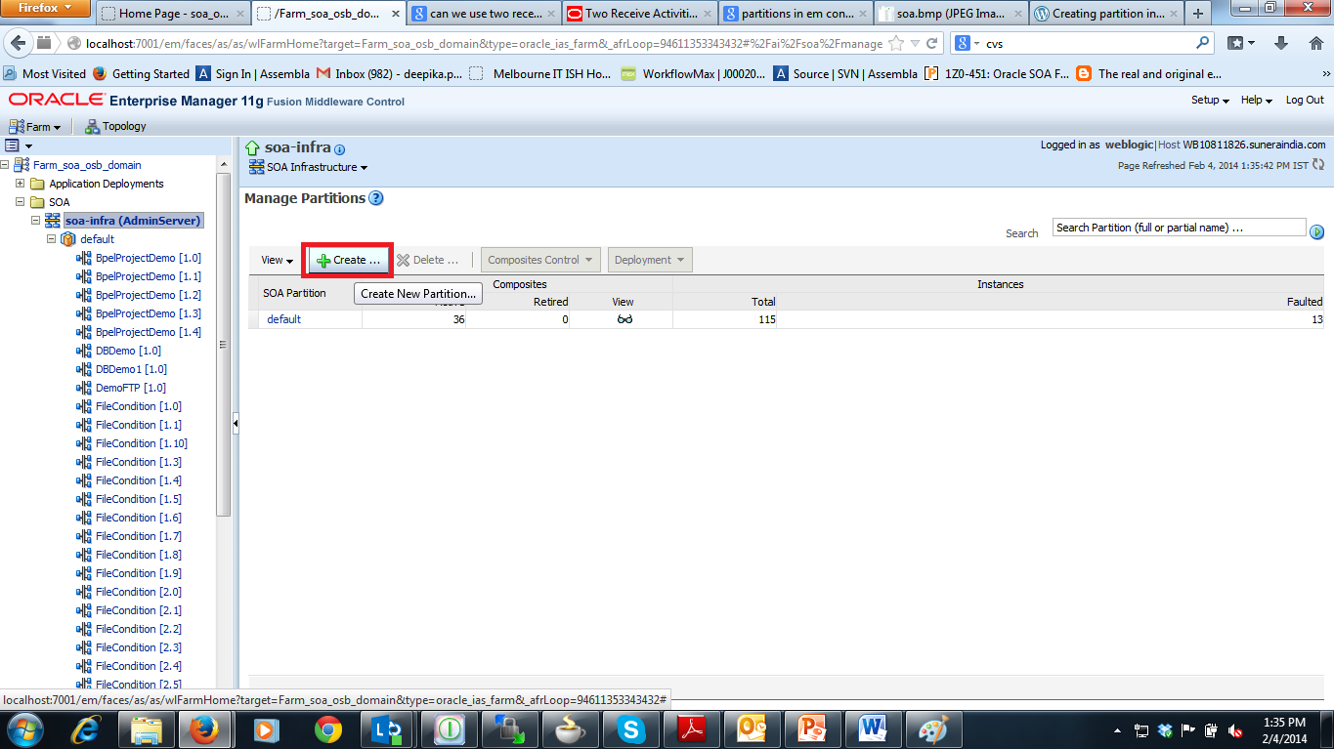

4. Now click on the create button to create a new partition.  After clicking the create button, a new screen will pop up, in this screen in the name field, you give the name of the partition as **UKLubes** after that click on the Create button. Refer to the screen shot below for better understanding.

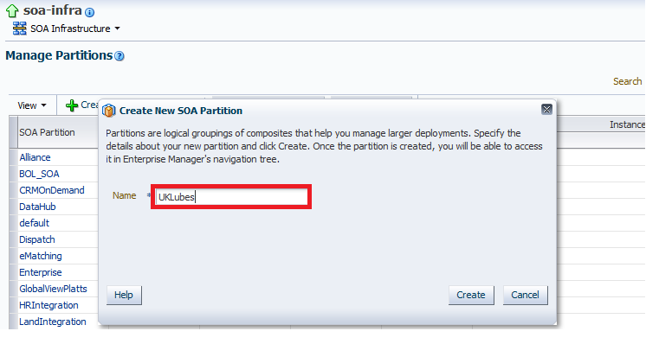

5. Now after the processing completes, you can see the partition created under the **soa-infra** called UKLubes

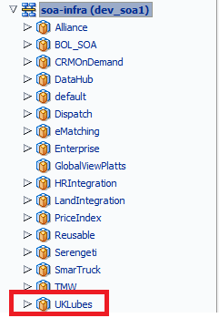

The partition is created in EM console in a SOA domain.