1.Show all records from the Sales table.
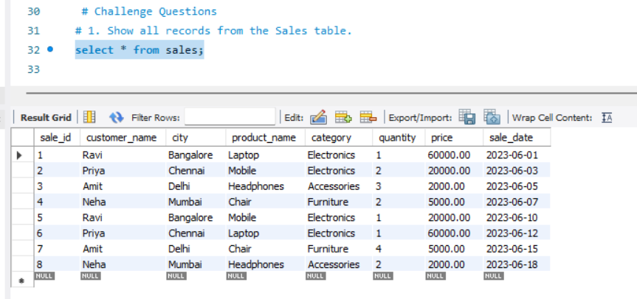
2. Display only customer names and cities.
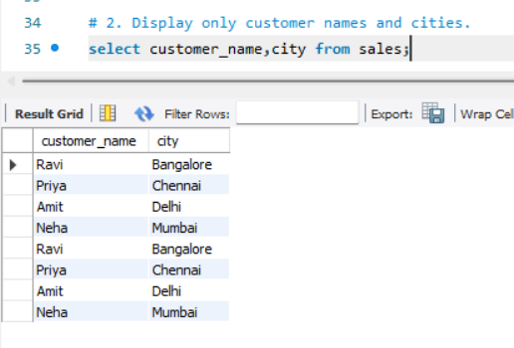
3. Show product name and price.
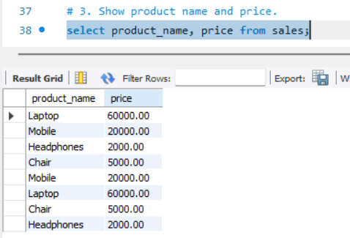
4. Show all sales where city is 'Bangalore'.
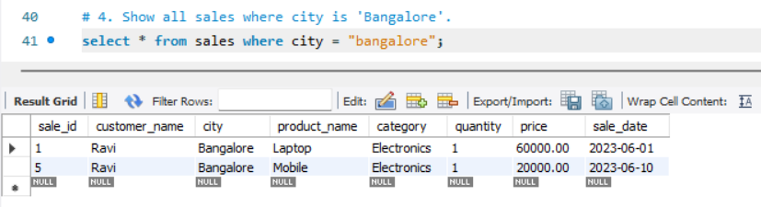
5. Find all products in 'Electronics' category.
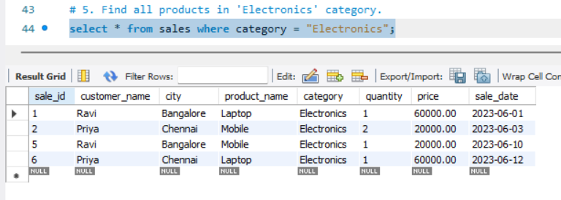
6. Show sales where price is greater than 10,000.
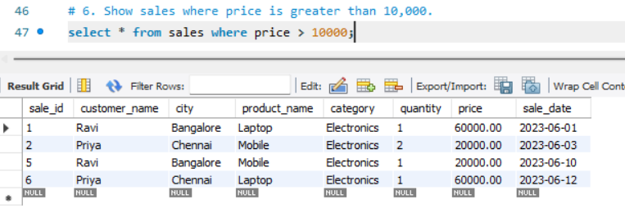
7. Display sales where quantity is more than 2.
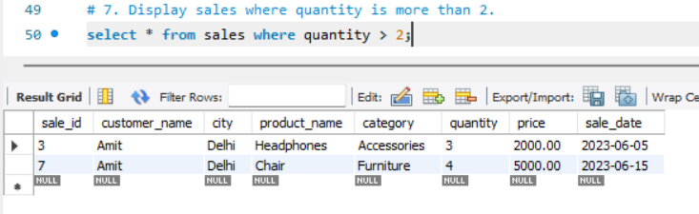
8. Show all sales sorted by price (low to high).
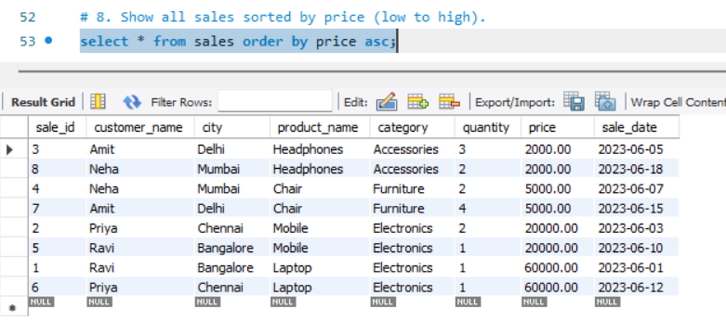
9. Display sales sorted by quantity (high to low).
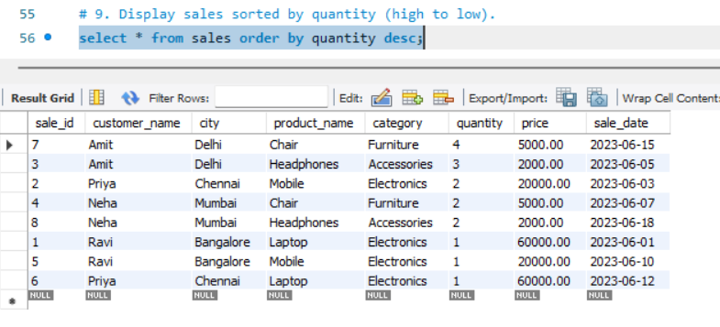
10. Show unique cities.
