Questions:
Level 1: Basic Filtering
1. Show all customers from Bangalore
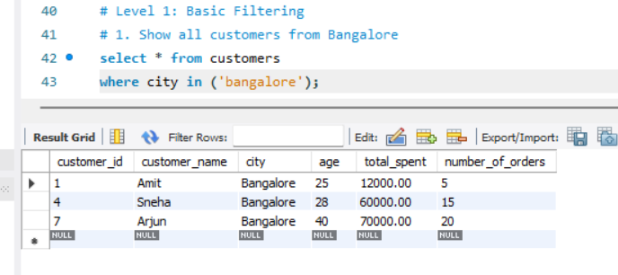
2. Display customers with total_spent > 20000
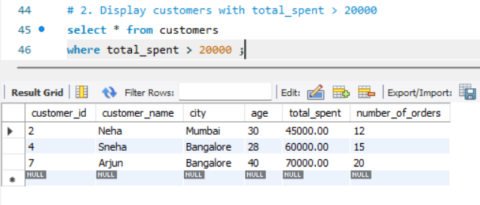
3. List customers aged between 25 and 35
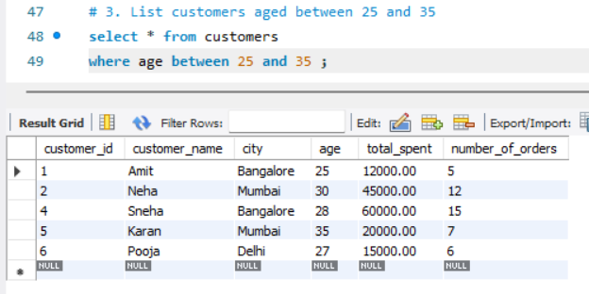
Level 2: Sorting & Aggregation
4. Show all customers sorted by total_spent (highest first).
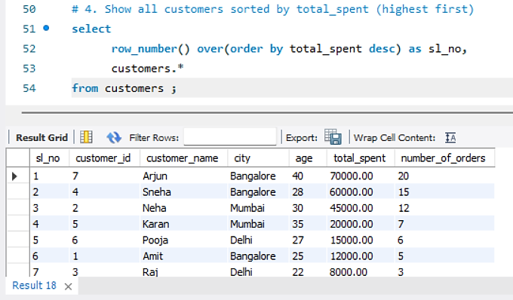
5. Find the total revenue generated
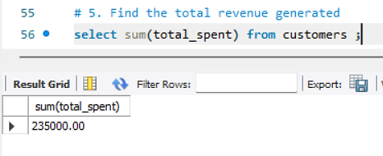
6. Find the average spending per customer
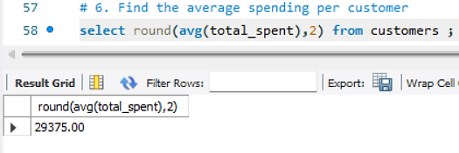

Level 3: Grouping
7. Find total spending per city.
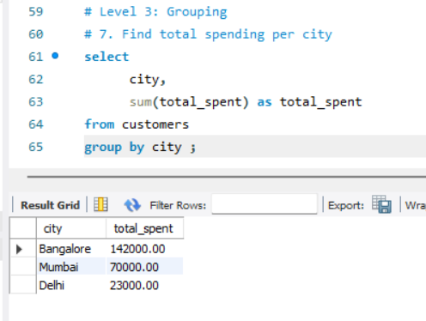
8. Count number of customers in each city
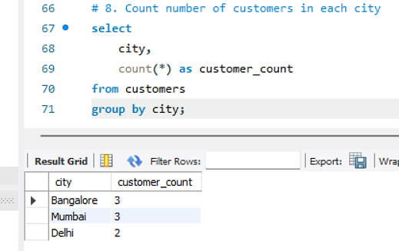

Level 4: Customer Segmentation (CORE TASK )
9.Count how many customers fall into each segmen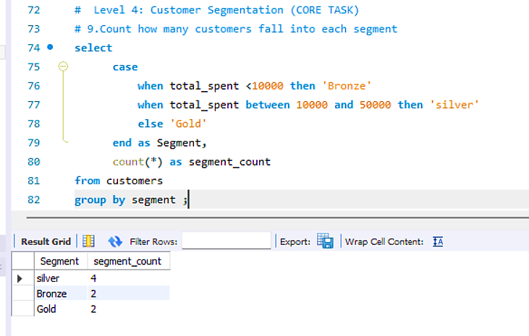
Level 5: Advanced Basic (HAVING)
10.Show cities where total spending is greater than 50000
